Quick Reference Guide: FD 50

Note: Terminal may prompt for more or less actions than listed here, depending on setup.

SALE / SWIPED
- Touch Credit
- Touch Sale
- Swipe card or key card # Enter
- Key sale amount Enter
- Key tip amount Enter
- Print Customer Receipt? * Yes or No
- Press Clear to return to idle prompt**

TIP ADJUST
- Touch Credit
- Touch Tip
- Key transaction number Enter
- Touch Edit
- Key tip amount Enter

REFUND
- Touch credit
- Touch refund
- Swipe card or key card # Enter
- Key server ID Enter
- Key refund amount Enter

VOID
- Touch Credit
- Touch More 3 times
- Touch Void Trans
- Key Invoice # Enter
- Touch Void
- Void Trans? Yes or No

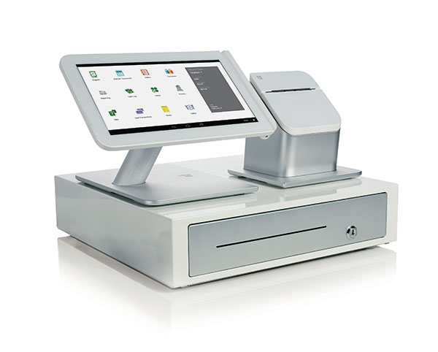

1st National Bankcard

REPRINT RECEIPT
- Touch Credit
- Touch More 2 times
- Touch Reprint
- Key invoice # or press Enter for last
Transaction Enter
- Print Cust receipt Yes or No

BATCH REPORTS (FOR TRANSACTIONS NOT YET SETTLED)
- Touch Credit
- Touch More 2 times
- Touch View Report or Print Report
- Touch desired report to view or print
- If viewing, choose to view by server ID or transaction
- If viewing, press Next to scroll

BATCH SETTLE
- Touch Credit
- Touch More
- Touch Close
- Confirm totals Yes or No
- Printing a customer receipt is an option for all transactions
** Press Clear to return to idle prompt after any function.
** A forced transaction may occur only after obtaining an authorization code
- Either by authorization or by performing an Authorization Only.

Manually Enter a Credit Card Charge
- Press Credit
- Press Sale
- Enter card number using the keys
- When prompted to enter the expiration date enter it using the keypad

