May 2022 Member Program

FAM Trips

WHAT: RMGA Membership Meeting & Program

WHEN: May 9, 2022
6:00 pm – Networking
6:30 pm – Short Meeting
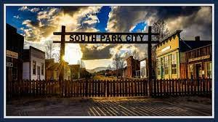
6:45 pm – Program

WHERE: Via Zoom

Topic: Rocky Mountain Guides' Member Meeting
Time: May 9, 2022 06:00 PM Mountain Time (US and Canada)

Join Zoom Meeting: https://us06web.zoom.us/j/83420656852

One tap mobile: +17207072699,83420656852# US (Denver)

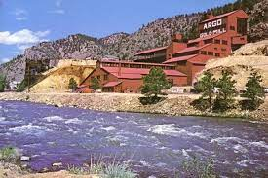
PROGRAM: Join RMGA on zoom for our final member meeting before summer break. We will be discussing two FAMtastic trips that explore Colorado's rich mining history. The Argo Mine in Idaho Springs and the South Park Ghost Town in Fairplay.

Dawn Nelson and David White will share details of the trips and how to join the fun IN PERSON.

Please join us for the meeting as we seek your feedback for the future of RMGA.

GUESTS: Members are encouraged to invite potential members as a guest to the meeting.

MEETING NIGHT CONTACT: J. Mark Blaising, Program Chair 303-830-8440 (voice) 303-263-8647 (text)

