RSAI 2022 Legislative Priority:
Transportation Equity
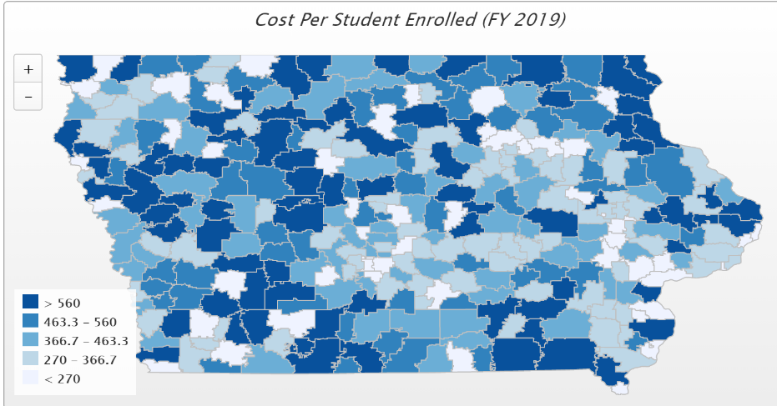
Background: In the 1950s, Iowa had over 4,000 school districts. Students walked to their neighborhood school and transportation costs were nonexistent for Iowa school districts. As budgets have tightened and enrollments declined, Iowa now has 327 districts (FY 2022) with varying square miles, disparate costs per pupil enrolled and hugely varying transportation costs.
Iowa’s foundation formula does not recognize the sparseness of population, square mileage or route miles for school districts, the number of students transported, or variance in road or geographic conditions. Transportation costs are paid out of the general fund.
Recent Progress: The Legislature has made strong gains in closing the transportation expenditure gap:
- SF 455 enacted in 2018 provided $11.2 million to 143 districts with the highest transportation costs in the state, a good start, but did not provide certainty.
- HF 307 enacted in 2019 provided $19 M in transportation as a supplement in the formula beginning in FY 2020. SF 2164 enacted in 2020, provided an increase of $7.3 million compared to the prior year, bringing the transportation total to $26.3 million for FY 2021. All districts that experienced transportation costs above the state average in FY 2019 were reimbursed for the difference and a small amount was then distributed to all districts based on enrollment.
- SF 269 enacted in 2021, provided an increased appropriation to the Transportation Equity Program under to equal the amount necessary to make all transportation equity aid payments (bring all districts down to the state average.) This was an increase of approximately $768,000. Starting in FY 2023, the appropriation will grow at the same rate as the categorical SCPP rate, absent any legislative action to the contrary.
Current Reality: the following describes transportation inequities from DE’s FY 2019 Transportation Report that are offset by the Transportation Equity Program:
- The range in transportation expenditures varied from a low of $22 to a high of $ 1,081 per student enrolled. With transportation funding in the formula, that range from high to low has been closed to $438 per pupil (although lagged by two years – FY 2022 equity payments are based on FY 2020 expenditures). Square miles per district range from a low of 2 to a high of 555 square miles, and route miles range from a low of 1,471 to a high of 746,902 miles.
- General fund dollars spent on busing would otherwise pay for staff and teachers (salary, benefits, training, support), curriculum, programs, technology, and energy. Lack of resources in these areas creates an unequal educational opportunity for students in districts with high transportation costs.
Formula and Transportation Equity: formula equity, closing the state and district per pupil gap within ten years and continued transportation equity support without burdensome reporting requirements.

