MUFON Field Investigator Toolkit

**Tiny SA Ultra Spectrum Analyzer and Signal Generator**

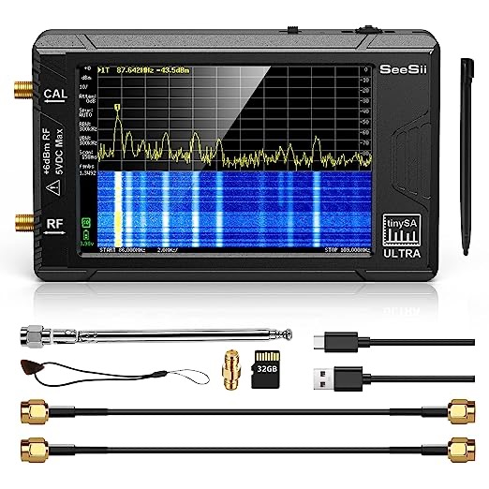

Prepared by Ray Graham, Field Investigator, Missouri, MUFON57691@gmail.com

**Overview**: This spectrum analyzer measures radio frequencies across a wide range of the electromagnetic spectrum. A spectrum analyzer is used to measure and view an electronic signal versus frequency. During UFO investigations, measurements taken can provide data regarding unusual or unexplained frequency broadcasts which could be caused by interaction with a non-human intelligence. The Ultra model described here also functions as a signal generator and can be used to broadcast a test signal on selected frequencies. Broadcasting a signal on frequencies that are sometimes associated with UAP or NHI activity (such as 1.6 gHZ) can potentially stimulate an NHI response.

**Product Details and Source**: Amazon, $207 (as of May 2024). https://amzn.to/3QWKG7A

**Scope**: This device is a portable instrument which can operate approx. 2 hours on its fixed internal battery. For use in UFO Investigations, it serves two primary functions:

1. Detect measurable frequencies broadcast in a field environment with readings taken during a suspected encounter with a NHI.

2. Broadcast a test signal on selected frequencies to potentially stimulate an NHI response.

**Unboxing and setup:** Using the USB-C port, charge before first use for an hour. A small red light shows charging status. Update firmware if desired at https://tinysa.org/wiki/pmwiki.php?n=Main.UpdatingTheFirmware

Run self-test by connecting one of the supplied SMA cables to the CAL and RF ports. Power on device from the switch on top. Touch screen to bring up right menu, then select CONFIG, then SELF TEST. The unit will conduct internal tests and should show all passed with Green status. To calibrate the low input power to the unit, leave the SMA cable connected, then in addition to its internal battery, an external battery source can be connected through the USB-C port to provide power during operation.

**Field Operations:**

Connect supplied antenna to RF connector port. Do not touch antenna while in use. Note that use of the antenna can damage the device if too powerful of a signal is received.

**Monitor Frequency Readings.**

Tap on screen (finger, stylus or guitar pick) to bring up menu on right.

Select “Mode”

Select “Spectrum Analyzer”

From Menu, select “Frequency”

Select “Start” “Stop” “Center” and “Span” for frequency range you want to detect. For example, to track the frequency 1.6 Ghz, select “Center” and on the keypad, select 1.6, then “G.”

To track historical info, turn on the waterfall by selecting “Display” then “Waterfall.” Toggle on.

**Generate a Signal.**

To generate a signal, use the Menu to select “Mode” then “Signal Generator.”

Select frequency to output, such as 1.6 Ghz, click on “Set”

On the touchpad, select “1.6,” then “G.”

**Observations and Misc Notes**

Power. In addition to it’s internal battery, an external battery source can be connected through the USB-C port to provide power during operation.

Stability. The unit is unstable standing upright. Recommend using a mount such as a cellphone holder in landscape to keep the unit stable while using.

Interface. The unit can be used in connection to a PC or laptop.

Ultra Features. In order to use the extended features of this device over the base unit, from the Menu, select “Config” then “More” then click the box to “Enable Ultra.” If prompted, enter Ultra Code: 4321.

* **TinySA Ultra**
  + Screen size 4 inch
  + Spectrum Analyzer for 0.1-800MHz or, with Ultra mode enabled, level calibrated up to 6GHz. Can observe signals up to 12GHz
  + Signal Generator with sine wave output between 0.1-800MHz or square wave up to 4.4GHz or rf test signal output up to 5.3GHz when not used as Spectrum Analyzer.
  + Switchable resolution bandpass filters from 200Hz to 850kHz
  + Built-in 20dB optional LNA
  + Color display showing max 450 points providing gapless covering up to the full frequency range.
  + MicroSD card slot for storing measurements, settings and screen captures.
* Input Step attenuator from 0dB to 31dB (can not be used in combination with LNA).
* A built-in calibration signal generator that is used for automatic self test and (low) input calibration.
* Connected to a PC via USB it becomes a PC controlled Spectrum Analyzer or Signal Generator
* Rechargeable battery allowing a minimum of 2 hours of portable use
* Max input level +10dBm. Do not destroy your tinySA
* The generator function can not be used as a tracking generator as you can not use the spectrum analyzer and generator functions at the same time.
* Due to the low cost and very small form factor there are certain relevant tinySA limitations and tinySA Ultra limitations

**Additional Notes, Fred Zewe**

Hey Ray ..  thanks in letting me know about the Tiny SA Ultra FUN toy you guys have purchased !!  Yes, nothing is too difficult in operating this unit.   It will just take time to play with it and getting used to the settings and its functions.  Here is a link that I thought you guys might enjoy in setting up the TinySA on your first go around ..  learning to turn it on and then doing the Self-Test of the unit and onto the Calibration.  They then will show you how to set up the Unit into Ultra Mode using the key code 4321 as to calibrate up to 5.34 Ghz.  You have to use an external signal generator above the 5.34 Ghz which I'm sure most don't have, thus you are done with the calibrations.

The only other warning that you need to be aware of with this TinySA is picking up HIGH Power RF ..  I saw that if it's above +10 dB, then you can DAMAGE your unit !!!  You don't want to do that, so you might want to set the "Attenuation" level to 20 or 30 dB first off before connecting your antenna to the RF Input injecting any outside RF signal to your unit.

Once you get the unit set up and calibrated then you can proceed in either 1) setting the SA into a frequency scan with Start/Stop frequencies or 2) selecting a specific frequency and bandwidth.  Of course, you can change the amplitude level to -10 or lower and then change the dB level per division on the monitor.  If you wish to view low power RF signals -70 dB or lower, you will have to reduce your frequency scan or bandwidth as to lower your noise floor seen on the monitor.   So, you will just have to play with these settings in observing more with the signal in whether it has any modulation, AM, FM or Pulse.

https://tinysa.org/wiki/pmwiki.php?n=Main.FirstUse

Here's a great link in how to capture a Screen Pic and save it to a file onto your 32 Ghz uSD card and then using the USB port to view the file you just created of the screen shot on your laptop !!  Then Save AS onto your laptop for your MUFON report !!

https://www.youtube.com/watch?v=zuTlxcXISTI

More FUN Ray !!  I'm sure you guys can checkout more videos on YouTube in learning more about your TinySA and other functions and Upgrading your firmware !!  Good luck in using your TinySA ..   : -)    Fred

|  |  |
| --- | --- |
|  | #1326a TinySA ULTRA uSD Card  Episode 1326a data and screen shots can be saved Be a Patron: https://www.patreon.com/imsaiguy  www.youtube.com |