**Do you suffer from:**

**Anxiety?**

**Depression?**

**Acne?**

**Chronic disease?**

**Acute or chronic inflammation?**

**Pain?**

**Insomnia? (trouble sleeping)**

**Arthritis?**

**Colitis?**

**Diverticulitis?**

**CBD oil can help!**

**Our CBD oil is not like the others.**

**Pure, organic and GMO-free.**

**Don't settle for anything less.**

**Ask the doctors if it is right for you!**

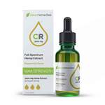 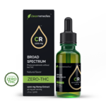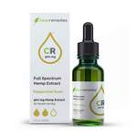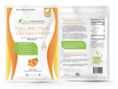

# Full Spectrum CBD Daily Fiber - 900mg 10oz.

# 900mg Full Spectrum Hemp Oil Tincture (natural or peppermint flavor)

**1200mg Broad Spectrum Hemp Oil Tincture (THC free)**

# 3000mg Max Strength Full Spectrum Hemp Oil Tincture (natural or peppermint flavor)