Board Members
Name | Role
Shelby Orme | President
Madison Toles | Vice President
Rebecca Garcia | Treasurer
Gabrielle Thomas | Secretary

Total Attendees: 10

Key Talking Points:
- Treasury Notes
- Updates on Exposed Cables
- Shared Street Topics
- Abandon Cars

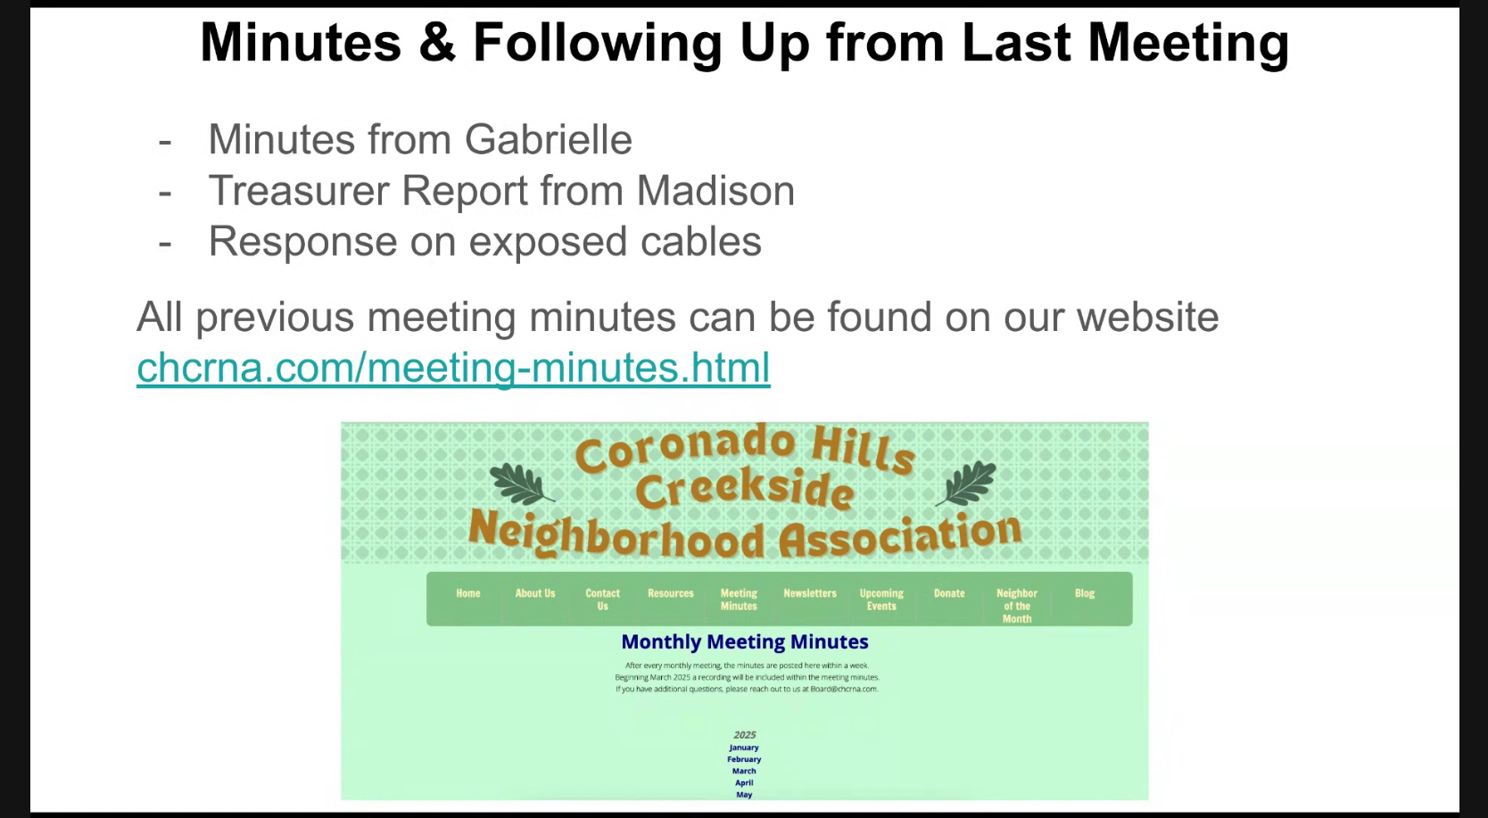

Meeting Notes:
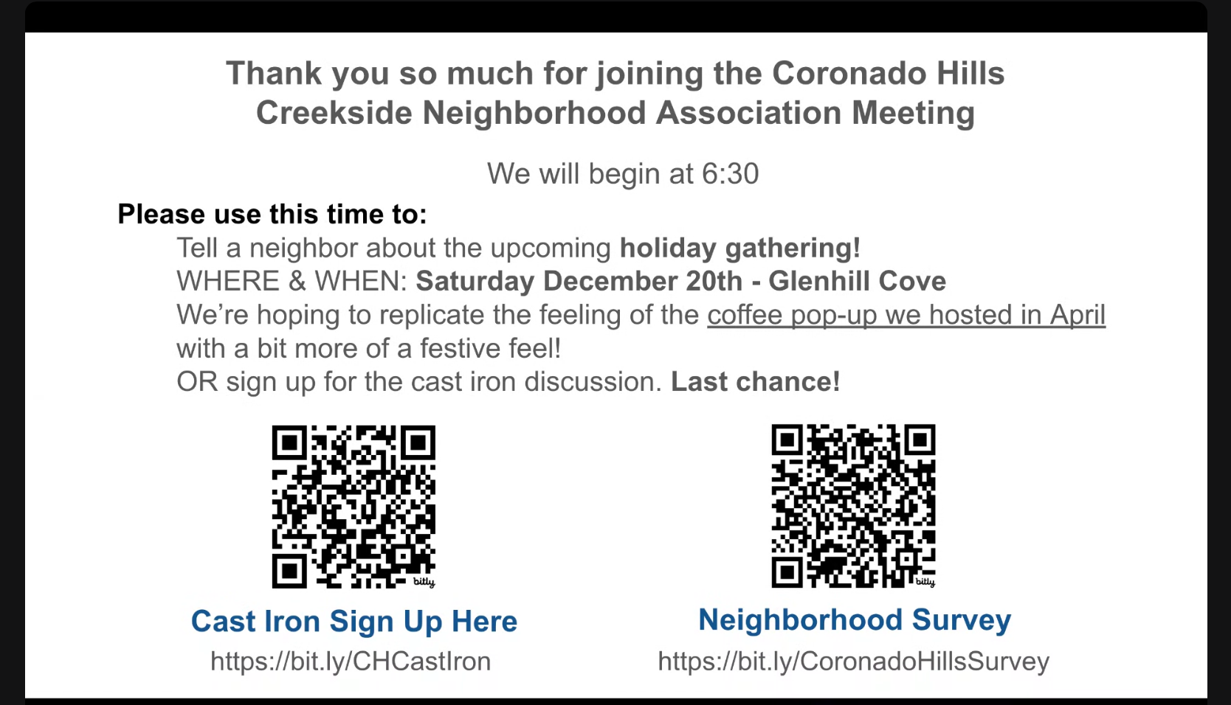
- Treasury Notes
  - Nov Account Balance $3,385.51
  - Dec Account Balance $3,291.75
  - Debits
    - $52.95 Printing newsletter
    - $40.81 Go Daddy Website Renewal fees
- Updates on Exposed Cables
  - Neighbor shared they received feedback the orange cable is google fiber or spectrum and the black cable is Time Warner but recommended
  - Neighbors have tried to get assistance by calling but could not get to a customer support rep
- Upcoming Events
  - Jan general meeting topic - Discussed replacing cast iron pipes
  - Holiday Party - Sat Dec 20 10am-12pm on Glenhill Cove
    - Event will have an optional cookie swap and games
  - https://meet.google.com/rvg-xejk-egj

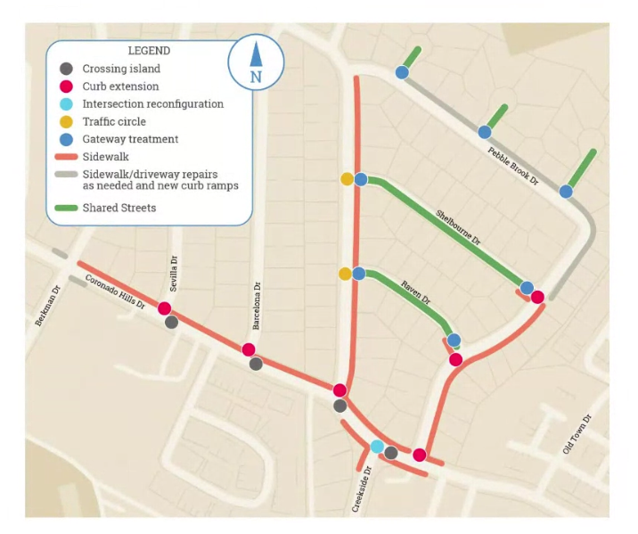
- Shared Street Topics
  - Discussed saving plants from sidewalk construction
  - Shared Street Website
  - Boards contact for project is Ming-ru.Chu@austintexas.gov
- Abandon Cars
  - Neighbor discussed that the silver car on Berkman has been removed but the Jeep is still there

