CONTACT UPDATE FORM
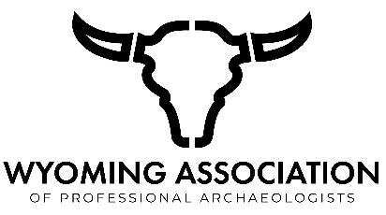

This form is for current Wyoming Association of Professional Archaeologists (WAPA) members to update their contact information. Please fill out the form and send it to the WAPA Secretary, via email (please refer to the Officers drop-down menu on the WAPA website for current email) or post:

Wyoming Association of Professional Archaeologists
ATTN: WAPA Secretary
Dept. 3431, 1000 East University Ave.
Laramie, WY 82071

Name(s):
Address:
City: |  | State: |  | Zip:
Phone:
Email(s):

Thank you,
WAPA Executive Committee

