^{PSALM 37 1-2} Don’t bother your head with braggarts
or wish you could succeed like the wicked. In no time they’ll shrivel like grass clippings and wilt like cut flowers in the sun. ³⁻⁴ Get insurance with God and do a good deed, settle down and stick to your last. Keep company with God, get in on the best. ⁵⁻⁶ Open up before God, keep nothing back; he’ll do whatever needs to be done: He’ll validate your life in the clear light of day and stamp you with approval at high noon.
⁷ Quiet down before God, be prayerful before him. Don’t bother with those who climb the ladder, who elbow their way to the top. ⁸⁻⁹ Bridle your anger, trash your wrath, cool your pipes—it only makes things worse. Before long the crooks will be bankrupt; God-investors will soon own the store.
¹⁰⁻¹¹ Before you know it, the wicked will have had it; you’ll stare at his once famous place and—nothing! Down-to-earth people will move in and take over, relishing a huge bonanza.
¹²⁻¹³ Bad guys have it in for the good guys, obsessed with doing them in. But God isn’t losing any sleep; to him they’re a joke with no punch line. ²⁷⁻²⁸ Turn your back on evil, work for the good and don’t quit. God loves this kind of thing, never turns away from his friends.
²⁸⁻²⁹ Live this way and you’ve got it made, but bad eggs will be tossed out. The good get planted on good land and put down healthy roots.

WINOOSKI UNITED METHODIST CHURCH
Winooski, VT
Sunday, April 29, 2018
Pastor Ellen Ravelin
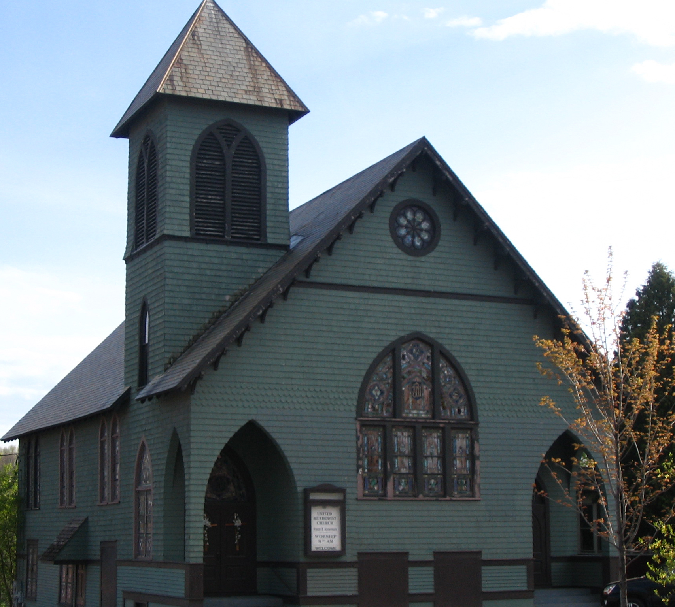

MUSIC: Rennay Maker

WELCOME TO OUR VISITORS! Please join us after worship for fellowship and coffee.

WINOOSKI FOOD SHELF: Second and fourth Saturday of the month between 9:30 - 11:30 AM and the second and fourth Wednesday of the month between 2:00 – 4:30 PM

Winooski UMC Bible Study Tuesday, 6:00-7:00 PM (Book of Revelation Chapter 1 & the Words of Jesus in Red).

Friday, May 4 at 5:00 – Potluck & Music at the church

OPENING PRAYER:
CALL TO WORSHIP: On back of the bulletin

“Hymn Sing!
Greet each other with the peace of Christ

Salvation is a Gift of Faith, not Works

SCRIPTURE READING: Ephesians 2:8-9, Galatians 5:4, Titus 3:4-5, James 2:24-26, 2 Corinthians 5:10

OFFERING of gifts to God, Doxology and Prayer

JOYS AND CONCERNS of the people

HYMN: “The Lord’s Prayer” p.271

BENEDICTION:
Website: winooskiunitedmethodistchurch.org
Church Phone: 655-7371; Pastor Ellen’s Phone: 655-9629


