RSAI 2017
Legislative Digest

June 30, 2017

About RSAI
The Rural School Advocates of Iowa began our advocacy journey in January, 2013, bringing together school leaders into an organization with the specific charge to collaborate and promote legislation that strengthens rural education for students, by building a voice for students and educators in Iowa. RSAI advocates for students in rural schools to assure a fair, equal and quality education. This group of 75 member districts continues to grow in both size and relevance.
RSAI is comprised of four quadrants of the state, known as the SE, SW, NE and NW regions. Each elects a representative to the RSAI Leadership Group and to the RSAI Legislative Group.
RSAI is recognized as a state affiliate of the National Rural Education Association: www.nrea.net
Visit the RSAI home page to find out more: www.rsaia.org

RSAI Leadership Group and Terms
SE Brad Breon, Moravia/Seymour, Superintendent, brad.breon@rsaia.org (Sept. 2017) Laurie Noll, Superintendent, Fairfield, was elected to a three-year term beginning Sept. 2017.
SW Paul Croghan, East Mills/Essex, Superintendent, paul.croghan@rsaia.org (Sept 2019)
NE Lee Ann Grimley, Springville, Board President, leeann.grimley@rsaia.org (Sept. 2018)
NW Robert Olson, Clarion-Goldfield/Dows, Superintendent, robert.olson@rsaia.org (Sept. 2020)
*Dan Smith, Harmony, Board President, dan.smith@rsaia.org At-large three year (Oct. 2018)
*Kevin Fiene, I-35, Superintendent, kevin.fiene@rsaia.org At-large three year (Oct. 2017)
*Dennis McClain, Clay Central Everly, Superintendent, dennis.mcclain@rsaia.org At-large three year (Oct. 2019)

Thanks to the RSAI Legislative Group (one-year term) who supported RSAI during the 2017 Session, includes at large members above * plus:
SW – Josh Hughes / Interstate 35 Board Member
NE – Duane Willhite /North Fayette Valley Superintendent
SE – Kerry Phillips / Harmony Superintendent
NW – Tara Paul / Estherville Lincoln Central Superintendent

Professional Advocate
Margaret Buckton, margaret@iowaschoolfinance.com
1201 63rd Street, Des Moines, IA 50311

Table of Contents
About RSAI, Leadership and Legislative Group Members Page 2
RSAI 2017 Legislative Priorities & Status Page 4
Legislative Session Approval and Veto Process Page 7
Executive Summary: 2017 Session in Review Page 8
State Budget Details Page 10
State Tax Credits Expected Claims Projection Page 12
Funding Formula History Resource & Enrolled Bills Page 13
Appropriations Acts
SF 166 State Supplementary Assistance Page 14
SF 516 Standings Appropriations Page 17
HF 642 Education Appropriations Page 17
Student Achievement/Teacher Quality Allocations Page 20
SF 130 Deappropriations for FY 2017 Page 21
Policy Bills Impacting PK-12 Education
SF 234 Texting and Driving Page 22
SF 238 Sexual Exploitation by School Employee
SF 240 State Assessments
SF 274 Governor’s Computer Science Initiative Page 23
SF 399 School Elections/Vacancy
SF 438 Public Bid Requirements
SF 499 Video Cameras in Bathrooms
HF 217 Disciplinary Actions/Licensed Employees Page 24
HF 291 Collective Bargaining Changes
HF 295 Prohibiting County Minimum Wage Page 25
HF 472 Teacher Loan Forgiveness Programs
HF 473 High School Equivalency Program
HF 518 Workers’ Compensation Page 26
HF 534 Child Care Facility Licensing
HF 564 Categorical Flexibility
HF 565 Education Super Flex Account Page 27
HF 569 403b Investment Vehicles Page 28
HF 573 Home Rule
HF 566 School Elections Page 29
Near Misses and Pending Issues Page 30
Pending RSAI Priorities Page 31
School Choice Talking Points and Status Page 32
2017 RSAI Position Papers Page 34
Section Analysis HF 291 Collective Bargaining Page 50
Resolution Template: Transfer to Student Activity Fund Page 55
DE Memo re; DOM Additional Reductions Page 56
Legislative Studies Committee Action 2017 Interim Studies Page 59
Advocacy and Other Legislative Resources Page 60

The following 2017 Legislative Priorities originated as key priority issues during the July RSAI Regional meetings. The Legislative Group reviewed and refined the Regional meeting activity, then submitted this language to the RSAI members at the annual meeting. The members at the annual meeting approved the following slate of priorities on Oct. 7, 2015. The RSAI 2016 Annual Meeting is scheduled for Oct. 25, 2017, at the FFA Enrichment Center, DMACC Ankeny Campus, 5:30 p.m. See the RSAI website meeting tab for more information: http://www.rsaia.org/. Status of this year’s activity is summarized:
- Transportation Equity: Supports a mechanism that covers school transportation costs that does not unreasonably disadvantage property tax payers in property poor districts or compete with general funds otherwise spent on providing education to students. Position paper found here.
and

- Equality in the formula: RSAI supports raising the state cost per pupil to the maximum district cost per pupil in the formula. Position paper found here.

Status: SF 455 was approved unanimously by the Senate, approved 22:1 in the House Education Committee, then assigned to the House Appropriations Committee, with a subcommittee recommending passage. The bill remains there, with the Revenue Estimating Conference lowering the revenue estimate on March 14, impacting both the current FY 2017 and the upcoming budget year FY 2018. The bill remains alive for the 2018 Session.

- State Penny for School Infrastructure Extension: RSAI calls on the Iowa Legislature to extend or repeal the sunset of the state penny for school infrastructure. Since voters in Iowa’s 99 counties approved the sales tax for public schools, any change in use of the revenue in the extension should be dedicated to educational purposes only. Position paper found here.

Status: HF 230 was approved by a subcommittee of the House Ways and Means Committee, but remains there, alive for consideration in the 2018 Session.

- Operational Sharing Incentives: Opportunities to achieve efficiencies, share capacity to operate, and redirect resources to educational programs, should be maintained and expanded to provide additional capacity to school districts to improve educational outcomes for students. Position paper found here.
Status: HF 633 was approved by the House 99:0 on April 17, was assigned to the Senate Appropriations Committee on April 18, and remains there, alive for consideration in the 2018 Session.

- Funding and Flexibility for At-risk Students: Resources for serving at-risk students should be based on need, such as the number/percentage of students eligible for Free and Reduced Price Lunch, in addition to enrollment of the district. The current disparity in dropout prevention capacity ceiling, with some districts held to 2.5% and others allowed to access up to 5% of regular program district cost is unfair, arbitrary, and based on old history no longer relevant to supporting student needs. Districts should be given flexibility in determining the expenditure of at-risk resources to support students to graduate college/career ready for success. Position paper found here.
Status: SF 8, Low Income Program Supplementary Weighting, was introduced by Sen. Quirmbach, but did not have a subcommittee meeting or hearing by the full Education Committee. HF 267, by Nielson, et al., same story in the House. HF 564 Categorical Flexibility, expanded flexibility for at-risk and dropout prevention.

- Standards, Assessment and Technology for Assessment: RSAI supports the Iowa Content Standards, including an aligned assessment and supports for the technology and bandwidth required to adequately administer the assessment. Assessments required by the state must be funded by the state. Position paper found here.
Status: SF 240 was signed by the Governor on May 11, 2017.

- State Supplemental Assistance: Due to non-educational priorities of the legislature, the education of students in rural districts has been disadvantaged by many years of low per pupil increases. Formula funding is especially critical to rural Iowa due to transportation costs, economies of scale, unique needs of students, mandates and compliance, the need for quality AEA services, and the ability to attract and retain quality staff in rural Iowa. The survival of rural schools depends on the return of education as the state’s top priority with an investment of meaningful new resources to improve opportunities for students. The resurrection of this priority will take several years of significant investment, thus RSAI supports a minimum of 6% non-categorical funding, as long as new mandates are funded outside of the formula and not instead of it.​​ The return to the legal and historical practice of setting the state cost per pupil as required by Iowa law exemplifies the prioritization of education. If the General Assembly does not set SSA in accordance with statutory timelines, the percent of SSA immediately reverts to the percent of state revenue growth predicted by the Revenue Estimating Conference (REC) for the year of the school budget being set, based on the March REC estimate for the out year, prior to any state general fund revenue reductions imposed by the legislature. Position paper found here.
Status: SF 166 Supplemental State Aid, set 1.11% increase in the state cost per pupil. The law no longer requires SSA be set in the legislative session a year preceding the start of the school year, so no action was taken on the FY 2019 state cost per pupil. Signed by the Governor Feb. 8, 2017.

- Rural Teacher Quality Program: RSAI supports a new Rural Quality Teacher Incentive Program, to ensure students in rural Iowa have access to great instruction and support district compliance with accreditation standards. Position paper found here.

Status: SF 475, Omnibus Education Policy, included some flexibility for districts to offer online learning courses to meet offer and teach requirements and to allow concurrent enrollment (community college) courses to supplant high school offer and teach requirements under certain circumstances. The bill was approved in the Senate, received republican but not democrat votes in the House Education Committee and remained on the House Calendar at the close of the Session.

- Summer School/Interventions: RSAI supports local district authority to determine if supplemental interventions during the school year, in addition to the regular program, would be more beneficial to non-proficient third-grade readers, if the district determines barriers will prevent offering a quality summer school program. Position paper found here.

Status: HF 642, Education Appropriations, repealed the mandated summer school for third-graders not proficient in reading, but kept in place the resources for early literacy interventions at $7.8 million, which was a slight reduction compared to the $8.0 million in FY 2017. Signed by the Governor on May 12, 2017.
- Quality Preschool: RSAI supports full funding of quality preschool. Due to changing demographics in rural Iowa, significant transportation costs, and lack of quality day care access, quality preschool for three- and four-year olds should be fully funded. Preschool students should be included in the regular student count at 1.0 per pupil cost. Position paper found here.

Status: HF 564, Categorical Flexibility, expanded the use of PK revenues to include 3 and 5 year olds (although those students don’t count for SVPP weighting to generate additional funds), also allow expanded flexibility for funds to cover the costs of snacks, translators and other expenses associated with PK. SF 121 by Petersen would have created ELL weighting for 4-year-old preschool students, but this bill did not receive a subcommittee hearing in the Senate Education Committee.
- Home Rule: District Flexibility: Iowa school districts should be subject to Home Rule to promote flexibility and creative decision-making as opposed to the more restrictive Dillon’s Rule interpretation of State authority. Position Paper Found here.

Status: HF 573, Statutory Home Rule, was signed by the Governor on May 10, 2017. The bill grants home rule to local school boards, with 4 exceptions, and requires statutes be interpreted broadly to effectuate the purposes of the legislation.

Legislative Session Approval and Veto Process
The 2017 Legislative Session drew to a close on April 22, 2017. Although 1,554 bills and 652 amendments were introduced in the Iowa Legislature this Session, 174 pieces of legislation made it to the Governor’s desk.
This Digest details legislation enacted by the 2017 Legislature and signed or vetoed by the Governor. In preparation for next year, we include a listing and explanation of some of the significant education and tax policy bills that moved through the process, ultimately not passing, which may resurface in the future. The information section of this digest includes position papers on issues of key interest to Iowa schools that guided RSAI advocates during the Session. The 2017 Session was the first of the two-year biennium of the 87th Iowa General Assembly. During the 2018 Legislative Session, bills that were introduced this year and moved partially through the process (approved during floor debate in the chamber of origin in the prior year) remain eligible for consideration. HF 633 Operational Sharing Incentives and SF 455 Transportation and Formula Equity, are good examples of bills left in committee at the conclusion of the 2017 Session that will remain in play for discussion next year, and both are priorities for RSAI members.
Process for Signature: The Governor has 30 days to review all legislation passed by the Legislature in the closing days of the Session:
- Bills received by the Governor during the last three calendar days of session (except Sundays) must be signed or vetoed within 30 calendar days. The deadline for Governor’s action was Monday May 22. The Governor completed his action on May 12.
- The Governor may exercise three types of vetoes: the veto, item veto, and pocket veto.
  - Veto indicates the Governor’s disapproval of an entire bill.
  - Item veto may be used only for bills which appropriate funds. This action strikes a specific item of an appropriations bill.
  - Pocket veto occurs when the Governor fails to take action within 30 calendar days on a bill received within the last three calendar days of session (except Sundays). The entire bill fails to become law in this situation. This rule is in contrast to the process during the Session prior to the last three days, wherein lack of action within three days means the bill becomes law.
- The Legislature may petition to convene a special session, which requires signatures of 2/3rds of the legislators. Additionally, the Iowa Constitution requires a 2/3rds majority vote in both chambers to override a veto.
- Lt. Governor, Kim Reynolds, was sworn in as Iowa’s 43 governor on May 24, 2017, as Governor Branstad resigned to accept the position of US Ambassador to China.

Executive Summary - 2017 Session in Review
This was an exciting year of advocacy for the Rural School Advocates of Iowa, as several RSAI priorities can be checked off the list! In what turned out to be a very challenging legislative session, RSAI members were effective in building urgency, yet still have much work to do in the key areas of transportation equity, formula equality and extending the operational sharing incentives.
Strained Budgets: The Revenue Estimating Conference lowered revenue growth estimates in both December 2016 and March 2017. Legislators balance the budget by reducing state expenditures and borrowing funds ($131 million) from the cash reserve fund as the last revenue adjustment happened so late in the fiscal year as to make additional reductions difficult. The Legislative Services Agency Monthly Revenue Memo through May 30 anticipates additional revenue shortfall, estimating the state general fund will close the fiscal year nearly $100 million short of the latest revenue estimate. Although restricted revenue growth hampered RSAI priorities of transportation and formula equity from moving forward, the tight budget stymied the conversation on state investment in school choice, also known as educational savings accounts or vouchers. Given the conversation at the national level and a strong and active lobbying presence in Iowa, school choice/voucher legislation is likely to move forward in the next session, absent sufficient advocacy to balance out the messages communicated by nonpublic schools and home school families. Expect tight budgets to continue unless Senators and Representatives revisit the revenue side of the equation.
NEW NREA Affiliate: Rural School Advocates of Iowa, as the state affiliate of the National Rural Education Association, includes Iowa rural school board members, administrators, and teachers in a network of over 3000 nationwide who advocate for rural schools, conduct rural education research, and share successes and challenges.
The NREA (National Rural Education Association) was originally founded as the Department of Rural Education in 1907. It is the oldest established national organization of its kind in the United States. Through the years it has evolved as a strong and respected organization of rural school administrators, teachers, board members, regional service agency personnel, researchers, business and industry representatives, and others interested in maintaining the vitality of rural school systems across the country.
Allen Pratt, Ed.D., NREA’s new Executive Director, shared resources from around the nation regarding vouchers and charter school experiences in rural school districts, helping to inform our Iowa advocacy in the coming session. Brad Breon, SE Region Representative, attended the NREA annual conference and represented Iowa as our RSAI delegate.

Find out more about NREA on their web site www.nrea.net

Observations of the 2017 Session:
- Conservative Budget Principles limited appropriations with low revenue growth as revenue reductions (tax cuts), larger than anticipated growth in tax credits and a soft farm economy delivered lower growth than would have otherwise occurred. This table shows the changes in the Revenue Estimating Conference from October 2016 through March 2017: 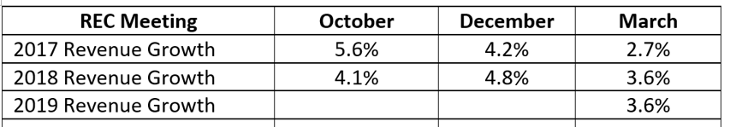
- Tax Credits: House Republican Appropriations and Ways and Means Committee chairs began conversations reviewing the growth in tax credits. Although initially promising as a means to restore revenue growth commensurate with our state’s economic growth, a closer look at proposals showed dedicated savings from curtailing tax credit growth would be directed to a taxpayer relief fund rather than made available to support essential state appropriations such as education.
- Pent up conservative agenda items received support of policymakers, with all three entities, the House, the Senate and the Governor’s office led by Republicans. Extreme restriction of nonpublic safety government employees collective bargaining, changes to workers’ compensation, elimination of municipal governments’ authority to set a minimum wage, legalizing the sale of fireworks, and elimination of state funding for health clinics that provide abortion services were among the most contentious debates sending legislation to the Governor’s desk.
- Flexibility: Expanding the uses of school categorical funds, creating a flexibility funding account to use some ending categorical balances for school priorities, and statutory home rule were among the biggest changes in school board authority to flexibly address the needs of students and stakeholders in their communities.
- Elimination of unfunded mandates: The mandate to retain third graders not proficient in writing and the repeal of the mandate requiring mentoring and induction programs (with the elimination of the teacher quality allocation to fund it) demonstrated a philosophy that unfunded mandates were not going to be allowed. Even the new state assessment required in SF 240, first to be required in the Spring of 2019, was accompanied by flexibility in the Professional Development per pupil supplements to pay for the costs of state testing (if PD is included.)
- This year’s 1.11% increase in the state cost per pupil is the third lowest in the history of the formula (1.0% in 2002-03 and 0.0% in 2011-12 were the only two instances lower than the 2017-18 school year rate.) However, other state government functions suffered significant reductions in funding. Despite the March REC lowering the revenue estimate, the legislature did not revisit the commitment of $40 million to school aid. They also kept in place, with only modest reductions, most line-items supporting public schools. The exceptions are noted in the detailed explanation of HF 642 Education Appropriations and SF 516 Standing Appropriations in this Digest.

Budget Summary: Projected Condition of the State’s General Fund Budget: the following is the LSA’s General Fund Balance Sheet which shows the expenditure limitation, total appropriations, and estimated ending surplus of $1.6 million for FY 2017 and $28.1 million for FY 2018: https://www.legis.iowa.gov/docs/publications/EOS/857783.pdf
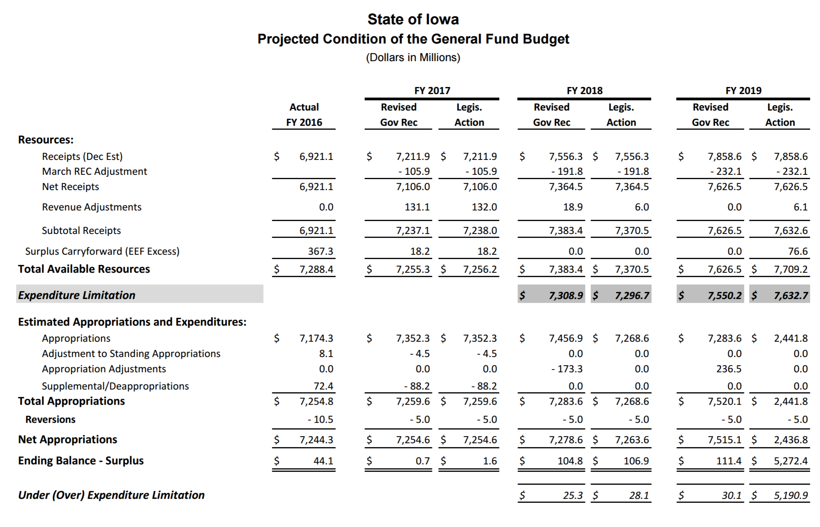
Budget Details: Estimated Position of State’s Cash Balance for FY 2017: The state’s Cash Reserve Fund, which is limited by law to a maximum of 7.5% of total budget, is calculated to be $422.4 million at the end of FY 2017, below the maximum $553.5 million. This is due to the legislature’s transfer of $131.1 million to the state General Fund for FY 2017, rather than making additional deappropriations in the last quarter of the fiscal year.
The Economic Emergency Fund, after transfer of $17.0 million to the Executive Council for performance of duty and a transfer of $18.2 million excess to the General Fund, is full at $184.5 million, which is the maximum 2.5% allowed in Iowa law (according to the LSA end of session balance sheet). The combined reserve fund balances are estimated to be $738.0 million on the end of FY 2017. That amount was calculated by the LSA before end of May predictions that lower than expected revenue growth would likely continue.
The LSA’s Monthly Revenue Memo, through May 31, 2017, indicates that revenues will continue to lag expenditures, by an estimated $100 million more than anticipated by the March REC. Governor Reynolds indicated her preference to avoid an across-the-board cut, preferring targeted expenditure reductions. The Governor and Legislature could avoid taking any action, causing the combined reserve funds to end the fiscal year $100 million lower than expected. The reserve fund balances from the LSA document at the end of Session follows:
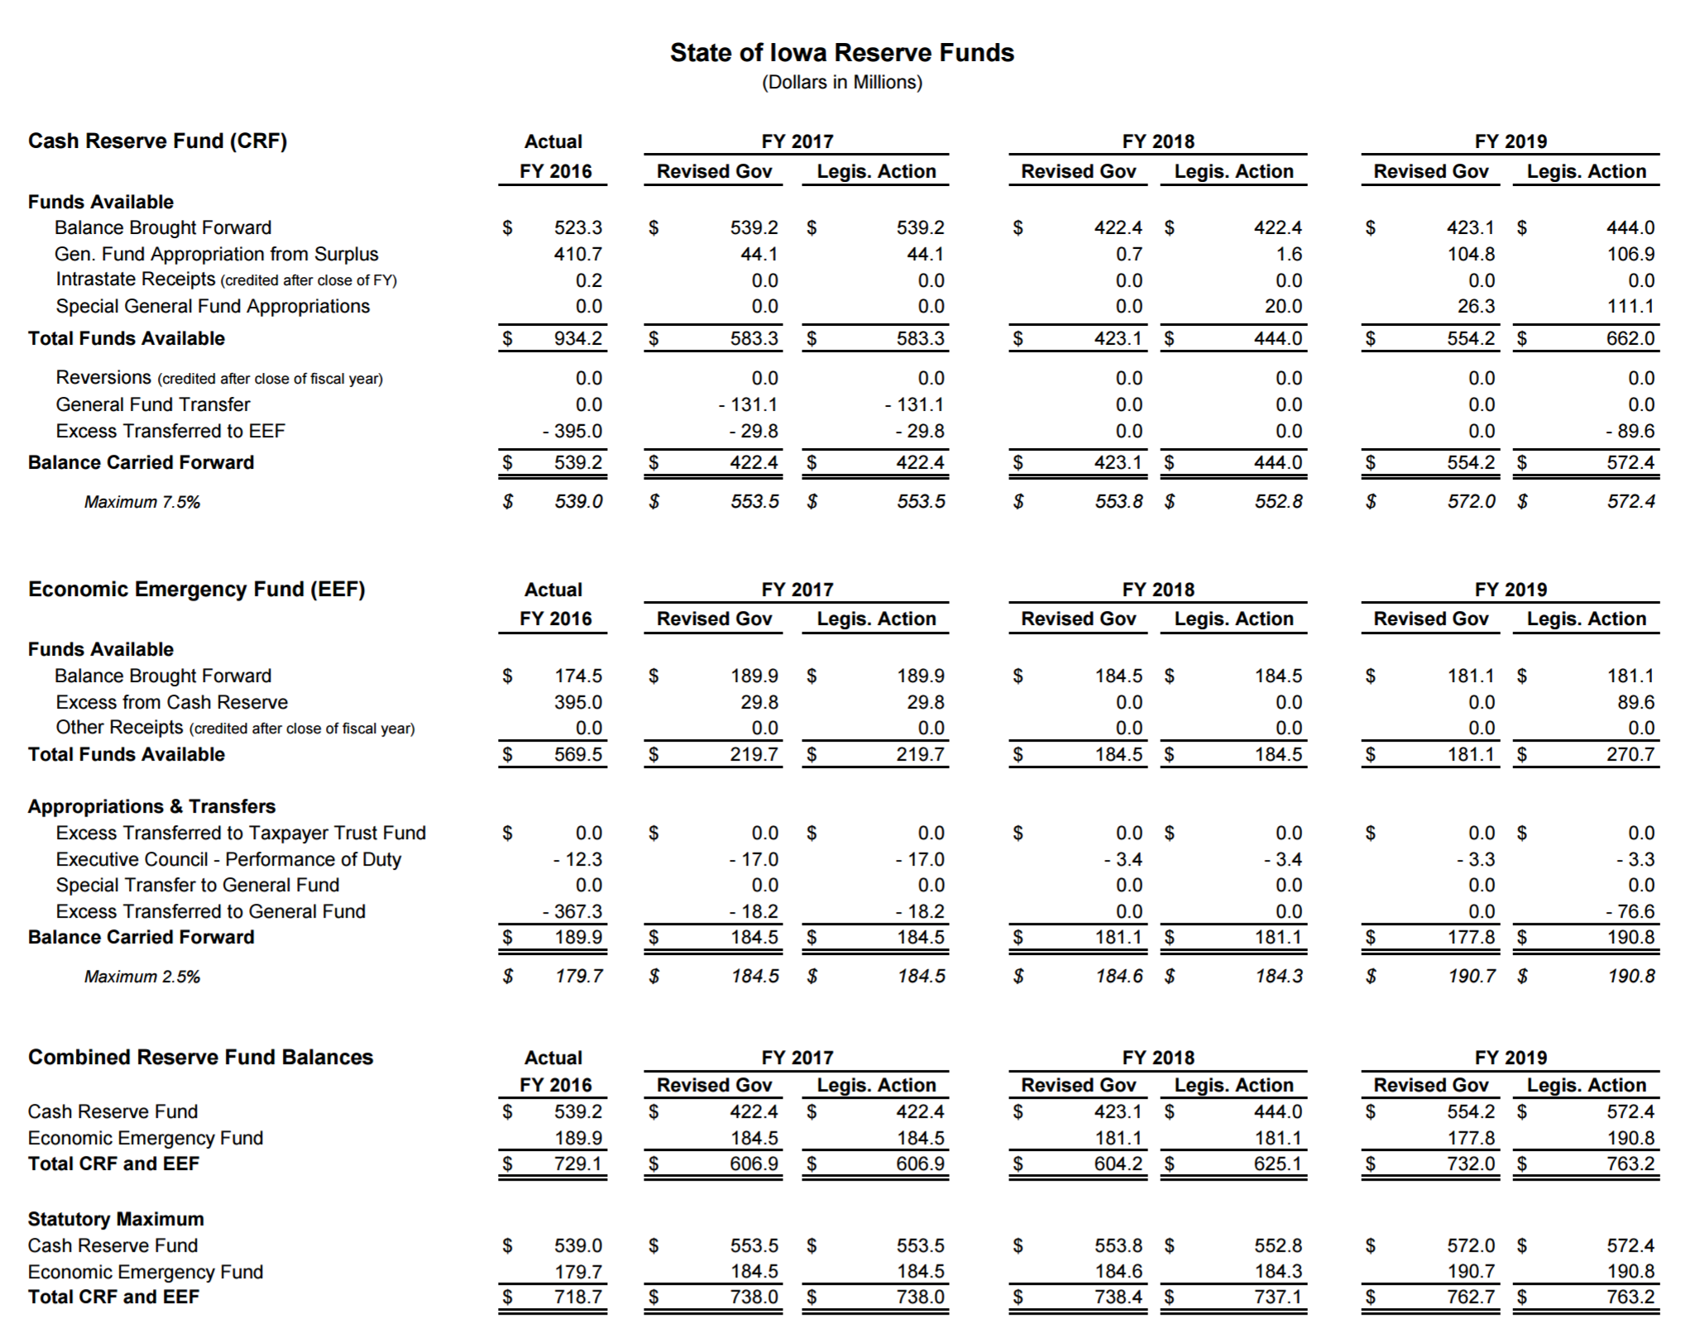
Expenditure Limitation: The FY 2018 net budget appropriation is $7,268.6 million (or $7.27 billion), which is below the FY 2017 adjusted appropriation amount of $7,345.6 million. That is $200,000 below the 99% expenditure limitation. The Legislature and Governor are required by Iowa law to approve a budget no greater than 99% of estimated revenues, including carry forward balances, unless they agree to not withstand that requirement in both the House and the Senate, with Governor’s signature.
State of State Revenues: LSA’s July 1 Monthly General Fund Revenue Memo information will be shared when available. It provides the analysis of state General Fund Revenues through June 30, 2017.
State Tax Credit Expected Claims Projection: As revenues have lagged expectations, attention has been directed to tax credits. The following chart from the LSA budget documents shows the expected growth in the credits from FY 2016 through FY 2018. The $57.9 million growth in capped programs represents a 43% increase in just two years. The uncapped programs growth of $14.9 million represents a 6.7% growth.
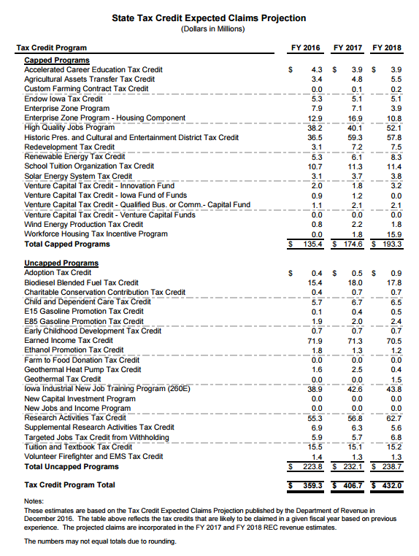
Funding Formula History: The June 11, 2014 edition of the LSA’s Fiscal update also includes a reference to historical changes in school finance funding provisions. The LSA document reflects legislative action through the 2014 Legislative Session. The document provides a brief summary of the provisions from 1971 to present and is available on the LSA website at: https://www.legis.iowa.gov/docs/LSAReports/k12Education/PublicSchlFunding_LawChanges_1971_to_Present.pdf

Enrolled Bills: The following bills impacting Education have been signed by the Governor unless there is a note detailing veto action. The Enrolled bills explained below are organized into Appropriations and Policy Acts.
A list of bills that received action but were not enacted follows under the Near Misses & Pending Issues section of this Digest. For access to the complete text and effective dates of all legislation approved or vetoed by the Governor, check the enrolled bills link on the legislative website.

APPROPRIATIONS ACTS
2017 Funding/Appropriations Bills Impacting Education
State Supplemental Assistance: SF 166 set the cost per pupil and categorical program supplement costs per pupil for the 2017-18 school year. The increase was 1.11% per pupil, or $73 per pupil more compared to the 2016-17 school year.
A spreadsheet indicating the fiscal impact of SF 166 for each district is found here: http://iowaschoolfinance.com/system/files/members/Excel/New%20Money%20Report%20FY%202018_0.xlsx
Details of the cost per pupil decision:
- Fiscal Note: https://www.legis.iowa.gov/docs/publications/FN/852129.pdf
- Sets a 1.11% increase in the state cost per pupil ($6,591 + $73 = $6,664). This percentage increase is also applied to AEA cost per pupil.
- Sets a 1.11% increase in the per pupil supplements: The fiscal note explains:
  - State Categorical Supplements. The State categorical supplements are funded entirely through State aid and generate funds for each school district and AEA through the school aid formula on a per pupil basis. The FY 2017 State cost per pupil funding levels for the teacher salary supplement (district and AEA), professional development supplement (district and AEA), and early intervention supplement (district only) will be increased by a 1.11% State percent of growth for FY 2018.
  - FY 2018 is the final year that the teacher leadership supplement (TLS) for the Teacher Leadership and Compensation (TLC) System will be rolled into the school aid formula, the end of a three-year process.
Property Tax Relief: The total cost to the state is $46.7 million in property tax replacement payment (PTRP) funding. This is an increase of $5.3 million compared to FY 2017 and an increase of $9 per student, bringing the total impact to $83 per pupil. SF 166 maintained the freeze of the additional levy portion of the formula at $750 per pupil which has been in place since FY 2014, which at that time, provided property tax relief of $15 per pupil.
Revenue Mix: The FY 2018 formula cost is funded by both state and local funds.
- State funds: The Combined District Cost (including special education, preschool, the categorical funds, supplementary weightings, AEA funds, budget guarantee dropout prevention and $.9.5 million excess from SAVE for property tax relief) requires a total of $3,208 million, which is an increase of $109 million on the fiscal note. Note: $54 million of this increase due to moving the last third of districts TLC program previously funded by grant dollars from the education appropriations bill into the formula. Additionally, the fiscal note assumes restoration of the $15 million continued reduction to the AEAs which was repeated in the standings appropriations bill. The net cost increase to the state is an estimated $40 million after those adjustments are made.
- Property taxes: The Combined district cost as described above requires a total of $1,476.7 million in local property taxes (generated by the $5.40 uniform levy and the additional levy of $750 per pupil). This is an increase of $55.36 million. Note: with the 1.11% increase in the cost per pupil, at a total cost of $23.6 million to local property tax payers, which is an increase of $13.2 million.
- Property Tax Reform: State funds are appropriated to replace Commercial Industrial Property reform valuation impacts on school budgets not included in the state funds totals above. There is $18.5 million in uniform levy replacement and $15 million in additional levy replacement, for a total of $33.5 million.
Categorical Funds: The 1.11% increase in per pupil supplements, also known as categoricals, included in SF 166, provides a total of $520.5 million statewide, for an increase of $59.9 million (12.9%). This includes $295.2 million for the teacher salary supplement, $33.5 million for the professional development supplement, $34.5 million for the early intervention supplement, and $157.4 million for the teacher leadership supplement (new school aid funding provision beginning in FY 2016 now fully phased into the formula for FY 2018). Just over 90% of the total increase is in this last category, as the final third of the state rolls their TLC grants into the formula.
Budget Guarantee: This is a 1% growth guarantee in regular program spending authority from one year to the next, not including any previous year’s budget guarantee amount, but resets annually. Thus the 1% cushion is temporary. FY 2018 budget guarantee stats:
  - In FY 2017, 110 districts were on Budget Guarantee ($10.4 million)
  - In FY 2018, 179 districts will be on Budget Guarantee ($23.6 million)
  - Funded entirely with property taxes
  - There is a budget guarantee for per pupil supplements, too.
  - It is funded entirely with state aid.
  - It provides each district and AEA with a minimum of the previous year’s level of funding (net of any previous year’s budget guarantee amount.)
  - Total cost for the per pupil supplements budget guarantee is an increase of $1.95 million

The Governor signed SF 166 on Feb. 8, 2017. RSAI was registered opposed as the funding level is not adequate to sustain the quality of education Iowa students need for future success. However, RSAI members should acknowledge the fact that the Legislature and Governor did not make additional deappropriations during the session that impacted school aid or revisit the 1.11% increase after the REC lowered the FY 2018 revenue estimate.
The following table, from the LSA Fiscal Note, Feb. 1, 2017, shows the detail of state funding and property tax impacts, associated with the 1.11% increase in the State Cost per Pupil for both regular program and categorical funds:

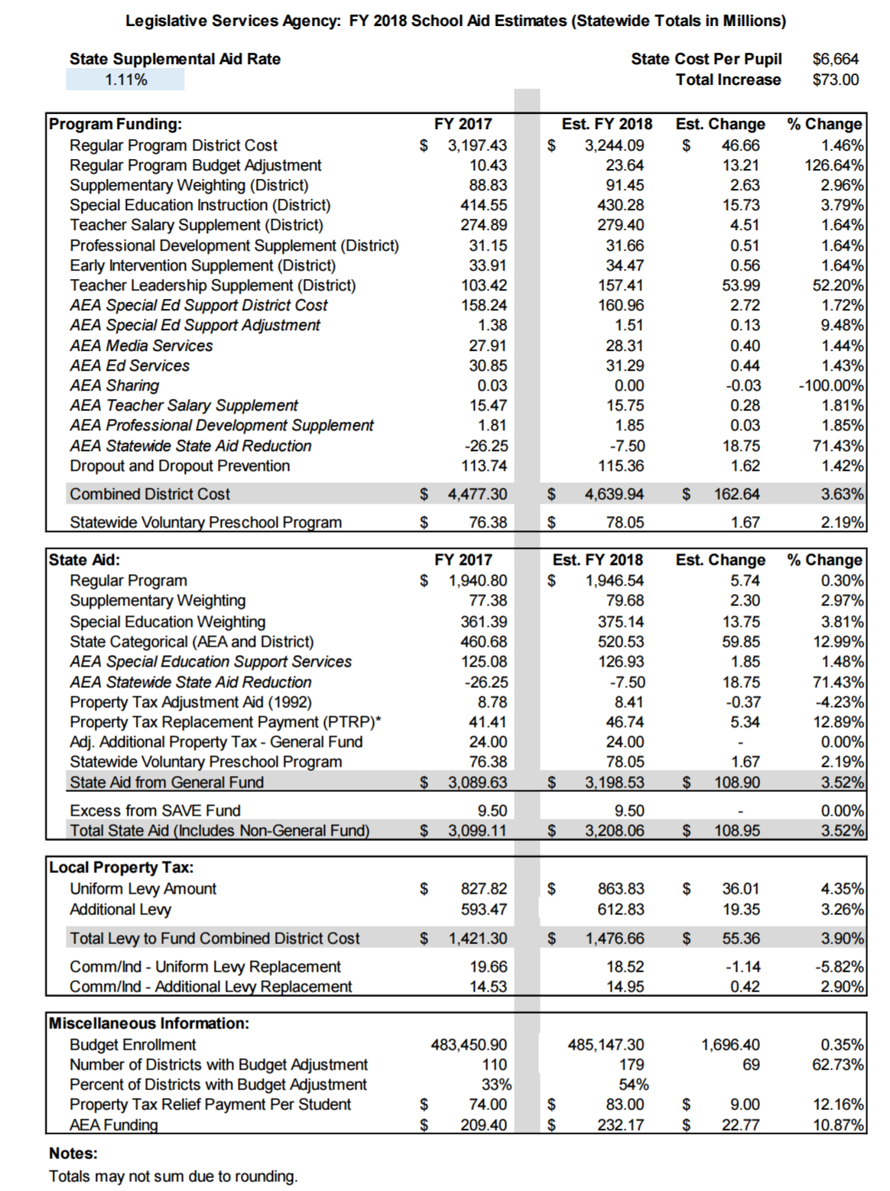
SF 516 Standings Appropriations: The LSA’s Notes on Bills and Amendments, https://www.legis.iowa.gov/docs/publications/NOBA/857483.pdf explains: this bill provides adjustments to several General Fund standing appropriations and results in a net decrease in appropriations of $12.5 million for FY18 and $2.4 million for FY19. The bill also transfers $131.1 million from the Cash Reserve Fund to the General Fund for FY17. Specific changes:
- Limits FY18 and FY19 appropriations to DE for nonpublic school transportation to $8.2 million.
- Limits FY18 and FY19 standing appropriations to DE for the Sac and Fox Indian Settlement to $96,000.
- Suspends the General Fund standing appropriation of $14.8 million to DE for the Instructional Support Program for FY18 (this practice has been ongoing since 2010).
- Reduces the FY18 State school aid funding to AEAs by $15.0 million (although this underfunding of AEAs has been ongoing for several years, this is slightly better than last year’s reduction of $18,750,000. There is an additional reduction of $7.5 million that is written into Iowa statute which also continued from prior years.
- Transfers $131.1 million from the Cash Reserve Fund to the General Fund for FY17. FISCAL IMPACT: The transfer is necessary to bring the FY 2017 General Fund budget into balance. The current balance in the Cash Reserve Fund, prior to this transfer, is $553.5 million. This transfer reduced the balance to $422.4 million as shown in the reserve balances section on page 11 of this Digest.
- Appropriates $20.0 million from the General Fund to the Cash Reserve Fund for FY18.
RSAI was registered as undecided on the bill, opposed to the continued reductions to the AEAs and Instructional Support, but in favor of using cash reserve to balance the FY17 budget.
HF 642 Education Appropriations: Here’s the link to the annotated Notes on Bills and Amendments, NOBA, which reports:

- “FY 2018: Appropriates a total of $908.4 million from the General Fund and 12,287.3 FTE positions for FY 2018 to the Department for the Blind, the College Student Aid Commission, the DE, and the Board of Regents. This is a decrease of $70.1 million and 452.9 FTE positions compared to estimated net FY 2017.”

Of the $70.1 million decrease, $52 million is due to elimination of Teacher Leadership and Compensation grants, which shows as a decrease here, but is truly a wash to the budget since TLC is funded in the formula (standings appropriations bill) beginning in FY 2018. Additionally, about $4.0 million of that reduction comes from elimination of the Mentoring and Induction allocation out of SATQ. Just under $10 million is decreased to regents’ institutions (universities). The bill cuts $3.0 million from the College Student Aid Commission, plus a $2.0 million decrease to AEAs which previously supported school districts in Teacher Leadership and Compensation and Iowa Core Curriculum implementation. (This bill does not make any reductions to the professional development supplement, of which a portion is used by school districts to implement the Iowa Core.)

New Programs: A new appropriation of $250,000 for FY 2019 to DE for the Computer Science PD incentive Fund.

Eliminated Programs: Regional Telecommunications Councils, Administrator Mentoring and Coaching, English Language Literacy Grant Program, AEA TLC Support System and Core Implementation, Competency-Based Education pilots, Teacher Mentoring and Induction, Summer school and 3rd grade retention mandate, and Community College Salary Support.

Delayed Program: $10 million for High Needs School grants is delayed until FY 2019.

There are both significant funding and policy changes included in this bill. Those of interest to PK-12 school leaders include:
- Early Childhood:
  - Changes to Early Childhood Iowa (ECI) funding include an increase of $17.0 million for the Early Childhood Iowa (ECI) general aid and elimination of the individual appropriations for the ECI Preschool Tuition Assistance and ECI Family Support and Parent Education, combining all three into a single appropriation. Total funding change for FY 2018 is a decrease of $143,000.
  - A decrease of $26,000 for Early Head Start Projects.
  - A decrease of $1.4 million for the Child Development Program (funds Shared Visions Preschool and Shared Visions Parent Support).
- A decrease of $52.0 million in the appropriation for Student Achievement/Teacher Quality. Beginning in FY 2018, the TLC program is funded entirely through the school aid formula. TQ Allocations changes also include:
  - A new allocation of $25,000 for Fine Arts mentoring program (eliminates the line-item appropriation of $25,000 for the program)
  - Allocates of up to $774,316 funding level for career development and evaluator training. This is a decrease of $12,500 from the previous allocation.
  - Allocates up to $1,123,910 for Teacher Development Academies. This is a decrease of $12,500 from the previous allocation.
  - Delays the allocation of $10,000,000 to high needs schools until FY 2019.
  - Elimination of the Mentoring and Induction allocation is a reduction of $4.0 million. (See the allocations table at the conclusion of this section on appropriations bills for history of student achievement/teacher quality and teacher leadership and compensation implementation and funding.)
- A decrease of $175,000 for Early Literacy - Successful Progression for Early Readers.
- An increase of $1.7 million for Community Colleges General Aid (although this seems like a large increase when other items are reduced, it does not fully restore the FY 2017 deappropriations impacting Community Colleges earlier in the session.)

The following policy changes are included in the bill:
- Teacher Shortage Loan Forgiveness Program: Beginning in FY 2018, the Program will not accept new applications but may continue renewing loan forgiveness for previous recipients. Funding is lowered from $392,452 to $200,000 for FY 2018. (Note: Teach Iowa Scholars loan payment program is funded at $400,000, same as FY 2017)
- 3rd Grade Retention and Summer School: Rescinds statutory requirements regarding summer reading programs and the requirements for 3rd grade retention. Also rescinds the requirement that districts with 15% or more of students not proficient in reading by the end of 3rd grade include strategies in their CSIP to address the problem. Requires that school districts continue interventions for students not proficient in 3rd grade until they are proficient, in grades beyond 3rd grade.
- New Voluntary Teacher Mentoring and Induction: Rescinds statutory requirements for teacher mentoring and induction programs and creates a voluntary teacher mentoring and induction option, which may be paid for by professional development funds at the school district level. (May also be funded with TLC funds if included in the district’s application for TLC.) Removes code sections requiring completion of mentoring in order to receive a career teacher license (career licensure will be based on successfully completing two comprehensive evaluations.)
Specific HF 642 items of interest to school leaders follow:
 | Actual 2016 | Estimated Net FY17 | Gov. Rec FY18 | HF 642 | HF 642 – Estimated Net FY17
Teacher Shortage Loan Forgiveness | $1,721 | $392,452 | $392,452 | $200,000 | -192,452
Teach Iowa Scholars | $400,000 | 400,000 | 400,000 | 400,000 | 0
DE Administration | $6,304,047 | 5,964,047 | 6,052,148 | 5,964,047 | 0
Career Technical Education Administration | $598,197 | 598,197 | 598,197 | 598,197 | 0
Career Technical Education Secondary | $2,630,134 | 2,630,134 | 2,630,134 | 2,630,134 | 0
Food Service | $2,176,797 | 2,176,797 | 2,176,797 | 2,176,797 | 0
ECI (Early Childhood Iowa) General Aid | $5,386,113 | 5,180,009 | 5,157,203 | 22,162,799 | 16,982,790
ECI Preschool Tuition Assistance | $5,428,877 | 5,225,294 | 5,166,650 | 0 | -5,225,294
ECI Family Support and Parent Ed | $12,364,434 | 11,900,768 | 11,838,946 | 0 | -11,900,768
Special Ed. Services Birth to 3 | $1,721,400 | 1,721,400 | 1,721,400 | 1,721,400 | 0
Nonpublic Textbook Services | $650,214 | 650,214 | 740,214 | 650,214 | 0
Student Achievement/Teacher Quality | $57,391,351 | 55,184,351 | 3,395,667 | 3,395,667 | -51,788,684
Jobs For America's Grads | $700,000 | 700,000 | 666,188 | 666,188 | -33,812
Attendance Center/Data Systems | $250,000 | 250,000 | 250,000 | 250,000 | 0
Administrator Mentoring | $1,000,000 | 289,441 | 500,000 | 0 | -289,441
English Language Learner Pilots | $500,000 | 481,250 | 478,750 | 0 | -481,250
On-line State Job Posting System | $250,000 | 230,000 | 230,000 | 230,000 | 0
Council and Task Force Support | $25,000 | 0 | 0 | 0 | 0
AEA Support System Teacher Leadership | $1,000,000 | 1,000,000 | 957,500 | 0 | -1,000,000
Successful Progression for Early Readers | $8,000,000 | 8,000,000 | 7,824,782 | 7,824,782 | -175,218
Early Literacy Warning System | $2,000,000 | 1,915,000 | 2,000,000 | 1,915,000 | 0
Iowa Reading Research Center | $1,000,000 | 962,500 | 957,500 | 957,500 | -5,000
High Needs Schools* | 0 | 0 | 0 | 0 | 0
Fine Arts Mentoring | 0 | 25,000 | 0 | 0 | -25,000
Midwestern Higher Education Compact | $100,000 | 100,000 | 100,000 | 115,000 | 15,000
AEA Distribution | $1,000,000 | 962,500 | 0 | 0 | -962,500
Community College General Aid | $201,274,647 | 199,540,605 | 198,331,418 | 201,190,889 | 1,650,284
Community College Salary Increase | $500,000 | 500,000 | 475,849 | 0 | -500,000
Early Head Start Projects | $600,000 | 600,000 | 574,500 | 574,500 | -25,500
Competency-Based Education | $425,000 | 338,000 | 0 | 0 | -338,000
Iowa Learning Online Initiative | $1,500,000 | 0 | 0 | 0 | 0
Regional Telecommunications Councils | $992,913 | 992,913 | 0 | 0 | -992,913
Child Development limitation | $12,606,196 | 12,133,464 | 12,070,433 | 10,730,000 | -1,403,464
UI - IA Online Advanced Placement Acad. | $481,849 | 481,849 | 481,849 | 481,849 | 0
UNI - Math and Science Collaborative | $5,200,000 | 5,200,000 | 5,479,000 | 5,446,375 | 246,375
 | $334,849,621 | $326,726,185 | $271,647,577 | $270,281,338 | ($56,444,847)
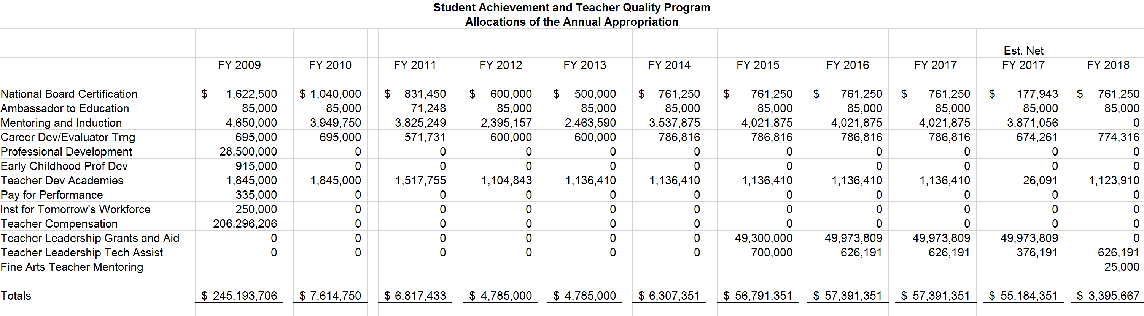
This chart shows the history of Student Achievement Teacher Quality Allocations since FY 2009, showing when the categorical supplements were rolled into the formula, demonstrates the change from SATQ act provisions to the new TLS (teacher leadership and compensation system) and shows the elimination of Mentoring and Induction allocations.

Other Appropriations Bills Impacting Schools

Deappropriations: SF 130 was signed by the Governor on Feb. 1, reducing state general fund spending in FY 2017 by $113 million. There were no cuts to PK-12 education funding, however, the community colleges were reduced $3 million, regent universities were cut $18 million and DE must apply $4.5 million in reductions to their budget with only five months left in the fiscal year. The bill also requires the Department of Management to administer an additional $11.5 million in cuts throughout the executive branch. A memo from the DE to the field on March 13, 2017, explains the additional reductions. That memo is included on page 56 of this Digest. The LSA’s NOBA provides additional information https://www.legis.iowa.gov/docs/publications/NOBA/852073.pdf
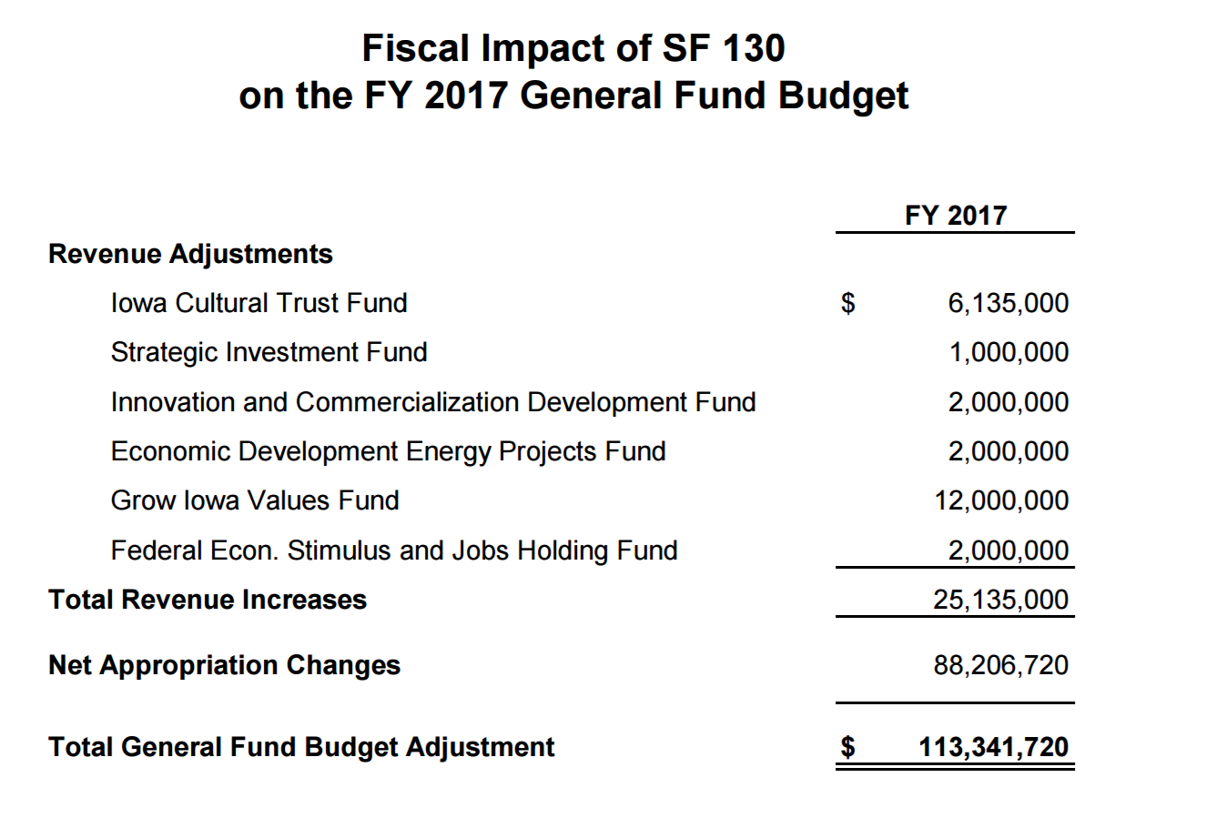
Significant Deappropriations
FY 2017 (dollars in millions)
Dept. of Human Services $35.9
Regents Universities 18.0
Dept. of Management
(discretionary reductions) 11.5
Corrections 5.5
Dept. of Education 4.5
Community Colleges 3.0
Judicial 3.0

Policy Bills Impacting PK-12 Education
SF 234 Texting and Driving: This bill prohibits the use of a hand-held electronic communication device to write, send, or read a text view an electronic message while driving a motor vehicle unless the motor vehicle is at a complete stop off the traveled portion of the roadway. The penalty for violation of this law is a $30 fine. RSAI did not register on this bill, but we thought you might like to know.
SF 238 Sexual Exploitation by a School Employee: This bill defines “School employee” as a person who holds a license, certificate, statement of professional recognition or authorization issued under chapter 272. a person employed by a school district full-time, part-time, or as a substitute, a person who performs services as a volunteer for a school district and who has direct supervisory authority over the student with whom the person engages in prohibited conduct, a person who provides contracted services to a school district and who has direct supervisory authority over the student with whom the person engages in prohibited conduct. The bill states that this does not apply if the prohibited conduct is with a student enrolled in a different attendance center than where the employee works and the person does not have direct supervisory authority over the student, and the employee does not have a teaching license. RSAI supported this bill.
SF 240 Assessments: This bill requires the state Board of Education (BOE) to approve a state assessment first used in 2018-19 school year. All students in grades 3-11 will be required to take math/reading tests. Students in grades 5, 8, 10 are required to take a science test. The state tests must be administered in the last quarter of the school year.
The bill repeals the transitional exception to keep administering the IA assessments, strikes the assessment task force, and strikes the requirement for the Legislature to approve the state BOE recommendation. However, the DE/state BOE will still be required to submit administrative rules through the legislative rules committee process.
RFP is required to include growth, align to Iowa core, be capable of measuring student performance in ELA (+ writing), math and science, and be available via computer/pencil and paper. The RFP submissions must address all areas of testing and vendors are allowed to collaborate (for example, Smarter Balanced Assessments only test ELA and math, so they would have to collaborate with a science test vendor in order to respond to the RFP). The DE is required to issue the RFP by July 1, 2017.
The bill requires evaluation of the proposals based ONLY on these criteria:
- feasibility of implementation by districts,
- costs to schools and state (provide and administer the tests and technical support)
- costs of acquiring infrastructure/technology readiness,
- degree of alignment,
- ability to measure student growth and proficiency,
- ability to meet requirements of ESSA, and
- instructional time required to conduct the test.
Lastly, the bill removes a mandate that nonpublic schools must administer the test and instead states that they may administer the state test.
RSAI was registered as undecided through most of the development of this policy, but changed our registration to support with the amendment that removed the requirement that the State BOE submit their recommendation to the legislature and the legislature was required to vote on it. As advocates connect with legislators before the next session, continue to stress the need to extend the state penny so school districts have resources to provide the technology infrastructure and devices to effectively administer the new state tests. The RFP was released on June 20. To read it, visit the Iowa Department of Administrative Services website (bid number RFP1117282197.)
SF 274 Governor’s Computer Science Initiative: This bill requires the DE to establish computer science standards for elementary, middle, and high school grades and requires the Board of Educational Examiners to establish an endorsement in computer science for teachers. The bill creates a Computer Science Professional Development Incentive Fund, from which school districts and teachers may receive funds as reimbursement for various forms of professional development relating to computer science. The bill states that it is the intent of the General Assembly to fund the new fund beginning in FY 2019. The bill also creates a computer science work group to identify and recommend computer science-related guidelines and potential policies for schools and submit a report to the Governor, DE, and the General Assembly by Nov.1, 2017.
The bill sets a goal that all school districts will provide computer science instruction:
b. “It is the goal of the general assembly that by July 26 1, 2019, each accredited high school offer at least one high-quality computer science course, each accredited middle school offer instruction in exploratory computer science, and each accredited elementary school offer instruction in the basics of computer science.”
School districts, AEAs or a group of districts may apply to DE to receive funds to reimburse tuition for teachers’ computer science professional development.
A specific task assigned to the Work Group is to make recommendations including how a high-quality computer science course can fulfil a mathematics or science graduation requirement.
SF 399 School Elections Vacancy/Appointment: This bill adds the requirement that the school board secretary call a special election if there is a school board vacancy after the filing period for nomination papers closes and a petition arises which calls for a special election to fill the vacancy. The bill also specifies that a board member appointed to fill a vacancy less than 180 days but more than 40 days before the regular school election serves as a temporary board member until a successor is elected. RSAI did not register on this bill.
SF 438 Public Bid Law Requirements: This bill prohibits a school district (or any government entity) from including a project labor agreement or requirement for a contractor or subcontractor to utilize union labor. The bill prohibits the school district from requiring a bidder, offeror, contractor, or subcontractor to enter into or adhere to an agreement with one or more labor organizations in regard to the public improvement or a related public improvement project. The bill also prohibits a bidder, offeror, contractor, or subcontractor from entering into or adhering to an agreement with one or more labor organizations in regard to the public improvement or a related public improvement project. The bill also prohibits the school districts from discriminating against a bidder, offeror, contractor, or subcontractor for becoming, remaining or refusing to become or remain a signatory to, or for adhering or refusing to adhere to, an agreement with one or more labor organizations in regard to the public improvement or a related public improvement project.

SF 499 Video Cameras in Bathrooms: This bill prohibits the state or a political subdivision of the state, including but not limited to a public library, public school, or other government office open to the public, from using a monitoring device (video camera) in a toilet, bath, or shower facility; locker room; common area within such a facility or room, including an area where a sink or changing table is located; or other space open to the public where a person has a reasonable expectation of privacy. RSAI did not register on this bill.
HF 217 Disciplinary actions taken against a licensed school employee reported to the board of educational examiners (BOEE). This bill adds to the list of actions for which disciplinary actions at the school must be reported to the BOEE, being on school premises or at a school-sponsored activity involving students while under the influence of, possessing, using, or consuming illegal drugs, unauthorized drugs, or alcohol. RSAI registered in favor of this bill.
HF 291 Collective Bargaining Changes: For any contract not already complete (ratified by association and approved by the board) on February 17, 2017, this bill made changes to Chapter 20 collective bargaining for employees who are not public safety employees.
The bill sets base wages as the only mandatory subject of collective bargaining and requires that base wages be narrowly construed. Excludes supplemental pay, insurance, transfer procedures, procedures for staff reduction, subcontracting for public services, intensive assistance procedures and evaluation from negotiations, which means they are prohibited subjects of bargaining.
The bill prohibits automatic payroll deduction for association dues. The bill establishes an ongoing process for certification and decertification of association representatives through elections requiring a simple majority (50% plus 1) of all employees covered by the bargaining unit (not a simple majority of those voting.)
The bill defines the arbitration process and limits arbitrators’ considerations, including a requirement that any final decision of the arbitrator must not be greater than the lower of 3% or consumer price index for Midwest urban consumers as set by federal Bureau of Labor Statistics. The bill prohibits an arbitrator from considering past contracts or employers’ ability to tax in the decision. Requires the arbitrator to consider comparability of similar work in the private sector, if available. Also removes consideration of prior contracts in the district if taken to an arbitrator.
The bill lengthens the probationary period for new teachers and administrators to three years, allows temporary and nonrenewable contracts and removes teacher’s ability to appeal termination to an adjudicator (appeal goes directly to court.)
RSAI was registered as undecided on this bill. A complete section analysis of the bill is included on page 50 of this Digest. In short, subjects of bargaining fall into these categories of mandatory (must be bargained), Permissive (other things mutually agreed by both management and labor to be bargained) and Prohibited (state law excludes these from the bargaining conversation):
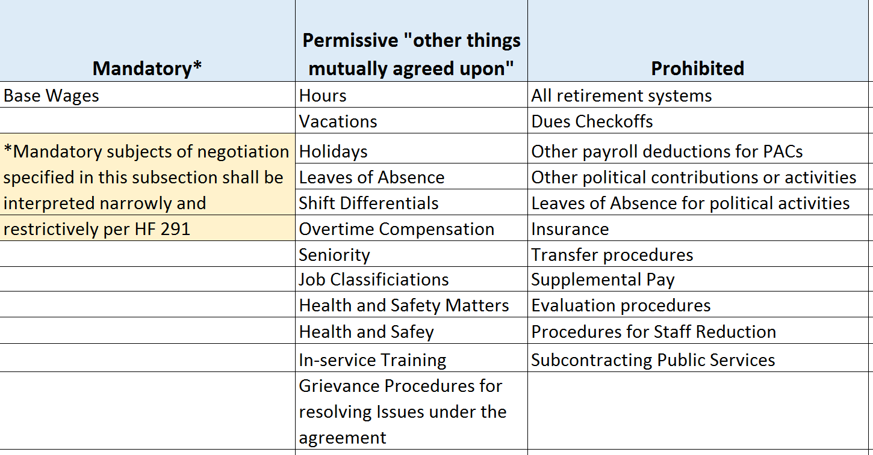
(Wages beyond base wages are permissive)
Iowa’s Public Employee Relations Board (PERB) has issued two rulings interpreting areas of the law. These rulings define base pay as the very minimum pay for the job and state that teacher salary supplement is not a prohibited subject of bargaining because it is wages in addition to base wages (which is permissive) rather than supplemental pay (which would be prohibited.) They also state that coach’s salaries, if the board has established and maintained the extracurricular job classification, which is permissive, then the base salaries of those job classifications is a mandatory subject of bargaining. Find information about the consumer price index, retention and certification elections, where to return signed contracts and HF 291 rolled into the full Chapter 20 law, on the PERB website at iowaperb.iowa.gov. The two rulings on supplemental pay and wages that are not base wages are found here:
- Oskaloosa Community School District and Oskaloosa Education Association, PERB Case No. 100823. See the ruling here.
- Columbus Education Association and Columbus Community School District, PERB Case No. 100820. See the ruling here.
HF 295 Prohibiting County Minimum Wage: This bill prohibits a local government from setting a minimum wage exceeding federal or state law. RSAI did not register on this bill.
HF 472 Eligibility for Teacher Loan Forgiveness Programs: This bill prohibits a teacher from being a recipient of both the Iowa Teach Iowa scholar loan forgiveness program and the Teacher shortage forgivable loan program. RSAI did not register on this bill.
HF 473 High School Equivalency Programs: This bill requires the state board of education to adopt rules relating to demonstrations of competence for purposes of this high school equivalency diplomas for adults (age 18 and older). The rules shall require such demonstrations to be equivalent to or of greater rigor than those required for high school graduation, and such demonstrations shall include but are not limited to a test battery, credit-based measures, and attainment of other academic credentials. RSAI did not register on this bill. The DE’s annual legislative guidance to the field explains further:
“The bill expands the ways in which competency can be demonstrated and requires the State BOE to adopt rules establishing standards for content and measuring competency. While the different pathways have yet to be decided, it will include the existing HiSET assessment, as well as models like the Adult Diploma offered by some of Iowa’s community colleges. Under this option, community college counselors review high school transcripts for existing passing credits and award transfer credit in those areas where core competencies are met. This allows equivalency students to focus on only the core competencies they are deficient in through additional postsecondary classwork.”
HF 518 Workers’ Compensation: This bill makes various changes to Iowa Code chapter 85 related to workers’ compensation by reducing benefits, limiting benefits, changing the qualifications for benefits, and reducing the interest rate calculation. RSAI did not register on this bill. The LSA’s Fiscal Note explains the following: https://www.legis.iowa.gov/docs/publications/FN/856169.pdf
Regarding shoulder injuries: The bill provides for training, at an Iowa community college, that at a minimum, will result in the awarding of an associate degree, or completion of a certificate program, that will enable a worker who has sustained a shoulder injury, as specified in Iowa Code section 85.34(2), to return to the workforce. The Iowa Workforce Development (IWD) Department is required to evaluate those workers for career and training opportunities. The Iowa community colleges are required to have a new Career Vocational Training and Education Program to address the needs of those workers. Each of those injured workers will be entitled to up to $15,000 for the payment of tuition, fees, and required equipment, to be paid for by the injured worker’s employer or employer’s insurer. The community college may be required to report each semester on the status of the employee’s training. An annual report on the Program is due to the General Assembly beginning December 1, 2018. The report is to be provided by the IWD, in cooperation with the Department of Education, the Insurance Division of the Department of Commerce, and all community colleges. Assumptions:
- The change to Iowa Code section 85.34(2)(m) pertaining to injuries to shoulders will result in an estimated reduction to benefit payments of 68.0% ($760,000) for the estimated 176 State shoulder injuries each year. This does not include the new Training Program costs.
- The change to Iowa Code section 85.34(2)(u) pertaining to permanent partial disability injuries to the body as a whole will result in an estimated reduction to benefit payments of 10.0% ($1.0 million) for those injuries.
- The change to Iowa Code section 535.3(1) pertaining to a decrease in the interest calculated on workers’ compensation payments will reduce the annual interest rate by an estimated 5.5%, resulting in an estimated reduction of $60,000.
HF 534 Child Care Facility Licensing Exception: This bill adds to the list of those facilities exempt from DHS child care licensing requirements to include an instructional program for children who are attending prekindergarten as defined by the state board of education under section 256.11 or a higher grade level and are at least four years of age, or are at least three years of age and eligible for special education services. RSAI monitored this bill.
HF 564 Categorical Flexibility, was signed by the Governor on May 11. This bill expands the allowable expenditures or several categorical funds including:
- Preschool: Allows districts to offer PK to a younger (3-year-old) or older (5-year-old) child, if space and funding are available, including funding from another school district account or fund from which PK program expenditures are authorized by law. Younger or older students are not counted as enrollment for state funding purposes. Also expands the use of PK funds for translators, safety equipment, snacks, playground equipment and repair costs, supplies, facility rental fees, and for any purpose determined by the school board as necessary to meet quality preschool program standards or directly or indirectly benefit students.
- Professional Development Supplement Per Pupil: Allows funds to pay for assessment costs to comply with state requirements, textbooks/instructional materials if professional development is included, mentoring and Induction (added in the Ed Approps bill) and prohibits DE from requiring a certain percentage of professional development supplement funds to be spent on Iowa Core implementation.
- Dropout Prevention/At-risk: Adds counselors to list of staff whose time may be prorated for providing services to at-risk/dropout prevention eligible students, allows dropout prevention funds to be spent on grade level, school wide or district wide prevention that serves students not necessarily eligible for DoP and eliminates the 5% cap on such expenditures, gives the district authority to designate the amount of time/salary/benefits for each such prorated staff position and include as part of the program plan submitted to DE. The bill also allows these funds to be spent on programs intended to address high rates of absenteeism, truancy or frequent tardiness.
- Safety Equipment: Allows a general fund transfer to the Student Activity Fund for safety equipment required for extracurricular contests. The school board is required to pass a resolution including the amount necessary to purchase protective and safety equipment required for any extracurricular interscholastic athletic contest or competition that is sponsored or administered by an organization defined in Iowa Code 280.13. A template of such a resolution is found on page 55 of this Digest.
The bill also directs the DE to defer to local decision making in areas of per pupil supplements including Teacher Salary Supplement (TSS), Professional Development Supplement (PD), and Early intervention/class size. The bill also defines “guidance” and prohibits DE guidance in these areas from being inconsistent with any statute, rule or other legal authority, or imposing any legally binding obligations or duties not required or reasonably implied by statute, rule or other legal authority. The bill states that guidance issued in violation of these requirements is not legally binding. (The bill doesn’t prohibit the DE from issuing guidance.)
Early versions of the legislation included language to expanded PPEL flexibility for transportation equipment repair (House version repealed the $2,500 threshold for use of PPEL to repair transportation equipment but the Senate amended that change out of the bill) TAG funding ending balances were removed in the House and conversation about energy efficiency were drafted as amendments but did not get included in the bill.
RSAI was registered in support of this legislation.
HF 565 Education Super Flex Account: The bill allows transfer of ending balances from Professional Development (PD), Preschool (PK), Home School Assistance Program (HSAP) or any discontinued program (such as the old market factor pay) to a flex fund account. The bill lists several purposes that could be funded by the flex account, including at-risk, talented and gifted (TAG), PD, PK, start-up costs for PK, HSAP or any general fund purpose.
The bill requires a school board resolution and public hearing: Resolution must state the original source and use of funds, the amount of the proposed expenditures, the fiscal year from which the transfer of such funds is to occur. Must also include a certification that the statutory requirements of the original purpose have been met or are no longer required. DE is required to prescribe the form for public notices. A copy of the resolution must be sent to DE and made available for any audit.
Although the bill has an effective date of July 1, 2017, the transfer first applies to ending balances for the budget year beginning July 1, 2017, which means the 2017-18 school year must be completed to determine the FY 2018 ending balance of the categorical fund before the funds can be transferred.
The bill sets criteria to demonstrate that the original intent of the categorical funds has been met before a transfer may occur:
- For PK: must have provided PK in the year in which a balance is carried forward to all eligible students for whom a timely application for enrollment was submitted
- For PD: states that all PD requirements of Chapter 284 are met
- For HSAP: must meet the statutory requirements for HSAP funding, including funding all purposes listed in Iowa Code 299A(12) subsections 2 and 3 and funding all requests for services and materials from parents of HSAP students
RSAI was registered in support of this legislation.
HF 569 403b Investment Vehicles: House File 569 concerns authorized investment vehicles in a tax-sheltered investment program established by the Department of Administrative Services (DAS). In addition to the nine current providers (four core and five optional), the bill permits an additional 21 providers for a total of 30. The Bill requires companies wishing to participate in the 403b program to utilize a third-party administrator selected by DAS and to use a common remitter. RSAI did not register on this bill.
HF 573 Home Rule: The bill grants school districts/school boards any broad and implied powers not inconsistent with the laws of the general assembly, or inconsistent with Administrative Rules, related to the operation, control and supervision of their public schools. The bill excludes this flexibility in four specific areas, specifying that school boards are prohibited from:
- levying any tax unless expressly authorized by the Legislature,
- charging fees not expressly authorized in statute,
- adopting a policy that would unreasonably interfere with the duties of a local, state or federal law enforcement agency, and
- states that, if the power or authority of a school district conflicts with the power and authority of a municipal corporation, county, or joint county-municipal corporation government, the power and authority exercised by a municipal corporation, county, or joint county-municipal corporation government shall prevail within its jurisdiction.
The bill also states that chapters 257, 257B, 274-301 and other statutes relating to the boards of directors of school districts and to school districts shall be liberally construed to effectuate the purposes of this bill.
RSAI was registered in support of this legislation.
In DE’s annual letter to the field regarding legislation, May 26, 2017, they suggest that school districts consider the following when thinking about increased local flexibility:
- “If there is a state statute or state administrative rule, then that authority is controlling and a district’s actions must be consistent with that authority.
- If there is an Iowa Supreme Court or Iowa Court of Appeals case, that case is controlling.
- If there is a declaratory order or contested case interpreting a state statute or rule, the order or case is controlling on the question to the extent that order or contested case is an authorized interpretation of the statute or rule under the Administrative Procedure Act or the Director’s power to interpret the school laws and school rules of the state of Iowa.
- If there is a federal statute, regulation, or case on point, then that authority is controlling.
- If there is an area of ambiguity in the law, the Department will liberally construe the statute or rule in favor of the district’s broad exercise of power.
- If there is no statute, case law, declaratory order, contested case, rule or guidance that covers the issue, then the district may exercise any broad and implied power, not inconsistent with law or rule related to the operation, control, and supervision of the school unless one of the exceptions in Iowa Code 274.3 applies.” Those exceptions are taxing authority, fees and interfering with law enforcement as explained above.

HF 566 School Elections: This bill changes the September regular school election to the first Tuesday after the first Monday in November of odd numbered years to coincide with the city/county elections. This first applies in November of 2019.

The bill sets a transition expectation so that those board members whose terms would have expired after the September 2019 election will stay on the board for two more months until after the November 2019 election.

The bill specifies the ballot order for the combined election offices and ballot initiatives:
- County, 2. City, 3. School districts, 4. Community college, 5. Any other political subdivision

The bill allows an individual to be on the ballot as a candidate for a city office and a school board office in the same election. The bill also delays elections of AEA board members two months and specifies that ballots are due back to the AEA secretaries’ offices by November 30.
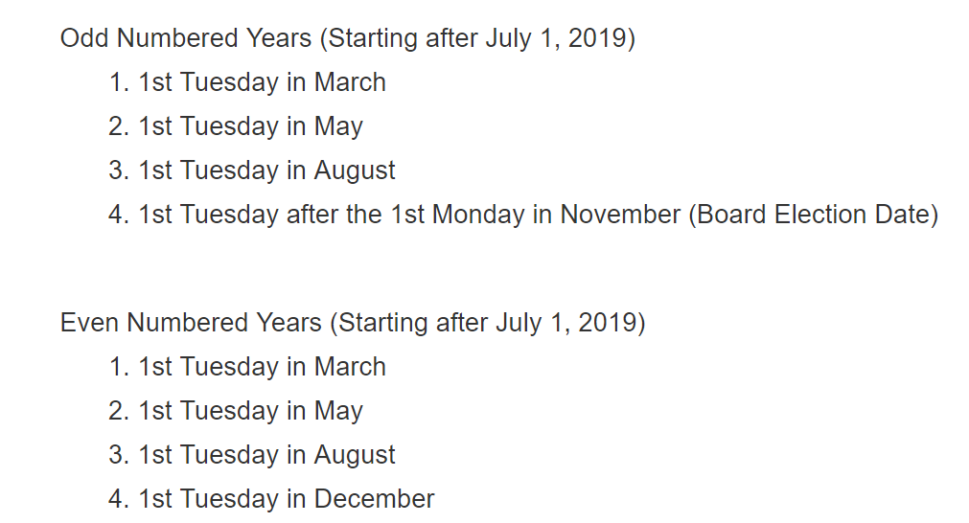
The bill also changes special school election dates to coincide with city special election dates (but the bill does not require cities/counties and schools to combine ballot initiatives on a special election date. The new special election date options are also effective beginning July 1, 2019 and include the following:

The fiscal note stated that the combined election may not save school districts money compared to holding the September school board election. Additionally, school boards may determine it is best not to include ballot initiatives when cities and counties are also having a ballot initiative during the special election, which may impact special election costs. The costs of the combined election will be prorated, but with a longer ballot and more polling places, may costs school more.

The fiscal note quotes the Iowa Secretary of State’s statistics; in the last four school elections, the voter turnout average was 6.5%. The average voter turnout for city elections in that same time frame was 21.3%. There may be some additional effects of increasing turn-out, such as lowering the possibility of a write-in candidate’s success, or raising the petition signature threshold for taking an Instructional Support Levy or other ballot initiative to the voters. RSAI was registered as opposed to this legislation which the governor signed on May 11.

Near Misses, Incomplete Progress,
Bills Still Alive in the 2018 Session

HF 648 Technical and Career Education: This bill restores a deleted reference to the CTE Opportunities and Partnerships program. The bill allows income received by schools to be coded as Miscellaneous Income. Allows a partnership to purchase certain consumable school supplies. Allows funding to be given to the partnerships in advance rather than as a reimbursement for expenditures already made. The House passed the bill, 98-0. It is now in the Senate Appropriations Committee. RSAI is registered in support. This bill will likely stay in Committee, on the agenda for 2018.
HF 652 Tax Credit Cap/Tax Expenditure Limitation Fund: This bill caps the growth in some tax credits, requires deposits of FY 2019 revenue into the Cash Reserve Fund, then requires future deposits into a new Tax Expenditure Limitation Fund.
The tax credits impacted include those in the table below, with the largest contributor to the fund being the Research Activities Tax Credit. The Earned Income Tax Credit which benefits lower income Iowans is not impacted by this bill. The bill is not expected to improve the condition of the state’s general fund since the savings are not kept in the general fund. It may or may not benefit schools in the future based on a future legislature’s determination of what to do with the fund’s resources. RSAI has yet not declared a lobbying registration on this bill.
The Fiscal Note provides the following detail:
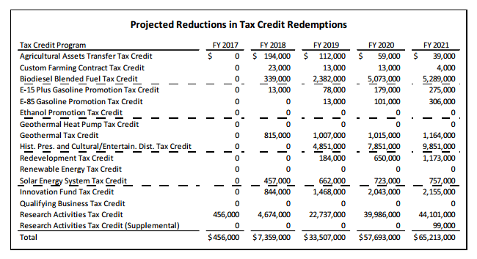
SF 512 Water Quality: This bill establishes a long-term commitment to water quality improvements in Iowa. The bill does not scoop funds from a SAVE extension but does have a small impact on SAVE fund revenue estimates. Details follow:
- Edge-of-field infrastructure program and in-field infrastructure program for agricultural water quality with funding on a cost-share basis. Soil & Water Division manages it, including reporting requirements and confidentiality.
- Wastewater Fund: Allows drinking water programs to quality for IFA wastewater treatment program, adds annual reporting requirements and a new program review committee.
- Creates a Water Quality Urban infrastructure program. Cost-share basis.
- Tax/Funding: Exempts metered water sales to residential customers from sales tax and establishes a 6% excise tax. Sets up transfers and funding provisions through 2029 repeal. Transfers $15 million in watering tax revenues now going to Vision Iowa to the Water Quality fund after 2020.
- Other: Includes findings on the Iowa nutrient reduction strategy. Deems that ag storm water or irrigation return flows are not point sources.
- Impact on SAVE: The fiscal note estimates a reduction of almost $4 million to SAVE fund revenue beginning in FY 2018 with slightly increasing amounts annually thereafter as sales taxes grow. The impact is roughly $8 per pupil lower SAVE fund allocations.
- Senate passed it 31-19, then the House amended it and passed it 79:19. It goes back to the Senate. RSAI is not registered as lobbying on this bill.

Pending RSAI Priorities: These bills are all alive/available for discussion in the 2018 Session, which is the second year of the biennium:
- SF 475 Education Omnibus Bill is on the House Calendar. RSAI was registered as undecided, but is now registered in favor pending positive changes to the bill. RSAI requested the provisions to allow CTE concurrent enrollment/community college courses to meet the requirements in two areas of career and technical education to meet accreditation. The bill remains on the House Calendar for debate, but it’s future is not certain.
- HF 230 SAVE Extension in House Ways and Means: The bill extends the SAVE sunset from 2029 to Jan. 1, 2050. See the RSAI web site for a position statement regarding the priority of extending the sunset and talk to all legislators during the Interim about moving this bill forward. Position paper found here.
- SF 455 Formula and Transportation Equity: The bill includes a 10-year phase-in to eliminate the $175 difference in the district and state costs per pupil and 10-year phase in to fund school transportation supplementary weighting, also over 10 years. Formula Equality Position paper found here. Transportation Position paper found here.
This RSAI priority is still in the House Appropriations Committee, stalled by the REC estimate and budget constraints. Thank your Senators, who voted unanimously to move this bill to the House and continue to impress upon House members the urgency of beginning the work of closing these equity gaps in the formula and in transportation funding.

School Choice
Nonpublic and home school advocates have gained ground in their call for education savings accounts, also known as school vouchers, for providing additional school choice for Iowa families. As the Revenue Estimating Conference continued to lower growth estimates in both December and March, the lack of significant new money for the legislature to appropriate for any new policies stifled this groups continued efforts. We expect additional attention to the issue in 2018.

Consider these talking points when advocating with legislators during the interim. School leaders are encouraged to work with public school parents and advocates to help educate the public about the impact of expanded school choice on public school students. Public school advocates are concerned about the welfare of all of Iowa’s children and are often working in partnership with home school parents and nonpublic schools in supporting the community’s children. But the following facts may help public school advocates engage in critical conversations regarding this important state policy consideration of expanding school choice:

- There are many quality school choice options in Iowa, including a public school in your neighborhood, public school in another neighborhood (open enrollment), virtual academy (CAM/Anita & Clayton Ridge), nonpublic schools, home school assistance (competent private instruction) and independent private instruction. Only one of these options charges tuition (nonpublic schools)
- There were 483,251 public school students in Iowa in the 2015-16 school year, of which 30,463 open enrolled to another school district. There were 33,040 nonpublic students, as reported in the 2016 Iowa Annual Condition of Education Report. It is unknown how many students are in home school learning environments, and although most home school families are likely providing a great educational experience for their children, it is unknown how many students in home school environments are not receiving a quality education since no oversight is required.
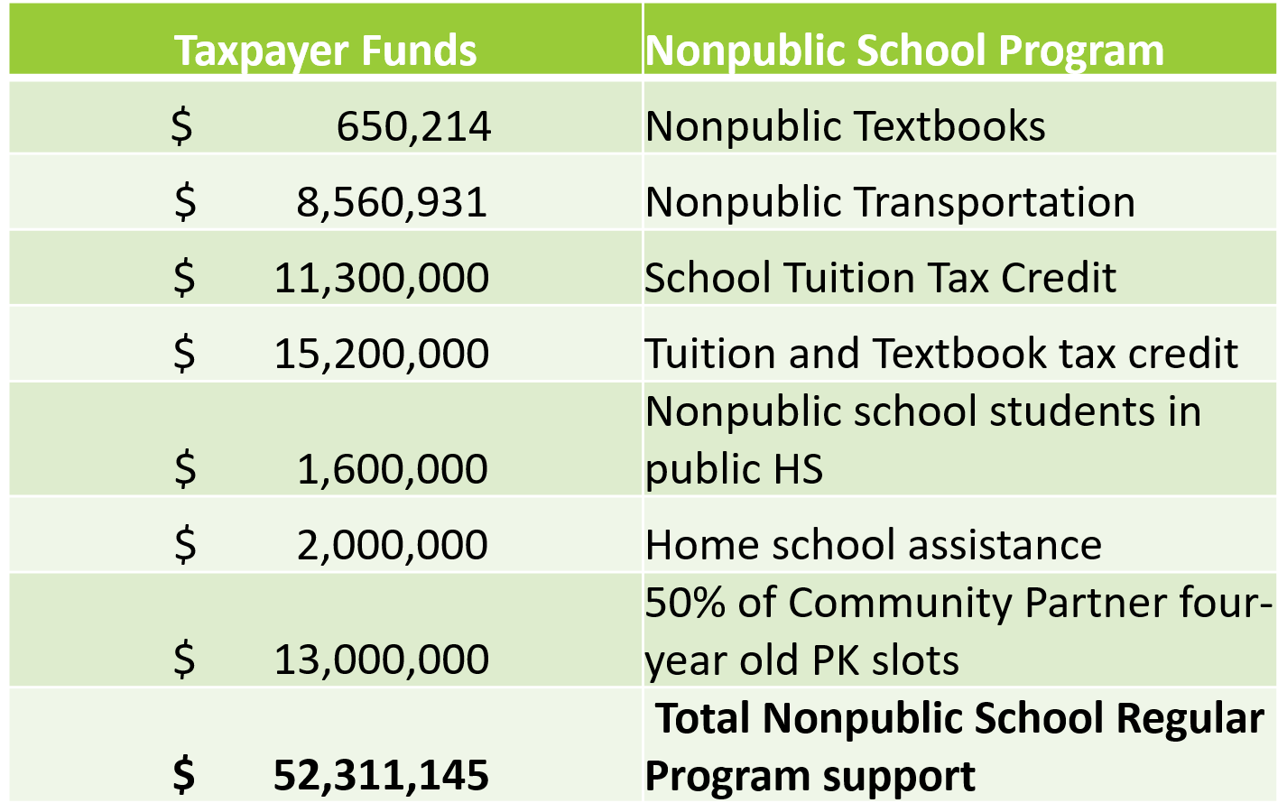
- In the FY 2017 state budget, $52.3 million was appropriated (or credited to taxpayers) to support nonpublic and home school students’ education, not including special education support from public schools, AEA support or professional development provided to nonpublic school teachers. The following table provides the detail of the expenditures and tax credits:
- RSAI is primarily that, especially for rural school districts, there are no private school alternatives. Expansion of vouchers would not provide additional choice for rural school parents, all the while diverting resources that could otherwise be spent on public education that rural schools desperately need.
- Significant school choice investments would either require new state revenues or compete with funds that would otherwise go to public education or other essential state services.
- Accountability – More conservative thinkers typically value good stewardship, oversight and accountability for the expenditure of state tax dollars. Recent instances of foster care student experiences with home school have brought additional attention and urgency to the issue of needed oversight.
- Of the 17 states that have either private school scholarships or a private school tuition or expenses tax credit, Iowa is one of only 5 that have both (AL, IA, IN, LA, SC) as reported in State Tax Subsidies for Private K-12 Education by the Institute for Taxation and Economic Policy Oct. 2016.
- That study also noted several specific concerns with charter schools and school vouchers in other states that could inform Iowa policy makers in crafting a school choice policy that protects children and delivers a quality education, including:
  - Dubious Education Benefit
  - Erosion of the public education system
  - Exaggerated cost savings (rewards current behavior but doesn’t increase private school enrollment)
  - Poorly targeted
  - Constitutional issues
  - Lack of Budgetary Oversight . . . for example, the report states Arizona’s tax credit system has grown at a faster rate than the general economy, in much the same way that Iowa tax credits have grown:
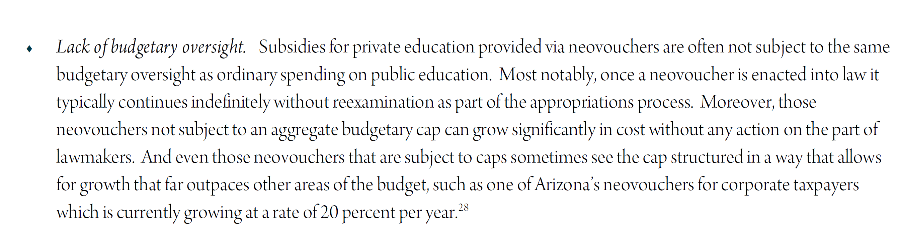
See the complete study here:
http://itep.org/itep_reports/2016/10/state-tax-subsidies-for-private-k-12-education.php#.WG-uxRsrJ3g

Position Papers
The following position papers, also posted on the RSAI legislative, supported advocacy work during the 2017 Legislative Session. Use these resources as conversation starters with legislative candidates or to discuss with parent or other stakeholder groups.
Whichever of these priorities remain a focus of RSAI for the 2018 Session, new position papers will be provided with updated information. These position papers and other resources, including this Digest, are found on the RSAI web site www.rsaia.org
- Transportation Equity: Position paper found here.
- State Penny for School Infrastructure Extension: Position paper found here.
- Equality in the formula: Position paper found here.
- Operational Sharing Incentives: Position paper found here.
- Funding and Flexibility for At-risk Students: Position paper found here.
- Standards, Assessment and Technology for Assessment: Position paper found here.
- State Supplemental Assistance: Position paper found here.
- Rural Teacher Quality Program: Position paper found here.
- Summer School/Interventions: Position paper found here.
- Quality Preschool: Position paper found here.
- Home Rule: Position Paper Found here.
RSAI Position Paper
Transportation Equity: A 2017 Legislative Priority

Background: In the 1950s, Iowa had over 4,000 school districts. Students could walk to their neighborhood school and transportation costs were nonexistent for Iowa school districts. As budgets have tightened and enrollments continue to decline, Iowa now has 333 districts (FY 2017) with varying square miles per pupil and hugely varying transportation costs.
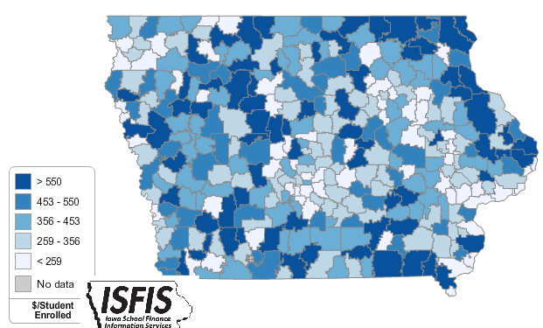
Iowa’s foundation formula does not recognize the sparseness of population, square mileage or route miles for school districts, the number of students transported, or variance in road or geographic conditions. As a result, districts with large transportation costs cover those costs out of the school general fund.
Current Reality: the following statistics describe current transportation inequities today from the DE FY 2015 Transportation Report:
- FY 2015 State cost per pupil was $6,366. There were an estimated 41 Iowa school districts that required at least 10% of that general fund cost per pupil for transportation.
- The range in transportation expenditures varies from a low of $57.82 to a high of $980.87 per student enrolled. Square miles per district range from a low of 2 to a high of 555 square miles, and route miles range from a low of 4,771 to a high of 1,264,105 miles.
- Property tax characteristics, including low valuation per pupil and corresponding higher tax rates, create challenges for districts with low tax capacity to pay for buses out of PPEL or Sales Tax funds, further stressing the general fund budget. When districts have larger transportation costs, both taxpayer and student inequities worsen.
- General fund dollars spent on busing would otherwise be available for staff and teachers (salary, benefits, training, and support), curriculum, programs, technology, and energy. Lack of resources in all of these areas creates an unequal educational opportunity for students in rural districts.
RSAI calls on the Iowa Legislature to address the issue of Transportation Equity: Supports a mechanism that covers school transportation costs that does not unreasonably disadvantage property tax payers in property poor districts or compete with general funds otherwise spent on providing education to students.

RSAI Position Paper Extend State Penny for School Infrastructure:
A 2017 Legislative Priority

Background: The State Penny for School Infrastructure, established in 2008, expires on Dec. 31, 2029. The original 20-year timeframe matched the typical bonding period for property-tax backed construction projects. State penny has helped schools address the age-old problem of equity and adequacy for school facilities. Use of the local option tax from 1998-2008 and the state penny sales tax for school infrastructure since have together:
- Funded technology expansions in districts (such as 1:1 initiatives)
- Elevated student learning (science labs, STEM, CTE and the arts, to name a few)
- Upgraded fields/facilities to encourage student/community participation and connection to school
- Resulted in fewer days lost due to extreme temperatures
- Returned saved energy dollars to the educational program
- Purchased items otherwise requiring PPEL levy increases or new Bond Issues
- Improved condition of otherwise aging bus fleet
- Reduced property taxes
- Provided additional property tax equity through dedication of use tax to property tax relief.

Current Reality: Nine years later, schools are feeling the pinch of a shortened bonding period:
- With only 12 years, a shortened bonding stream has left approximately $700 million of borrowing capacity on the table, compared to a full 20-year period.
- With low interest rates and unmet needs, this is the wrong time to turn to property taxes rather than sales taxes to continue facilities repair and construction.
- The replacement cost of Iowa schools is estimated to be $16.4 billion (July 1, 2014). The state penny provides an annual investment of 2.55%, a reasonable amount to maintain and update Iowa schools, including funding for technology, equipment, buses and additional property tax relief.
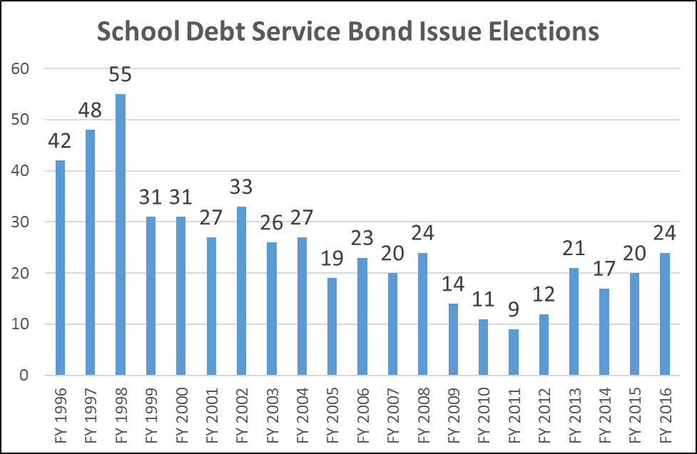
- Fallback will always be property taxes. Inequity in valuations means that some districts will utilize PPEL/Debt Service property taxes bearing no relationship to enrollment or need. Iowa will return to the infrastructure mess we were in with inadequate school facilities and unequal student resources.
History of the number of bond issues approved by voters annually proves the point: fewer bond issues have been passed every year since the start of the state penny. That track record will continue if the penny can be bonded against for the full 20 years. Absent that action, as the time frame shortens, the number of bond issues backed by property taxes will escalate.
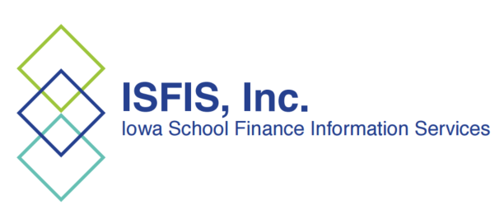

RSAI calls on the Iowa Legislature to extend or repeal the sunset of the state penny for school infrastructure. Since voters in Iowa’s 99 counties approved the sales tax for public schools, any change in use of the revenue in the extension should be dedicated to educational purposes.
School Infrastructure Local Option Taxes were first available to districts in FY 1999. The State Penny was passed in the 2008 Session.
RSAI Position Paper Student Equality - State and District Cost Per Pupil
A 2017 Legislative Priority

History: Before the Iowa school foundation formula was created, school districts depended almost entirely on local property taxes for funding. The level of support varied due to many factors, including community attitudes about the priority of education and local property tax capacity. The formula set a State Cost Per Pupil (SCPP) and brought all districts spending less up to that amount. A combination of some local property tax and some state foundation aid provided funding. Those districts which spent more than the newly defined SCPP were allowed to continue, funded by local property tax payers. Although the formula was created in the mid-1970s, the difference between the SCPP and a higher District Cost Per Pupil (DCPP) has remained. This graphic shows the property tax and state aid components of the SCPP and the DCPP above the $6,591 (FY 2016-17 SCPP).
Up to $175 above SCPP funded with local property tax
$6,591 State Cost Per Pupil
DCPP
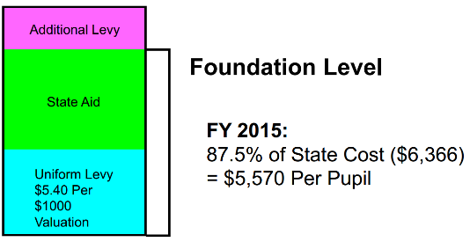
FY 2017:
87.5% of State Cost ($6,591) = $5,797 funded with state aid and local property tax

Current reality: In FY 2017, 163 districts (48.8%) are limited to the $6,591 as their District Cost per Pupil (DCPP). The other 170 districts (51.1%) have a DCPP ranging from $6,592 to $6,766, or $1 to $175 more. When the Legislature determines the increase in the SCPP, that dollar amount is added to the DCPP, so the gap continues at the same dollar amount. On a percentage basis, the $175 is much less today than it was in 1975. However, when school budgets are tight, every dollar matters. This table shows the count of districts based on the range of authority in the formula to exceed the SCPP.
FY 2017 Count of Districts | Amount DCPP is Greater than SCPP
162 | $0
65 | $1 to $35
48 | $36 to $70
25 | $71 to $105
19 | $106 to $140
14 | $141 to $175
Total = 333
Inequity impacting students: The amount of funding generated per pupil for regular education is not the same for all districts. Thus, a student, based solely on the historical practice of the district of residence, can generate more funding or less funding. Another critical question for policy makers relates to the multipliers or formula weightings for special student needs. Those multipliers, applied to the DCPP, generate different amounts of support for students, such as special education students, by application of the formula.
After nearly 40 years of the current formula, the question is, “Should ALL Iowa public school students generate the same amount of funding, on a per student basis, for their regular education costs?”

Solutions: The state could appropriate an estimated $85 million to eliminate the inequality. That total includes both the amount required for the state to assume the entire amount of DCPP already paid with property taxes in those districts that have authority (just over $11 million) plus the supplement for those districts that are held to the minimum ($74 million).
Other possible solutions to promote equality without lowering the per pupil amount available for any school district include:
- Give all local districts spending authority for the difference and allow school boards to decide locally whether to fund it. This solution maintains the state’s funding commitment without increasing it and provides local property taxes to support community schools.
- Set the state cost per pupil at the highest amount but lower the foundation percentage threshold from 87.5% to an amount that balances the impact on the state and on property taxes.
  - While both of these solutions depend on local funding, since many districts have sufficient cash on hand, there would be little cash reserve levy impact for several years in many districts.
- Allow local district authority to use cash reserves to fund the difference under certain circumstances. SSB 1254 and HSB 240, both introduced in the 2015 Legislative Session, include a parameter that the cash reserve levy in the base year may not be exceeded in a future year if providing funds for this purpose. HF 2182, introduced in the 2016 Session, was a short-term limited authority to use cash reserve, giving the legislature time to come up with a more permanent solution.
- Phase in a long-term commitment to eliminate the inequality over time. SF 2104 creates both a transportation and formula equality phase in, beginning with $5 per pupil July 2017, $10 per pupil July 2018, $20 per pupil annually thereafter until the $175 gap is eliminated (by 2027).
- A combination of the two options above would also be possible – authority in the meantime, close the gap over the long haul.

RSAI supports raising the state cost per pupil to the maximum district cost per pupil in the formula.

RSAI Position Paper
Operational Sharing Incentives: A 2017 Legislative Priority

Background: Operational sharing incentives were extended during the 2014 legislative session in HF 2271. Changes were made to both the positions covered and the amount of funding received by districts beginning with the 2013-14 school year and through the 2019-20 school year. School Counselors and Curriculum Directors were added to the positions covered. Funding was changed from a per student amount to a fixed amount per position. The funding is a level amount for five years. The fixed amount per position is as follows: Superintendent - 8 students, Human Resources, Business Manager, Operations and Maintenance, and Transportation - 5 students, and Counselors and Curriculum Directors – 3 students. Total additional students generated per district cannot exceed 21 (total of $138,411 per district in FY 2017 dollars). The Fiscal Note estimated a maximum of $46.5 million in FY 2016, of which $40.8 million would be state aid and $5.7 million funded through local property tax. The FY 2017 actual supplementary weighting, equal to 2,815 students, is an estimated $18.6 million, well below the total capacity estimated. 160 school districts utilize these sharing incentives.
Current Reality:
- Sharing incentives create the capacity for districts to discuss efficiencies that may not otherwise be politically viable. The incentives promote good working relationships with neighboring districts and help smaller districts continue to meet accreditation demands with limited general fund resources. Sharing also allows expertise to be concentrated in positions and provides more oversight and capacity for complying with Iowa laws.
- The amount of weighting, especially for those positions generating 3 students, may not be sufficient to justify sharing.
- Since the time frame for sharing is only five years, it provides less incentive for a district to engage in sharing in years two through five when the incentive is limited to a shorter time period.
- Although districts may share other positions, there are no incentives available for those positions.
- This program has been a life line for rural school districts, especially those with declining enrollment, during several years of low per pupil funding increases in the formula.
RSAI calls on the Iowa Legislature to maintain a commitment to and extend the timeline for Operational Sharing: Opportunities to achieve efficiencies, share capacity to operate, and redirect resources to educational programs, should be maintained and expanded to provide additional capacity to school districts to improve educational outcomes for students. Additionally, sharing of school superintendents is economically and educationally advantageous and should be allowed to continue without a time limitation.

Funding and Flexibility for At-Risk Students:
A 2017 Legislative Priority
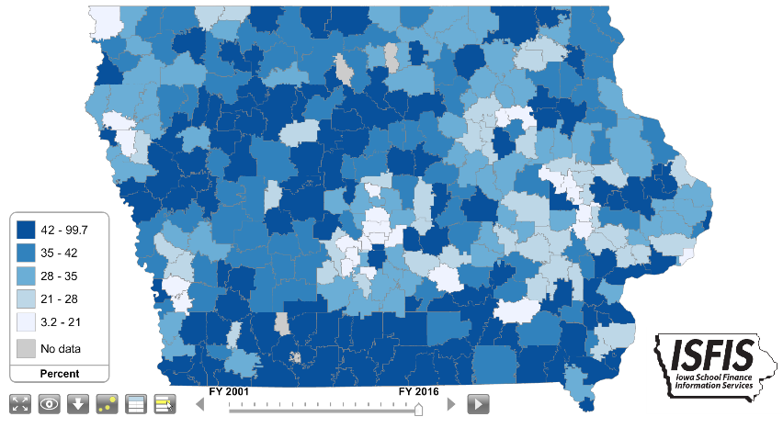
Background: Iowa has traditionally been a homogenous state with relatively low rates of poverty compared to the rest of the nation. As such, Iowa’s funding formula had little recognition of low income as a driver of at-risk student funding or programing. In 2001, about 28% of students were eligible for Free and Reduced Lunch, with the lowest district percentage of eligibility at 4.2%. Dropout Prevention funding is based on total enrollment count, not the percentage of students at-risk. DoP funding is limited to 2.5% of the total regular program district cost or up to 5% of regular program district cost based on historical practice.
Current Reality: In FY 2016, 41.8% of students enrolled were eligible for Free and Reduced Price Lunch. (Iowa DE web site, 2015-16 Iowa Public School K-12 Students Eligible for Free and Reduced-price Lunch B by District)
- Poverty is no longer concentrated in Iowa’s urban centers but found throughout the state. Of the 63 school districts in FY 2015 with more than half of their students eligible for Free and Reduced price lunch, 49 are rural school districts. In Iowa’s smallest enrollment category, districts below 300 enrolled, there were 47.2% eligible (Iowa Condition of Education Report, Jan. 2016)
- Iowa’s funding for at-risk students and dropout prevention resources, combined with targeted grant funds for high-needs schools, translates into a 9.8% additional funding commitment for these students. This falls short of the national average investment, which is an additional 29% funding beyond the base for low-income students. (American Institute for Research, Study of a new Method of Funding for Public Schools in Nevada, Sept. 2012)
- Students from low income families are more likely to begin school behind their peers academically, exhibit nonproficient literacy skills, especially in early elementary grades, and to fall further behind over summer breaks, unless schools have the resources, staff and programs to meet their needs.
- Current requirements for dropout prevention and at-risk expenditures are still regulated by the state, not allowing school districts to truly engage in prevention for younger students at-risk of early and subsequent failure without significant state oversight.
- Quality teaching is critical for success of low-income students, yet teacher shortages and lack of funding for sparsity creates additional challenges for rural schools in hiring and supporting teachers.
RSAI calls on the Iowa Legislature to address the issue of Funding and Flexibility for At-risk Students: Resources for serving at-risk students should be based on need, such as the number/percentage of students eligible for Free and Reduced Price Lunch, in addition to enrollment of the district. The current disparity in dropout prevention capacity ceiling, with some districts held to 2.5% and others allowed to access up to 5% of regular program district cost is unfair, arbitrary, and based on old history no longer relevant to supporting student needs. Districts should be given flexibility in determining the expenditure of at-risk resources to support students to graduate college/career ready for success.
Standards, Assessment and Technology for Assessment
A 2017 Legislative Priority
Background:
On Sept. 17, 2015, the State Board of Education initiated rules to begin the process of implementing the Smarter Balanced Assessment Consortium (SBAC) suite of assessments as Iowa’s new state test, following the near unanimous recommendation of the Assessment Task Force. The rules intended first administration of the test statewide in the spring of 2017. During the 2016 Session, the legislature did not appropriate funds and delayed the requirement for schools to use SBAC until the spring of 2018. Although the legislature also agreed to have the State BOE rules reviewed again in Dec. 2016, Gov. Branstad vetoed that requirement as the education associations, including RSAI, requested. The Iowa DE is planning to issue an RFP in fall 2016 for the test administrator and planning to prepare schools for the spring 2018 use of SBAC.

Although a summative test is required for federal accountability compliance, school leaders also recognize the importance of formative assessments along the way to inform instruction. The suite of assessment tools, including the formative assessments, the online digital library and the professional development included in the task force recommendations, will help teachers diagnose what students know and can do, and change instruction based on that information.
Current Reality:
- SBAC will cost an estimated $10 million. Although school districts may have invested funds locally for formative and interim assessments, it is unclear if they will be able to redirect the funds immediately or if it’s better for staff and students to phase in the changes over a few years. (Please note: $10 million is an estimate based on information during the 2016 Session. With a new RFP in the works, that estimate may change.)
- Computer adaptive test: In the SBAC, which students take on the computer, prior answers determine subsequent questions. Standards mastery for students at both ends of the learning spectrum will be better identified. Students are less frustrated with the test and more engaged. Iowa students interviewed after participating in the piloting of the SBAC tests confirmed their preference for this test format. Yet delivery of this test in the spring testing window to all Iowa students required to be tested depends on adequate technology infrastructure and devices. Some districts are more ready than others to deliver tests online. Extension of the state penny sales tax will provide additional long-term resources for adequate school technology.
RSAI supports the Iowa Content Standards, including an aligned assessment and supports for the technology and bandwidth required to adequately administer the assessment. Assessments required by the state must be funded by the state.

RSAI Position Paper: State Supplemental Assistance for 2017
Background: The Iowa Legislature annually determines the state cost per pupil, which pays for the annual cost of doing business in Iowa schools. Iowa Code Section 257.8 requires the per pupil amount be enacted by the Legislature and Governor within 30 days of the release of the Governor’s budget in the year prior to the budget year. In recent years, Iowa’s state cost per pupil has experienced record low increases. In six of the last seven years, the rate of growth in the state cost per pupil has been lower than cost increases typically experienced by school districts. Additionally, the rate has been set too late by the legislature for school districts to rationally conduct business.
Current Reality:
- The 1.25% increase in the state cost per pupil for the 2015-16 school year was signed by the Governor on July 3, two days into the fiscal year. That year, the state general fund grew by more than 6%.
- The 2016-17 increase of 2.25% was signed by the Governor on April 6, 2016 (less than 90 days prior to the start of FY 2016-17). At the October 12 REC meeting, the estimate for FY 2017 State General Fund revenues net receipts plus transfers, was set at 5.6% growth, or $387 million.
- SSA for FY 2018 at 4% would cost just over half of the projected FY 2017 revenue growth (an estimated $160 state dollars out of $290.8 million revised REC Dec. Estimate) and just under half of the FY 2018 projected revenue growth ($344.4 million). If revenues lag the December estimate, the state’s Economic Emergency Fund and Cash Reserve Fund are completely full, providing a further cushion against any short term revenue reduction.
- The slight improvement in Iowa’s expenditure ranking in the last two years is due to recent investments for the teacher leadership and compensation system. Without meaningful resources to support the regular program, schools see class size increases and inadequate funds for operating costs. TLC has further contributed to teacher shortage areas, with the impact magnified in rural districts.
- The costs of staff continue to rise, as do the costs of curriculum, textbooks, utilities, transportation and supplies. Additional requirements demand more resources: early literacy efforts, summer school, before- and after-school programs, needy school populations, increasing STEM program, implementation of higher expectations with the SBAC state test and the goal to graduate every student college or career ready for a successful future.
- Since Iowa’s funding formula is based on enrollment, districts with fewer students every year are doubly challenged to provide great programs and supports. Formula funding is especially critical to rural Iowa due to transportation costs, economies of scale, unique needs of students, mandates and compliance, the need for quality AEA services, and the ability to attract and retain quality staff in rural Iowa.
State Supplemental Assistance: The survival of rural schools depends on the return of education as the state’s top priority with an investment of meaningful new resources to improve opportunities for students. The resurrection of this priority will take several years of significant investment, thus RSAI supports a minimum of 6% noncategorical funding, with new mandates funded outside of the formula and not instead of it.
RSAI supports a return to the legal and historical practice of setting the state cost per pupil as required by Iowa law, which exemplifies the prioritization of education. If the General Assembly does not set SSA in according with statutory timelines, the percent of SSA immediately reverts to the percent of state revenue growth predicted by the Revenue Estimating Conference (REC) for the year of the school budget being set, based on the March REC estimate for the out year, prior to any state general fund revenue reductions imposed by the legislature.

RSAI Position Paper: Teacher Quality in Rural Iowa 2017
Background: All students, regardless of their zip code, deserve and require access to a great education for future success, which has always depended on great teachers. Although rural Iowa schools have traditionally been full of excellent teachers with a strong work ethic, flexibility, and dedication to student success, conditions in rural Iowa are making it difficult to attract and retain great teachers for the future:
- Teacher shortage areas exist in many content areas, but especially at the secondary level (math, science, music, career and technical areas, foreign language and agriculture) and special education, school counselors and teacher librarians across the spectrum (PK-12). See the complete list on DE’s web site: https://www.educateiowa.gov/teacher-shortage-areas
- When there are shortages, the market tends to compel teachers from rural areas to move toward higher paying urban and suburban districts. Rural schools are finding fewer qualified candidates, and sometimes no candidates at all, to fill vacant and mandated positions.
- The implementation of the teacher leadership and compensation system, now in its third and final year of phase-in, has further increased demand for teachers to fill vacant positions to replace teacher leaders. This additional demand has made a difficult challenge even more so.
- Teachers in rural areas are very likely to have multiple preps, whereas teachers in urban centers may be able to focus on teaching one or two classes multiple times per day. For example, a teacher in a rural district may teach and prepare lessons and activities across an entire content area, such as Algebra I, Geometry, Algebra II, trigonometry, Calculus and a Statistics course. Despite lower class sizes, multiple preps increase the workload significantly.
- Some rural schools have been able to help a willing and capable teacher obtain certification in a shortage area of content, but the rules require provisional licensure status no longer than two years. With fewer colleges and universities within a short distance, it is a burden to complete the licensure requirements within two years. With student loans to pay, additional tuition and costs of coursework may be beyond the financial capacity of lower compensated rural teachers and nearly unattainable for new teachers given the starting pay of the new teacher in a rural area. Additionally, new rural teachers most likely will be learning their jobs for the first time as well as being saddled with nearly unmanageable multiple preparations.
- Some community members, dedicated to the rural area, may be willing to teach in areas of their expertise, but can’t afford to quit working for two years to obtain the appropriate degree and license required.
- Rural communities have much to offer, but may not be attractive to young teachers looking for amenities in a more urban setting.
- Additional transportation costs come off the top of the per pupil revenues, leaving even less revenue to pay teachers at the attractive rate needed to overcome the market shortages and amenity deficits.
Current Reality: The teacher pay gap, defined as the wage gap between public school teachers and similar workers, grew from a negative 5.5% in the 1979 to a record -17% in 2015, according to Education Week. “In their findings, authors Lawrence Mishel, who is president of the Economic Policy Institute, and labor economist Sylvia A. Allegretto, who is chair of the Center on Wage and Employment Dynamics at the Institute for Research on Labor and Employment at University of California, Berkeley, cite recruiting and retaining high-quality teachers as crucial issues in K-12 education today, and say that in order to draw new teachers to the profession, fair compensation is necessary.
"Continued budget austerity at all levels of government have created pressure to restrain teacher compensation," Mishel wrote in an email. "The consequence is greater difficulty to recruit and retain the teachers all policymakers say we need."
The following data helps policy makers understand the extremes as well as the averages:
- Iowa teacher pay is ranked in the middle of the pack at 25 (DE Annual Condition of Education Report 2016), and is now $4,673 below the USA average teacher pay for the 2013-14 school year. Iowa ranks 6th in the Midwest, behind neighboring states Wisconsin ($1,742), Minnesota ($2,815) and Illinois ($8,187). This data is from 2013-14, prior to TLC implementation, which may close the gap somewhat on an average basis with other states, but is not likely to have much impact on beginning teacher pay.
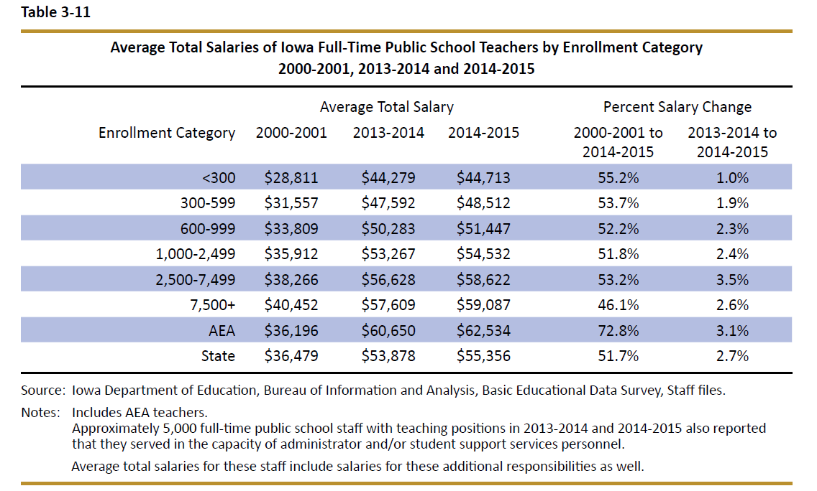
- Teacher pay variance between rural and urban/suburban schools is significant and worsening. In this table from the DE’s Annual Condition of Education Report, the gap is identified by school size (which is a good but not perfect predictor of rural districts), showing an almost $15K difference in pay between the averages of the smallest and largest category of school size.
- Continued budget pressures forcing whole grade sharing and consolidation typically require even more of the district cost per pupil spent on transportation, with less remaining to pay teachers at a sufficient level to eliminate the shortages and close the gap with larger districts.

Rural Teacher Quality Incentive Program: RSAI supports a new Rural Quality Teacher Incentive Program, to ensure students in rural Iowa have access to great instruction and support district compliance with accreditation standards. Suggested components of a program include:
1) Education Loan Forgiveness, to help new teachers offset student loan debt if they remain in rural school districts,
2) Expansion of temporary licensure to three years for teachers working for shortage area licensure to achieve the necessary credit hours,
3) Alternative models of licensure for shortage area teaching positions in rural Iowa,
4) Use of management fund to pay for certification course requirement costs for teachers working toward licensure in shortage area positions, and
5) Funding of transportation equity so rural education dollars may be spent on the classroom, including teachers.
RSAI Position Paper: Summer School/Reading for 2017
Background: The 2013 Iowa Legislature required that non-proficient third-grade readers attend an intensive summer reading program or be retained in third grade. The 2016 Legislature delayed the mandate until the summer of 2018. The 2017 Legislature and Governor are tasked with funding the requirements of the program, further delaying the mandate, or eliminating it. Iowa Code Section 279.68 requires the summer program or retention conditions, including a list of good cause exemptions for some students to move forward to 4th grade without the summer school program. The Iowa Reading Research Center’s Report on the 2016 Intensive Summer Reading Program (ISRP) Study of several summer 2016 pilot projects provides additional evidence and context for the challenges school districts will face in implementing this mandate. Rural districts which typically experience excess transportation costs and lower class sizes may have additional challenges to offering an Intensive Summer Reading Program within the $9.25-$13.82 million estimated cost range of the report. Find the full report here: http://www.iowareadingresearch.org/documents/2016_ISRP_Study_Report-FINAL.pdf
Current Reality:
- The IRRC report states, “Iowa joins 19 other states and Washington, D.C. in this move, prompted in part by the serious long-term consequences (e.g., dropping out of school, criminal behavior) associated with students’ early reading difficulties. It has been estimated that approximately 25% of Iowa’s third graders (about 9,000 students) are at risk for reading failure and, thus, might benefit from participating in summer reading programs.” The report stated, “Study results show all three conditions used were equally effective at preventing a decline in reading skills that can typically occur during the summer months when away from the classroom. On average, however, the ISRPs did not lead to statistically significant growth on tests of students’ reading abilities.” The study further explained that the professional development required to provide teachers with the instructional skills to improve results was below that which research shows is necessary to prepare teachers to change their practice during the regular school year, but was not specific to summer school professional development.
- The report estimates per pupil summer school expenditures would range from $1,193 to $1,813. Because not all students will be required or choose to attend ISRPs, these figures might be considered the maximum expense. Of course, the cost of retaining the student is an additional year of the school at an average total cost of $11,427, estimated by the report. But if more students choose not to attend Summer School and the retention consequence kicks in, the costs could well exceed the $9.25-$13.82 million median cost in the report.
- For those students who initially attend, but do not successfully complete the summer program, summer school and retention costs incurred range of $12,619 to $13,240 total per student served by both.
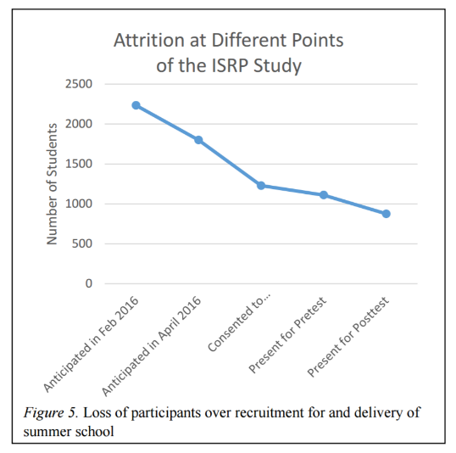
- The IRRC report gives an indication of student attrition: “Of the 149 classes to serve 2,235 students anticipated to be in the study, after adjusting for lack of personnel, internal issues in districts, inability to coordinate transportation across districts forming a consortium, and indicators of low parent interest in summer school, in fact, only 1,229 parents consented for their children to participate and even fewer students (1,111) ultimately showed up for summer school. . . .only 876 student were present for the posttest.” The study reports that total attrition was 51%, and attrition from pretest to post test was 21%. They also suggest that there was no consequence for low attendance in the pilot, so absences and attrition might be different if attending summer school was mandatory.
- Class size challenges were evident in the study. “Any district that had 16 – 18 students who were eligible was required either to accept only the first 15 students whose parents consented to participate or offer two classes of 8 to 9 student in order to maintain compliance with Criterion 4. Given the poor attendance experienced, the latter option might have had classes that dwindled down to two or three students, with the district still responsible for hiring two teachers and maintaining two classrooms.” The study also reported challenges with cooperation between districts.
Reading Interventions/Summer Schools: RSAI supports local district authority to determine if supplemental interventions during the school year, in addition to the regular program, would be more beneficial to non-proficient third-grade readers, if the district determines barriers will prevent offering a quality summer school program.

RSAI Position Paper
Preschool: A 2017 Legislative Priority

Background: Iowa’s Statewide Voluntary PK Program participation, first implemented in 2007-08, has grown to serve 22,695 4-year-olds in 2014-15. That means there were still some 16,000 estimated students registering for kindergarten not served in the SVPP. The importance of reading proficiently by the end of third grade is heightened, as the state looks toward implementing mandatory third-grade retention for non-proficient readers, unless they experience a summer school program. The old adage, an ounce of prevention is worth a pound of cure, applies to this issue.

Why does preschool matter? The Perry Preschool Project, 40 years later, documents $17 savings for every dollar invested (earlier findings of $8 saved for every dollar invested are also often cited.) Once considered a strategy just to support working parents with child care needs, the majority of states now view access to high-quality preschool programs as a critical long-term economic investment in the future workforce. Education Commission of the States, Oct. 2014, http://www.ecs.org/docs/early-learning-primer.pdf: Six Rigorous long term evaluation studies have found that children who participated in high-quality preschool programs were:
- 25 percent less likely to drop out of school.
- 40 percent less likely to become a teen parent.
- 50 percent less likely to be placed in special education.
- 60 percent less likely to never attend college.
- 70 percent less likely to be arrested for a violent crime.
National Conference of State Legislatures quotes studies on long term return on investment. http://www.ncsl.org/research/human-services/new-research-early-education-as-economic-investme.aspx

Sarah Daily, Initiatives from Preschool to Third Grade: A Policymaker’s Guide, shows reductions in costly outcomes that quality preschool prevents. (Denver, CO: Education Commission of the States, October 2014) http://www.ecs.org/docs/early-learning-primer.pdf

Barriers to Expansion. Improvements in access for students, especially students from low income families, depend on additional flexibility of funding. During the 2016 Session, transportation expenditures were clarified so they can be prorated for efficiency’s sake. But those costs eat into the 0.5 weighting assigned to preschool students very quickly in rural districts. Additional expenses to grow programs, such as outreach to market and create urgency that preschool is important, wrap-around services to accommodate working families, and costs of sharing programs with neighboring districts to achieve an economy of scale beyond instructional costs, remain barriers to reaching all children. Additionally, school districts need consistency, timeliness and predictability of funding.
RSAI supports full funding of quality preschool. Due to changing demographics in rural Iowa, significant transportation costs, and lack of quality day care access, quality preschool for three- and four-year olds should be fully funded. Preschool students should be included in the regular student count at 1.0 per pupil cost.
RSAI Position Paper
Home Rule District Authority: A 2017 Legislative Priority
Background and History: A Home Rule framework for decision-making starts with the assumption that local leaders, closest to students and communities, will make the best decisions for their schools.
This is in contrast to Iowa’s current system of Dillon’s Rule, which states that schools can only do what is expressly authorized in state law. Dillon’s Rule is based on a court case in 1868, in the Iowa Supreme Court. Iowa cities and counties were granted home rule via Iowa constitutional amendment (municipalities in 1968 with the 25th amendment and counties via the 37th amendment in 1978.) Both of those amendments specifically excluded taxing authority, which remains heavily regulated by the State. Additional background on change to home rule for Iowa is found in the Legislative Guide to Iowa Local Government Initiative and Referendum, LSA, December 2008, found here.
Such flexibility has not yet been extended to school districts, although for many other purposes of statutory interpretation, school districts are considered to be municipalities. Either a constitutional amendment or legislation granting Home Rule authority would not eliminate any current laws, but would grant flexibility in the areas not written. School districts would still be required to follow laws that prescribe their actions as well as avoid actions prohibited in law.
Why do school leaders support Home Rule?
- School districts are called upon to deliver results, but often cannot exercise local authority to implement new practices, update processes, or think creatively.
- If a school takes an unacceptable action in a home rule environment, the legislature may later prohibit it.
- Recent examples involve the need to change Iowa law to allow districts to make electronic payments rather than “stamp warrants” or consider a bus motor as “transportation equipment” for physical plant and equipment levy uses.
- Transition to home rule need not be cumbersome. The state of Kansas moved to statutory home rule for schools in 2003, without court challenge since.
Decision-makers closest to communities are in the best position to make decisions benefiting students in those communities. What Alexander Hamilton explained 1787 holds true today: “It is a known fact in human nature that its affections are commonly weak in proportion to the distance or diffusiveness of the object. Upon the same principle that a man is more attached to his family than to his neighborhood, to his neighborhood than to the community at large, the people of each State would be apt to feel a stronger bias towards their local governments than towards the government of the Union; “Federalist, no. 17 Federal v. Consolidated “, Dec. 5, 1787
RSAI calls on the Iowa Legislature to give school districts needed flexibility: Iowa school districts should be subject to Home Rule to promote flexibility and creative decision-making as opposed to the more restrictive Dillon’s Rule interpretation of State authority.

Collective Bargaining HF 291 Section Analysis
HF 291 Collective Bargaining Changes: Itemized Detail and Resources
Section 1: Defines “supplemental pay” as any payment of moneys or other things of value in addition to compensation received pursuant to any other permitted subject of negotiation in section 20.9 related to employment relationship.
Section 2: Restricts PERB duties to only administering chapter 20 (not interpreting or applying the law)
Section 3: Requires PERB to contract with a vendor as necessary to conduct association certification and recertification elections required by section 20.15. Requires fees for the cost of the election be paid by the association on the ballot in advance of the election.
Sec. 4: Adds evaluation to list of employer rights (hire, evaluate, promote, demote, transfer, assign and retain public employees) and states that employers may suspend or discharge public employees.
Sec. 5: Adds a new subsection to employee rights to exercise any right or seek any remedy provided in law and lists several related code chapters involving civil suits, civil rights and civil service chapters.
Sec. 6: scope of negotiations: Specifies that for bargaining units without at least 30% public safety employees, process to meet in advance of employer budget-making process and restricts mandatory subject of bargaining to base wages only, with other matters mutually agreed upon being permissive. Requires that mandatory subjects (base wages) be interpreted narrowly and restrictively. Excluded from negotiations: dues checkoffs and other payroll deductions for PACS, insurance, leaves of absence for political activities, supplemental pay, transfer procedures, evaluation procedures, procedures for staff reduction, subcontracting public services, shall also be excluded from the scope of negotiations. Allows a contract term for up to 5 years.
Sec. 7: Adds to prohibited practice that employees can’t negotiate with employer or board member who isn’t the designated bargaining rep for the employer.
Sec. 8: Doubles the wait period to two years if employee organization fails to comply with an injunction or is convicted of violating this section and requires they go through certification process again to be the bargaining unit.
Sec. 9: Elections: For initial certification elections, changes requirement from 10% to 30% of public employee signatures in the unit. Changes the standard from majority of those voting to majority of those in the bargaining unit. If there is no majority, the bargaining unit shall not be represented by an employee organization. Requires two-year wait from date of last certification election. Retention elections: requires PERB to conduct an election to retain and recertify the bargaining rep of a unit prior to the expiration of the collective bargaining agreement and determines when the elections shall occur. Bargaining rep continues if majority of those public employees in the unit vote to retain. If majority don’t vote to retain, the unit is decertified and there is no rep until a recertification election is successful. Decertification elections: if petition is filed, PERB shall submit question to public employees of the unit and the ballot shall ask whether the bargaining rep of the public employees in the unit shall be decertified. If majority vote to decertify, there is no bargaining rep until a certification election is successful. Petition for decertification can only be considered by PERB if the current collective bargaining agreement exceeds two years in length. Invalidation of elections: specifies who files written objections regarding misconduct or circumstances employees from freely expressing their preferences and process to hold a second election. Also addresses state agreements. See PERB Statement on their website about Recertification Elections: https://www.iowaperb.iowa.gov/have-questions
Sec. 10: applies to state employees only
Sec. 11: Strikes section about employee prohibited practice of negotiating with board (replaced by new section 20.10 which is sec. 7 above.)
Sec. 12: Allows both parties to agree to deadline for exchange of final offer before arbitration.
Sec. 13: Restricts arbitrator from considering any new evidence on any subject excluded from negotiations except for that necessary to consider comparability. Sets a limit on arbitrator awards for bargaining units (includes schools) requiring arbitrator to award the lessor of
a) 3% or
b) CPI for all urban consumers for Midwest region set by US Dept. of Labor, BLS or a successor index. s PERB to notify parties of the CPI mentioned above and allows PERB to get help from Dept. of Workforce Development. (That rolling average CPI is on the PERB Web site www.iowaperb.iowa.gov )
Requires arbitrator to consider (for schools) 1) comparison of wages, hours, conditions of employment with other public employees doing comparable work, giving consideration to factors peculiar to the area and the classifications involved. To the extent adequate applicable data is available, shall also compare base wages, hours and conditions of employment of with private sector employees doing comparable work. 2) interest and welfare of the public 3) financial ability of the employer to meet the cost of an offer in light of current economic conditions of the public employer. Requires arbitrator to give substantial weight to employers’ authority to utilize funds if restricted to special purposes or circumstances by state or federal law, rules, regulations or grant requirements. Prohibits the arbitrator from considering either past practice/past collective bargaining agreements or the employer’s ability to fund an award through the increase or imposition of new taxes, fees or charges or to develop other sources of revenue.
Sec. 14: States this law doesn’t prohibit individual political contributions, as long as they are not through payroll deductions.
Sec. 15: Requires collective bargaining agreements to be in writing and signed by both parties. Requires employer to file agreement with PERB. Requires PERB to maintain a searchable database of collection bargaining agreements and other info on an internet site.
Sec. 16: Increases the time period from 6 months to 36 months during which a supervisory member of any dept. or agency employed by state of Iowa is prohibited from requesting and receiving a reduction in rank from retiring and receiving benefits associated with the lower rank.
Sec. 17: Adds arbitration to the list of proceedings for which a mediator is not required to testify.
Sec. 18: Applies only to transient employees of DOT
Sec. 19: Adds evidence of employee support for retention and recertification votes to confidential records, and Sec. 20 includes how an individual employee voted is confidential record.
Sec. 21 and 22: eliminates payroll dues deduction and further prohibits employers from authorizing or administering a payroll dues deduction for membership in an employee organization.
Sec. 23: Doesn’t apply to schools: Eliminates references regarding pension or annuity retirement system (lists waterworks system or other publicly owned utility)
Sec. 24: Clean up language adding “not retained or recertified” to list of public organizations
Sec. 25: Transition Procedures/Emergency Rules; as of the effective date of the act (February 17, 2017) parties, mediators, and arbitrators engaging in any collective bargaining procedures who have not completed such procedures shall immediately terminate any procedures in process. Nullifies any CB agreement in process not yet completed. Requires schools to complete negotiations that impact the remainder of calendar year 2017 by June 30, 2017 unless mutually agree to later date. Requires PERB to adopt emergency rules. PERB transition guidance is found on their website here.
Sec. 26: Effective on enactment (Governor signed it on Feb. 17, 2017)
Sec. 27: Applicability provisions: Does not apply to CB agreements already in effect (having been ratified by both the association members and the school board prior to signature), but applies to CB procedures occurring on or after the effective date. Also specifies that preexisting contracts may continue dues deductions.
DIVISION II: EDUCATOR MATTERS
Sec. 28: Allows contracts to be modified (in addition to current law referencing either continuing or terminating a contract.) Allows temporary contracts for period up to 6 months. Allows temp contract to fill a vacancy for employee on military leave. States that temporary contracts are not subject to discharge procedures/rights to appeal.
Sec. 29: specifies that some protection provisions of teachers except for appeal of termination to adjudicator, apply to community college “teachers” in certain circumstance.
Sec. 30: Requires the school board to establish evaluation criteria and procedures and removes evaluation from negotiations. Removes grievance procedure requirements regarding teacher termination.
Sec. 31: Lengthens timelines for private hearing requested by teacher after receiving termination notice, private hearing must be held between 20-40 days (was 10-20). Requires district to furnish teacher documentation which may be presented to the board 10 days (was 5) before the private hearing. Requires teachers to provide district with documentation that teacher expects to present at the hearing 7-days prior (was 3).
Sec. 32: Adds “witnesses for the parties” as individuals allowed to participate in the private hearing. Eliminates board authority to subpoena witnesses. Strikes waiting period of 5 days after teacher does not show at the private hearing, allowing board to proceed with determination. Adds another option to board action of issuing the teacher a one-year, nonrenewable contract (currently board can suspend teacher with or without pay for a period specified by the board.) Eliminates fact finding from record of the public hearing. Requires the written decision of the board and the record of the private hearing are exempt from public records requirements.
Sec. 33: Strikes 279.16(3) (referring no-show witnesses to county court) and strikes 279.16(5 which allowed the superintendent or teacher to provide briefs or written arguments within 3 days of the conclusion of the private hearing.)
Sec. 34: Allows teacher to appeal board’s decision to terminate directly to court (removes intermediate appeal to adjudicator from the process.) The Board Secretary is required to transmit to the reviewing court the original or certified copy of the entire record which may be the subject of the petition for review. The court is to give weight to the board’s decisions, but may reverse, modify or grant any other appropriate equitable or legal relief.
Sec. 35: Increases probationary period of newly hired teacher who has previously completed a probationary period from 1 to 2 years. Allows board to terminate a probationary teacher without cause. Requires board to notify teacher of termination by April 30. Within 10 days, the teacher may request a private conference with the board to discuss reasons for termination. There is no appeal process unless the termination was based on an alleged violation of a constitutionally guaranteed right of the teacher. Eliminates an alleged violation of Chapter 20.10 rights to question the board’s final and binding decision for probationary teacher. Eliminates reference to grievance procedures in this code section.
Sec. 36: Eliminates supplemental pay for coaches from mandatory subject of bargaining. Eliminates the requirement that a coaching contract be continued automatically. Requires that if the coaches contract and a collective bargaining agreement in force conflict, the provisions of the CB agreement apply. Allows board to terminate a coaching contract for any lawful reason following an informal hearing before the school board. The board’s decision is final.
Sec. 37: Eliminates requirement that administrator contract includes compensation per week for 5 consecutive days or month of four consecutive weeks, instead requiring contract to include the rate of compensation.
Sec. 38: Allows temporary contract with administrator for up to 9 months.
Sec. 39: In addition to termination the board may issue a one-year nonrenewable contract to an administrator. Increases administrator probationary period from 2 to 3 years, but the board may extend it for an additional year with consent of the administrator.
Sec. 40: Allows an administrator after receiving notice of termination to request a private hearing. Increases the timeline to setting the private hearing between 20-40 days (was 10-20 days). Requires any witnesses to be sequestered. The procedure occurs before an administrative law judge. The administrator may appeal to the board for a private hearing within 10 days. Eliminates fact finding. Requires the written decision of the board and the record of the private of the private hearing are not public records.
Sec. 41: Discharge of a teacher: adds definition of just cause including but not limited to a violation of the code of professional conduct and ethics of the BOEE if the board has taken disciplinary action.
Sec. 42: Eliminates grievance and evaluation procedures from negotiations. Eliminates additional teaching standards and criteria from negotiations.
Sec. 43: Teacher Quality Committee: Strikes reference to negotiated agreement regarding evaluation procedures. Instead of the contract, requires the TQ Committee to determine the compensation for teachers on the committee for work beyond the school day.
Sec. 44: Specifies that intensive assistance and its implementation are not subject to grievance procedures or negotiation. States that a teacher having received intensive assistance regarding an Iowa teaching standard or criteria is not subject to another round of intensive assistance on the same standard.
Sec. 45: Strikes requirement of peer review for teachers in one year of the three-year evaluation cycle.
Sec. 46: Allows district evaluation and review after teacher completes intensive assistance and if the teacher did not successfully complete the intensive assistance program, they can terminate the teacher’s contract immediately, terminate the contract at the end of the year, or continue the contract for a period not to exceed one year.
Sec. 47: Strikes the appeal by teacher to an adjudicator
Sec. 48: This section is effective on enactment
Sec. 49: Applicability provisions: applies to all collective bargaining procedures occurring on and after the effective date of this division.
Sec. 50: If an individual resigns in lieu of termination, was discharged or demoted as the result of a disciplinary action, the documented reasons and rationale for the action are considered public records.
Sec. 51: Applies to state employees only, not schools. Prohibits confidentiality or nondisclosure provisions in personnel settlement agreements.
Sec. 52: Requires public employer that takes disciplinary action that could be a public record to notify the employee prior to taking the disciplinary action that the info placed in the employee’s personnel file as a result of the disciplinary action may become a public record.
Sec. 53: Effective on enactment and Sec. 54 Applicability on enactment
Secs. 55-64 civil services provisions not impacting school districts.
Sec. 65. Public Employee Health Insurance: Requires that a public employer offer health insurance to all permanent, full-time employees employed by the public employer. There is no definition of full-time employee in the statute. Note: this does not require the district to pay for the insurance.

Resolution template to transfer school general funds to the student activity fund for safety equipment effective on enactment and retroactive to school year beginning July 1, 2016

Whereas participation in athletic and other school extracurricular activities furthers the skills, development, character and growth of our students, and
Whereas safety of our student athletes is of paramount importance to the district, and
Whereas student activity funds are insufficient to cover the costs of protective and safety gear required by the Athletic Associations for students participating in those activities, and
Whereas the Iowa Legislature authorizes school boards to use school general funds for these purposes consistent with the enactment of HF 564 during the 2017 Legislative Session, effective for the school year beginning July 1, 2016,
BE IT THEREFORE RESOLVED:
That the Board of Directors of the _____________ Community School District approves the transfer of $________________ from the general fund to the student activity fund for expenditures that occurred between July 1, 2016 and June 30, 2017 for protective and safety gear required for athletic competition.

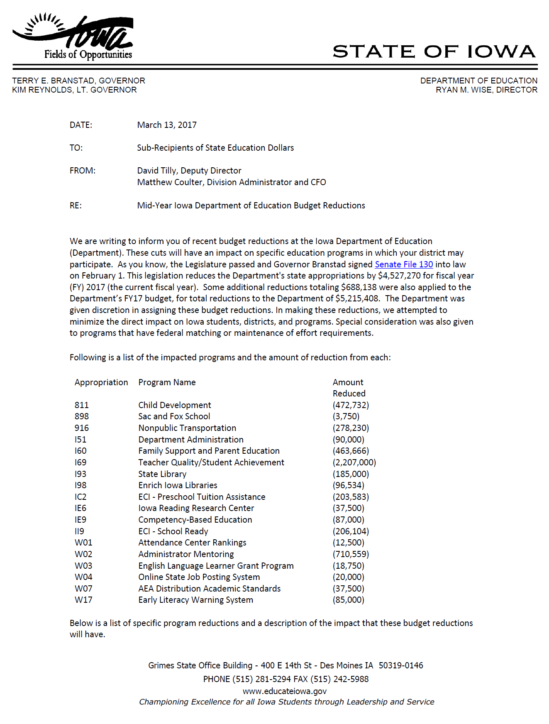
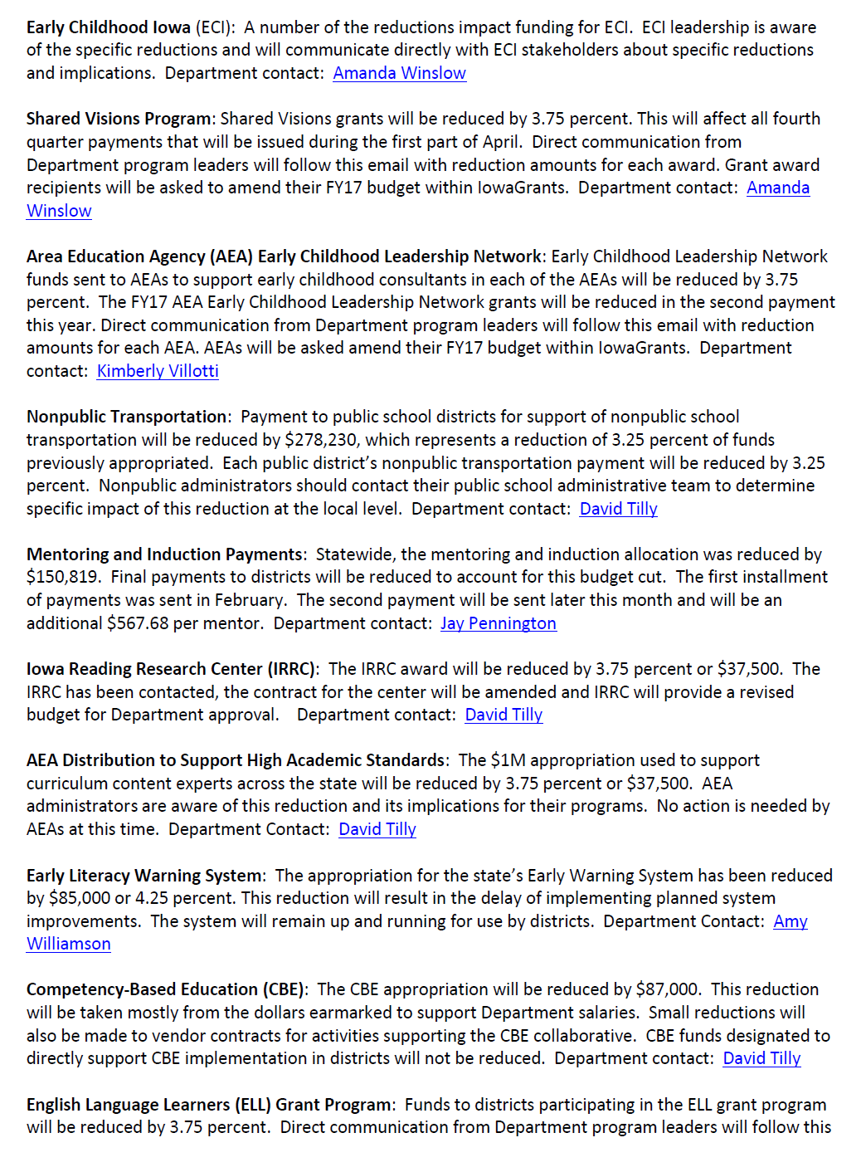
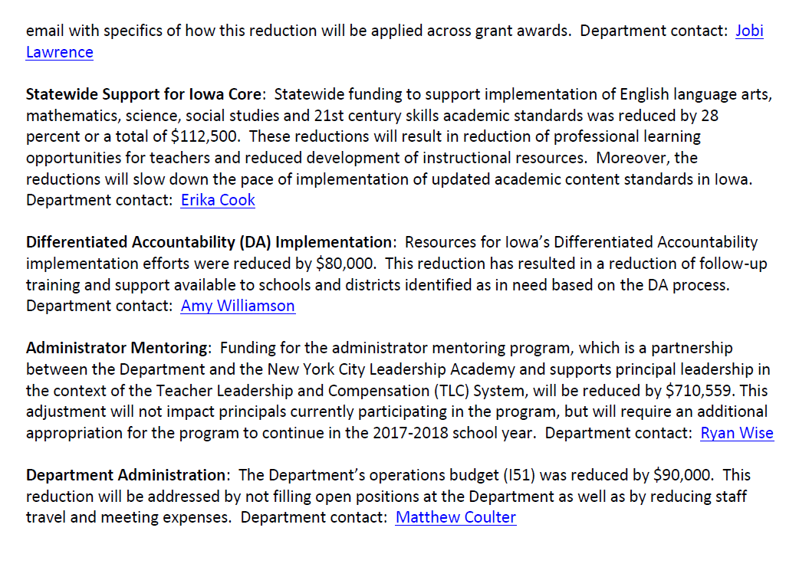

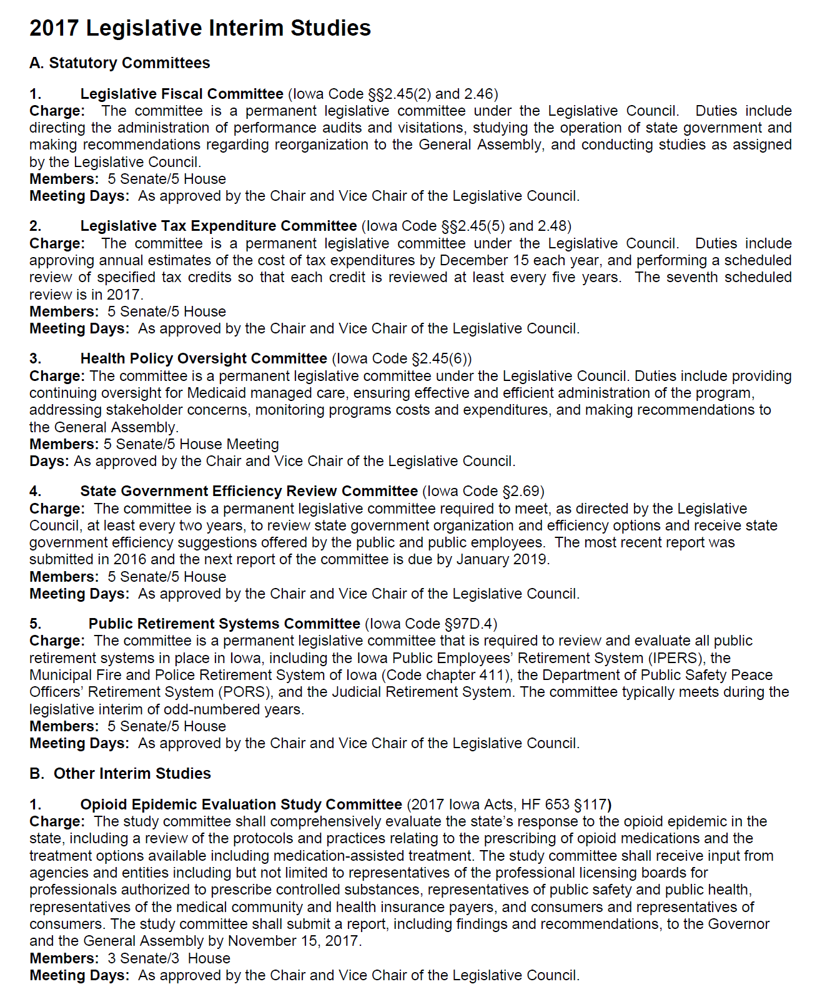
Advocacy and Other Legislative Resources

Iowa State Legislature
https://www.legis.iowa.gov/
Iowa Department of Education Legislative Page including Bill Tracking, Legislative Reports and Guidance and Updates on Legislation
https://www.educateiowa.gov/resources/legislative-information
Rural School Advocates of Iowa Legislative Page
http://www.rsaia.org/legislative.html
RSAI Final Capitol Recap Video End of Session and Interim Advocacy
2017 RSAI Legislative Recap & PPT
Parents for Great Iowa Schools
http://parentsforgreatiowaschools.com/
ISFIS Web Site: Conference Presentations
http://www.iowaschoolfinance.com/conference_handouts
Sessions on Decision-making Paradigm Shift with new Flexibility, School Election changes and Summary of Legislative Action.

2017 Iowa Department of Education Reports to Legislature

Antibullying Programming and Projected Expenditures
Career and Technical Education Redesign Implementation Report
Child Development Coordinating Council Annual Report
Competency-based Education Report
Early ACCESS Legislative Report
Early Childhood Assessment
Educational Programs for Children's Residential Facilities Rules Progress Report
English Language Learners Report
Equal Opportunity and Affirmative Action Report
Iowa Autism Council 2017 Priorities
Iowa Early Intervention Block Grant Program (Class Size) 2016-2017
Iowa Reading Research Center Report
School Association Reporting FY2016
Secure an Advanced Vision for Education (SAVE) Report FY2016
Senior Year Plus and STEM Report
Student Achievement, Accountability and Professional Development Annual Report
Supplemental Assistance for High-Need Schools Report
Teacher Leadership and Compensation Status Report
Virtual Schools in Iowa Annual Report

2016 DE Reports

Assessment Task Force Report - Science
Charter and Innovation Zone Schools in Iowa
Child Development Coordinating Council Shared Visions Annual Report
Closing Achievement Gaps Report
Early ACCESS Governor's Report
Iowa Autism Council 2016 Priorities
Iowa Core Annual Report
Iowa Early Intervention Block Grant Program (Class Size)
Iowa Reading Research Center Legislative Report
Kindergarten Literacy Assessment Preliminary Report
School Association Reporting
SAVE-SILO Legislative Report
Virtual Schools in Iowa Annual Report

NOTES

