
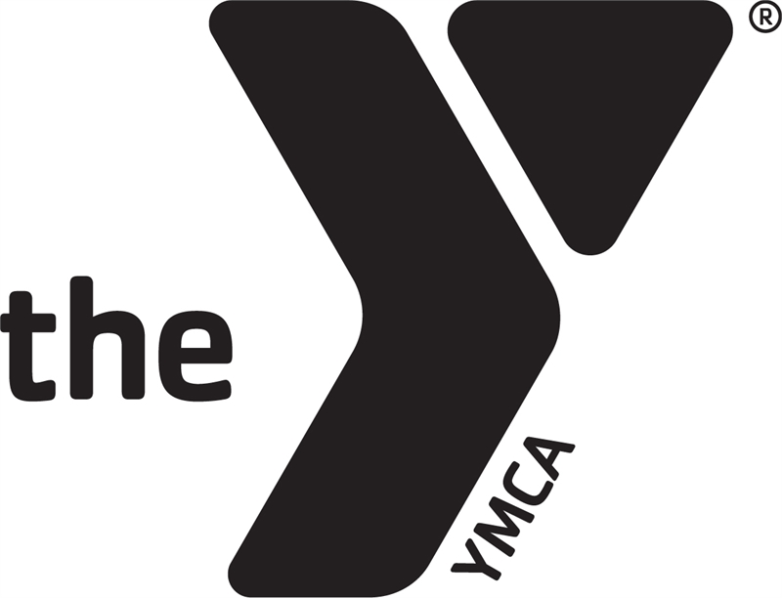

THE YMCA OF ACADIANA
BEFORE & AFTER SCHOOL ENRICHMENT

PARENT HANDBOOK
The YMCA of Acadiana
800 E. Farrel Rd
Lafayette, LA 70508
993-9622 office
993-9632 fax

Website: www.theymcaofacadiana.com

Dear Parents,

August is here again and the YMCA of Acadiana is happy to have the opportunity to run our Before or After School Enrichment program at your child’s school. We would like to thank you for enrolling your child/children and we look forward to a great school year.

This handbook will inform you of our payment policies, schedules, program rules and what is expected of our staff, the children and you as a parent of a YMCA camper. The YMCA wants this to be a safe and exciting school year for all children.

We hope you take the time to read this information and go over some of it with your child as before & after-school enrichment begins.

Sincerely,

The YMCA of Acadiana Staff

Payment Policies

Fees for Before & After School Enrichment:

Before School Enrichment weekly fees vary for each program.
Registration Fee: $70.00 for the first child ($50.00 each additional child).

Weekly Fee: $42.00 per week for first child
$30.00 per week for each additional child
$10.00 per day per child if they only attend 1 or 2 days


**$25.00 per week for Lafayette & Vermilion Parish Employees.

**$25.00 per week for Active Military
It is important for the YMCA that we support our educators and Active Military. If you or your spouse is a teacher or active military, you are qualified for a reduced rate! We just need a photo copy of your active military ID or documentation stating that you are a teacher on your school’s letterhead, signed by your principal.

No Payment means no child care. Please refer to our office director, Teri Chan, for any issues regarding payments.

We must receive your payment each Monday of the week attending.

Failure to pay will result in our contacting you to pick up your child. The child is not allowed to return until balance is paid in full.

You may pay your fees online, calling in a payment to the office or with the Site Director at the time of pick up on Monday and receive a receipt upon request. _____________________________________________________________

What not to bring to After School Enrichment:

- No electronic devices.
- No cell phones
- No outside games or toys.
- No trading cards or card games

We are not responsible for any lost or stolen items.

We will provide plenty of activities for the kids… toys from home are distractions and can cause problems between the kids.

Basic Rules for YMCA participants

- Treat everyone with respect.

- Speak for yourself!

- No bullying, teasing, shunning, or ridiculing of any kind.

- No hitting, kicking, biting, or negative physical contact (fighting) with others.

- Share YMCA of Acadiana equipment and games with others.

- Pick up after yourself and others.

- Absolutely no inappropriate language or gestures.

- Have a positive attitude and be willing to participate.

- Always ask for permission to use the restroom or get water.

- Listen to and follow the directions of before & after-school staff members.

- Additional rules may apply at certain cites.

- The YMCA of Acadiana reserves the right to make additional rules at any point during the school year.

The YMCA of Acadiana trains its workers on dealing with children’s moods and behavior. Our staff will do their best to provide a safe and caring environment for all of the campers.

YMCA DISCIPLINARY PROCEDURES

- Child will be given a verbal warning for misbehavior the first time.

- If the misbehavior continues, the child will be given:

  - 5 minutes from group activity

- If a child misbehaves again, your child will receive a BEHAVIOR REPORT. The counselor, director, parent, and camper will sign the behavior report.

PARENTS WILL BE NOTIFIED AT PICK UP

4. If a 2nd BEHAVIOR REPORT is filled out, the child will receive the following:
SUSPENSION FOR 1 DAY

5. If a 3rd BEHAVIOR REPORT is filled out, the child will receive the following:

SUSPENSION FOR 3 DAYS

6. If a 4th BEHAVIOR REPORT is filled out, the child will receive the following:


EXPULSION FROM THE PROGRAM – PARENTS WILL BE CALLED!

* A CHILD MAY BE EXPELLED IMMEDIATELY FOR THE FOLLOWING:

- HARMS ANOTHER CHILD OR COUNSELOR
- STEALS
- DAMAGES PROPERTY
- USES FOUL LANGUAGE
- TOTALLY DISRUPTIVE TO THE GROUP
- LEAVES AREA WITHOUT PERMISSION

PROPER BEHAVIOR INCLUDES THE FOLLOWING:

- RESPECTING THE RIGHTS OF OTHERS
- USING APPROPRIATE BEHAVIOR FOR EACH ACTIVITY
- STAYING WITH YOUR GROUP
- LISTENING AND FOLLOWING DIRECTIONS
- RESPECTING STAFF
- HAVING FUN!!
The YMCA of Acadiana in no way supports corporal or physical punishment of any child. Time out is our only form of punishment and consists of the child sitting in an area away from the other children but in sight of workers at all times.

Reminders for our Parents:

According to the Louisiana Family Code of State Law, the Y and its staff is obligated to report any signs of child abuse or neglect.

The YMCA cannot provide care for sick children. Please do not send your child to before or after-school if they are ill or contagious. Should your child become ill while attending before or after-school, we require that your child be picked up as soon as possible after we contact you. We will contact parents immediately if their child becomes ill or injured.



Pick up:

Pick up is by 6:00 pm each day. You must sign your child out each day.

Please show your I.D. to the staff at pick up for the first week or so until they are familiar with whom you are.

Sign out everyday is important for the safety of your children!

A child picked up after the designated time will be charged $1.00 a minute thereafter. Parents will be required to sign a late pick-up sheet as well. This allows us to document the number of times a child is picked up late from our program.

Any child that is not picked up after all phone numbers have been called will be turned over to the Police Department.

If your child is picked up late 3 times, they will be dismissed from the program.


Medicine and Emergency:

We do not give out over the counter medication however we will give prescribed medicine only after a medicine release form has been filled out by the parent/legal guardian.

Please make sure all information on your registration form is correct and please let us know throughout the school year if there are any changes that need to be made. This information is important in case of an emergency.
___________________________________________

Custody / Court Orders
In order for us to honor any custody or court papers we must have a copy of the papers for our office and before & after-school site.
__________________________________________________

Parent Behavior
Parents need to maintain a calm & respectful demeanor with our staff (the same is expected of our staff). Failure to do so may result in your child/children’s dismissal from the YMCA program.
__________________________________________________

Complaint or Concerns
We expect our workers to treat all parents with respect and would like all parents to do the same.

Any parent or guardian with complaints or concerns about our programs may contact the YMCA office at 993-9622 or contact Doc at 781-3872.

We are daily trying to improve our programs and it is your feedback that is most important in making those improvements. Please feel free to submit questions & comments at any time.
__________________________________________________

Important Contact Information


Mr. Dennis “Doc” Stepanek
(337)781-3872
Executive Director
doc@theyofacadiana.com

Ms. Teri Chan
Office Director
teri@theyofacadiana.com

Ms. Phyllis Weaver
Senior Program Director
phylllis@theyofacadiana.com

Ms. Jaime LeBlanc
Program Director
jaime@theyofacadiana.com

