OFFERING SONG
(We invite you to sing along.)
Worship & Praise
156—What Have We to Offer?
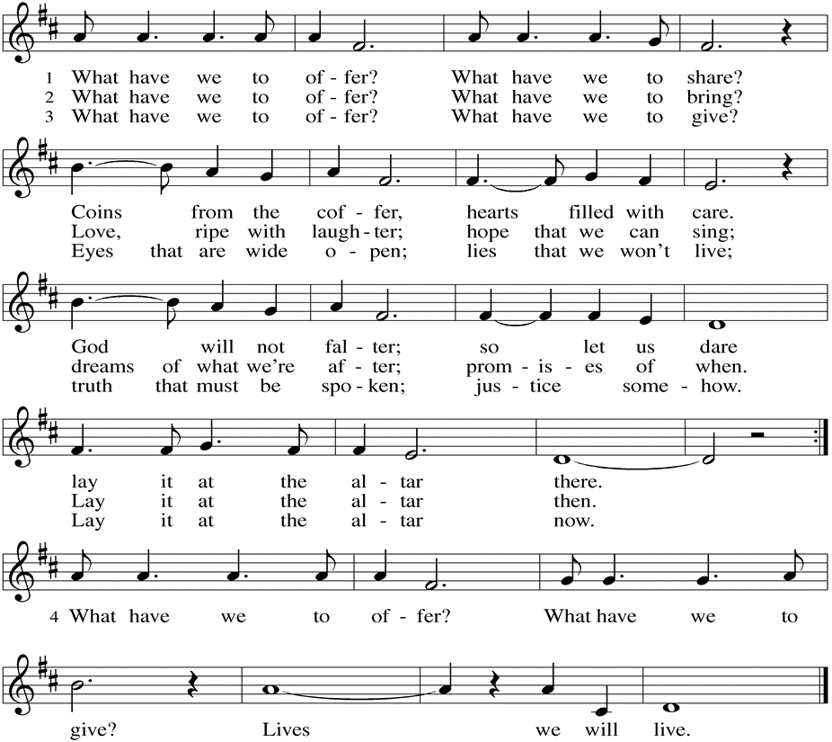
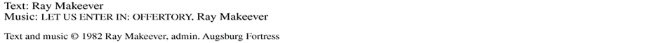

(Usher(s) brings the Tithes and Offerings up front to the Assistant.)

V. We invite you to stand as you are able.

OFFERING PRAYER
V. Let us pray,
Lord of the harvest,
we return to you a portion of what you have given to us.
Turn us to set our hope not on the uncertainty of riches,
but on you, who richly provides for us.
Multiply what we have gathered
to bless all who are suffering and in need,
through Jesus Christ our Lord.
C. Amen.

GREAT THANKSGIVING
V. The Lord be with you.
C. And also with you.

V. Lift up your hearts.
C. We lift them to the Lord.

V. Let us give thanks to the Lord our God.
C. It is right to give him thanks and praise.

V. It is indeed right and salutary that we should at all times and in all places offer
thanks and praise to you, O Lord, holy Father, through Christ our Lord; who rose
beyond the bounds of death and, as he promised, poured out your Spirit of life
and power upon the chosen disciples. At this the whole earth exults in boundless
joy. And so, with the Church on earth and the hosts of heaven, we praise your
name and join their unending hymn:

SANCTUS
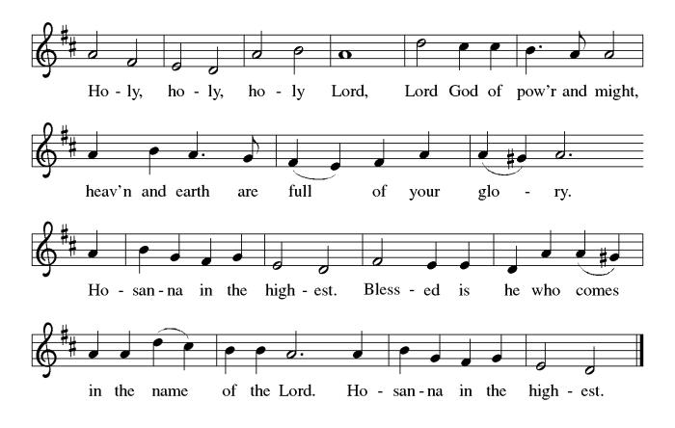

THE EUCHARISTIC PRAYER
V. Blessed are you, Lord of heaven and earth, in mercy for our fallen world you gave
your only Son, that all those who believe in Him should not perish, but have
eternal life. We give thanks to you for the salvation you have prepared for us
through Jesus Christ. Send now your Holy Spirit into our hearts that we may
receive our Lord with a living faith as He comes to us in His holy supper.
C. Amen. Come, Lord Jesus.

V. In the night in which he was betrayed our Lord Jesus took bread,
he gave thanks; broke it, and gave it to his disciples, saying:
Take and eat; this is my body, given for you.
Do this for the remembrance of me.

V. Again, after supper, He took the cup, he gave thanks,
and gave it for all to drink, saying:
This cup is the new covenant in my blood,
shed for you and for all people for the forgiveness of sin.
Do this for the remembrance of me.

SHARING OF THE PEACE
V. May the peace of the Lord be with you always.
C. And also with you.
V. Now, let us share God’s Peace with one another.

(Please respect your neighbor if they desire to still only offer a peace sign or wave.)



(Following the Sharing of the Peace, we invite you to be seated.)

OFFERING
V. We now worship God with our tithes and offerings, wine and bread for use in holy
communion, and monetary gifts to support our ministry for service in God’s name.
Our Ushers will be around to your pews to pass the Offering Plates.

(Ushers come forward to get the Offering Plates from the Assistant.)

(Vicar and Assistant prepare the Altar for Communion.)

Paul Bowker (Church Member)
Virginia Davidson (Vicki Rinier's Family)
BettyAnn & Bill Whitman (Mary Melnicoff's Friends)
Bob Poole (Kathy Poehler's Family)
David Smith (Heather & Vicar Vince Piekarski’s Family)
Joe Smith (Heather & Vicar Vince Piekarski's Family)
Barbara Hoitink (Lucas & Sabrina Munson's Family)
Kathy Raynor (Philomena Noak’s Friend)
The Family & Friends of Miriam Peres de Carvalho (Bob & Maria Fritsch's Family)
The Family & Friends of Kristi Pankratz (David & Renee Jones' Family)
The Family & Friends of Ruth Bruno (Vincent & Anthony Bruno, & Vicar Ken
Bassett's Family)
(Additional Names Added Prior to the Worship Service.)
A. God of grace,
C. receive our prayer.

A. Proclaiming God, you gift the church proclamation through music. We thank you
for all music ministers of this congregation. Transform your church through the
musical arts. God of grace,
C. receive our prayer.

A. Resurrecting God, you crown your beloved children with righteousness. We thank
you for those who have died in faith, fought the good fight, finished the race, and
kept the faith. God of grace,
C. receive our prayer.

(Here other intercessions may be offered.)

V. Watch over all of us who are worried and suffering, and especially those whose
names we now say aloud or hold within our hearts (pause). God of grace,
C. receive our prayer.

V. We offer our prayers, O God, trusting in your everlasting grace and mercy,
through Jesus Christ our Lord.
C. Amen.

THE LORD’S PRAYER
(We ring the bell throughout the Lord’s Prayer at all services to
invite those in the community to join in praying the Lord’s Prayer.)
V. May we now join with one another and pray together as Jesus has taught us.
C. Our Father, who art in heaven, hallowed be thy name, thy kingdom come,
thy will be done, on earth as it is in heaven. Give us this day our daily
bread; and forgive us our trespasses, as we forgive those who trespass
against us; and lead us not into temptation, but deliver us from evil. For
thine is the kingdom, and the power, and the glory, forever and ever.
Amen.

LAMB OF GOD

(We invite you to be seated.)

HOLY COMMUNION
V. Communion here is pretty simple, and all who are baptized and believe in Jesus
Christ are welcome at the table.

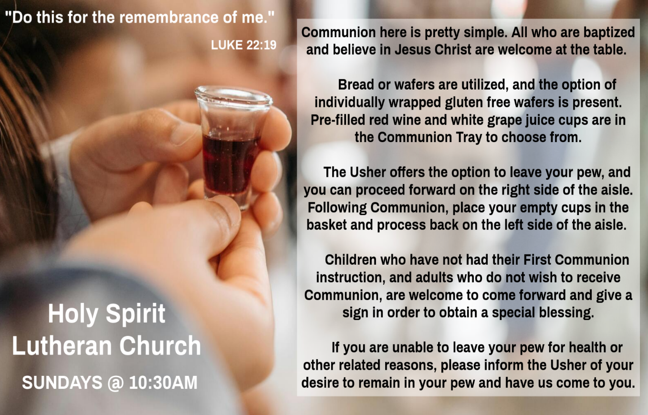

INVITATION TO COMMUNION
V. Jesus welcomes sinners and eats with them.
Come to this meal of mercy.
C. Amen.

(Distribution of Holy Communion)

COMMUNION HYMN
(Please enjoy various music offered by our Organist during your
quiet time, prayer, and reflection following Holy Communion.)

(Vicar and Assistant remove Communion Vessels from the Altar.)

V. We invite you to stand as you are able.
Mary Skain (Kathy Poehler's Friend)
Robert Chaplin (Mary Melnicoff's Friend)
Jack Wieckouski (Theresa & Kim McGinley's Family)
Carolyn Santarpio (Bob Fritsch's Friend)
Harry (Judy Brannan's Friend)
Janet K (Philomena Noak's Friend)
Michael Hart (Diana DeNote's Friend)
Rocco Leonard DeNote (Diana DeNote's Family)
Al Singer & Family (Frank Ford's Friends)
Sherri Lynn (Bob Fritsch's Friend)
John Bannco (Bob Fritsch's Friend)
Nancy Pazarinie (Bob Fritsch's Family)
Jane & Paul Eiben (Rose Lang's Friend)
Joe DiMassimo (Judy Brannan & Mary Melnicoff's Friend)
Tommy Stanford (Sue Waltz's Family)
Audrey McAlister (Sue Waltz's Family)
Joe Waltz (Sue Waltz's Family)
Denny Papst (Rose Lang’s Friend)
Mike & Alice Rhoades (Rose Lang’s Friends)
Chris (Judy Brannan's Friend)
Helen Ehlers (Judy Brannan's Friend)
Hailey (Fran Green's Friend)
Leanne Bueth (Joan Kilcoyne's Family)
Janett MacFarlane (Carol Amundsen's Friend)
Patrick Davenport (Sue Waltz's Friend)
Thish Kelly (Theresa & Kim McGinley's Family)
Edward Chapleski (Allison Call's Family)
Scott Levin (Rose Lang's Friend)
Lynne Curlett (Del McKenna's Family)
Alice Ann Dennis (Diana DeNote's Family)
Nancy Taylor (Ted & Diane Bell's Family)
Santa Isabel Lutheran Church (Elizabeth, NJ)
Messiah Lutheran Church (Oakland, NJ)
Carol Brand (Skip & Bonnie Millard’s Friend)
Joyce Thompson (TDPWC Member)
Barbara Paynter (Leon Stitt’s Family)
Ruth (Anthony & Vincent Bruno's Family)
Tom M (Philomena Noak's Family)
William T Hodgetts (Pastor William Hodgetts’ Family)
A. Sustaining God, you create all the beauty around us. We give you thanks for the
harvest of your creation. Restore creation as the seasons change. God of grace,
C. receive our prayer.

A. Governing God, you bring peace and justice through mercy. Guide judges,
lawmakers, attorneys, and those in any authority to act with compassion and
understanding. God of grace,
C. receive our prayer.

A. Healing God, you comfort those who suffer. Console people whose lives are
disrupted by cancer, disease, and illness. Bring your healing mercy to any in
need; especially:
BettyAnn Rich-White (Church Member)
Chip & Marie Hand (Church Members)
Lynn Bargstadt (Church Member)
Frank Ford (Church Member)
Carol Amundsen (Church Member)
Kim McGinley (Church Member)
Anthony DeLuca (Church Member)
Frank Brunner (Church Member)
Joan Sommerman (Church Family)
Arleen Kinka (Church Family)
Rick Lang (Church Family)
Suzie Clark (Rose Lang's Friend)
Francis Clock (Dianna DeNote’s Family)
Andrew Hudak (Rose Lang’s Friend)
Viena Murtha (Bob Fritsch’s Friend)
Sharon Waicus (Skip & Bonnie Millard's Friend)
Karen O'Brien (Paul Bowker's Friend)
Dustin Irizzary (Mary Melnicoff's Family)
The Bryan Family (Wanda Bryan's Family)
Craig Brearey (Judy Brannan & Mary Melnicoff's Friend)
Sarah Dutton (Frank Ford's Family)
Christina McNasby (Fran Green’s Family)
The Kinkson Family (Judy Brannan's Friends)
Mark Stephen Dennis (Diana DeNote's Family)
Bill Lodge (Skip & Bonnie Millard's Friend)
Ron Anderson (Bill Kelly's Friend)
Bud Brearey (Judy Brannan & Mary Melnicoff's Friend)
POST COMMUNION BLESSING
V. May the body and blood of our Lord Jesus Christ strengthen us and keep us
always in His grace.
C. Amen.

POST COMMUNION CANTICLE
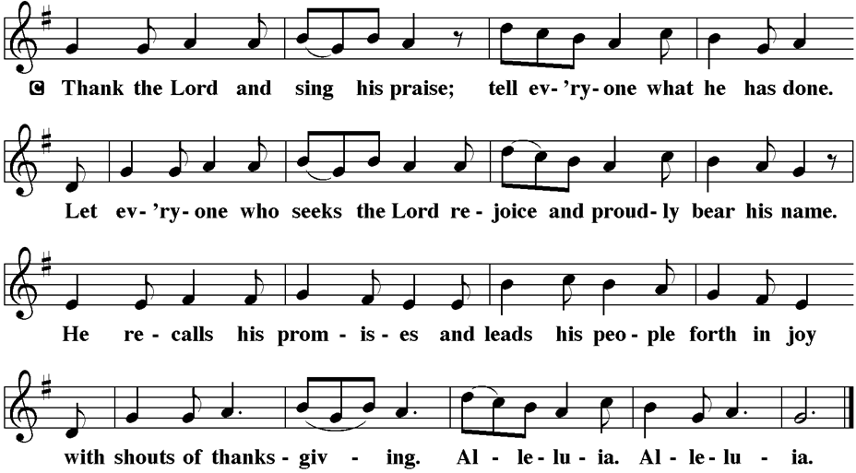

PRAYER AFTER COMMUNION
A. Let us pray,
O God,
through this meal you have strengthened us
and appointed us to be your servants.
Send us to do good and to share our possessions
with all in need.
We ask this in Jesus’ name.
C. Amen.

BLESSING
V. The God of righteousness,
who gives justice to the oppressed,
who gives food to the hungry,
who sets the prisoners free,
☩ bless you now and forever.
C. Amen

SENDING HYMN
(We invite you to sing along.)
Lutheran Book of Worship—Green Book
369—The Church's One Foundation

(Assistant extinguishes the Altar Candles half way through the Sending Hymn.)

(Vicar processes out once the Altar Candles have been extinguished.)

(We invite you to be seated.)

BIRTHDAYS, ANNIVERSARIES, & ANNOUNCEMENTS
(Offered by Assistant and Congregation.)

ANNIVERSARY
26th Bonnie & Skip Millard

DISMISSAL
A. Go in peace. Do not lose heart.
C. Thanks be to God.

POSTLUDE
(Music offered by our Organist as we depart following our Worship Service.)
We Shall Behold Him

LICENSES & EXPIRATION DATES
Worship Service Content is used via permission through Augsburg Fortress Liturgies Annual License #SB144368. The next Subscription Renewal Date is 2/28/2026.
Our Hymns and Worship Music are used via permission through CCLI One
License #11327166. The next Subscription Renewal Date is 1/31/2026.
APOSTLES’ CREED
V. God has indeed made us his people through our Baptism into Christ. Living
together in trust and hope let us confess our faith together using the Apostles’
Creed.
C. I believe in God, the Father almighty,
creator of heaven and earth.

I believe in Jesus Christ, God’s only Son, our Lord,
who was conceived by the Holy Spirit,
born of the Virgin Mary,
suffered under Pontius Pilate,
was crucified, died, and was buried;
he descended to the dead.
On the third day he rose again;
he ascended into heaven,
he is seated at the right hand of the Father,
and he will come to judge the living and the dead.

I believe in the Holy Spirit,
the holy catholic church,
the communion of saints,
the forgiveness of sins,
the resurrection of the body
and the life everlasting.
Amen.

PRAYERS OF INTERCESSION
(The prayers are prepared locally for each occasion.)
V. Renewed in God’s everlasting grace, let us pray for the church, the world, and all
creation.

(A brief silence.)

A. Uniting God, you draw your church together as the one body of Christ. Bring
congregations into conversation and dialogue so the church is transformed and
reformed in your abundant grace. God of grace,
C. receive our prayer.

GOSPEL READING
The coming reign of God will involve unexpected reversals of fortune with
judgment rooted in mercy. Jesus tells a parable in which the one who humbles
himself is exalted and the one who exalts his own righteousness is humbled.

V. The Holy Gospel According to Luke, the 18th Chapter (Verses 9-14).
C. Glory to you, O Lord.

V. 9 [Jesus] also told this parable to some who trusted in themselves that they were
righteous and regarded others with contempt:10 “Two men went up to the temple
to pray, one a Pharisee and the other a tax collector. 11 The Pharisee, standing
by himself, was praying thus, ‘God, I thank you that I am not like other people:
thieves, rogues, adulterers, or even like this tax collector. 12 I fast twice a week; I
give a tenth of all my income.’ 13 But the tax collector, standing far off, would not
even lift up his eyes to heaven but was beating his breast and saying, ‘God, be
merciful to me, a sinner!’ 14 I tell you, this man went down to his home justified
rather than the other, for all who exalt themselves will be humbled, but all who
humble themselves will be exalted.”

V. This is the Gospel of the Lord,
C. Praise to you, O Christ.

(We invite you to be seated.)

SERMON
(Delivered by Vicar Vince Piekarski.)

V. We invite you to stand as you are able.

HYMN OF THE DAY
(We invite you to sing along.)
Lutheran Book of Worship—Green Book
507—How Firm a Foundation


CONFIRMATION & SUNDAY SCHOOL
“Here We Stand” allows our young folks to go through a 2-year process while focusing on the Bible and Luther’s Small Catechism. We resumed year two of our studies together earlier TODAY, Sunday, October 26th, from 9-10AM.

WORSHIP MINISTRY
The most important thing we do each week is gather together as God's people to Worship. God is the center and focus of everything we do. Participating in Worship is active, as Liturgy means the work and actions of the people gathered. Everything we do during the week to prepare for Worship, and everything we do as we Assist in leading Worship is important. We are thankful for all the wonderful work being done. If you have questions, or are interested in any position, reach out to Vicar Vince.
Sign-up sheets are located on the bulletin board between the church offices.

CLINICAL PASTORAL EDUCATION
Vicar Vince has been blessed with the opportunity of joining Chaplain Stephen Faller on-line for CPE classes on Sunday afternoons from 4PM-8:30PM on Zoom. Please be respectful of this if you happen to see his car at the church.

FOOD PANTRY
Open every Thursday, and the last Saturday of every month, from 10AM to 1PM. 59 people were served in September and 485 people have been served in 2025. Donations can be dropped in the outdoor drop-box, in the money jug in the back of the Church, mailed into the Church Office, or placed in the Offering Plate. Volunteers are needed. Sign-up sheets are located on the bulletin board between the church offices. If you have questions or need training see Heather, Vicar Vince, or Bonnie.
A special thank you goes out to all who donate, pray, and help in any way!

Thursday, 10/30 | Thursday, 11/6 | Thursday, 11/13
Tori & Bob | Garnet, Kim, & Theresa | Garnet & Cathie
COMMUNITY FOOD DONATIONS, DELIVERIES, & MORE
Our local North Cape May Acme provides us with Expiring Soon, Recently Expired, and Slightly Damaged Food and Items weekly. Kathy helps those in need by delivering items each Saturday in the community, brings leftover items to the Church for church members in need, and those who visit the food pantry during the week. Additional items are taken over to the Branches Outreach in Rio Grande on Monday.


We have another awesome opportunity to combat food insecurity with Thrivent! We were approved for $250 of seed money, and have collected 500 items. We have qualified for an extra $500. Let’s keep collecting items until October 31st.

BULLETIN ENTRY DEADLINE
The Bulletin is Printed on Thursdays during Church Office Hours. Changes need to be submitted to Vicar Vince or Heather no later than Thursday by 4PM. Thank you!

CHURCH OFFICE HOURS
Open Thursdays from 6PM to 8PM to serve the Congregation, the Community,
and to continue handling the business of the Church. Feel free to stop in to talk,
pick-up or drop off something, pray in the Sanctuary, or for whatever reason.

DONATION STATION
Get on the train and place all purchased items in the specified project donation bins located on the counter by the front doors. See Heather for more information.


Please join us NEXT, Sunday, November 2nd for our All Saints Sunday Worship Service. Please add names to the All Saints List hanging on the bulletin
board between the church offices, or you can call or email Vicar Vince. We want to
make sure that we honor the memory of those loved ones that have passed away
since last year’s All Saints Sunday during our Worship Service.
R. 5 Happy are the people whose strength is in you,
whose hearts are set on the pilgrims’ way.
6 Those who go through the balsam valley will find it a place of springs,
for the early rains have covered it with pools of water.
7 They will climb from height to height,
and the God of gods will be seen in Zion.
C. Happy are the people whose strength is in you. (Ps. 84:5)

SECOND READING
The conclusion of this letter to a young minister offers a final perspective on life
from one who faced death. Though others let him down, Paul was sure of his
faith in the Lord, who stood by him and lent him strength.

R. Our Second Reading is from the 4th Chapter of 2nd Timothy (Verses 6-8, 16-18).

R. 6 As for me, I am already being poured out as a libation, and the time of my
departure has come. 7 I have fought the good fight; I have finished the race; I
have kept the faith. 8 From now on there is reserved for me the crown of
righteousness, which the Lord, the righteous judge, will give me on that day, and
not only to me but also to all who have longed for his appearing.

16 At my first defense no one came to my support, but all deserted me. May it not
be counted against them! 17 But the Lord stood by me and gave me strength, so
that through me the message might be fully proclaimed and all the gentiles might
hear it. So I was rescued from the lion’s mouth. 18 The Lord will rescue me from
every evil attack and save me for his heavenly kingdom. To him be the glory
forever and ever. Amen.

R. This is the Word of the Lord.
C. Thanks be to God.

V. I invite you to stand as you are able, and I invite you to announce the Gospel
Acclamation with me.
GOSPEL ACCLAMATION
C. Alleluia. All who exalt themselves will be humbled, but all who humble
themselves will be exalted. Alleluia. (Luke 18:14)

now he will remember their iniquity
and punish their sins.

19 Have you completely rejected Judah?
Does your heart loathe Zion?
Why have you struck us down
so that there is no healing for us?
We look for peace but find no good,
for a time of healing, but there is terror instead.
20 We acknowledge our wickedness, O Lord,
the iniquity of our ancestors,
for we have sinned against you.
21 Do not spurn us, for your name’s sake;
do not dishonor your glorious throne;
remember and do not break your covenant with us.
22 Can any idols of the nations bring rain,
or can the heavens give showers?
Is it not you, O Lord our God?
We set our hope on you,
for it is you who do all this.

R. This is the Word of the Lord.
C. Thanks be to God.

PSALM
R. Our Responsorial Psalm is from the 84th Psalm (Verses 1-7).
C. Happy are the people whose strength is in you. (Ps. 84:5)

R. 1 How dear to me is your dwelling,
O Lord of hosts!
2 My soul has a desire and longing for the courts of the Lord;
my heart and my flesh rejoice in the living God.
3 Even the sparrow has found a home, and the swallow a nest where she may
lay her young,
by the side of your altars, O Lord of hosts, my king and my God.
4 Happy are they who dwell in your house!
They will always be praising you.
C. Happy are the people whose strength is in you. (Ps. 84:5)
WOMEN OF THE CHURCH
The next monthly meeting will be on Monday, November 3rd, at 6PM.
New members are always welcome to attend! Contact Judy for more information.

BIBLE STUDY & FAITH DISCUSSIONS
Bible Study & Faith Discussions was started in order to focus on various readings,
books, Bible verses, people of faith, and other general topics. Group Members offer
various points of view while reviewing the Bible and various aspects of faith while
being respectful and supportive of each other. We are off this upcoming Tuesday, October 28th, due to Vicar Vince attending a Celebration of Life Service. We will resume our group on Tuesday, November 4th. Come join us at 6PM.

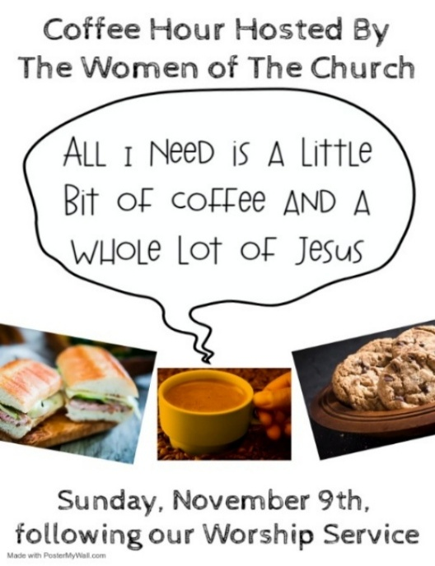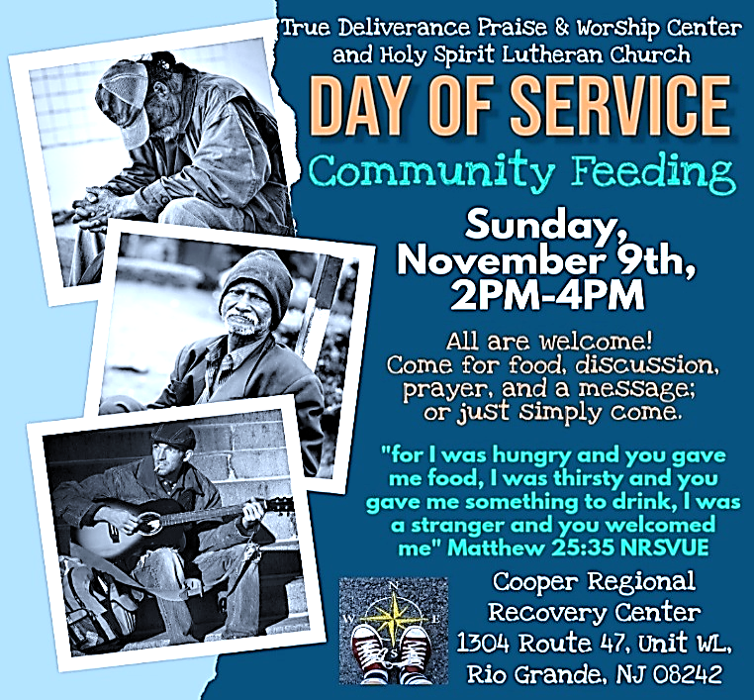

PREACHING AT BROOKDALE
Vicar Vince preaches at Brookdale Senior Living in Cape May Court House again on Sunday, November 16th, at 1PM. Holy Communion will follow the service.

CHURCH COUNCIL
Share your comments, concerns, questions, or joys with one of our Church Council Members who can bring them back to our meetings. Visitors are always welcome to attend and listen to what is going on in and around the church. Join us In- Person or on our Conference Call at our next Meeting on Tuesday, November 18th, at 6PM.
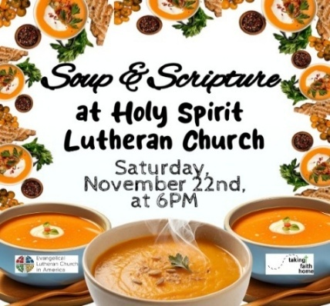

INTINCTION DURING COMMUNION
Intinction while communing together will occur in the months that have a fifth Sunday. If you have any questions please see Vicar Vince. Our next time doing this will be on Sunday, November 30th, during our 10:30AM Worship Service.

PRAYER LIST
Our Prayer List continues to lengthen and we realize the important need for prayers and healing. Sometimes the unfortunate result is that someone has passed away, and the words “The Family & Friends of” appear before someone’s name. However, sometimes we forget names are still on the list and their health has improved or the they are no longer struggling, and they can be removed. Please share the good and bad stories as we continue to pray for strength and healing. Names can be added or removed from the list on the clipboard in the Narthex prior to the Worship Service, by calling the church office, or addressing it on the Conference Call. Please let us know the relation to the person(s) you listed so we can be more mindful with our prayers. Names will stay on the list until removed by the person(s) who requested prayer.

PRAYER SHAWL MINISTRY
Prayer Shawls, Lap Quilts, Scarves, and other items have been made with love. Blessed items are located in the Narthex, and are free for anyone. Members of the group continue working at home on new stitches and patterns. We are blessed to be able to continue collecting new items. We have a donation station of yarn and other items located in the Narthex. You can find some new supplies for your next creation!

HOME COMMUNION MINISTRY
A Minister is available if you have a loved one, or if you desire services. We look forward in sharing the Word and Holy Communion! Please inform Vicar Vince, Kathy, or the Church Office so plans can be made for visits.
PRAYER OF THE DAY
V. The Lord be with you.
C. And also with you.

V. Let us pray,
Holy God, our righteous judge, daily your mercy surprises us with everlasting
forgiveness. Strengthen our hope in you, and grant that all the peoples of the
earth may find their glory in you, through Jesus Christ, our Savior and Lord.
C. Amen.

(We invite you to be seated for our Readings and Psalm.)

FIRST READING
In a time of drought, the people pray for mercy, repenting of their sins and the
sins of their ancestors. They appeal to God to remember the covenant, to show
forth God’s power, and to heal their land by sending life-giving rain.

R. Our First Reading is from the 14th Chapter of Jeremiah (Verses 7-10, 19-22).

R. 7 Although our iniquities testify against us,
act, O Lord, for your name’s sake;
our rebellions indeed are many,
and we have sinned against you.
8 O hope of Israel,
its savior in time of trouble,
why should you be like a stranger in the land,
like a traveler turning aside for the night?
9 Why should you be like someone confused,
like a mighty warrior who cannot give help?
Yet you, O Lord, are in the midst of us,
and we are called by your name;
do not forsake us!

10 Thus says the Lord concerning this people:
Truly they have loved to wander;
they have not restrained their feet;
therefore the Lord does not accept them;

HYMN OF PRAISE
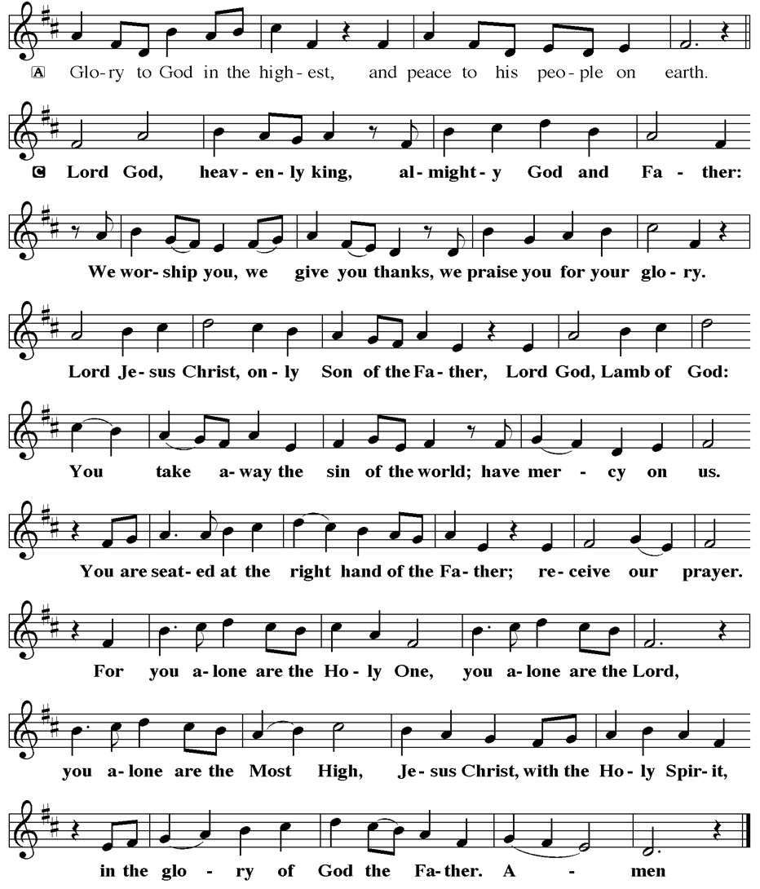
TITHES, OFFERINGS, & ENVELOPES
2025 Offering Envelopes are available. Please see Heather if you have not received yours, or would like to have some. For we do indeed worship God with our tithes and offerings. We hear this in scripture, “Each of you must give as you have made up your mind, not reluctantly or under compulsion, for God loves a cheerful giver.”
(2 Corinthians 9:7) Feel free to drop your envelopes in the offering plate, mail them to the church, or drop them off in the locked mailbox. Thanks for your continued support in the mission of our church, its ministries, the NJ Synod, and other needs!

ED GREEN CAPITAL IMPROVEMENT FUND
We continue raising money for unforeseen costs or repairs. Kathy sells Wawa Tickets for $6, the donation bin is in the back of the church, and we have our Annual Church Rummage Sale. Thanks for your continued donations, prayers, and support!

SPACE AVAILABLE
​​​​​Do you know anyone interested in utilizing our Fellowship Hall for a Party or Event?
It is a suggested $50 refundable security deposit, and $250 for facility use. There is no alcohol or games of chance permitted due to ELCA policy. Please contact Vicar Vince or the Church Office with questions, for info, or to reserve a date and time.

FAVORITE HYMNS
Carol is willing to play some of your favorite hymns for the Prelude & Postlude each Sunday during our Worship Service. Feel free to let her know of your suggestions.

INTERESTED IN BECOMING A NEW MEMBER
Have you been attending our church for a while? Have you just recently returned to church after being away for a bit? Maybe you transitioned from another church,
or just started to recently attend our church. We are glad to have you, and would love to have you as a member of our Congregation. See Vicar Vince for more info.

BAPTISM
We are a church whose unity is in Jesus Christ, who gathers us around word and water, wine and bread. Baptism is a significant part of our faith journey as we come from the baptismal waters to live a new life as children of God. Our baptism sets us out on a lifelong journey that is characterized by our relationship to God, our relationship to our faith community, our relationships in our community and the wider world. Living our baptismal covenant means living a life of growth in the faith practices of discipleship. Please see Vicar Vince for more information.
FIRST COMMUNION
Although no particular age for first communion is prescribed by The Use of the Means of Grace, one guideline is offered. Because admission to the Sacrament is by invitation of the Lord to the baptized, "baptized children begin to commune on a regular basis at a time determined through mutual conversation that includes the pastor/vicar, the child, and the parents or sponsors involved, within the accepted practices of the congregation.” Each congregation is encouraged to ask the question of readiness for first communion, establish their own policies regarding age and practice, and accompany that practice with catechesis appropriate to the age of the communicant. If anyone has questions, please see Vicar Vince.

2025 CHURCH DIRECTORY
Additional copies are by the Church Office on the bookshelves. We continue keeping it updated and undoubtedly miss a few changes or have made a few errors. There are spaces for changes in info, new people’s info, notes, and your favorite Bible verses. Please continue to inform the Church Office of any changes or updates.

LIBRARY
New books are added to our library from time to time. Several are borrowed and read and exchanged. Who knows, you might find one particularly interesting and share that with someone as well. Reading is a great way to pass spare time, learn, and explore. You may find some fresh ideas for prayer, ways to grow more spiritually, ways to grow closer to God, or some opportunities to understand our faith more. Visit the library between the church offices and see what books are there!

We also have an extended library located in Vicar Vince’s office. There are Bibles of various translations, books from his personal collection, books inherited from Pastor Leah, movies, past Bible Study Curriculums, and more. Just ask to check things out!

TAKING FAITH HOME
Vicar Vince was introduced to Milestones Ministries weekly guides for faith-filled studies and conversations through a Seminary class. A decision was made to pass these along to you. If you missed a week, or lost your insert, check our website for past issues. Feel free to ask questions and provide feedback to Vicar Vince.

NEWSLETTER
Collect information, stories, pictures, and reports for our next seasonal publication. Submit everything to Vicar Vince in-person or via email at vpie8282@gmail.com.

APOSTOLIC GREETING
V. May the grace of our Lord Jesus Christ, the love of God,
and the communion of the Holy Spirit be with you all.
C. And also with you.


V. In peace, let us pray to the Lord.
C. Lord, have mercy.

V. For the peace from above, and for our salvation, let us pray to the Lord.
C. Lord, have mercy.

V. For the peace of the whole world, for the well-being of the church of God,
and for the unity of all, let us pray to the Lord.
C. Lord, have mercy.

V. For this holy house, and for all who offer here their worship and praise,
let us pray to the Lord.
C. Lord, have mercy.

V. Help, save, comfort, and defend us, gracious Lord.
C. Amen.
V. Merciful and loving God,
C. we are your stiff-necked people.
We trample on the needy.
We grumble about your grace to others.
We turn away from the poor.
Have mercy on us and forgive our sins.
Rejoice over us as ones who were lost
and have been found.
Amen.

V. Even when we are faithless, God remains faithful.
Jesus Christ came into the world to save sinners.
You who were lost have been found.
In the name of ☩ Jesus, your sins are forgiven!
C. Amen.

GATHERING HYMN
(We invite you to sing along.)
Lutheran Book of Worship—Green Book
229—A Mighty Fortress Is Our God

JERSEY JOTTINGS
Weekly e-newsletter connecting our synod together with weekly prayer, upcoming events, synod and churchwide activities, mission stories, congregational activities, and more. Sign up https://www.njsynod.org/stay-connected or download the app.

VICAR APPOINTMENT ON MARCH 19TH, 2023
A Memorandum of Understanding on the Matter of Pastoral Appointment
In Theological Education for Emerging Ministries (TEEM) Candidacy
TO: Congregation Council, Holy Spirit Lutheran Church, Villas
FROM: The Rev. Tracie L. Bartholomew, Bishop, New Jersey Synod

Dear Brother and Sisters in Christ,
This memorandum is in support of your discussions with Vincent Piekarski as pastor of Holy Spirit, Villas. Because this is not the usual pattern for completing the educational and candidacy requirements for ordination, it is my hope that this memorandum will both provide guidelines and engage in conversation with those who are invested in this process.

I would say at the outset that because Vincent is an outstanding candidate for the Ministry of Word and Sacrament, we will all want to do whatever is necessary to assure that his placement serves the mission of the church in the best possible fashion.

The following notes reflect my own understanding of this matter:
(1) The appointment for Vincent will begin on April 1, 2023. At this time, Vincent
will assume all responsibilities of a regularly called pastor, including presiding at
the Sacrament of Holy Communion and Baptism at Holy Spirit, Villas.
(2) A pastoral appointment in the TEEM process is an option for completing
seminary educational requirements and the steps of the candidacy process.
Upon completion of the candidacy process and seminary education, the
candidate may receive and accept a call to ordained ministry from the
congregation where the appointment is being served.
(3) This appointment is jointly supervised by the Office of the Bishop and the TEEM
pastor’s seminary. A mentoring relationship with a local pastor is required for the
length of this appointment.
(4) The synod of candidacy origin will be responsible for the approval process.
(5) Upon approval for ordination, the congregation would be expected to extend a
call to the pastoral appointee.
(6) Compensation for the TEEM pastor will be according to the guidelines of the New
Jersey Synod. All normal forms of compensation should be in place for the term
of the appointment, including stipulation that base salary and housing shall be in
accord with synod guidelines for first call at time of ordination.
(7) The ELCA Portico benefit plan for lay persons in full-time church service should
be used for the pastoral appointee up to the time of ordination, whereupon the
benefit package is to be converted to the plan for ELCA clergy.
(8) A decision for Pastoral Appointment is made with the agreement of a synod and
its candidacy committee, and the ELCA, normally represented by the regional
staff person of each in consultation with the seminary and its Director for
Contextual Education.
(9) Pastoral Appointment in a TEEM Candidacy is an option that is to serve the
mission of the Church in a particular and vital way and is not to be viewed or
used as a means to circumvent the normal candidacy process and/or first call
placement process.

In the specific case of Vincent, the New Jersey Synod remains responsible for the candidacy and approval process, and has agreed to this proposal for Appointment at Holy Spirit, Villas.

Continued blessings to both Holy Spirit and Vincent Piekarski as you embark on this journey of mutual ministry. As partners in ministry, we walk with you and rejoice in this new relationship.

VICAR VINCE’S DAY OF REST
A day of rest can have physical, mental, and spiritual beneficial. “Mittwoch,” German for mid-week, or Wednesday, is the day that Vicar Vince will use to recharge and do some other things. Please do not hesitate to reach out if there is an emergency!

VICE PASTOR UPDATE
Pastor William Hodgetts attends Council and provides Supervision for Vicar Vince.

TRUE DELIVERANCE PRAISE & WORSHIP CENTER
Reverend Maria Brooks and True Deliverance Praise & Worship Center utilize our facilities from 1-4PM on Sundays. TDPWC hosts or assists with other events throughout the year. TDPWC hosts a Prayer Line on Mondays, Wednesdays, & Fridays at 5PM on the Conference Call 1-657-390-7957; & Bible Study on Thursdays at 6:30PM on Zoom. See Rev. Brooks for more information.
CONFERENCE CALL CHECK-IN
(Roll Call and Attendance.)

WELCOME & ANNOUNCEMENTS
(Vicar (V), Assistant (A), Reader (R), and Congregation (C).)

INTRODUCTION
A. Genuine repentance and pretentious piety stand in stark contrast in the gospel
and all around us. All creation stands in need of God’s forgiveness. Keep the
faith. God’s people shall be accounted righteous for Jesus’ sake. Our God is
merciful to sinners. For this we worship and glorify God forever.

PRELUDE
(Music offered by our Organist at the start of our Worship Service.)
Shall We Gather At The River

CHIMES
(Music offered by our Organist at the start of our Worship Service.)
Jesus Loves Me

V. We invite you to stand as you are able.

CONFESSION & FORGIVENESS
(All may make the sign of the cross, the sign that is marked at baptism.)
V. Blessed be the holy Trinity, ☩ one God,
our maker, our helper, and our keeper.
C. Amen.

V. Trusting in God’s mercy, let us confess our sin
in the presence of God and of one another.

(Silence is kept for reflection.)


We, the Evangelical Lutheran Church of the Holy Spirit, are People of God, who
are called by the Holy Spirit to pray, worship, joyfully proclaim Jesus Christ,
and compassionately witness and serve others in Christian Love.


We are glad that you joined us for Worship today! Thank you for enriching our time together! We would like to get to know you better, and for you to get to know us better too. Brochures, welcome gifts, prayer shawls, Bibles, and other items are available throughout the church. We would be happy to show you around and share about our ministries. Please do not hesitate to speak up and ask questions.
Also, please make sure you sign-in on our clipboard on the podium in the lobby.


Our Worship Services are conducted in coordination with our Conference Call.
Join us at 657-390-7423 or 701-802-5170, with access code 8221190#.
You may need to dial 1 first depending on your phone plan. After logging in please announce your name and feel free to talk with others until we get started.


SANCTUARY CANDLE FOR OCTOBER
Given to the Glory of God & In Memory of GARY WALTZ
by Loving Family, Sue Waltz, Shutter’s Dougherly, & DeJesus.
ALTAR CANDLES FOR OCTOBER
Given to the Glory of God & In Memory of JOAN NASH by Jean Zimmerman.
ADDITIONAL OFFERINGS FROM OUR NEIGHBORS
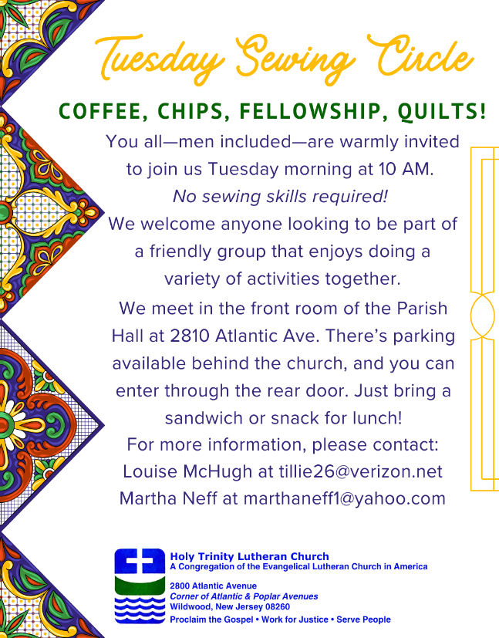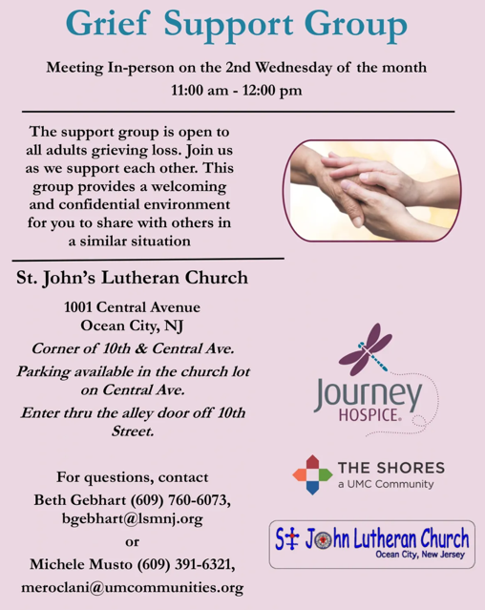

ST. BARNABAS CARES THRIFT STORE
Are you a person who enjoys staying active, interacting with others, likes the flexibility of working an hour or two per month and would like to support a good cause? If so, then St. Barnabas Cares Thrift Store is looking for you! The store in the Villas is looking for friendly, outgoing people to volunteer and sell clothing. There is no heavy lifting, but instead you would be arranging clothing attractively for sale. The Thrift Store is open 11-3 Monday through Saturday so even volunteering a few hours a month will help. If interested, please call Maureen Kersch 609-425-1317.

JUST FRIENDS
Promotes a spirit of fellowship among adults 50 years and older. Bring your own lunch to enjoy, beverages and deserts are provided. Everyone is welcome regardless of faith or parish affiliation. The group meets in Our Lady Star of The Sea Parish Hall on the last Wednesday of the month from 12Noon to 2PM from September through May. For more info call Martine Simonis 609-884-5312 x 110.
EVANGELICAL LUTHERAN CHURCH IN AMERICA & NJ SYNOD
Formed in 1987 by the merger of three Lutheran Church bodies – the ALC (American Lutheran Church), the LCA (Lutheran Church in America), and the AELC (Association of Evangelical Lutheran Churches). Learn more at www.elca.org.

The New Jersey Synod is a geographical grouping of Evangelical Lutheran Church in America (ELCA) congregations sharing mission and ministry. It is one of 65 synods comprised of 143 congregations with over 45,000 baptized members.

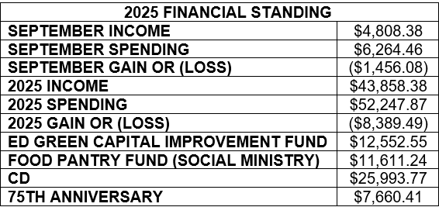

CHURCH STAFF & VOLUNTEERS
VICAR, BIBLE STUDY & FAITH DISCUSSIONS, NEWSLETTER, & WEBSITE
Vicar Vince Piekarski
VICE PASTOR
Pastor William Hodgetts
ORGANIST & PIANIST
Carol Amundsen
CHURCH OFFICE, SUNDAY SCHOOL, & FOOD PANTRY
Heather Piekarski
CHURCH COUNCIL PRESIDENT
Mary Melnicoff
CHURCH COUNCIL VICE PRESIDENT
Judy Brannan
CHURCH COUNCIL TREASURER
Bonnie Millard
CHURCH COUNCIL SECRETARY
Vicki Rinier
CHURCH PROPERTY
Frank Ford & Wayne Rand
WELCOME TO
HOLY SPIRIT LUTHERAN CHURCH
A Member of the Evangelical Lutheran Church in America, New Jersey Synod
1220 Bayshore Rd., Villas, NJ 08251, 609-886-2414,
holyspiritlutheran@comcast.net, holyspiritvillas.com, facebook.com/holyspiritvillas
Vicar Vince Piekarski can be contacted at any time for conversation or prayer through call or text at 412-225-0287, or through email at vpie8282@gmail.com.
SUNDAY, OCTOBER 26TH, 2025
20TH SUNDAY AFTER PENTECOST / REFORMATION SUNDAY
10:30AM WORSHIP SERVICE WITH HOLY COMMUNION 