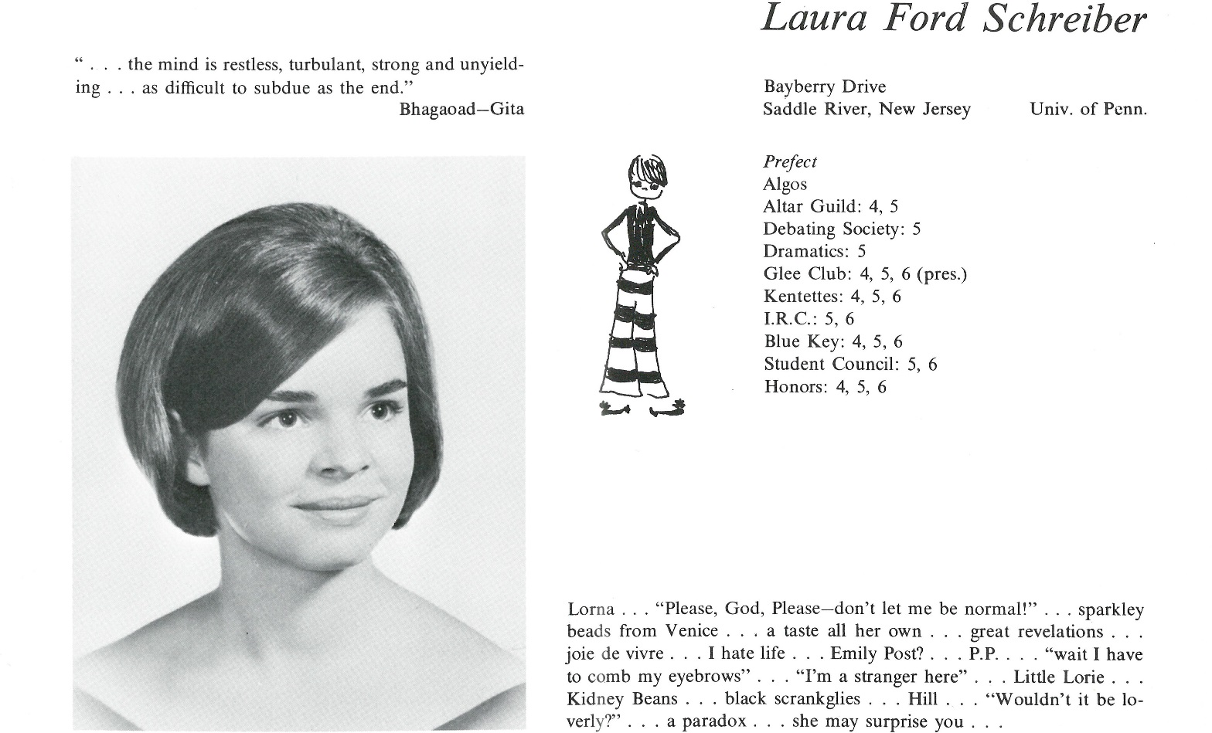

Laura F. Schreiber Washburn

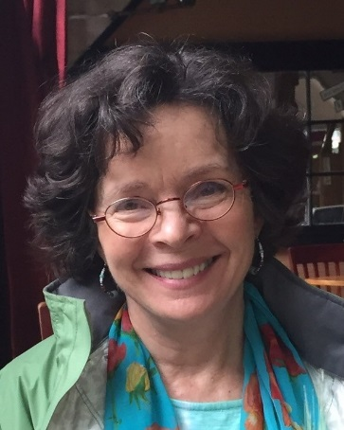Hello, Kent friends:

These days I'm working as a therapist, with a private practice in Amherst, Massachusetts. I feel lucky to have discovered this profession after a previous career in freelance writing and editing. After college on the East Coast and a year of working in a publishing house in New York, I got a Master's degree in creative writing (poetry) at Stanford, which resulted in my living in San Francisco for the next five years.

After my coursework at Stanford was over, I had a little apartment on Russian Hill, on Macondray Lane, a quiet footpath. I worked as a paralegal to pay my monthly rent of $250. These were great years, ending (not tragically) with a fire in my apartment building and the end of a relationship, and my moving back East. I went to Boston, where I met my husband David Washburn, through our mutual friend Edie Read. David was soon to take a job with a UN agency in Geneva, Switzerland, and he invited me to go along. We got married in Geneva, and lived there for the next two years.

Returning to the US, we settled in "Western Mass," so-called because it's a different culture, more rural and laid-back than the eastern part of the state. We had two boys: Taylor, who now works as a lawyer in Seattle, and Owen, who works in the philanthropy department of a bank in Chicago. We wish they were closer, but they're doing well.

When the kids were young I had writing and editing jobs until, at 48, I went back to school in social work, and became a therapist. This work is actually closer to writing poetry than journalism, I discovered, because it focuses on a deeper part of life. It's rewarding to work with people on what is most important in their lives.

My two sisters both went to Kent--Susan, '65 and Kathy, '72. During these years of social upheaval, life at Kent, as everywhere, was rapidly changing, and for this reason Kent was a very different experience for each of them. We in the class of '67 were somewhere in the middle, but would go off into another world entirely.

I've traveled quite a bit in my life--to Rwanda, to Bali and also to Europe numerous times. Bebe Deming, Cynnie Keller, Susie Sutherland and I were all in Paris at the same time, spring term of our sophomore year in college. I'm back in Switzerland now, on vacation, as I write this--it seems I can't get enough of the Alps.

Life is challenging, of course, but full of joy as well. I think in getting older that we do develop wisdom, bit by bit. Today, to my good fortune, Edie, Bebe and Cynnie are still among my closest friends. Kent gave me the chance to get to know many wonderful people well, which was the best part of my experience there.



______________________________________________________________

______________________________________________________________ ______________________________________________________________ ______________________________________________________________ ______________________________________________________________ ______________________________________________________________ ______________________________________________________________ ______________________________________________________________ ______________________________________________________________

Attach Picture in .jpg Format

______________________________________________________________

______________________________________________________________

___________________________________________________________________________________ _________________________________________________________________________________________________________________________________________________________________________________________________________________________________________________________________________________________________________________________________________________________________________________________________________________________________________________________________________________________________________________________________________________________________________________________________________________________________________________________________________________________________________________________________________________________________________________________________________________________________________________________________________________________________________________________________________________________________________________________________________________________________________________________________________________________________________________________________________________________________________________________________________________________________________________________________________________________________________________________________________________________________________________________________________________________________________________________________________________________________________________________________________________________________________________________________________________________________________

___________________________________________________________________________________