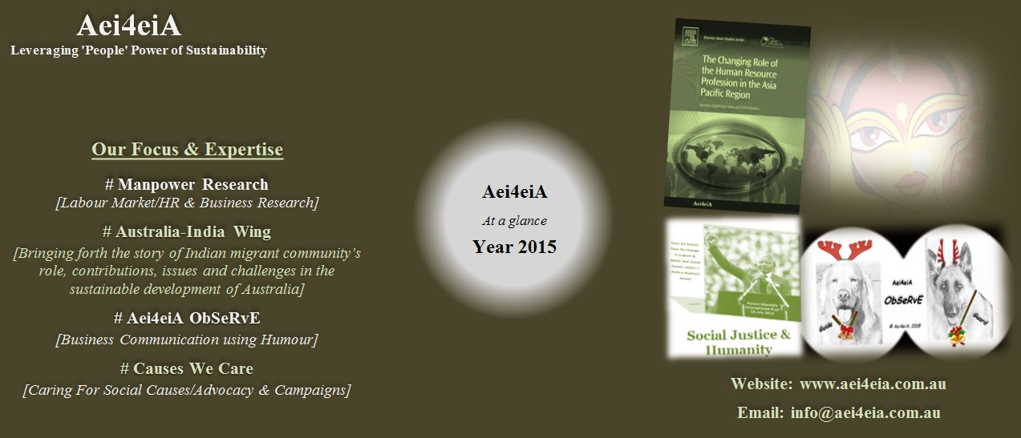

New Book Released: **"**[**The Changing Role of the Human Resource Profession in the Asia Pacific Region**](http://store.elsevier.com/The-Changing-Role-of-the-Human-Resource-Profession-in-the-Asia-Pacific-Region/Jayantee-Saha/isbn-9780857094759/)**"** (Elsevier Publication, Oxford, UK). This book is based on **over two years of rigorous research** conducted by **Aei4eiA** and co-authored by **Dr. Jayantee Mukherjee Saha,** Director and Principal Consultant, Aei4eiA. ***6 industries analysed*** {*Tourism & Hospitality | Retail| Healthcare| Education| Security| Energy*}, ***17 Asia Pacific economies*** *compared,* ***10 case studies*** *documented-* All in **ONE** book.

Endorsed by global experts and leading academicians- *…“The story in this volume is a positive one about how good employment principles that have been developed elsewhere can both transform the burgeoning businesses in Asia and also the communities where they operate. It is a story that deserves to be taken seriously, not just by employers but by policy makers in those countries and in the international agencies that advise them….”-***Prof. Peter Cappelli, George W. Taylor Professor of Management And Director, Center for Human Resources, The Wharton School of the University of Pennsylvania, United States of America.** [[**More**](http://www.aei4eia.com.au/Changing-Roleof-HR.html)]

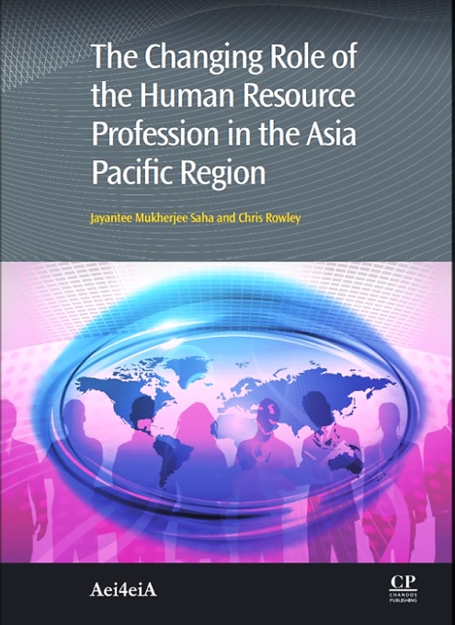

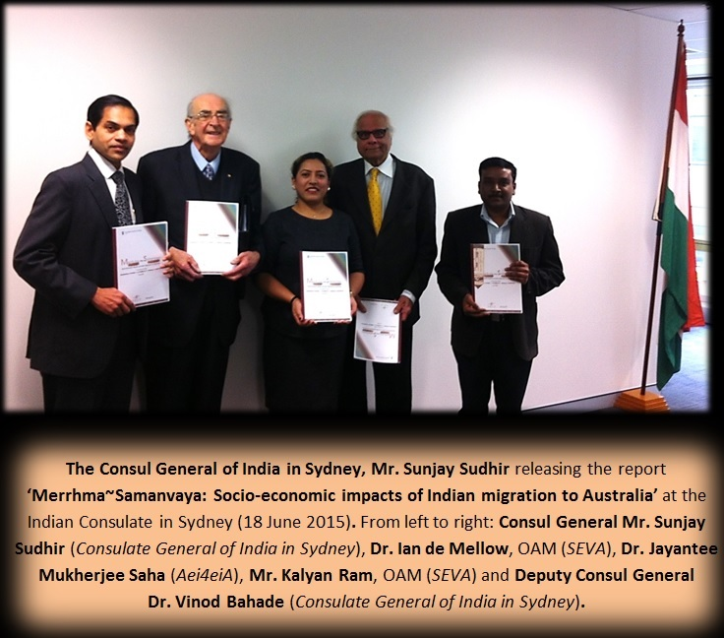

**'Merrh-ma~Samanvaya: Socio-Economic Impacts of Indian Migration To Australia'.** This first of its kind report was released by Consul General of India in Sydney. [[**More**](http://www.aei4eia.com.au/Merrh-ma~Samanvaya.html)]

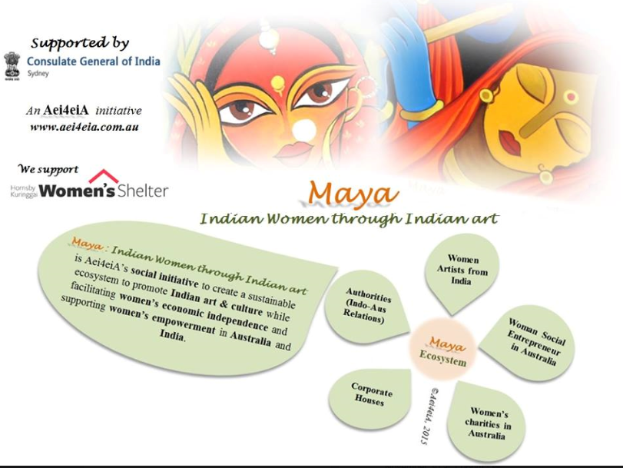

Dr. Jayantee Mukherjee Saha, Director and Principal Consultant Aei4eiA recognised for **Excellence in Policy Research** by the United Indian Association (UIA), the peak body representing Australians of Indian origin in NSW.

**“Maya: Indian Women through Indian Art” -**Ourinnovative social initiative launched. [[**More**](http://www.aei4eia.com.au/Maya.html)]

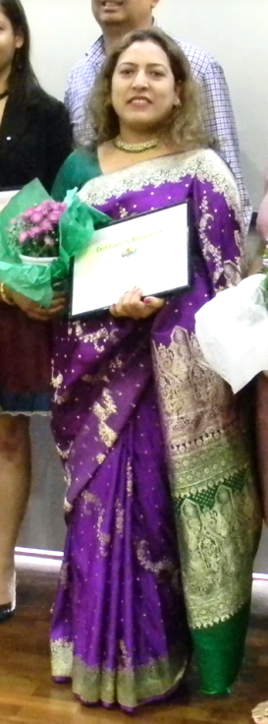

**A few research-based columns published in the media [**[**More**](http://www.aei4eia.com.au/)**]**

**When ships sailed and trade swelled bringing Australia and India closer**

**The Brown Beauties: Balancing Indian ancestry with Australian citizenry**

**The Bugle Calls, the Great War and Chords of the Colonial Cousins**

**Shades of Banyan trees: Elderly Indians in Australia**



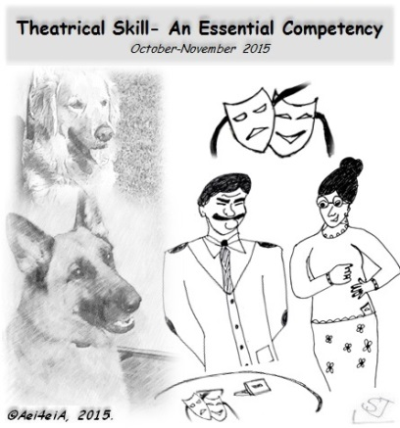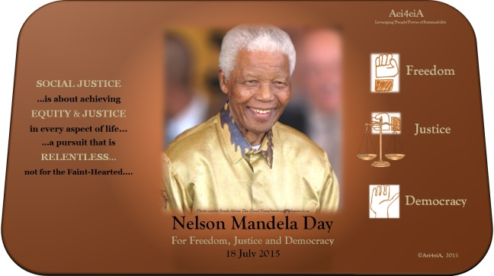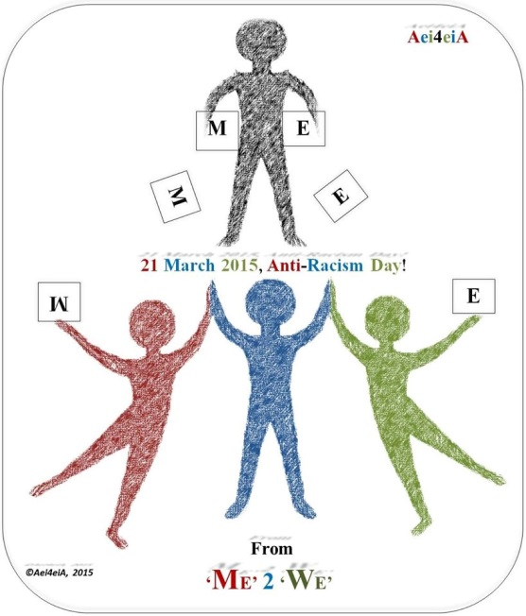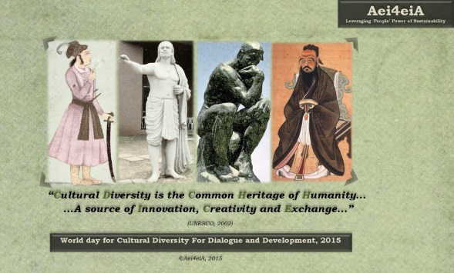

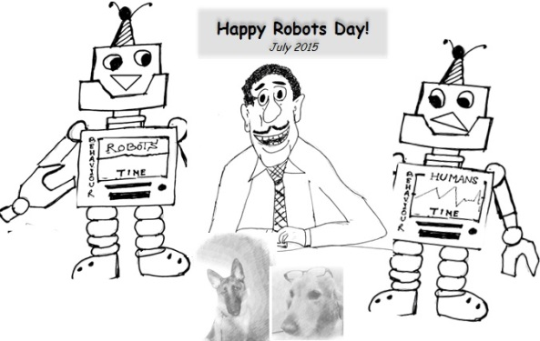

**Aei4eiA ObSeRvE** dealing with **workplace issues** ranging from *Equal Opportunity, Pre-Screening, Frugal Innovation, Emotional Intelligence, Job Description, Corporate Leadership**and*[[**More**](http://www.aei4eia.com.au/Aei4eiA-Observe.html)]

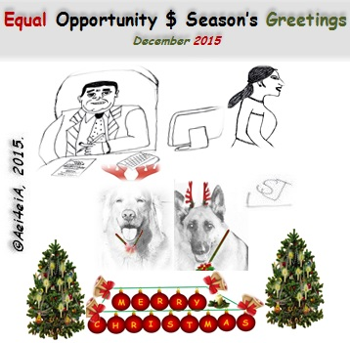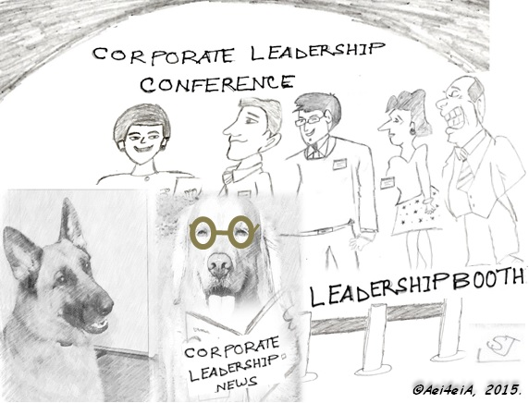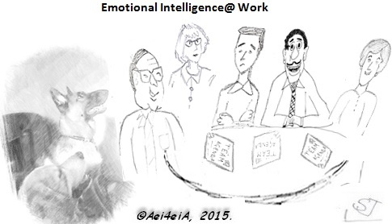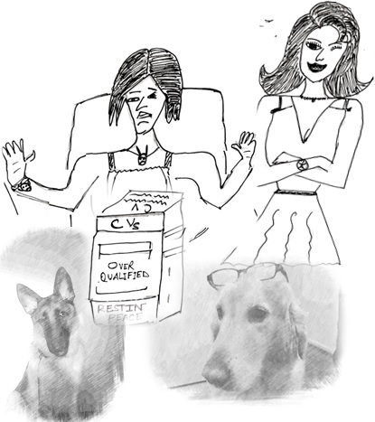

We campaigned for the

**Causes We Care** for[[**More**](http://www.aei4eia.com.au/Causes_we_care_for.html)]….

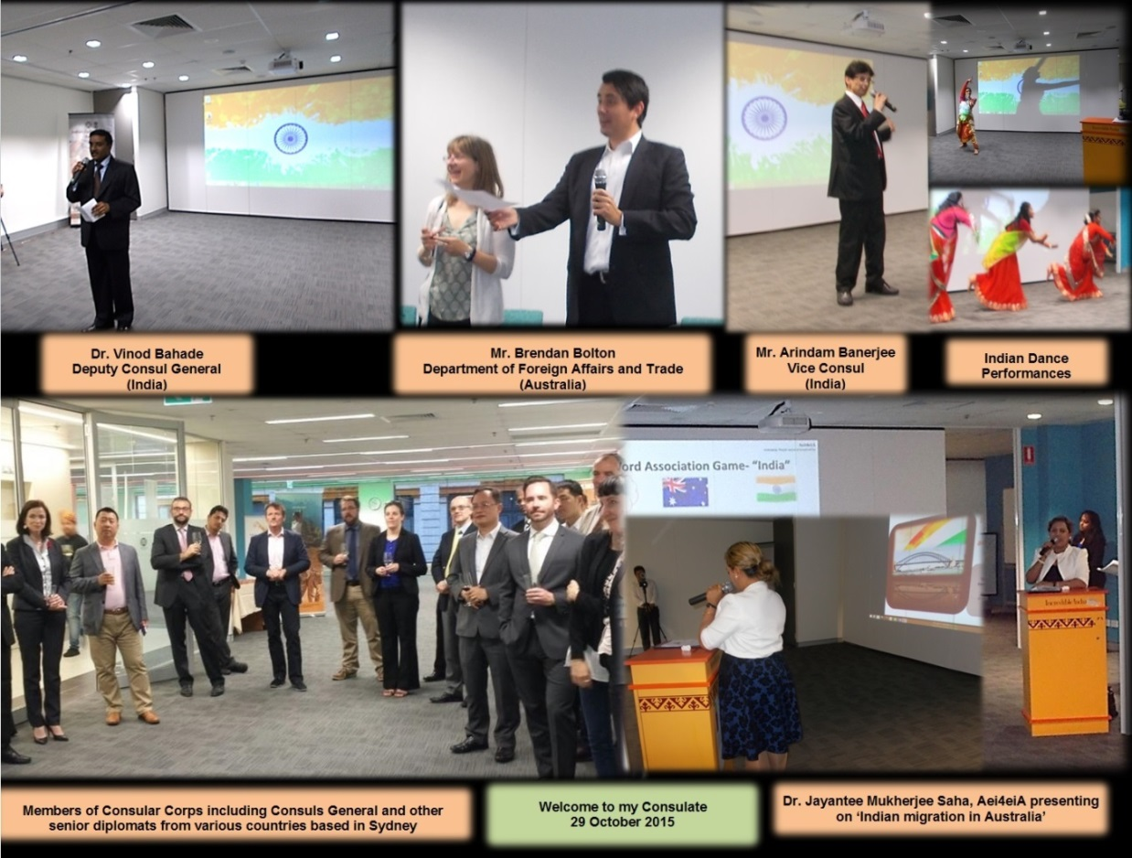

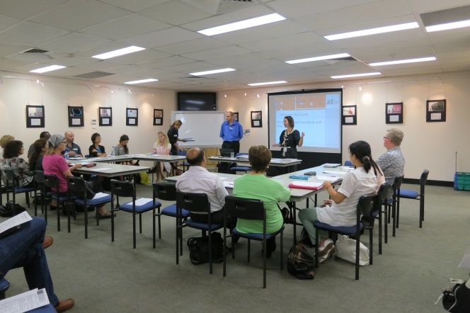

Actively **participated** and **contributed** in many forums/events….. [[**More**](http://www.aei4eia.com.au/)]



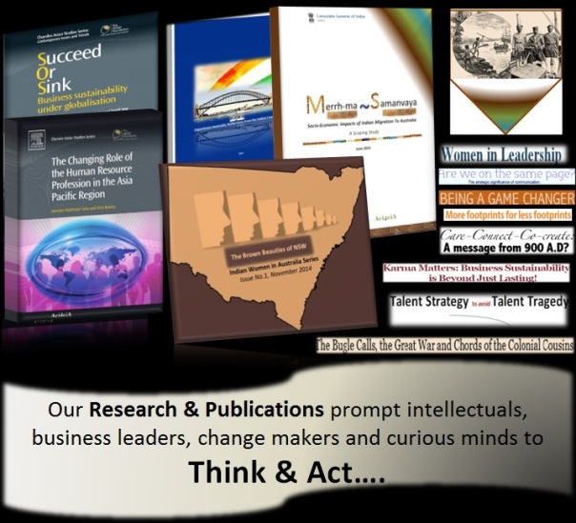

Released our **Corporate Video**… *Small is the new Big...Slow & Steady is the new**Fast...presenting* ***Aei4eiA***....….. [[**More**](http://www.aei4eia.com.au/)]





….And **that is not all**…. We are relentless… **Always in Action…! Team up with us** and **together,** we can make **a positive difference…..**

Email: **info@aei4eia.com.au** Phone: **+61 2 8005 6809** Website: **www.aei4eia.com.au**

