Risk Management Principles
Applied to Hiking
(Provided by: HighCountryExplorations.com)

Risk is an important part of life. Testing limits fuels growth. Challenge has led humans to use fire, to traverse oceans and deserts, to climb the highest mountains, and to journey into space. The risk-free life may not be worth living, but those who take risks and expect to survive must plan ahead and prepare as well as possible.
—James A. Wilkerson, M.D., editor, Medicine
For Mountaineering, 5th Ed., page 348

Bear bells provide an element of safety for hikers in grizzly country. The tricky part is getting them on the bears.
—Bruce Cochran, Everything You Wanted to Know About Camping

We take risks, we know we take them. Therefore, when things come out against us, we have no cause for complaint.
—journal entry of Robert Falcon Scott of the 1912 Antarctic expedition,
made at death camp after the return from the Pole

Central Issues Addressed in This Article
What is meant by “risk management” and how can its principles be applied to hiking and backpacking? What are the highest probability risks faced by experienced wilderness travelers? By inexperienced travelers? What can we learn by analyzing actual wilderness emergencies, accidents, illnesses, etc.? Should we approach risk management systematically?

Traditional Wisdom From Experienced Risk Managers
There are many “truths” that can be learned from competent risk managers and those who deal with emergencies on a regular basis. Here is a synthesis of many of these truths. How self-evident are they to you?

Becoming Risk Managers: There is no way to eliminate all risk. A life lived to the fullest is fraught with risks. However, unless we consciously choose a lifestyle full of danger and taking chances and gambling with the odds against us, the responsible approach is to become a risk manager rather than a risk taker. The first step in becoming a risk manager is to identify the risks by examining the possible outcomes of a situation. Even though a risk manager will usually end up taking some risks, the primary focus should be on understanding, preventing, minimizing and mitigating the identified risks.

Prevention Strategies and Emergency Avoidance: The most important risk management strategy is to avoid emergencies in the first place. The primary focus should be on prevention and only secondarily on how to deal with the possible emergencies that might happen in the wilderness. To avoid emergencies we need the right combination of skills, knowledge, experience, gear, preparation and attitude. We can hike for a lifetime and still be adding depth to these elements. We also avoid emergencies by being both physically and mentally prepared. Being in good physical condition is a good preliminary to mental conditioning. Mental conditioning begins with an honest assessment of strengths and weaknesses. It also includes an ongoing “What if?” mindset. To avoid emergencies, we need to pick our hiking partners carefully. We need partners who complement our skills and experience. We need partners who are not selfish, and who have a similar level of risk tolerance. There should be no serious personality conflicts. As a starting point, we should ascertain the competency levels of those we go out with.

Domino Impact of Large and Small Casual Events: Emergencies seldom have one cause. There is the obvious cause (injury caused by a slip on icy terrain on a steep slope) and more fundamental causes (being in a hurry and not having practiced ice axe arrests for years). In analyzing an accident or emergency, many small things often contribute. For example, losing a glove in cold weather could result in preoccupation with keeping one’s bare hand warm resulting in not noticing a trail junction and taking the wrong fork. When suspicious about the direction of travel, discovering that one’s compass is not working properly and that you had put the wrong map into your pack. None of these unfortunate events by themselves causes this hypothetical person to get lost, but taken together become significant. Often the underlying fundamental causes and the small contributory causes combine to form a chain of events like a line of dominos falling over (hence the “Domino Impact) in the subheading).

Broad Range of Risks to Manage: Even though it is natural to think of risk management primarily in terms of emergencies that might result in bodily harm, there are other types of risks to manage: economic, psychological, social and legal risks. For example, if you do not get the proper permits, there is a legal risk and an economic risk (if fined). Another example of a risk that is not an emergency is that of getting sick a week after returning from a trip because of drinking bad water or practicing poor hygiene. This is a physical risk, but no immediate action is required; that is, it is usually not an emergency per se.

Assisting Those Less Experienced: To avoid getting caught up in emergency situations caused by others, we need to assist those with less experience. We need to freely share our own knowledge and experience. We need to get discussions going on the more controversial aspects of risk management. We need to get the less experienced to brainstorm risk prevention strategies. Everyone will benefit when we do these kinds of things.

Selective Prevention Strategies: To become a good risk manager, a “What if?” mind set should selectively focus on the most common problems experienced by wilderness travelers. We need to place our primary focus on the most probable events (rather than on the worst things that can, but seldom do, happen). One exception to this would be focusing on those situations which could have very serious consequences, but which are relatively easy to control even though the actual risk might be fairly low. A good example would be packing a helmet and wearing it while scrambling in areas of loose rock. Even though focusing on the most probable events should be the main criteria, other events should be considered.

Habitual Safe Behavior: The safest individuals are those who make safety a habit. We need to habitually act in a safe and responsible manner by paying attention to details and not getting sloppy. Emergency situations often arise from a sequence of small mistakes and misjudgments. Examples of safe habits regarding wilderness travel: careful selection of gear taken, agreed turn-around times, checking weather forecasts, asking locals about known conditions, contingency exit plans, and a willingness to abort a trip that is not going well.

Perceptions vs. Realities: Sometimes the perception of risk is not the same as the reality. Inexperienced wilderness travelers often greatly exaggerate some risks (e.g., the risks from wild animals) and do not fully understand others (e.g., hypothermia and dehydration). Probably the best example of distorted perceptions involves loved ones who have little experience in the wilderness and who choose to stay at home.

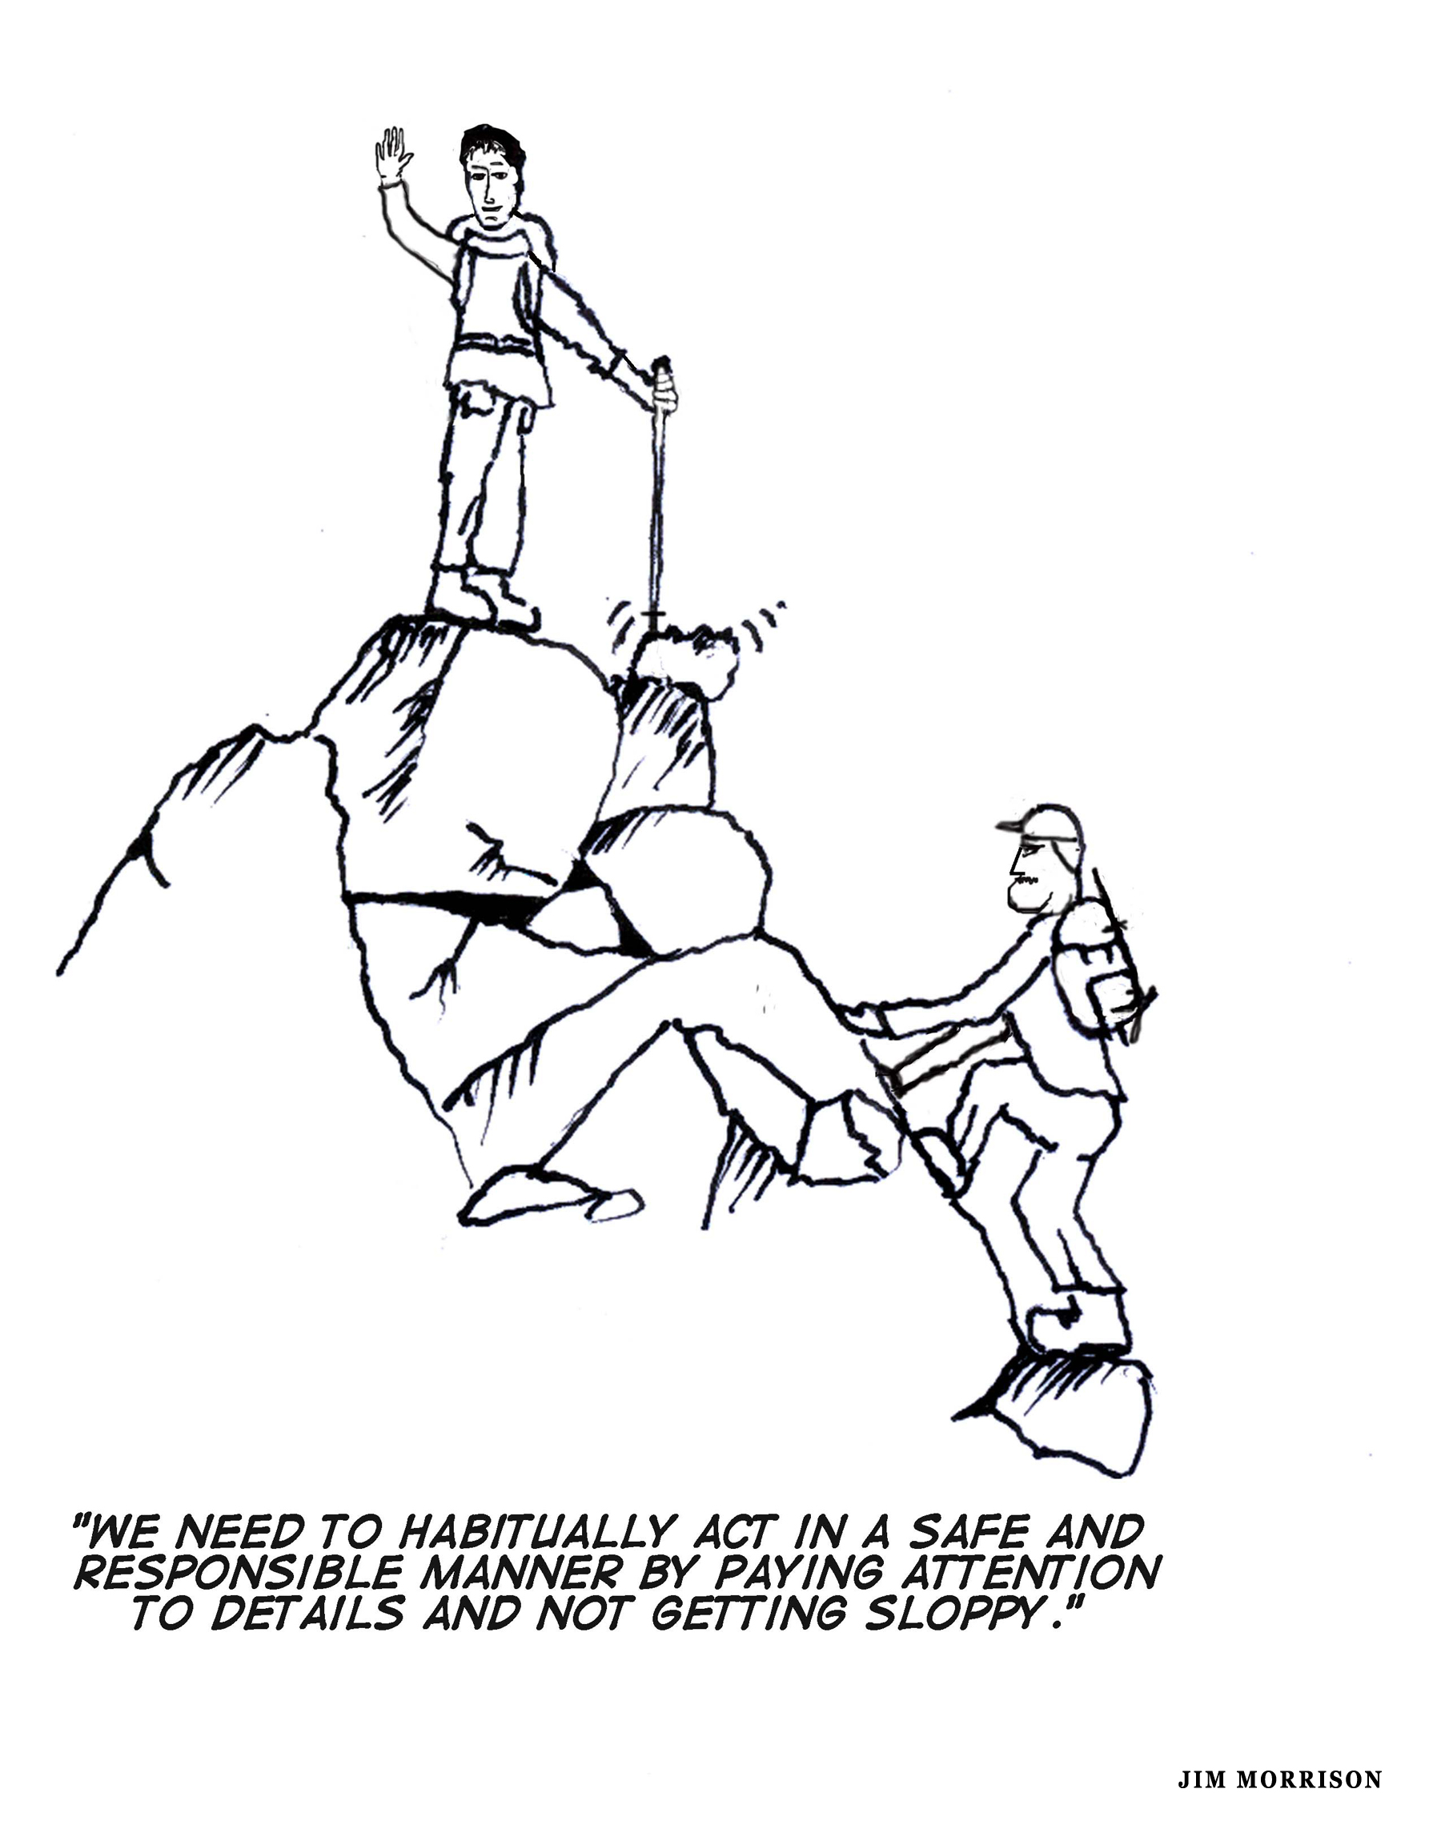

Systematic Approaches to Risk Management Related to Hiking
My research and experience lead me to recommend the following phases or steps to systematically and effectively manage risks when involved in hiking and backpacking activities.

- Pre-trip analysis should include gathering pertinent data and brainstorming potential risks for a specific trip. Include potential failures of critical pieces of gear and weaknesses of party members as part of this analysis.

- Prioritize the risks for the specific trip (i.e., those having the highest probability of becoming a problem or those with the most severe consequences in spite of lower probability).

- Make specific decisions on the highest priority risks identified in Step #2 by:

  - Eliminating or minimizing the risk (e.g., treat the drinking water with an effective treatment method)

  - Accepting the risk without further action (e.g., selective drinking from water sources without treatment)

  - Controlling or mitigating the identified risks (e.g., during the trip take medication that kills known parasites in the water; get tested for parasites after the trip is over)

  - Avoiding the identified risks altogether by canceling or radically changing the trip

  - Transferring the risk to others (e.g., purchasing quality medical insurance to cover serious illnesses).
4. If eliminating or minimizing the risk is one of the decisions made, decide upon effective prevention strategies for the most probable risks identified.
5. Minimize or mitigate the risks by taking action on the strategies that have the greatest return for time, money and energy spent. This would include both prevention strategies and developing some contingency plans for selected emergencies.

6. Conduct a post-trip analysis. Do this debriefing if an emergency or a near miss has occurred. Be careful not to place blame. Instead, play detective in obtaining the perspective of all participants as to what exactly happened and as to the fundamental or underlying causes.

If time and energy are limited, spend at least some time on Steps #1 and #2. In other words, consciously acknowledge the risks for an upcoming trip.
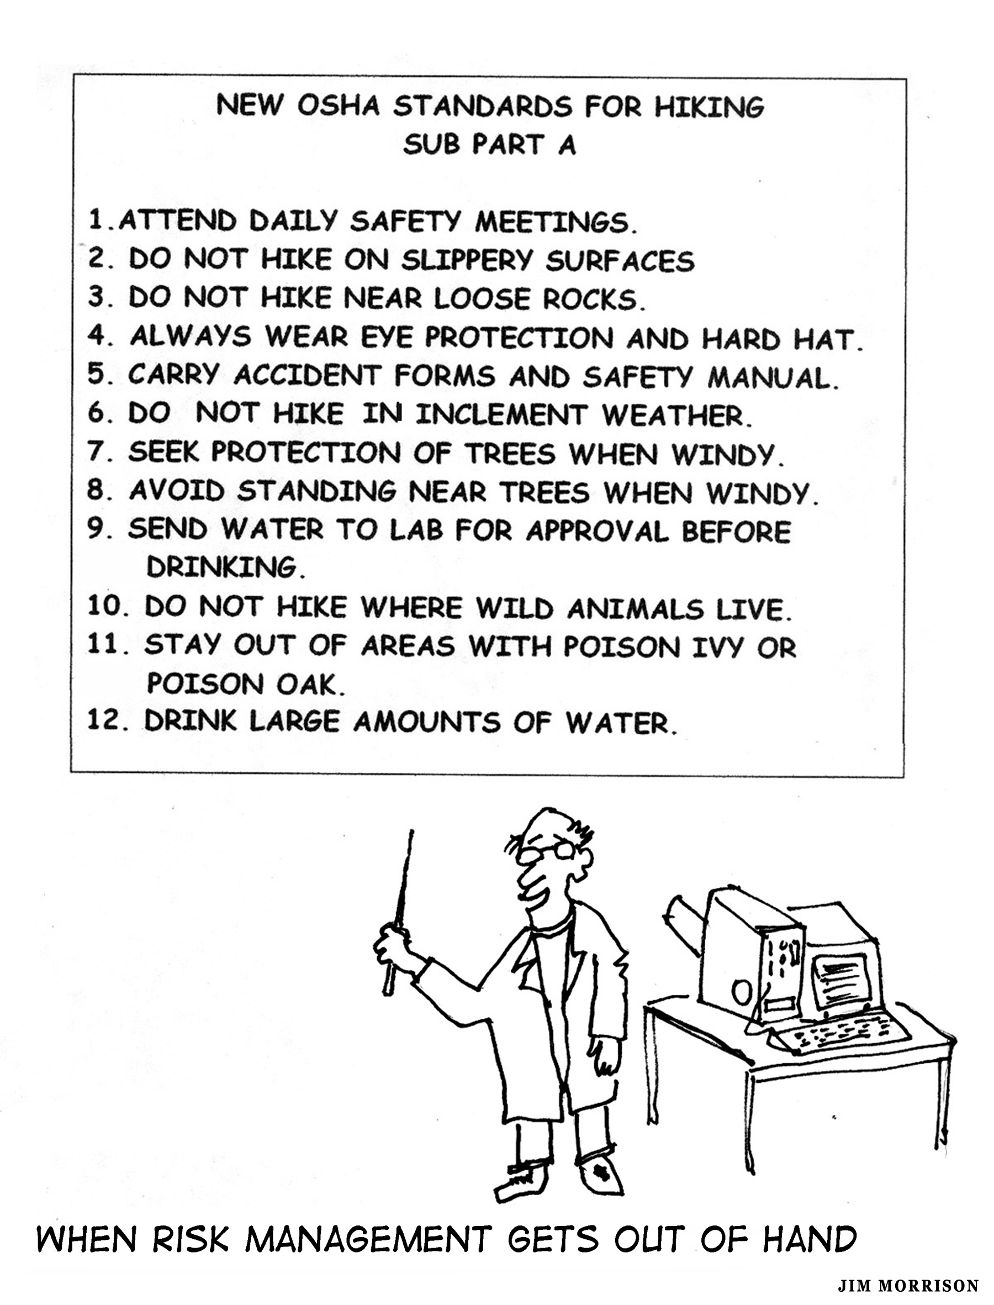

Why Undertake Systematic Analyses of Risks?

Why go through a systematic risk analysis process such as that detailed above? Why not just rely on experience and common sense? Do not most serious emergencies involve the inexperienced or the few who indulge in high-risk behaviors?
The obvious answer to these questions and challenge to systematic risk management is to make such an analysis situational. The more experienced the hiker and the more low-key the trip, the less the need for risk analysis. Longer, more aggressive trips to faraway places that include some less experienced people deserve a high level of analysis and action to minimize and mitigate the risks. In addition, hikers with a relatively high-risk tolerance will do less than those with a low threshold. Most importantly, gain a conscious understanding of systematic risk analysis and management in order to decide how much of it to apply to a specific trip. Finally, think of managing risk as a skill that allows you to go further and do it more safely rather than a task that limits you to what you can or cannot do.
Another answer to the “Why?” questions posed at the beginning of this section is contained in this quote:

After you go through the process [of risk analysis and developing prevention strategies] several times, it will become second nature. You’ll find yourself quickly developing into a knowledgeable and skilled ultralight risk manager.
—George Cole, Lightweight Backpacking and Camping: A Field Guide to Wilderness Hiking Equipment, Technique, and Style, page 267

For most trips, we can learn to do it quickly with little expenditure of time, effort or money.
Yet another answer to those challenging systematic risk analyses is that most of us are not very good at evaluating many kinds of risks. This is especially true when our enthusiasms cause us to rationalize our situation (i.e., it will not happen to me) rather than learn to manage the actual risks involved. The following quote (from an unknown source) takes this point to its logical conclusion.

We humans are very bad at evaluating risks, and certainly if you stay home rather than hike next week you run the risks of being in a horrible auto accident, being a victim of a violent crime (on the average more likely in the city than in the wilderness), and perhaps additional health risks associated with breathing polluted air, not getting enough exercise, or being depressed because you aren't out in the wilderness where you know you belong.

What Can Actual Emergencies In the Mountains Tell Us?
We can learn a lot from the experience of others. Consequently, we should be able to learn something about risk management related to hiking from experienced wilderness travelers. To assist in this endeavor, I first summarize my own experiences from fifty-plus years of hiking, backpacking, crosscountry skiing and climbing. I then relate some unique experiences from two close friends who agreed to jog their memories and share their experiences. The three of us have over 130 years of wilderness experience.
Memorable Experiences of Wilderness Emergencies
- I broke both my fibula and ankle at the end of a weeklong high traverse in the North Cascades of Washington State. My crampon caught on some ice when I unexpectedly slipped on steep snow and severely torqued my leg in the process. I was stabilized and airlifted out by a helicopter from Whidbey Island Naval Air Station. After a long recovery process, I have full use of the damaged leg.

- While on a climb of the Brothers in the Olympic Mountains of Washington State, one of the leaders of our party (approximate age 60) took a long step (stretch) upward and felt a sharp muscle tear. It soon became obvious that any further climbing, up or down, would be extremely painful if not impossible. Several cell phones in the party were mobilized to successfully call search and rescue. A Coast Guard helicopter was able to lift the patient off the summit just before nightfall. Two party members who agreed to stay with the injured climber were not lifted off and spent a long and miserable night huddled on the summit. They made their own way down the next day.

- Deep in the North Cascades of Washington, I received an inch long cut on the palm of my hand after slipping on a wet, down-sloping rock slab and falling on the adze end of my ice axe. After a forced march out of the mountains in the dark and heavy rain with failing flashlights, a hot shower and a few hours’ sleep at a roadside motel, an ER doctor sewed up my hand the next day.

- Two of us were walking down a relatively flat ridge between two crevasses after a climb of Mt. Rainier. We were roped up when my partner slipped unexpectedly. He pulled us both into a relatively shallow crevasse. The only injury to either of us was a facial cut when my glacier glasses were jammed into my face. The cut required Band-Aids, but no stitches.

- My son and I were with a group of 10-12 snowshoers in the Central Cascades. We were at the back of the party and following a zigzag snowshoe trail up a steep slope when an avalanche let go. Both of us were able to ride/swim on top of the avalanche for 200-300 feet downhill. We were separated on the ride down, but neither of us were hurt.

- Five of us were on an overnight snowshoe and ski trip in Mt. Rainier National Park with a goal of sleeping in igloos we would build. While building the igloos, we were joined by a party of three camping nearby with a tent. We woke up the next morning to a heavy dump of snow and blizzard conditions. The other party had left. We decided to head back after accidentally kicking off an avalanche in a large bowl. Crossing some gullies lower down, we first came across a hand sticking out of the snow, then another person with just their head out and finally the third member of the party covered just to the knees. The had avalanche happened only moments before and we were able to extricate all three quickly. They were shaken but not seriously injured.

- On an attempted climb of Denali (Mt. McKinley), a member of our party, loaded down with his full (60 lb?) pack, fell into a big crevasse on the Muldrow Glacier. He was roped up and his fall was easily arrested. Fortunately, there was plenty of manpower to effect a quick rescue. He was not injured in the process.

- On an attempted climb of Denali (Mt. McKinley), a member of our party was scalded when a pot of boiling water tipped over onto his sock-covered foot. The sock held in the heat providing a good-sized, second-degree burn. Two party members stayed with the burn victim for a few days waiting for the burned skin to heal enough so he could continue climbing.

- On a circumambulation of Mt. Adams in Washington State, a member of our party slipped on steep hard crusted snow. He was using an ice axe, but not wearing crampons. He slid down a hundred feet or so before coming to a stop. The combination of his heavy pack and a too-short ice axe interfered with his attempt to self-arrest. Fortunately, he missed some nearby rocks and only his pride was injured.

- Three of us were leading a group of college students on an off-trail adventure in the Central Cascades as part of a summer sociology course. One member of the party cracked his leg bone while jumping from one rock to another with his full pack. After it happened, he informed us that he had a history of brittle bones and bone cracks. Two members of the party hiked out 15 miles to report the emergency. His leg was splinted and he was then moved a short distance to an open area ready for evacuation by helicopter.

- On a day hike to Snow Lake in the Central Cascades, I was wandering off-trail and ran into a nest of hornets or wasps. I was stung multiple times. After an hour or so, I suffered an allergic reaction with swelling and itching around my face and extremities. What started out as a leisurely trek back to the trailhead became a hurried and somewhat anxious retreat. No allergy medications were available at the time. Finding that I am allergic to both bee stings and neoprene, I now carry two levels of allergy medication when I am out and about: antihistamine capsules and an Epi-pen for injecting adrenaline.

- I came down with a case of bronchitis accompanied by a high fever on the first day of a weeklong trip into the North Cascades Recreation Area. The bronchitis had evolved out of a chest cold that I had acquired 5-6 days before the start of the trip. After two days of complete rest in a base camp, our party decided to terminate the trip and hike 15 miles back to the trailhead. The decision to terminate the trip was made easier when it became obvious that a rather large, lightning-caused fire blocked our route.

_______________________________

The above summary of my own experiences does not include some ankle sprains, abrasions, sunburns, etc. It also does not include my experience with mountain rescue.

Experiences Of Close Friend, Jim Morrison
Jim Morrison, a close friend and fellow hiker/scrambler/climber/sailor, has traveled extensively in Washington, Alaska, California, and Arizona since 1965. He spent many years as a volunteer firefighter and EMT. Here is a summary of his experiences in the mountains of various incidents and emergency situations.

- “While ice climbing on the Matanuska Glacier in Alaska, my friend Don fell and shredded the seat of pants. He was only sore and shaken, but later that day he twisted his ankle. He was unable to climb the next day, but was able to walk out. I think the seat of his pants and his ego suffered the most.”

- “My daughter Jamie developed a sore knee when halfway between Canada and Rainy Pass on the Pacific Crest Trail. An Ace bandage and aspirin gave her nearly complete relief from the pain for the next 40 miles. She also thought she looked pretty macho wearing the bandage on her knee.”

- “Neil Lind was one of my most faithful companions. In 1975 he fell while traversing a steep snowfield and when he put out his foot to stop himself on a rock, after having slid some distance, he broke his ankle. We did not know it was broken until many days later when it was x-rayed. We taped it up tight with an Ace bandage and he used his ice ax as a crutch (which was about the only way we knew to use ice axes then). We took a climbing class the very next spring.”

- “On an easy part of the trail, after about 10 miles of hiking, a party member crossed a dry creek and slipped on the rocks climbing up out of the creek bed and hit his head. He had a one-inch laceration on his scalp. I asked about other injuries and then I cleaned it up with alcohol wipes and examined him for signs of brain injury. Finding nothing remarkable, and because the bleeding had stopped, no further treatment was necessary. It could not easily be bandaged because it was in the hairline and he had rather long hair. We balding mountaineers have at least one advantage!”

- “On a very hot summer day while doing strenuous climbing in the Olympics, one of our party became extremely weak. This was surprising because he had always seemed to be in at least as good of condition as everyone else in the party. He was also carrying extra water for the climb and was drinking regularly. But his pace became slower and slower. Even though there are many possible causes for fatigue, two possible causes are either hyponatremia (excessive loss of sodium) or hypokalemia (excessive loss of potassium) or both. One of the reasons for this opinion is the fact that the individual in question suffers from high blood pressure and therefore chooses to severely limit his intake of salt. This lack of electrolytes combined with drinking lots of water (which flushes out electrolytes) could have been the cause of his weakened condition. A nutrient deficiency, especially the depletion of glycogen, is another common cause of fatigue and could have been a factor.”

Experiences Of “Willie” Willette
A friend and fellow hiker/scrambler/climber, Lloyd “Willie” Willette, has hundreds of backcountry trips under his belt since 1978, including numerous trips as an instructor for a college mountaineering course. He related the following unique emergency situations (summarized not quoted).

- One of the leaders of a college mountaineering class suffered a unique calf muscle injury while scrambling on a climb of the Brothers in Olympic National Park. The injury happened while taking a long step upwards, a move he had made thousands of times in the past. It was extremely painful for him to walk. A helicopter rescue was initiated. The other members of the party walked back to the base camp.

- An out-of-shape beginning hiker fell apart physically and mentally from exhaustion and dehydration. A doctor in the party, a close friend of the patient, just happened (??) to be carrying the supplies necessary to administer an IV, which he proceeded to do. The patient recovered quickly and walked out under his own power.

- A female member of the party became exhausted. The main reason seemed to be that she was embarrassed about urinating in a public setting and had decided not to eat or drink much to avoid that embarrassment. After the patient was encouraged to eat and drink, she made a rapid recovery.

Methodology and Generalizations from the Above Incidents
The methodology used above is simple: relate all of the serious incidents happening to a small group of highly experienced individuals over a lifetime of wilderness experience (three individuals accumulating 130+ years of experience). The purpose is to learn more about the specific risks from hiking and scrambling and backpacking, which only occasionally involves some mountaineering. Several of the incidents related in the previous section happened in a mountaineering context. I acknowledge that a review of the American Alpine Journal’s annual accident reports would yield much quantitative information about serious mountaineering accidents, but it would also take away from the purpose of including the above experiences. If there were a similar report of accidents happening in hiking and backpacking contexts to experienced wilderness travelers, it would also be quite helpful. I know of no such reporting.
Even though reports from additional experienced outdoors people would be helpful, we have plenty of anecdotes in the previous sections to make some useful generalizations. But what generalizations can be made from the 18 incidents related above? One is that there is a wide variety. They are all over the map, making risk more difficult to assess and manage. Even with such variety, one should still attempt to assess the potential risks for specific trips.
Another generalization is that highly experienced individuals often find themselves in mixed groups with a range of experience. Adding inexperience to the mix considerably expands risk assessment and management activities.
Broken legs and ankles and sprained knees are a common theme, especially when traveling on steep snow. In some cases, an ice axe practice before or during the trip might be helpful. Because of the nature of wilderness travel, extra attention should be paid to prior conditioning of the lower extremities. Balance exercises would also be helpful.
Another generalization is that helicopters are being utilized at an increasing rate. From a risk management standpoint, this fact dictates that knowledge of the different forms of emergency communication from the wilderness is essential, especially for those who travel far off the beaten path. Click on this link for detailed information on this kind of communication: Wilderness Emergency Communication Devices Analyzed.
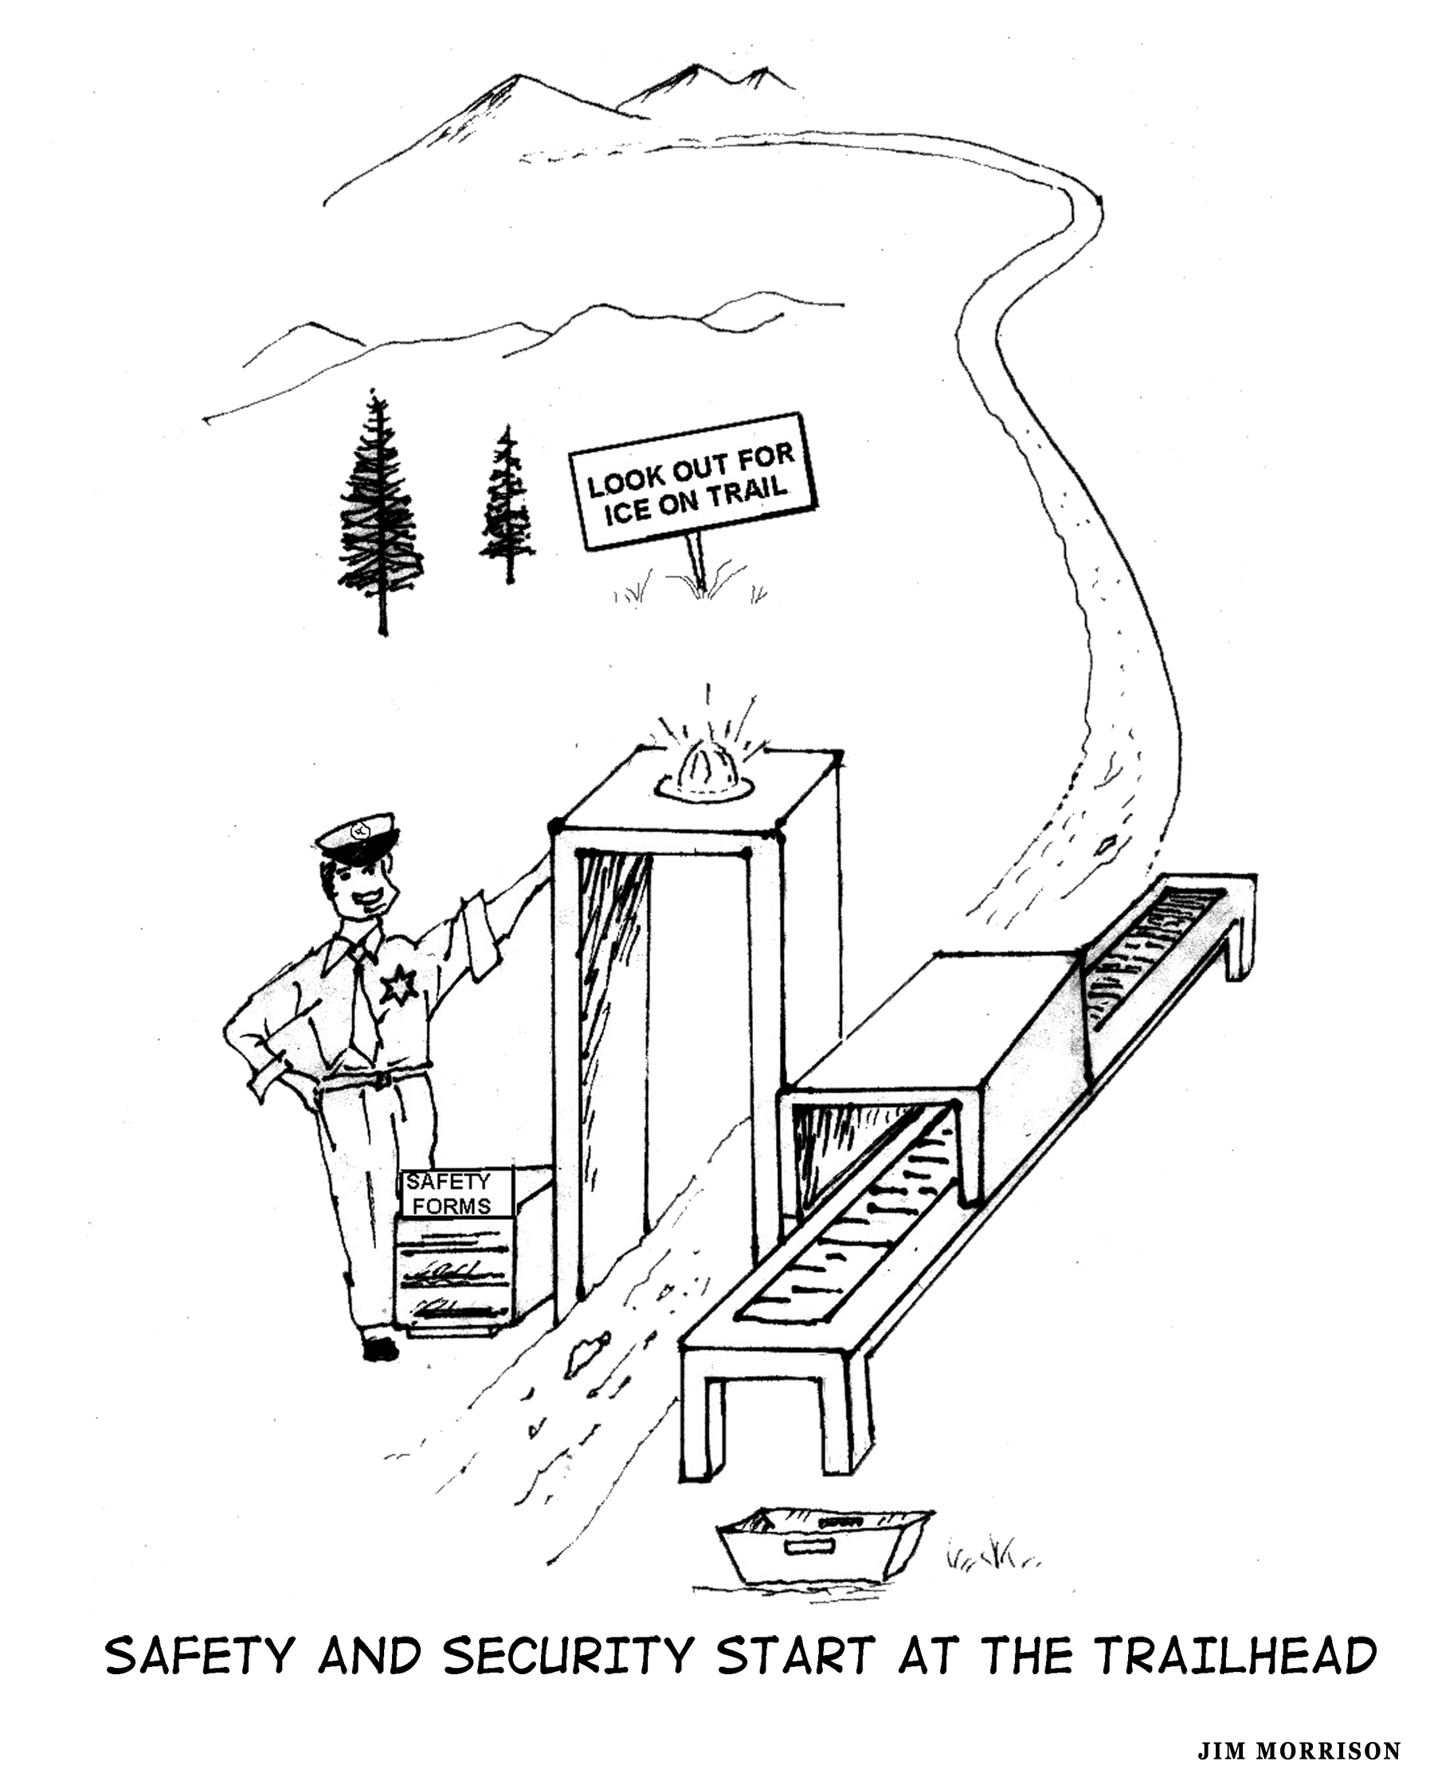

Reader Participation: Generalizations from Personal Experience
First, find a quiet place and make notes about your own personal experiences in the wilderness with emergencies, accidents, illnesses, etc. Second, add to your list experiences involving friends and fellow travelers in the wilderness about which you have accurate knowledge. Third, write down additional risk management principles and generalizations (in addition to those already related at the beginning of this article by your author).

Highest Probability Risks for the Experienced Hiker
Following is my assessment of the highest probability risks in the wilderness by individuals who are experienced, in good conditioning and properly equipped:

- Falling, slipping, sliding and losing control (on snow, steep slopes, crossing rivers, logs, rough trails resulting in sprained ankles, knees and backs or broken bones.

- Getting sick from contaminated water, food or poor hygiene.

- Getting lost or separated from the party.

- Drowning or serious injury attempting to cross fast-moving water.

- Hypothermia

- Allergic reactions to insect stings, pollens, medications and certain types of food. Anaphylactic shock (a severe allergic reaction) can occur from any of these causes. Even if there is no previous history of allergic reactions, there is some chance that you or someone else in the party is susceptible.

The risks above are listed in order of my evaluation of probability (highest to lowest). These priorities are based only on my own observations and research (and subject to the limitations of my own wilderness travel experiences). Obviously, all of these things can happen to anyone, experienced or not. This list is generic for most trips into the wilderness. Risk factors should be added for specific trips as appropriate (e.g., wild animal attacks, falling rock and ice, forest fires, flash floods, snakes, poison ivy, ticks, lightning, altitude sickness, avalanche).

Additional High Probability Risks for the Inexperienced
The following is my assessment of the most probable incidents suffered by the inexperienced, those not in good condition and those who are lacking in their equipment (in addition to the risks listed in the previous section).

- Dehydration and Exhaustion
- Hypothermia (too cold) and hyperthermia (over heating)
- Painful sunburn
- Getting caught out after dark without survival equipment
- Carbon monoxide poisoning
- Debilitating blisters

Reader Participation: Assessment of Highest Probability Personal Risks
The prioritized risks listed in the two previous sections are obviously subject to debate and might not be consistent with your own experiences. They are shared mainly to encourage the development of your own list, relative to your levels of experience, conditioning, gear, types of trips, etc. With this lead-in, consider writing down, in order of priority, your assessment of the most likely risks faced on future trips into the wilderness.

Some Final Thoughts
Consider reviewing other articles on this website (“Safety and Prevention” section) that focus on common risks faced by wilderness travelers. Many of the prevention strategies discussed in these articles will be obvious to the experienced hiker, but there just might be a few new strategies to add to your bag of tricks. Also, consider reviewing two articles that relate indirectly to risk management. One is Being Systematic About Outdoor Gear. Gear selection for specific trips should be closely tied to risk assessment. The other article is “Wilderness Safety—A Debate”. This article goes into considerable depth comparing how lightweight and conventional hikers and backpackers deal with a variety of common risks.

Additional Issues For Reflection
- Time and Energy Spent on Risk Management: When should we spend a lot of time and when give only a cursory nod to risk assessment and management activities? Is the difficulty and complexity of successful risk management for wilderness travel a good reason not to spend much time with it?

- Systematic Risk Analysis: How important is it to undertake a systematic risk analysis on longer, more complex trips? How persuasive were the arguments given earlier for such an analysis? What are the strongest arguments against this?

- Loved Ones and Risk: What are the best ways to deal with loved ones whose perceptions of potential risks for an upcoming trip are on the high end of the scale?

- Unrealistic Assessment of Risks: What is the best course of action when dealing with others who have an unrealistic assessment of the risks of traveling in the wilderness?

- Teachability of Risk Management: If risk prevention strategies and risk management principles can be taught/learned, what is the best way to learn/teach this subject? How much does this subject depend upon experience in the field and how much on theory, principles and “book learning?” Has this article been effective in substantially increasing your knowledge and understanding of risk management?

- Dealing with Adrenaline Junkies: What is the best course of action if you or your best friend can accurately be categorized by cliché terms like “adrenaline junkie” or “crisis addict”? Is this generally something that should be dealt with or ignored? What if they or you are in denial?

- Consciously Choosing High Risk Activities: What should one conclude about a person who habitually acts in an unsafe and irresponsible manner (assuming they are not harming others with their behavior)? What should one conclude about an otherwise mentally healthy person who habitually acts in such a manner while fully acknowledging the nature of their behavior?

- Rationality of Indulging in High Risk Activities: Are there good reasons to consciously choose a lifestyle of danger, taking chances, and gambling with the odds against us? Are some so good at risk management that they can actually minimize the risks of doing what most would classify as high-risk activities?

- Radical Change in Risk Behavior: How likely is it for a person to radically change their risk tolerance, say from a very conservative attitude to a liberal one? How much of a role do age and experience play in making changes?

