

2025
DOUBLES OPEN

Our first major tournament of the year with 24 entries, the highest number in 11 years!!

Not only that 22 of the 48 players were none members, so thanks to everyone for the amazing support this year.

Round 1, saw the 2024 champions Geoffroy & Toby get off to a good start winning 13 – 6 over a very good team in Alan & Michel.

Two 13 – 0 wins as Daniel & James Villalard beat John-Pierre & Nigel and Keith & Mo beat Janet & Margaret.

Gary & Wendy couldn’t get to 13 against Matt & Nickey but won 12 – 4, whilst the closest match was a 13 – 10 win for Alex & Tony over Ross & John and Katrina & trevor beat 2022 champions Neil & Ross.

Round 2 saw champions Geoffroy & Toby hand out a 13 – 0 to Trevor & Katrina as did Neil & Ross to John & Ross!

Gary & Wendy lost the closet match to Daniel & James 9 – 8! Wins for new players Mark & Scott 13 – 7 over a very experienced Keith & Kevin and also Daniel & Jamie13 – 3 over Janet & Margaret.

Round 3, Cliff & Judy beat John-Pierre & Nigel for their first win and Keith & Kevin just won 13 – 12 over Danielle & Paul.

Two matches finished 12 – 11 with Callum & Andrew just edging out Alex & Tony whilst colin & Jim did the same to Trevor & Katrina.

Brian & Stephen kept the run of 13 – 0 as they beat Daniel & James whilst the big match of the round went they way of Laurent & Matt 13 – 4 over Geoffroy & Toby.

Round 4, In the final round and the quest for ranking points and the top 8 some big matches.

Geoffroy & Toby recovered from their round 3 loss to beat Andrew & Callum 13 – 4 to finish second in the Swiss rankings, whilst the two other teams unbeaten played each other but Laurent & Matt beat Brian & Stephen 13 – 0! To top the rankings. Brian & Stephen third and Andrew & Callum forth.

Fifth place went to Alan & Michel who beat Gary & Wendy 13 – 7 to make it through with the latter knocked out.

Ross & Neil 13 – 8 win over Alex & Tony gave them sixth place with the latter losing out. Jake & James 13 – 0 win over Keith & Kevin wasn’t enough to get them through but a surprised as Daniel Deveau & Jamie Burrows beat Daniel & James Villalard 13 – 9 to finish seventh, a great performance.

Eighth place also finishing on three wins was Matt Scholefield & Nicky Maindonald whose 13 – 10 win over Colin & Jim saw them take the last Quarter final spot.

FINAL SWISS RANKINGS
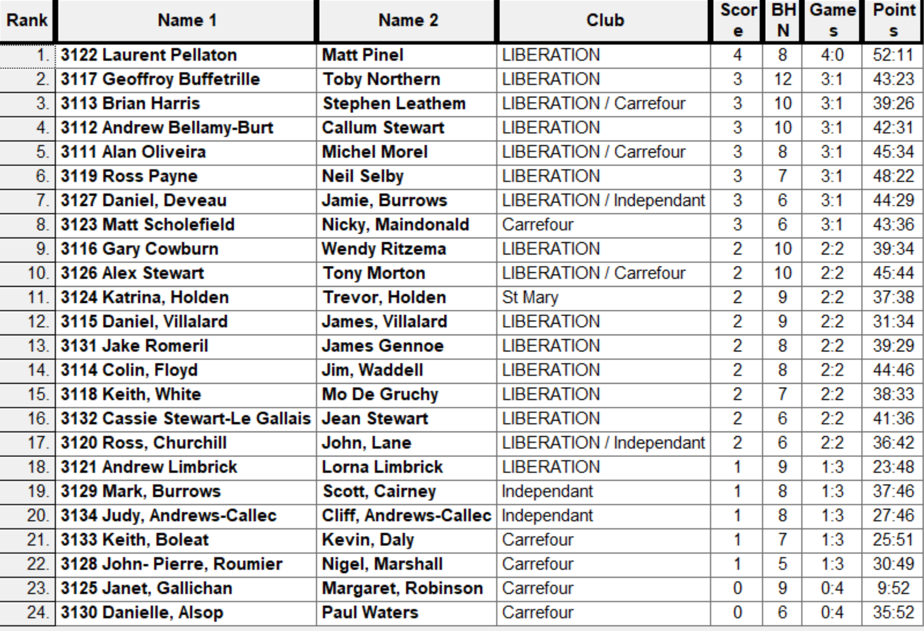

Quarter Final Draw

Ranked 1st Matt Pinel & Laurent Pellaton V Matt Scholefield & Nicky Maindonald Ranked 8th
Ranked 2nd Geoffroy Buffetrille & Toby Northern V Daniel Deveau & Jamie Burrows Ranked 7th
Ranked 3rd Brian Harris & Stephen Leathem V Neil Selby & Ross Payne Ranked 6th
Ranked 4th Andrew Bellamy-Burt & Callum Stewart V Alan Oliveria & Michel Morel Ranked 5th

A couple of unlucky shots saw Laurent & Matt struggle early on but their quality shone through as they avoided the Swiss curse beating Matt & Nicky 13 – 9.

A fairly comfortable win for Geoffroy & Toby but some good play by Daniel & Jamie saw them pick up six points.

Well after winning their first three matches of the day it seems Brian & Stephen just ran out of steam as they lost to Neil & Ross 13 – 4. One shock though as a poor performance by their standards and some good play saw Alan & Michel make the Semi-finals.

Semi Final Draw

Ranked 1st Matt Pinel & Laurent Pellaton V Alan Oliveria & Michel Morel Ranked 5th

Ranked 2nd Geoffroy Buffetrille & Toby Northern V Neil Selby & Ross Payne Ranked 6th

Ranked first and second showed their class in the semi finals as Laurent & Matt won 13 – 3 and Geoffroy & Toby won 13 – 1. Although were not sure who moved the coche the most times between Neil & Ross in their side quest!

In the third place play-off between Alan Oliveria & Michel Morel and Neil Selby & Ross Payne. A very even match went down to the wire but Neil & ross just edged the win 13 – 11 to take third.

The final between Laurent & Matt and Geoffroy & Toby was played at the highest level of pointing and shooting with just fractions between the two teams. Laurent and Matt took an early lead 5 – 3 before Geoffroy & Toby pushed forward to 12 – 6 but Laurent & Matt fought back but couldn’t make it in the end as Geoffroy & Toby retained their title winning 13 – 10.

Thanks to all those who helped out on the day to make it another great competition.

Club email address - liberationpc@gmail.com

Club Website - www.liberationpetanque.co.uk

Kind Regards

Toby Northern

Chairman

Liberation Petanque Club

2025 - Winners 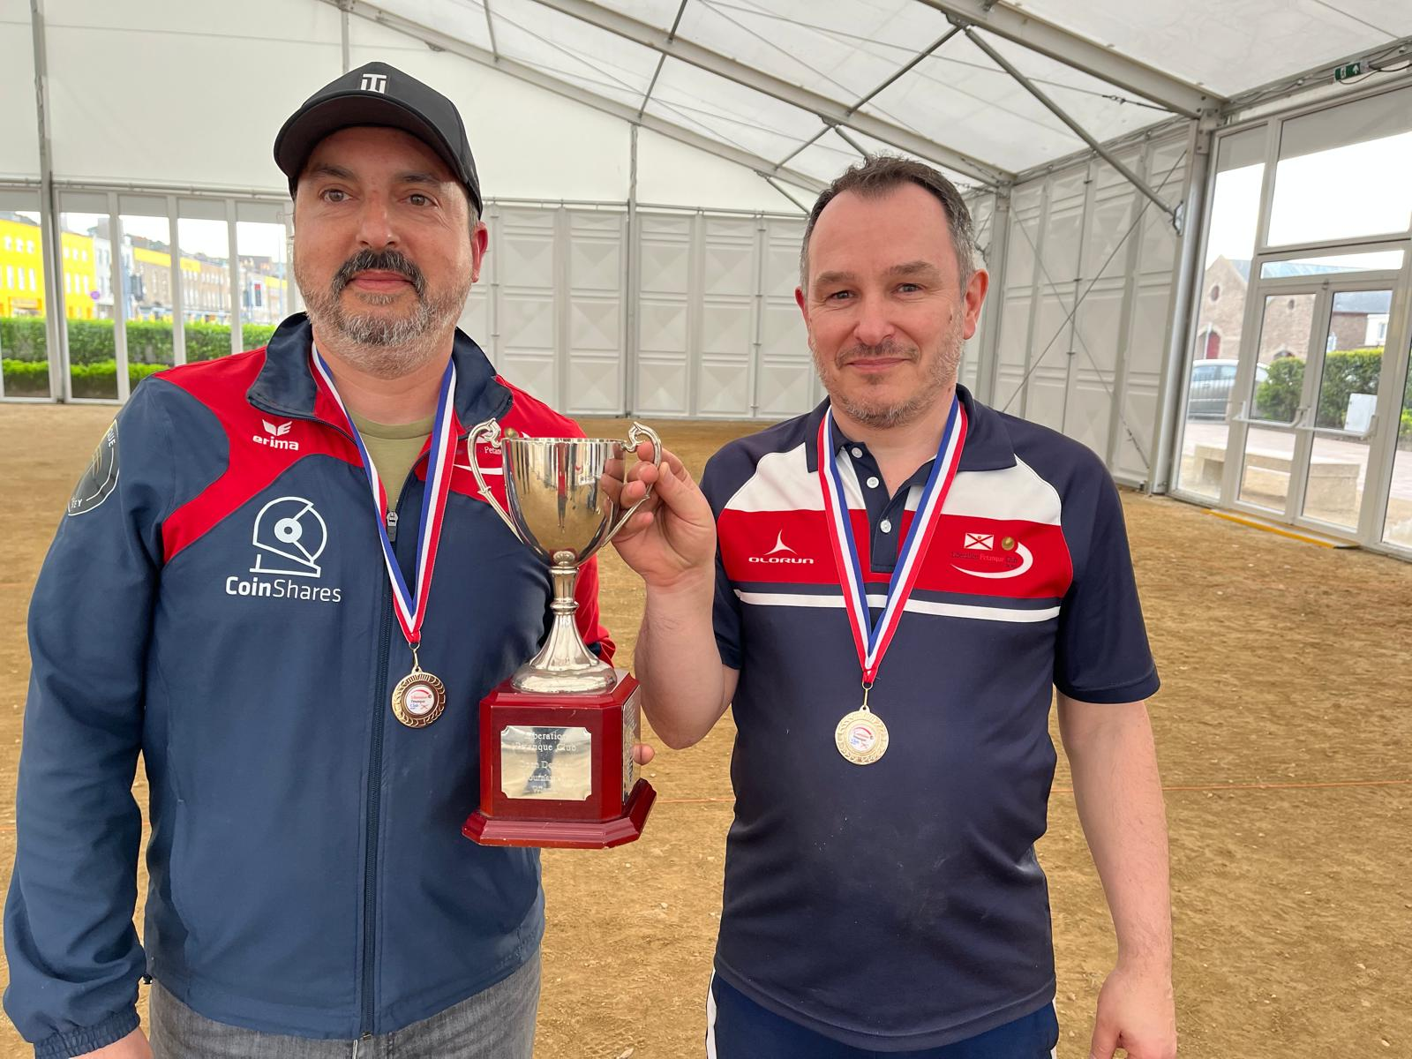
2024 - Winners
