RSAI Position Paper Student Equality - State and District Cost Per Pupil
A 2017 Legislative Priority

History: Before the Iowa school foundation formula was created, school districts depended almost entirely on local property taxes for funding. The level of support varied due to many factors, including community attitudes about the priority of education and local property tax capacity. The formula set a State Cost Per Pupil (SCPP) and brought all districts spending less up to that amount. A combination of some local property tax and some state foundation aid provided funding. Those districts which spent more than the newly defined SCPP were allowed to continue, funded by local property tax payers. Although the formula was created in the mid-1970s, the difference between the SCPP and a higher District Cost Per Pupil (DCPP) has remained. This graphic shows the property tax and state aid components of the SCPP and the DCPP above the $6,591 (FY 2016-17 SCPP).
Up to $175 above SCPP funded with local property tax
$6,591 State Cost Per Pupil
DCPP
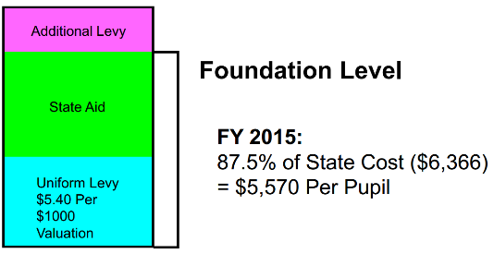
FY 2017:
87.5% of State Cost ($6,591) = $5,797 funded with state aid and local property tax

Current reality: In FY 2017, 163 districts (48.8%) are limited to the $6,591 as their District Cost per Pupil (DCPP). The other 170 districts (51.1%) have a DCPP ranging from $6,592 to $6,766, or $1 to $175 more. When the Legislature determines the increase in the SCPP, that dollar amount is added to the DCPP, so the gap continues at the same dollar amount. On a percentage basis, the $175 is much less today than it was in 1975. However, when school budgets are tight, every dollar matters. This table shows the count of districts based on the range of authority in the formula to exceed the SCPP.
FY 2017 Count of Districts | Amount DCPP is Greater than SCPP
162 | $0
65 | $1 to $35
48 | $36 to $70
25 | $71 to $105
19 | $106 to $140
14 | $141 to $175
Total = 333
Inequity impacting students: The amount of funding generated per pupil for regular education is not the same for all districts. Thus, a student, based solely on the historical practice of the district of residence, can generate more funding or less funding. Another critical question for policy makers relates to the multipliers or formula weightings for special student needs. Those multipliers, applied to the DCPP, generate different amounts of support for students, such as special education students, by application of the formula.
After nearly 40 years of the current formula, the question is, “Should ALL Iowa public school students generate the same amount of funding, on a per student basis, for their regular education costs?”

Solutions: The state could appropriate an estimated $85 million to eliminate the inequality. That total includes both the amount required for the state to assume the entire amount of DCPP already paid with property taxes in those districts that have authority (just over $11 million) plus the supplement for those districts that are held to the minimum ($74 million).
Other possible solutions to promote equality without lowering the per pupil amount available for any school district include:
- Give all local districts spending authority for the difference and allow school boards to decide locally whether to fund it. This solution maintains the state’s funding commitment without increasing it and provides local property taxes to support community schools.
- Set the state cost per pupil at the highest amount but lower the foundation percentage threshold from 87.5% to an amount that balances the impact on the state and on property taxes.
  - While both of these solutions depend on local funding, since many districts have sufficient cash on hand, there would be little cash reserve levy impact for several years in many districts.
- Allow local district authority to use cash reserves to fund the difference under certain circumstances. SSB 1254 and HSB 240, both introduced in the 2015 Legislative Session, include a parameter that the cash reserve levy in the base year may not be exceeded in a future year if providing funds for this purpose. HF 2182, introduced in the 2016 Session, was a short-term limited authority to use cash reserve, giving the legislature time to come up with a more permanent solution.
- Phase in a long-term commitment to eliminate the inequality over time. SF 2104 creates both a transportation and formula equality phase in, beginning with $5 per pupil July 2017, $10 per pupil July 2018, $20 per pupil annually thereafter until the $175 gap is eliminated (by 2027).
- A combination of the two options above would also be possible – authority in the meantime, close the gap over the long haul.

RSAI supports raising the state cost per pupil to the maximum district cost per pupil in the formula.

