Pay online directions Hamden
Link to DU online payment:
Type:https://app.thestudiodirector.com/danceunlimitedct/portal.sd
Or Click Here
- Your username is the email address we have on file.
Enter the password or if this is the first time an existing customer is using online registration, they will need to select the Forgot Your Password? link. The system will send an email to the address they used to log in, with instructions for setting up a password. 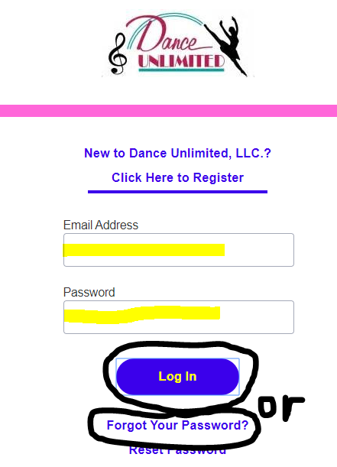

- Under My Account click on Pay Now: 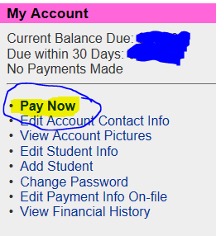
- Enter your card number and expiration drop down and click Next: 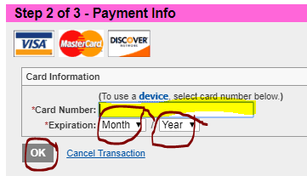
- Now that your card information is entered click Next: 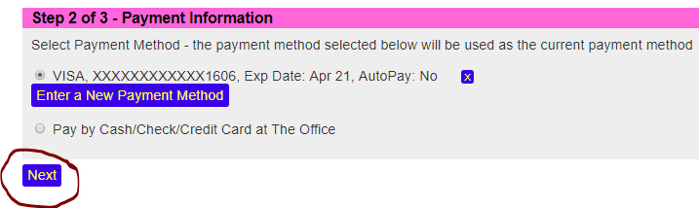
Note: in the future you can enter a new payment method to change the credit card #.
- Click the box I have read the above agreement and agree the all of its terms then click on Accept. 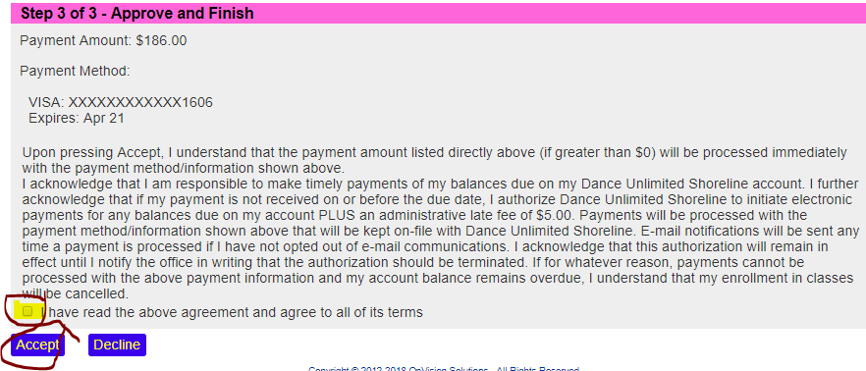
- Check your email for your receipt.

