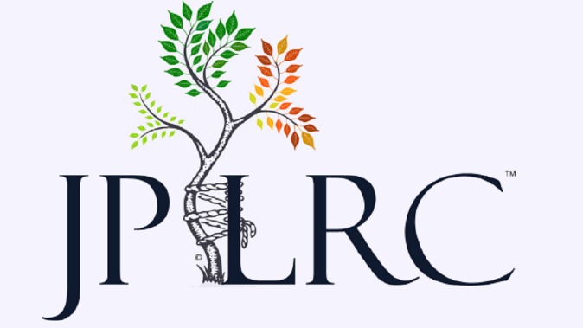

Employment Policy

The Joint Preservation and Limb Reconstruction Center, and its parent company JPLRC, LLC are equal opportunity employers. We are always seeking qualified candidates to fill a number of roles. As a growing practice, we are continually seeking to expand. If you feel that you have a particular talent, or exceptional qualification, please contact us and inquire about any positions that may be available.

Please contact Dr. Matthew Harris, Director at the Joint Preservation and Limb Reconstruction Center via email at dr_harris@jplrc.com or via <https://jplrc.com/contact.html>