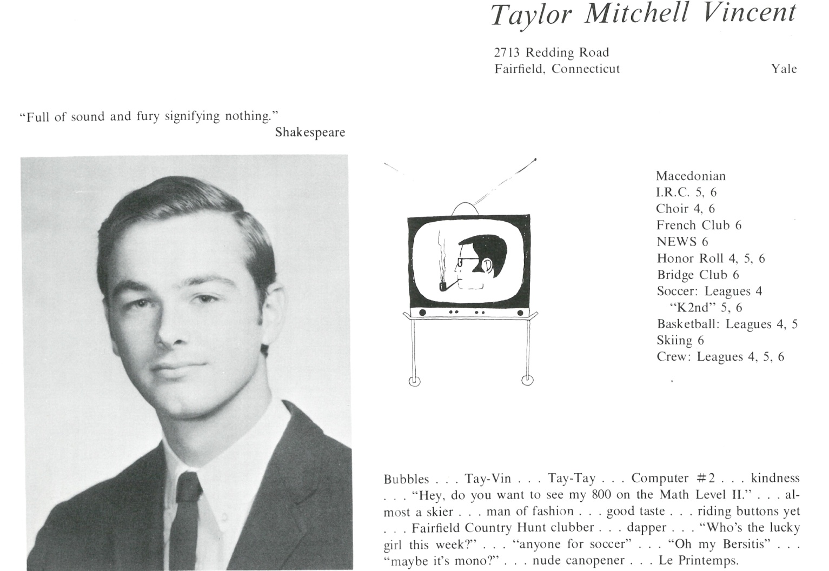

Taylor M. Vincent

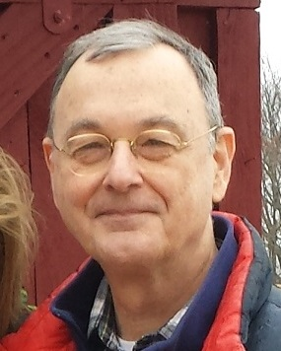The gamut: Yale, commercial banking, international advertising (trips to Europe & Canada), small business coach, semi-retired. Some very good times.

Married to Susan, father of Ross. All good.

Awaiting further developments.

There are rocks on the beach and thorns on the rose, but a beach is a beach and a rose is a rose.



______________________________________________________________

______________________________________________________________ ______________________________________________________________ ______________________________________________________________ ______________________________________________________________ ______________________________________________________________ ______________________________________________________________ ______________________________________________________________ ______________________________________________________________

Attach Picture in .jpg Format

______________________________________________________________

______________________________________________________________

___________________________________________________________________________________ ___________________________________________________________________________________________________________________________________________________________________________________________________________________________________________________________________________________________________________________________________________________________________________________________________________________________________________________________________________________________________________________________________________________________________________________________________________________________________________________________________________________________________________________________________________________________________________________________________________________________________________________________________________________________________________________________________________________________________________________________________________________________________________________________________________________________________________________________________________________________________________________________________________________________________________________________________________________________________________________________________________________________________________________________________________________________________________________________________