WELCOME TO
HOLY SPIRIT LUTHERAN CHURCH
A Member of the Evangelical Lutheran Church in America, New Jersey Synod
1220 Bayshore Rd., Villas, NJ 08251, 609-886-2414,
holyspiritlutheran@comcast.net, holyspiritvillas.com, facebook.com/holyspiritvillas
Vicar Vince Piekarski can be contacted at any time for conversation or prayer through call or text at 412-225-0287, or through email at vpie8282@gmail.com.
SUNDAY, NOVEMBER 30TH, 2025
FIRST SUNDAY OF ADVENT
10:30AM WORSHIP SERVICE WITH HOLY COMMUNION
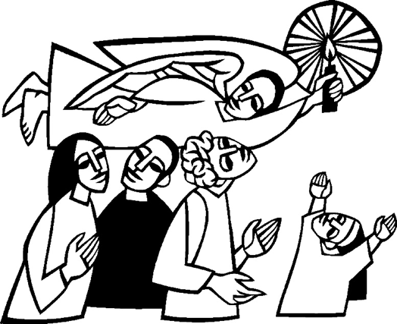

We, the Evangelical Lutheran Church of the Holy Spirit, are People of God, who
are called by the Holy Spirit to pray, worship, joyfully proclaim Jesus Christ,
and compassionately witness and serve others in Christian Love.


We are glad that you joined us for Worship today! Thank you for enriching our time together! We would like to get to know you better, and for you to get to know us better too. Brochures, welcome gifts, prayer shawls, Bibles, and other items are available throughout the church. We would be happy to show you around and share about our ministries. Please do not hesitate to speak up and ask questions.
Also, please make sure you sign-in on our clipboard on the podium in the lobby.


Our Worship Services are conducted in coordination with our Conference Call.
Join us at 657-390-7423 or 701-802-5170, with access code 8221190#.
You may need to dial 1 first depending on your phone plan. After logging in please announce your name and feel free to talk with others until we get started.

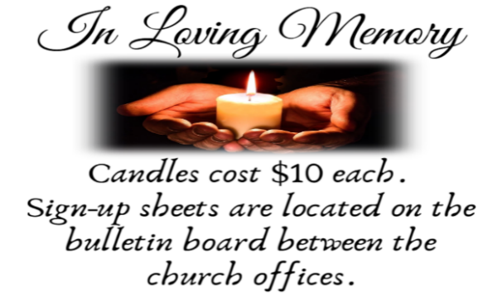
SANCTUARY CANDLE FOR NOVEMBER
Given to the Glory of God & In Memory of ED GREEN by Fran Green & Family.
ALTAR CANDLES FOR NOVEMBER
Given to the Glory of God & In Memory of PHILIP ZIMMERMAN, JR.
by Jean Zimmerman.
CONFERENCE CALL CHECK-IN, WELCOME, & ANNOUNCEMENTS
(Vicar (V), Assistant (A), Reader (R), and Congregation (C).)

INTRODUCTION
A. The new church year begins with a wake-up call: Christ is coming soon! In today’s
readings both Paul and Jesus challenge us to wake from sleep, for we know
neither the day nor hour of the Lord’s coming. Isaiah proclaims the day when God
will gather all people on the holy mountain and there will be no more war or
suffering. Though we vigilantly watch for the promised day of salvation, we wait
for what we already have: Christ comes among us this day as the word and meal
that strengthens our faith in the promises of God.

PRELUDE
(Music offered by our Organist at the start of our Worship Service.)
Moment Musicale

CHIMES
(Music offered by our Organist at the start of our Worship Service.)
The Advent of Our God

V. We invite you to stand as you are able.

CONFESSION & FORGIVENESS
(All may make the sign of the cross, the sign that is marked at baptism.)
V. Blessed be the holy Trinity, ☩ one God,
whose home is heaven and earth,
whose salvation is sure.
C. Amen.

V. Let us confess our sin in the presence of God and of one another.

(Silence is kept for reflection.)

V. Long-expected God,
C. we confess that we look to ourselves
for the peace and security only you can provide.
We reach for swords and spears,
reluctant to release our grip on the ways of war.
We become impatient while waiting
and weary of keeping awake.
Free us from self-reliance,
and teach us to live in harmony with our neighbors.
Increase our trust in God’s timing,
and awaken us to your advent among us,
that we may abound in the hope you have promised.
Amen.

V. God judges us not as we deserve,
but according to God’s own righteousness.
☩ You are freed and forgiven,
saved by grace,
and ready to welcome the Savior.
C. Amen.

GATHERING HYMN
(We invite you to sing along.)
With One Voice—Blue Book
627—My Lord, What A Morning

APOSTOLIC GREETING
V. May the grace of our Lord Jesus Christ, the love of God,
and the communion of the Holy Spirit be with you all.
C. And also with you.

KYRIE
V. In peace, let us pray to the Lord.
C. Lord, have mercy.

V. For the peace from above, and for our salvation, let us pray to the Lord.
C. Lord, have mercy.

V. For the peace of the whole world, for the well-being of the church of God,
and for the unity of all, let us pray to the Lord.
C. Lord, have mercy.

V. For this holy house, and for all who offer here their worship and praise,
let us pray to the Lord.
C. Lord, have mercy.

V. Help, save, comfort, and defend us, gracious Lord.
C. Amen.

HYMN OF PRAISE
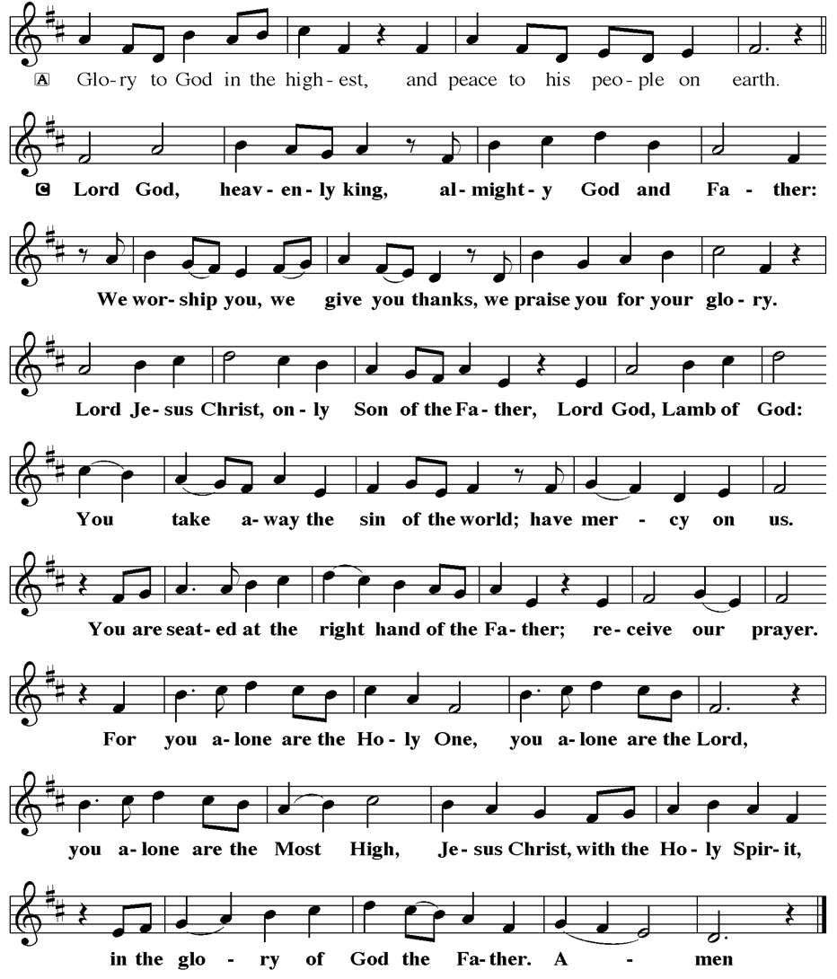
PRAYER OF THE DAY
V. The Lord be with you.
C. And also with you.

V. Let us pray,
Stir up your power, Lord Christ, and come. By your merciful protection save us
from the threatening dangers of our sins, and enlighten our walk in the way of
your salvation, for you live and reign with the Father and the Holy Spirit, one God,
now and forever.
C. Amen.

(We invite you to be seated for our Readings and Psalm.)

FIRST READING
The visionary message presented in this reading focuses on a future day when
God establishes a universal reign of peace. Divine decisions will make war
obsolete, and the worshiping community responds: “Let us walk in the light of that
Lord now!”

R. Our First Reading is from the 2nd Chapter of Isaiah (Verses 1-5).

R. 1 The word that Isaiah son of Amoz saw concerning Judah and Jerusalem.

2 In days to come
the mountain of the Lord’s house
shall be established as the highest of the mountains
and shall be raised above the hills;
all the nations shall stream to it.
3 Many peoples shall come and say,
“Come, let us go up to the mountain of the Lord,
to the house of the God of Jacob,
that he may teach us his ways
and that we may walk in his paths.”
For out of Zion shall go forth instruction
and the word of the Lord from Jerusalem.
4 He shall judge between the nations
and shall arbitrate for many peoples;
they shall beat their swords into plowshares
and their spears into pruning hooks;
nation shall not lift up sword against nation;
neither shall they learn war any more.
5 O house of Jacob,
come, let us walk
in the light of the Lord!

R. This is the Word of the Lord.
C. Thanks be to God.
PSALM
R. Our Responsorial Psalm is from the 122nd Psalm.
C. I was glad when they said to me, “Let us go to the house of the Lord.”
(Ps. 122:1)

R. 1 I was glad when they said to me,
“Let us go to the house of the Lord.”
2 Now our feet are standing
within your gates, O Jerusalem.
3 Jerusalem is built as a city
that is at unity with itself;
4 to which the tribes go up, the tribes of the Lord,
the assembly of Israel, to praise the name of the Lord.
C. I was glad when they said to me, “Let us go to the house of the Lord.”
(Ps. 122:1)

R. 5 For there are the thrones of judgment,
the thrones of the house of David.
6 Pray for the peace of Jerusalem:
“May they prosper who love you.
7 Peace be within your walls
and quietness within your towers.
8 For the sake of my kindred and companions,
I pray for your prosperity.
9 Because of the house of the Lord our God,
I will seek to do you good.”
C. I was glad when they said to me, “Let us go to the house of the Lord.”
(Ps. 122:1)

SECOND READING
Paul compares the advent of Christ to the coming of dawn. We live our lives
today in light of Christ’s coming in the future.

R. Our Second Reading is from the 13th Chapter of Romans (Verses 11-14).

R. 11 Besides this, you know what time it is, how it is already the moment for you to
wake from sleep. For salvation is nearer to us now than when we became
believers; 12 the night is far gone; the day is near. Let us then throw off the works
of darkness and put on the armor of light; 13 let us walk decently as in the day,
not in reveling and drunkenness, not in illicit sex and licentiousness, not in
quarreling and jealousy. 14 Instead, put on the Lord Jesus Christ, and make no
provision for the flesh, to gratify its desires.

R. This is the Word of the Lord.
C. Thanks be to God.

V. I invite you to stand as you are able, and I invite you to announce the Gospel
Acclamation with me.

GOSPEL ACCLAMATION
C. Alleluia. Show us your steadfast love, O Lord, and grant us your salvation.
Alleluia. (Ps. 85:7)

GOSPEL READING
Jesus describes his second coming as a sudden, turbulent event that will bring
about deep change to our normal, day-to-day lives. Therefore, he urges people to
stay awake, be aware, and wait expectantly, because the Son of Man will come
unannounced.

V. The Holy Gospel According to Luke, the 24th Chapter (Verses 36-44).
C. Glory to you, O Lord.

V. [Jesus said to the disciples,] 36 “About that day and hour no one knows, neither
the angels of heaven, nor the Son, but only the Father. 37 For as the days of
Noah were, so will be the coming of the Son of Man. 38 For as in the days before
the flood they were eating and drinking, marrying and giving in marriage, until the
day Noah entered the ark, 39 and they knew nothing until the flood came and
swept them all away, so, too, will be the coming of the Son of Man. 40 Then two
will be in the field; one will be taken, and one will be left. 41 Two women will be
grinding meal together; one will be taken, and one will be left. 42 Keep awake,
therefore, for you do not know on what day your Lord is coming. 43 But
understand this: if the owner of the house had known in what part of the night the
thief was coming, he would have stayed awake and would not have let his house
be broken into. 44 Therefore you also must be ready, for the Son of Man is
coming at an hour you do not expect.”

V. This is the Gospel of the Lord,
C. Praise to you, O Christ.

(We invite you to be seated.)

SERMON
(Delivered by Vicar Vince Piekarski.)

(Following the Sermon, we invite you to stand as you are able.)

HYMN OF THE DAY
(We invite you to sing along.)
Lutheran Book of Worship—Green Book
25—Rejoice, Rejoice, Believers

APOSTLES’ CREED
V. God has indeed made us his people through our Baptism into Christ. Living
together in trust and hope let us confess our faith together using the Apostles’
Creed.
C. I believe in God, the Father almighty,
creator of heaven and earth.

I believe in Jesus Christ, God’s only Son, our Lord,
who was conceived by the Holy Spirit,
born of the Virgin Mary,
suffered under Pontius Pilate,
was crucified, died, and was buried;
he descended to the dead.
On the third day he rose again;
he ascended into heaven,
he is seated at the right hand of the Father,
and he will come to judge the living and the dead.

I believe in the Holy Spirit,
the holy catholic church,
the communion of saints,
the forgiveness of sins,
the resurrection of the body
and the life everlasting.
Amen.

PRAYERS OF INTERCESSION
(The prayers are prepared locally for each occasion.)
V. In our waiting and watching, we come to you in prayer, O God, trusting your
promise to renew the church, the nations, and the whole creation.

(A brief silence.)

A. God of the people, we come seeking wisdom and instruction. Uphold and
strengthen lay leaders, teachers, deacons, vicars, pastors, and bishops. Teach
us your ways and lead us in your paths. God of grace,
C. hear our prayer.

A. God of the earth, we seek your goodness in the grandeur of creation. Empower
us to care for forests and oceans, as we see you in the world around us. God of
grace,
C. hear our prayer.

A. God of the nations, grant wisdom to leaders, judges, and mediators. Cast out
words of hate and transform them into words for building up community. Remake
implements of war to sow peace. God of grace,
C. hear our prayer.

A. God of healing, bring comfort and strength. We pray for our kindred and
companions who are ill or despairing; especially:
those affected by HIV and AIDS, as we remember World AIDS Day
BettyAnn Rich-White (Church Member)
Chip & Marie Hand (Church Members)
Lynn Bargstadt (Church Member)
Frank Ford (Church Member)
Carol Amundsen (Church Member)
Kim McGinley (Church Member)
Anthony DeLuca (Church Member)
Frank Brunner (Church Member)
Joan Sommerman (Church Family)
Arleen Kinka (Church Family)
Rick Lang (Church Family)
Suzie Clark (Rose Lang's Friend)
Francis Clock (Dianna DeNote’s Family)
Andrew Hudak (Rose Lang’s Friend)
Viena Murtha (Bob Fritsch’s Friend)
Sharon Waicus (Skip & Bonnie Millard's Friend)
Karen O'Brien (Paul Bowker's Friend)
Dustin Irizzary (Mary Melnicoff's Family)
The Bryan Family (Wanda Bryan's Family)
Craig Brearey (Judy Brannan & Mary Melnicoff's Friend)
Sarah Dutton (Frank Ford's Family)
Christina McNasby (Fran Green’s Family)
The Kinkson Family (Judy Brannan's Friends)
Mark Stephen Dennis (Diana DeNote's Family)
Bill Lodge (Skip & Bonnie Millard's Friend)
Ron Anderson (Bill Kelly's Friend)
Bud Brearey (Judy Brannan & Mary Melnicoff's Friend)
Mary Skain (Kathy Poehler's Friend)
Robert Chaplin (Mary Melnicoff's Friend)
Jack Wieckouski (Theresa & Kim McGinley's Family)
Carolyn Santarpio (Bob Fritsch's Friend)
Harry (Judy Brannan's Friend)
Janet K (Philomena Noak's Friend)
Michael Hart (Diana DeNote's Friend)
Rocco Leonard DeNote (Diana DeNote's Family)
Al Singer & Family (Frank Ford's Friends)
Sherri Lynn (Bob Fritsch's Friend)
John Bannco (Bob Fritsch's Friend)
Nancy Pazarinie (Bob Fritsch's Family)
Jane & Paul Eiben (Rose Lang's Friend)
Joe DiMassimo (Judy Brannan & Mary Melnicoff's Friend)
Tommy Stanford (Sue Waltz's Family)
Audrey McAlister (Sue Waltz's Family)
Joe Waltz (Sue Waltz's Family)
Denny Papst (Rose Lang’s Friend)
Mike & Alice Rhoades (Rose Lang’s Friends)
Chris (Judy Brannan's Friend)
Helen Ehlers (Judy Brannan's Friend)
Leanne Bueth (Joan Kilcoyne's Family)
Janett MacFarlane (Carol Amundsen's Friend)
Patrick Davenport (Sue Waltz's Friend)
Thish Kelly (Theresa & Kim McGinley's Family)
Edward Chapleski (Allison Call's Family)
Scott Levin (Rose Lang's Friend)
Lynne Curlett (Del McKenna's Family)
Alice Ann Dennis (Diana DeNote's Family)
Nancy Taylor (Ted & Diane Bell's Family)
Santa Isabel Lutheran Church (Elizabeth, NJ)
Messiah Lutheran Church (Oakland, NJ)
Carol Brand (Skip & Bonnie Millard’s Friend)
Joyce Thompson (TDPWC Member)
Barbara Paynter (Leon Stitt’s Family)
Ruth (Anthony & Vincent Bruno's Family)
Tom M (Philomena Noak's Family)
William T Hodgetts (Pastor William Hodgetts’ Family)
Paul Bowker (Church Member)
BettyAnn & Bill Whitman (Mary Melnicoff's Friends)
Bob Poole (Kathy Poehler's Family)
David Smith (Heather & Vicar Vince Piekarski’s Family)
Joe Smith (Heather & Vicar Vince Piekarski's Family)
Barbara Hoitink (Lucas & Sabrina Munson's Family)
Kathy Raynor (Philomena Noak & Mary Melnicoff’s Friend)
Ed Cox (Church Family)
Audrey Knott (Judy Brannan’s Family)
Brownie (Diana & Rocco DeNote's Dog)
Jordan (Carol Amundsen's Friend)
Myrna (Brookdale Resident)
The Family & Friends of Patti Faikish (Fran Green's Friend)
Jeremy Pochatko (Vicar Vince Piekarski's Friend)
(Additional Names Added Prior to the Worship Service.)
A. Surround all with care and consolation. God of grace,
C. hear our prayer.

A. God of new possibilities; when addiction, wounds, and jealousy tears down and
frays relationships, show us how to journey with one another. Nurture therapists,
counselors, chaplains, and sponsors in their care for others. God of grace,
C. hear our prayer.

A. God of all time, build up our lives that we would reflect your grace. At the last,
bring us with all the saints to your holy city where peace and goodness make a
home. God of grace,
C. hear our prayer.

(Here other intercessions may be offered.)
V. Watch over all of us who are worried and suffering, and especially those whose
names we now say aloud or hold within our hearts (pause). God of grace,
C. hear our prayer.

V. Draw near to us, O God, as we commend all for whom we pray, trusting in your
mercy through Jesus Christ, Emmanuel.
C. Amen.

SHARING OF THE PEACE
V. May the peace of the Lord be with you always.
C. And also with you.
V. Now, let us share God’s Peace with one another.



(Please respect your neighbor if they desire to still only offer a peace sign or wave.)

(Following the Sharing of the Peace, we invite you to be seated.)

OFFERING
V. We now worship God with our tithes and offerings, wine and bread for use in holy
communion, and monetary gifts to support our ministry for service in God’s name.
Our Ushers will be around to your pews to pass the Offering Plates.

(Ushers come forward to get the Offering Plates from the Assistant.)

(Vicar and Assistant prepare the Altar for Communion.)

OFFERING SONG
(We invite you to sing along.)
Worship & Praise
156—What Have We to Offer?
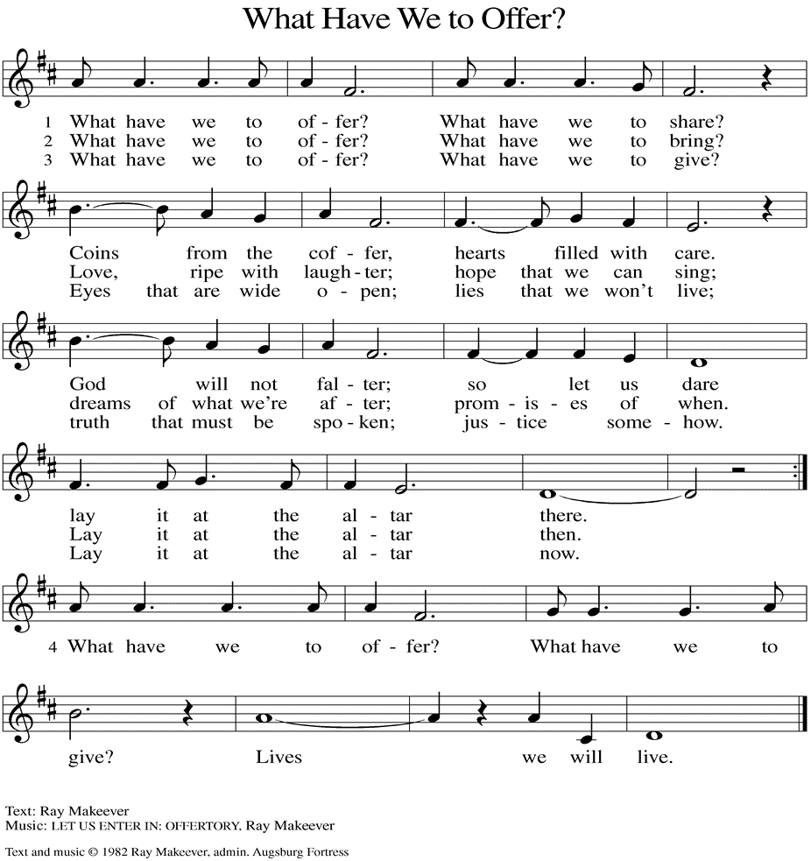
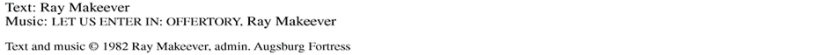

(Usher(s) brings the Tithes and Offerings up front to the Assistant.)

V. We invite you to stand as you are able.
OFFERING PRAYER
V. Let us pray,
Nourishing God,
you are water in the wilderness and streams in the desert.
Through this meal, satisfy our parched places,
that we may rejoice and be for the world
signs of your kingdom come.
C. Amen.

GREAT THANKSGIVING
V. The Lord be with you.
C. And also with you.

V. Lift up your hearts.
C. We lift them to the Lord.

V. Let us give thanks to the Lord our God.
C. It is right to give him thanks and praise.

V. It is indeed right and salutary that we should at all times and in all places offer
thanks and praise to you, O Lord, holy Father, through Christ our Lord; who rose
beyond the bounds of death and, as he promised, poured out your Spirit of life
and power upon the chosen disciples. At this the whole earth exults in boundless
joy. And so, with the Church on earth and the hosts of heaven, we praise your
name and join their unending hymn:

SANCTUS
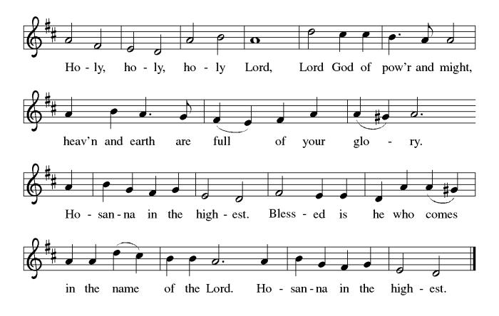

THE EUCHARISTIC PRAYER
V. Blessed are you, Lord of heaven and earth, in mercy for our fallen world you gave
your only Son, that all those who believe in Him should not perish, but have
eternal life. We give thanks to you for the salvation you have prepared for us
through Jesus Christ. Send now your Holy Spirit into our hearts that we may
receive our Lord with a living faith as He comes to us in His holy supper.
C. Amen. Come, Lord Jesus.

V. In the night in which he was betrayed our Lord Jesus took bread,
he gave thanks; broke it, and gave it to his disciples, saying:
Take and eat; this is my body, given for you.
Do this for the remembrance of me.

V. Again, after supper, He took the cup, he gave thanks,
and gave it for all to drink, saying:
This cup is the new covenant in my blood,
shed for you and for all people for the forgiveness of sin.
Do this for the remembrance of me.

THE LORD’S PRAYER
(We ring the bell throughout the Lord’s Prayer at all services to
invite those in the community to join in praying the Lord’s Prayer.)
V. May we now join with one another and pray together as Jesus has taught us.
C. Our Father, who art in heaven, hallowed be thy name, thy kingdom come,
thy will be done, on earth as it is in heaven. Give us this day our daily
bread; and forgive us our trespasses, as we forgive those who trespass
against us; and lead us not into temptation, but deliver us from evil. For
thine is the kingdom, and the power, and the glory, forever and ever.
Amen.

LAMB OF GOD

(We invite you to be seated.)

HOLY COMMUNION
V. Communion here is pretty simple, and all who are baptized and believe in Jesus
Christ are welcome at the table.

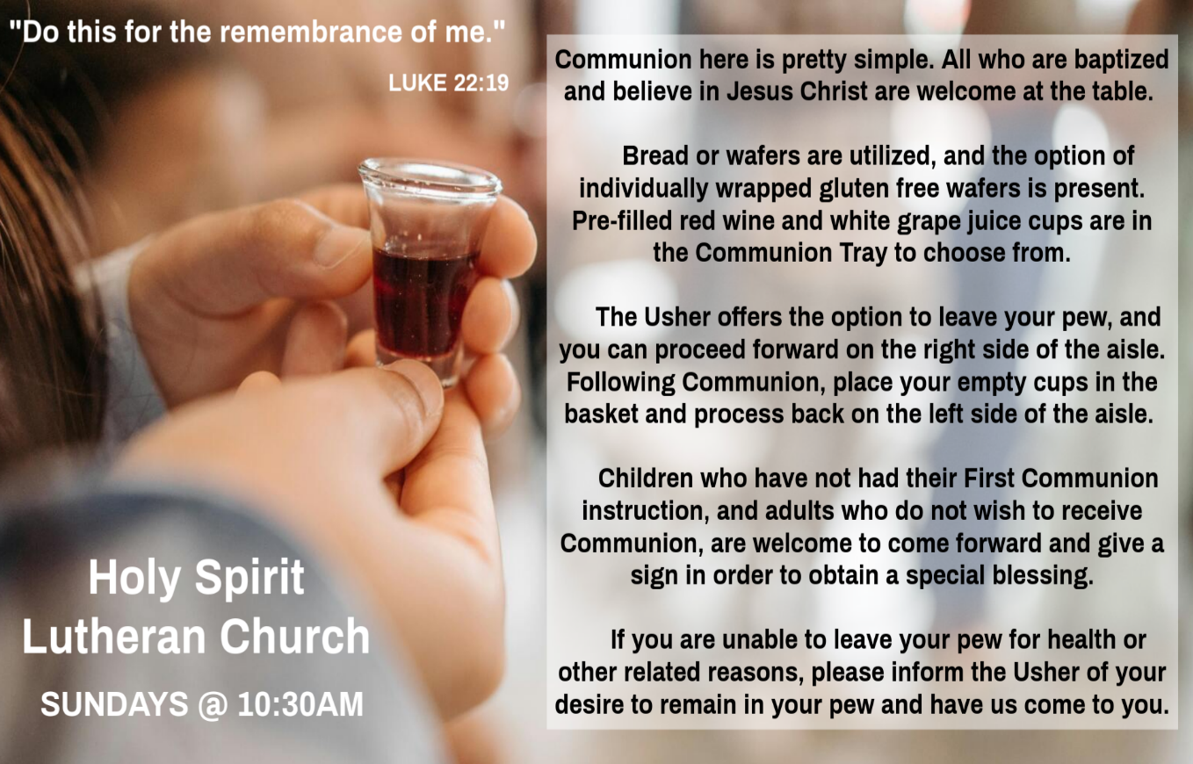

INVITATION TO COMMUNION
V. Here is life. God is with us.
Come, receive what God has promised.
C. Amen.

(Distribution of Holy Communion)

COMMUNION HYMN
(Please enjoy various music offered by our Organist during your
quiet time, prayer, and reflection following Holy Communion.)

(Vicar and Assistant remove Communion Vessels from the Altar.)

V. We invite you to stand as you are able.

POST COMMUNION BLESSING
V. May the body and blood of our Lord Jesus Christ strengthen us and keep us
always in His grace.
C. Amen.

POST COMMUNION CANTICLE
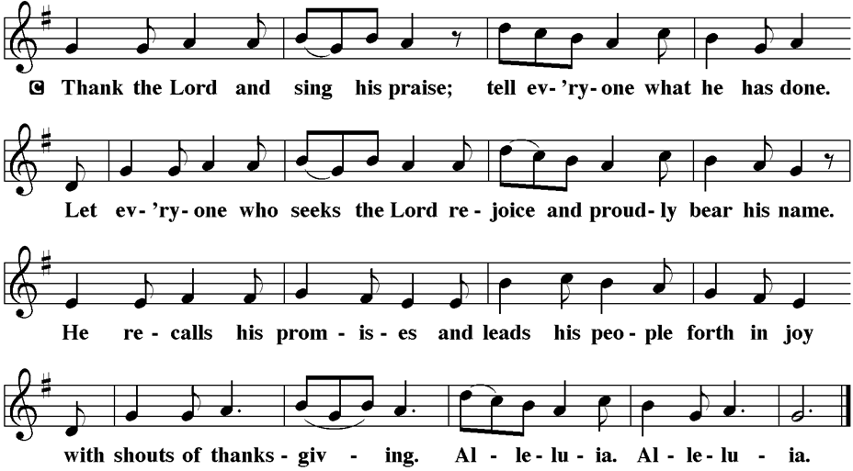

PRAYER AFTER COMMUNION
A. Let us pray,
God our host,
at this table you have fed us with joy and gladness.
Send us forth, eager to share the feast,
welcome the stranger,
and bear good fruit in the name of Jesus.
C. Amen.

BLESSING
V. May God who comes among us,
Father, ☩ Son, and Holy Spirit,
grant you patience in waiting, peace in the darkness,
and good news to share today and always.
C. Amen.
SENDING HYMN
(We invite you to sing along.)
With One Voice—Blue Book
744—Soon and Very Soon

(Assistant extinguishes the Altar Candles half way through the Sending Hymn.)

(Vicar processes out once the Altar Candles have been extinguished.)

(We invite you to be seated.)

BIRTHDAYS, ANNIVERSARIES, & ANNOUNCEMENTS
(Offered by Assistant and Congregation.)

BIRTHDAYS
30th Caylee Thomas
2nd Leon Stitt
6th Anthony DeLuca

DISMISSAL
A. Go in peace. Keep awake.
C. Thanks be to God.

POSTLUDE
(Music offered by our Organist as we depart following our Worship Service.)
Epilogue on “Silver Street”

LICENSES & EXPIRATION DATES
Worship Service Content is used via permission through Augsburg Fortress Liturgies Annual License #SB144368. The next Subscription Renewal Date is 2/28/2026.
Our Hymns and Worship Music are used via permission through CCLI One
License #11327166. The next Subscription Renewal Date is 1/31/2026.

CONFIRMATION & SUNDAY SCHOOL
“Here We Stand” allows our young folks to go through a 2-year process while focusing on the Bible and Luther’s Small Catechism. Studies for year two of our program have resumed. There will be no class this week due to Thanksgiving. We will meet again next Sunday, December 7th, and every Sunday from 9-10AM.

INTINCTION DURING COMMUNION
Intinction while communing together will occur in the months that have a fifth Sunday. Our next time doing this will be TODAY, Sunday, November 30th.

WORSHIP MINISTRY
The most important thing we do each week is gather together as God's people to Worship. God is the center and focus of everything we do. Participating in Worship is active, as Liturgy means the work and actions of the people gathered. Everything we do during the week to prepare for Worship, and everything we do as we Assist in leading Worship is important. We are thankful for all the wonderful work being done. If you have questions, or are interested in any position, reach out to Vicar Vince.
Sign-up sheets are located on the bulletin board between the church offices.

CLINICAL PASTORAL EDUCATION
Vicar Vince has been blessed with the opportunity of joining Chaplain Stephen Faller on-line for CPE classes on Sunday afternoons from 4PM-8:30PM on Zoom. Please be respectful of this if you happen to see his car at the church.
WOMEN OF THE CHURCH
The next monthly meeting will be on Monday, December 1st, at 6PM, and the Women will be holding their Annual Cookie Exchange. New members are always welcome to attend! Contact Judy for more information.

BIBLE STUDY & FAITH DISCUSSIONS
Bible Study & Faith Discussions was started in order to focus on various readings,
books, Bible verses, people of faith, and other general topics. Group Members offer
various points of view while reviewing the Bible and various aspects of faith while
being respectful and supportive of each other. Join us on Tuesdays at 6PM.

FOOD PANTRY
Open every Thursday, and the last Saturday of every month, from 10AM to 1PM. 96 people were served in October and 734 people have been served in 2025. Donations can be dropped in the outdoor drop-box, in the money jug in the back of the Church, mailed into the Church Office, or placed in the Offering Plate. Volunteers are needed. Sign-up sheets are located on the bulletin board between the church offices. If you have questions or need training see Heather, Vicar Vince, or Bonnie.
A special thank you goes out to all who donate, pray, and help in any way!

Thursday, 12/4 | Thursday, 12/11 | Thursday, 12/18
Tori & Cathie | Garnet, Joe, & Patti | Patti & Garnet

COMMUNITY FOOD DONATIONS, DELIVERIES, & MORE
Our local North Cape May Acme provides us with Expiring Soon, Recently Expired, and Slightly Damaged Food and Items weekly. Kathy helps those in need by delivering items each Saturday in the community, brings leftover items to the Church for church members in need, and those who visit the food pantry during the week. Additional items are taken over to the Branches Outreach in Rio Grande on Monday.

BULLETIN ENTRY DEADLINE
The Bulletin is printed on Thursdays during Church Office Hours. Changes need to be submitted to Vicar Vince or Heather no later than Thursday by 4PM. Thank you!

CHURCH OFFICE HOURS
Open Thursday from 6PM to 8PM to serve the Congregation, the Community,
and to continue handling the business of the Church. Feel free to stop in to talk,
pick-up or drop off something, pray in the Sanctuary, or for whatever reason.


Please join us this year as we have added well over 10 more trees, and are over 60 total. Check out all the other decorations while enjoying food, refreshments, and fellowship time with one another. We look forward to you, your family, and your friends coming out and joining the fun while getting into the holiday spirit.
Friday, December 5th 6-9PM
Saturday, December 6th 6-9PM
Sunday, December 7th 1-4PM
Our Facebook Live Tree & House Tour will be Sunday Evening, December 7th at 9PM for those that cannot attend in-person. RSVP to Heather 724-875-6895 or Vicar Vince at 412-225-0287. We are located at 16 W Tampa Ave., Villas, NJ 08251.

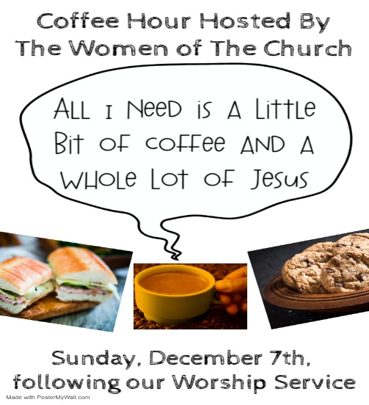

NEWSLETTER
Collect information, stories, pictures, and reports for our next seasonal publication. Winter starts on Sunday, December 21st. All information needs submitted to Vicar Vince in-person or via email at vpie8282@gmail.com no later than December 14th.

PREACHING AT BROOKDALE
Vicar Vince preaches at Brookdale Senior Living in Cape May Court House again on Sunday, December 14th, at 1PM. Holy Communion will follow the service, as well as True Deliverance Praise & Worship Center will be joining us for Caroling.
CHURCH COUNCIL
Share your comments, concerns, questions, or joys with one of our Church Council Members who can bring them back to our meetings. Visitors are always welcome to attend and listen to what is going on in and around the church. Join us In- Person or on our Conference Call at our next Meeting on Tuesday, December 16th, at 6PM.

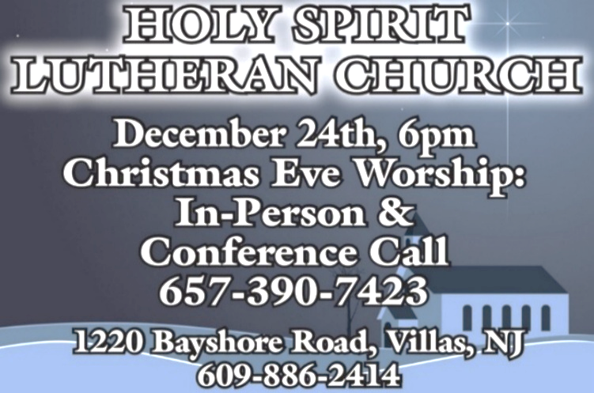

TITHES, OFFERINGS, & ENVELOPES
2026 Offering Envelopes will be available in the back of the church starting on Christmas Eve. We do indeed worship God with our tithes and offerings. We hear this in scripture, “Each of you must give as you have made up your mind, not reluctantly or under compulsion, for God loves a cheerful giver.” (2 Corinthians 9:7) Feel free to drop your envelopes in the offering plate, mail them to the church, or drop them off in the locked mailbox. Thank you for your continued support in the mission of our church, its ministries, the New Jersey Synod, and other needs!

DONATION STATION
Get on the train and place all purchased items in the specified project donation bins located on the counter by the front doors. See Heather for more information.

ANNUAL CONGREGATIONAL MEETING
As 2025 winds down we will be wrapping up the books and reports in preparation for a new year. 2026 will bring about several new things and changes I am sure, but one thing is for certain, we will be meeting as a Congregation for our Annual Meeting. We will discuss and review things, as well as vote on a new budget. I know it is rather early to think about things, but please start compiling your committee reports and make sure Sunday, February 8th is on your calendars, in your planners, or in your phones to meet after our Worship Service together.

CHURCH DIRECTORY
The 2025 Church Directory is by the Church Office on the bookshelves. We continue keeping it updated, but we undoubtedly miss a few changes or have made a few errors. The printed church directories have spaces for changes in info, new people’s info, notes, and your favorite Bible verses. If you have changes or updates please inform the Church Office to keep us up to date. Our 2026 Church Directory will be made available to you the week following our Annual Congregational Meeting.

PRAYER LIST
Our Prayer List continues to lengthen and we realize the important need for prayers and healing. Sometimes the unfortunate result is that someone has passed away, and the words “The Family & Friends of” appear before someone’s name. However, sometimes we forget names are still on the list and their health has improved or the they are no longer struggling, and they can be removed. Please share the good and bad stories as we continue to pray for strength and healing. Names can be added or removed from the list on the clipboard in the Narthex prior to the Worship Service, by calling the church office, or addressing it on the Conference Call. Please let us know the relation to the person(s) you listed so we can be more mindful with our prayers. Names will stay on the list until removed by the person(s) who requested prayer.

PRAYER SHAWL MINISTRY
Prayer Shawls, Lap Quilts, Scarves, and other items have been made with love. Blessed items are located in the Narthex, and are free for anyone. Members of the group continue working at home on new stitches and patterns. We are blessed to be able to continue collecting new items. We have a donation station of yarn and other items located in the Narthex. You can find some new supplies for your next creation!

HOME COMMUNION MINISTRY
A Minister is available if you have a loved one, or if you desire services. We look forward in sharing the Word and Holy Communion! Please inform Vicar Vince, Kathy, or the Church Office so plans can be made for visits.
SPACE AVAILABLE
​​​​​Do you know anyone interested in utilizing our Fellowship Hall for a Party or Event?
It is a suggested $50 refundable security deposit, and $250 for facility use. There is no alcohol or games of chance permitted due to ELCA policy. Please contact Vicar Vince or the Church Office with questions, for info, or to reserve a date and time.

ED GREEN CAPITAL IMPROVEMENT FUND
We continue raising money for unforeseen costs or repairs. Kathy has been selling Wawa Tickets for $6, but we have learned the program will end in 2025. Please use your tickets that you have purchased before the end of the year. We will seek out a new fundraiser. We still have the donation bin in the back of the church and our Church Rummage Sale. Thanks for your continued donations, prayers, and support!

INTERESTED IN BECOMING A NEW MEMBER
Have you been attending our church for a while? Have you just recently returned to church after being away for a bit? Maybe you transitioned from another church,
or just started to recently attend our church. We are glad to have you, and would love to have you as a member of our Congregation. See Vicar Vince for more info.

BAPTISM
We are a church whose unity is in Jesus Christ, who gathers us around word and water, wine and bread. Baptism is a significant part of our faith journey as we come from the baptismal waters to live a new life as children of God. Our baptism sets us out on a lifelong journey that is characterized by our relationship to God, our relationship to our faith community, our relationships in our community and the wider world. Living our baptismal covenant means living a life of growth in the faith practices of discipleship. Please see Vicar Vince for more information.

FIRST COMMUNION
Although no particular age for first communion is prescribed by The Use of the Means of Grace, one guideline is offered. Because admission to the Sacrament is by invitation of the Lord to the baptized, "baptized children begin to commune on a regular basis at a time determined through mutual conversation that includes the pastor/vicar, the child, and the parents or sponsors involved, within the accepted practices of the congregation.” Each congregation is encouraged to ask the question of readiness for first communion, establish their own policies regarding age and practice, and accompany that practice with catechesis appropriate to the age of the communicant. If anyone has questions, please see Vicar Vince.

LIBRARY
New books are added to our library from time to time. Several are borrowed and read and exchanged. Who knows, you might find one particularly interesting and share that with someone as well. Reading is a great way to pass spare time, learn, and explore. You may find some fresh ideas for prayer, ways to grow more spiritually, ways to grow closer to God, or some opportunities to understand our faith more. We also have an extended library located in Vicar Vince’s office. There are Bibles of various translations, books from his personal collection, books inherited from Pastor Leah, movies, past Bible Study Curriculums, and more. Visit the library between the church offices, or just ask to be able to check things out.

FAVORITE HYMNS
Carol is willing to play some of your favorite hymns for the Prelude & Postlude each Sunday during our Worship Service. Feel free to let her know of your suggestions.

JERSEY JOTTINGS
There is a weekly e-newsletter connecting our synod together with weekly prayer, upcoming events, synod and churchwide activities, mission stories, congregational activities, & more. Sign up at www.njsynod.org/stay-connected or download the app.

VICAR APPOINTMENT ON MARCH 19TH, 2023
A Memorandum of Understanding on the Matter of Pastoral Appointment
In Theological Education for Emerging Ministries (TEEM) Candidacy
TO: Congregation Council, Holy Spirit Lutheran Church, Villas
FROM: The Rev. Tracie L. Bartholomew, Bishop, New Jersey Synod

Dear Brother and Sisters in Christ,
This memorandum is in support of your discussions with Vincent Piekarski as pastor of Holy Spirit, Villas. Because this is not the usual pattern for completing the educational and candidacy requirements for ordination, it is my hope that this memorandum will both provide guidelines and engage in conversation with those who are invested in this process.

I would say at the outset that because Vincent is an outstanding candidate for the Ministry of Word and Sacrament, we will all want to do whatever is necessary to assure that his placement serves the mission of the church in the best possible fashion.

The following notes reflect my own understanding of this matter:
(1) The appointment for Vincent will begin on April 1, 2023. At this time, Vincent
will assume all responsibilities of a regularly called pastor, including presiding at
the Sacrament of Holy Communion and Baptism at Holy Spirit, Villas.
(2) A pastoral appointment in the TEEM process is an option for completing
seminary educational requirements and the steps of the candidacy process.
Upon completion of the candidacy process and seminary education, the
candidate may receive and accept a call to ordained ministry from the
congregation where the appointment is being served.
(3) This appointment is jointly supervised by the Office of the Bishop and the TEEM
pastor’s seminary. A mentoring relationship with a local pastor is required for the
length of this appointment.
(4) The synod of candidacy origin will be responsible for the approval process.
(5) Upon approval for ordination, the congregation would be expected to extend a
call to the pastoral appointee.
(6) Compensation for the TEEM pastor will be according to the guidelines of the New
Jersey Synod. All normal forms of compensation should be in place for the term
of the appointment, including stipulation that base salary and housing shall be in
accord with synod guidelines for first call at time of ordination.
(7) The ELCA Portico benefit plan for lay persons in full-time church service should
be used for the pastoral appointee up to the time of ordination, whereupon the
benefit package is to be converted to the plan for ELCA clergy.
(8) A decision for Pastoral Appointment is made with the agreement of a synod and
its candidacy committee, and the ELCA, normally represented by the regional
staff person of each in consultation with the seminary and its Director for
Contextual Education.
(9) Pastoral Appointment in a TEEM Candidacy is an option that is to serve the
mission of the Church in a particular and vital way and is not to be viewed or
used as a means to circumvent the normal candidacy process and/or first call
placement process.

In the specific case of Vincent, the New Jersey Synod remains responsible for the candidacy and approval process, and has agreed to this proposal for Appointment at Holy Spirit, Villas.

Continued blessings to both Holy Spirit and Vincent Piekarski as you embark on this journey of mutual ministry. As partners in ministry, we walk with you and rejoice in this new relationship.

VICAR VINCE’S DAY OF REST
A day of rest can have physical, mental, and spiritual beneficial. “Mittwoch,” German for mid-week, or Wednesday, is the day that Vicar Vince will use to recharge and do some other things. Please do not hesitate to reach out if there is an emergency!

VICE PASTOR UPDATE
Pastor William Hodgetts continues to attend our Church Council Meetings
and provides Supervision and Support to Vicar Vince.

ADDITIONAL OFFERINGS FROM OUR FRIENDS & NEIGHBORS
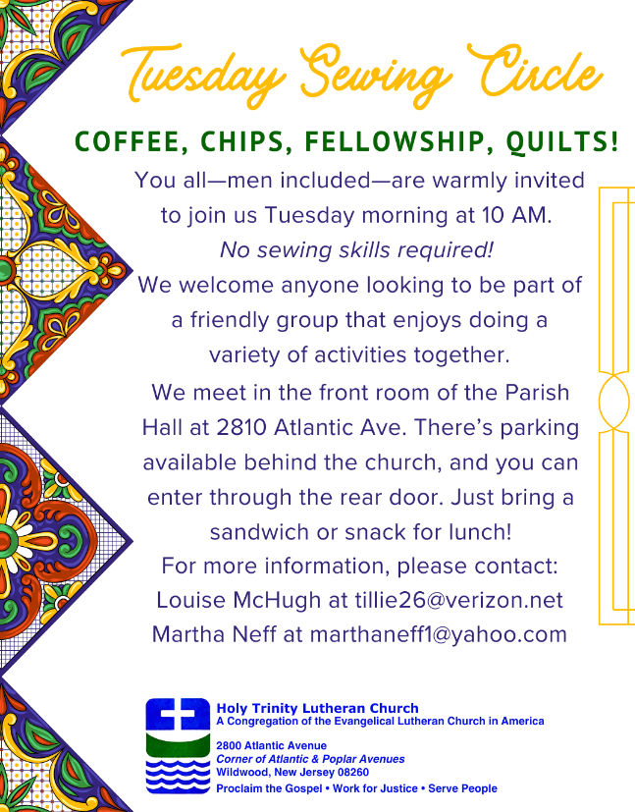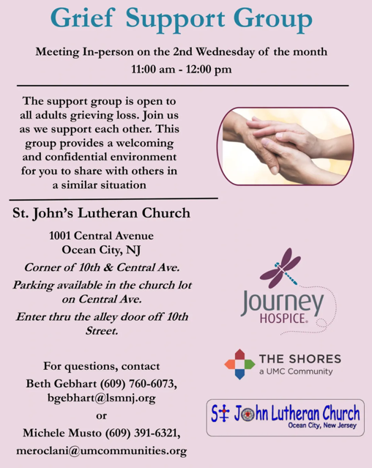
TRUE DELIVERANCE PRAISE & WORSHIP CENTER
Reverend Maria Brooks and True Deliverance Praise & Worship Center utilize our facilities from 1-4PM on Sundays. TDPWC hosts or assists with other events throughout the year. TDPWC hosts a Prayer Line on Mondays, Wednesdays, & Fridays at 5PM on the Conference Call 1-657-390-7957; & Bible Study on Thursdays at 6:30PM on Zoom. See Rev. Brooks for more information.

JUST FRIENDS
Promotes a spirit of fellowship among adults 50 years and older. Bring your own lunch to enjoy, beverages and deserts are provided. Everyone is welcome regardless of faith or parish affiliation. The group meets in Our Lady Star of The Sea Parish Hall on the last Wednesday of the month from 12Noon to 2PM from September through May. For more info call Martine Simonis 609-884-5312 x 110.

ST. BARNABAS CARES THRIFT STORE
Are you a person who enjoys staying active, interacting with others, likes the flexibility of working an hour or two per month and would like to support a good cause? If so, then St. Barnabas Cares Thrift Store is looking for you! The store in the Villas is looking for friendly, outgoing people to volunteer and sell clothing. There is no heavy lifting, but instead you would be arranging clothing attractively for sale. The Thrift Store is open 11-3 Monday through Saturday so even volunteering a few hours a month will help. If interested, please call Maureen Kersch 609-425-1317.

WHAT IS THE EVANGELICAL LUTHERAN CHURCH IN AMERICA?
The ELCA was formed in 1987 by the merger of three Lutheran Church bodies –
the ALC (American Lutheran Church), the LCA (Lutheran Church in America), and the AELC (Association of Evangelical Lutheran Churches). Learn more at elca.org.

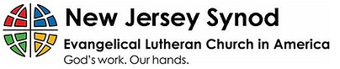
WHAT IS THE NEW JERSEY SYNOD?
The New Jersey Synod is a geographical grouping of Evangelical Lutheran Church in America (ELCA) congregations that share the mission and ministry of the Church on the New Jersey territory. It is one of 65 synods in the ELCA. The NJ Synod is comprised of 143 congregations, which include over 45,000 baptized members.

2025 FINANCIAL STANDING
OCTOBER INCOME | $10,356.00
OCTOBER SPENDING | $16,460.45
OCTOBER GAIN OR (LOSS) | ($6,104.45)
2025 INCOME | $54,214.38
2025 SPENDING | $68,708.32
2025 GAIN OR (LOSS) | ($14,493.94)
ED GREEN CAPITAL IMPROVEMENT FUND | ($546.45)
FOOD PANTRY FUND (SOCIAL MINISTRY) | $11,212.04
CD | $26,245.92
75TH ANNIVERSARY | $4,585.43

CHURCH STAFF & VOLUNTEERS
VICAR, BIBLE STUDY & FAITH DISCUSSIONS, NEWSLETTER, & WEBSITE
Vicar Vince Piekarski
VICE PASTOR
Pastor William Hodgetts
ORGANIST & PIANIST
Carol Amundsen
CHURCH OFFICE, SUNDAY SCHOOL, & FOOD PANTRY
Heather Piekarski
CHURCH COUNCIL PRESIDENT
Mary Melnicoff
CHURCH COUNCIL VICE PRESIDENT
Judy Brannan
CHURCH COUNCIL TREASURER
Bonnie Millard
CHURCH COUNCIL SECRETARY
Vicki Rinier
CHURCH PROPERTY
Frank Ford & Wayne Rand



