

**JERSEY International Open**

International 2025 Open Competition Weekend 25th to 27th July

**Minimum Guaranteed Prize Fund for the Weekend - £2000**

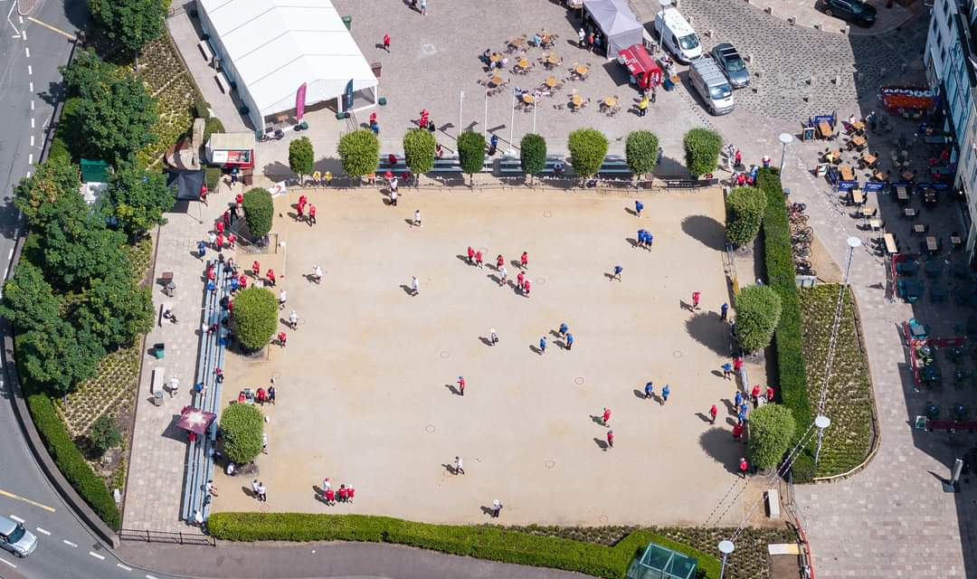

We are based in the Heart of Jersey’s Capital, St Helier surrounded by Bars, Restaurants, and the main shopping centre.

Following the success of our International Opens over the last 3 years we have been encouraged to put on another event in 2025. The event will be spread over the three days with a different competition to be held each day.

Friday - Open Singles Competition

Saturday - Open Doubles Competition

Sunday - Open Triples Competition

**Entry Fees and Prize Fund Breakdown**

**Entry Fees are as follows:**

**Doubles - £40 per team (£20pp)**

**Triples - £60 per team (£20pp)**

**Singles - £20 per person**

**Singles First Prize – Minimum starting amount of £200**

**Doubles First Prize – Minimum starting amount of £300 per team**

**Triples First Prize – Minimum starting amount of £300 per team**

**Once minimum entries have been met the prize fund will increase with each entry received thereafter.**

**Saturday Evening we will again be holding a buffet should you wish to attend this please also include on your entry form**

**Competition Format’s**

**\*Subject to Review\***

We will be using the Swiss System for all three competitions (As used in the European and World Championships).

The **Start Time** of all our competitions with be 8.45am ( singles 9.15) with check in closing at 15 minutes before.

Maximum Entries 52 Singles – 44 Doubles & Triples Teams / Players (Increased) **tbc**

4 Qualifying Rounds

Timed Matches (Singles 40m + 1 Additional ends), tbc

(Doubles 50m + 1 additional ends) tbc

(Triples 50m + 1 additional ends) tbc

**In the Knockout Rounds 2 extra ends will be allowed.**

Qualifying Criteria - Wins

- BHN (Opponents Wins)

- Points Difference

***Example with 40 Players / Teams (*Subject to Review*)***

Top 16 Teams / Players through to **Main Competition**

Teams / Players finishing 17th to 32nd Through to **Plate Competition**.

Teams / Players finishing 33rd to 48th Through to **Consolege Competition**.

All other Teams / Players eliminated

**Knockout stages - Last 16**

Last 16 Match 1 - 1st v 16th

Last 16 Match 2 - 2nd v 15th

Last 16 Match 3 - 3rd v 14th

Last 16 Match 4 - 4th v 13th

Last 16 Match 5 - 5th v 12th

Last 16 Match 6 - 6th v 11th

Last 16 Match 7 - 7th v 10th

Last 16 Match 8 - 8th v 9th

**Knockout Stages - Quarter-Finals**

Winner - Match 1 v Winner - Match 8

Winner - Match 2 v Winner - Match 7

Winner - Match 3 v Winner - Match 6

Winner - Match 4 v Winner - Match 5

**Knockout Stages - Semi-Finals**

Winner - Match 1 v Winner - Match 4

Winner - Match 2 v Winner - Match 3

**Links and Travel Information**

[**https://www.jersey.com/getting-here**](https://www.jersey.com/getting-here)

**Two Hotels right next to the terrains**

**The Royal Yacht**

[**https://www.guestreservations.com/the-royal-yacht/booking?msclkid=8baf2515ce0910ef1311441871889839**](https://www.guestreservations.com/the-royal-yacht/booking?msclkid=8baf2515ce0910ef1311441871889839)

**Pomme D’Or**

[**https://www.seymourhotels.com/pomme-dor-hotel/**](https://www.seymourhotels.com/pomme-dor-hotel/)

**These hotels are fairly expensive**

**so try** [**https://www.booking.com/**](https://www.booking.com/)

**Or there are two Premier Inn in Jersey.**

**Club Contacts**

**Email: liberationpc@gmail.com**

**Website:** [**http://www.liberationpetanque.co.uk/**](http://www.liberationpetanque.co.uk/)

**Phone: Toby - 07700 330537**

**Any Questions please let us know.**

**Kind Regards**

**Toby Northern**

**Chairman**

**Liberation Petanque Club**

*Please note the club holds the right to cancel the competition if there is an Insufficient number of teams who enter.



International 2025 Open Competition Weekend 25th to 27th July

**Entry Form**

**Friday (25th July) - Open Singles Competition**

**SOLD OUT**

**Player 1** ____________________

**Email:** ____________________ **Contact No.** ____________________

**Saturday (26th July) - Open Doubles Competition**

**Player 1** ____________________ **Player 2** ____________________

**SOLD OUT**

**Email:** ____________________ **Contact No.** ____________________

**Email:** ____________________ **Contact No.** ____________________

**Sunday (27th July) - Open Triples Competition**

**Player 1** ____________________ **Player 2** ____________________

**Email:** ____________________ **Contact No.** ____________________

**Email:** ____________________ **Contact No.** ____________________

**Player 3** ____________________

**Email:** ____________________ **Contact No.** ____________________

**Buffet Attendee’s (No.)** ____________________ **£20 pp**

Please email entry forms to [liberationpc@gmail.com](mailto:liberationpc@gmail.com)

The clubs preferred method of payment is BACS which should be sent once entry has been confirmed.

|  |  |  |  |  |
| --- | --- | --- | --- | --- |
| **Sort Code** |  | **40 -25 - 34** | **Account Number** | **92557738** |

Alternatively, you can send this form and payment to Flat 5, Zeeland House, Midvale Road, St Helier, JERSEY, JE2 3YR.