
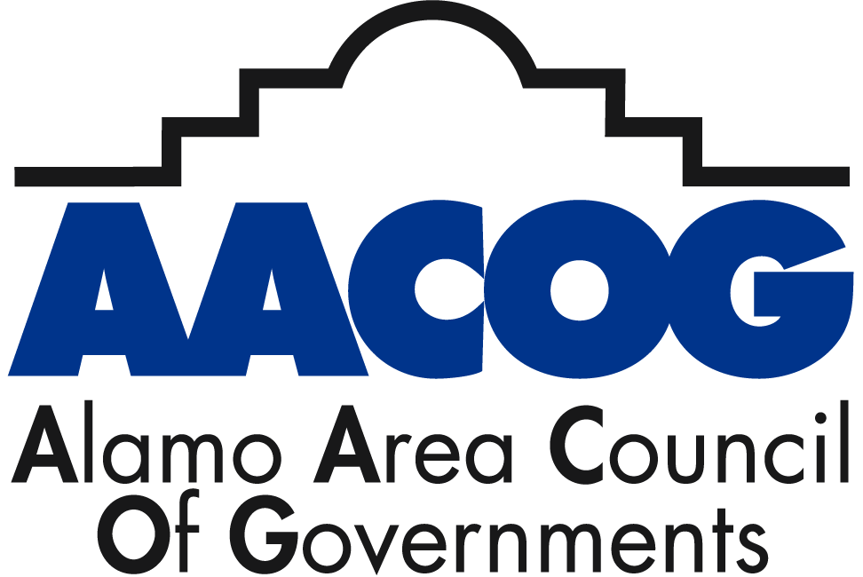

Rides 4 TX Heroes

“Rides 4 TX Heroes”, a free transportation program for Veterans, their spouses, widows/widowers of spouses, and Dependents in the Alamo Region.

As transportation can be a challenging barrier for many in accessing benefits and services in the Alamo region, AACOG has collaborated with the Texas Veterans Commission to provide free rides to Veterans and their immediate family members.

The program is available throughout the 13-county AACOG Region, including Atascosa, Bandera, Bexar, Comal, Frio, Gillespie, Guadalupe, Karnes, Kendall, Kerr, McMullen, Medina, and Wilson Counties. The rides can be used for a variety of purposes – grocery shopping, medical appointments, prescription pick-ups, visiting government offices, job interviews, education, and other essential transportation needs. Five to seven days’ notice is normally required to schedule rides once the Veteran has registered for the program.

For questions or to register for the program, please visit www.txveteransnetwork.com, or call our toll-free number 888-SA4 VETS (888 724 8387). For more information, visit http://aacog.com/495/Veteran-Programs

The Rides 4 TX Heroes program goal is to provide military members, veterans and family members with transportation and other supportive services assistance through TX Veterans Network (formerly TXServes San Antonio). We are eager and available to accept Veteran applicants! The Rides 4 TX Heroes program is supported by a grant from the Texas Veterans Commission Fund for Veterans’ Assistance, which provides grants to organizations serving veterans and their families.

The AACOG Rides 4 TX Heroes program is supported by a grant from the Texas Veterans Commission Fund for Veterans’ Assistance. The Fund for Veterans’ Assistance provides grants to organizations serving Texas Veterans and their families. For more information, go to www.tvc.texas.gov.

Rides 4 TX Heroes
1-888-724-8387 (1-888-SA4-VETS) or TXVeteransnetwork.com

Q: How many rides are provided?
A: Rides Vary on funding, but most riders receives assistance with at least 2-3 rides. Additional rides may be provided on a case-by-case basis. All clients registered with the program are provided information on other services in their area that may provide long-term transportation support.
Q: Is the service provided door-to-door?
A: Yes, provided from the home of the rider directly to the destination and then back to the home.
Q: Can the program provide rides to people with disabilities?
A: Yes. Rides can be provided to those who use walkers, canes, wheelchairs, electric wheelchairs, and scooters, or have other conditions such as vision impairments.
Q: Can a helper accompany me if I need assistance?
A: Yes, any caregiver (spouse, friend, paid caregiver, adult child, etc.) can accompany the rider to the rider’s destination and return trip.
Q: Are the drivers insured?
A: R4TH utilizes only fully licensed and insured transportation vendors to provide rides. These include government and non-profit ride services, such as Alamo Regional Transit, as well as commercial Vendors such as taxi services.
Q: What are the age and income requirements for the rider?
A: Riders must be over 18 or a qualifying child accompanied by the parent. There are no income requirements for riders. No disability status is required – the program is open to all veterans.
Q: How much notice is needed to arrange a ride?
A: After registration/documentation process is completed, a minimum of 5 BUSINESS DAYS is needed. This does not include weekends/ holidays.
Q: What are some of the reason I should register even if I don’t usually need rides?
A: Several reasons, first, registering can allow a “donation” of your rides to veterans who need more rides (such as vets who have repeat medical treatments) Also, registering ahead allows quicker assistance when on the few occasions you might need a ride, such as when you vehicle is in the shop or a family member can’t transport you to the airport!

Q: What forms do I have to fill out?
A: NONE! Registration can be completed over the phone with Texas Veterans Network Staff. Verification of Veterans or Veteran Spouse status is required.
Q: What type of verification are required?
A: This varies from client to clients. Veterans - DD214; NGB-22, National Guard Report of Separation and Record of Service; NA Form 13038, Certification of Military Service; VA Official Letter; E-Benefits summary letter with character of service listed; Honorable discharge certificate; Uniform Services ID Card; State of Texas Issued Driver License with Veteran designation; Certificate verifying Active Duty Status from DOD Manpower Data Center (ONLY – currently serving active duty); Dependents – Uniform Services ID Card; Marriage Certificate; Birth Certificate; Adoption Certificate; Surviving Spouses - Uniform Services ID Card; Marriage Certificate; Death Certificate or one of the forms listed above for Veterans eligibility.
Q: If I have to provide my DD214 (Proof of Discharge), how is the information kept secure?
A: Most riders do not have to provide a DD214 (See above). In cases where this is the only documentation available, riders can FAX the DD214 directly to AACOG via a secure fax-line. Because AACOG is a government agency, it has strict privacy requirements and secures computer systems. The documentation is stored on server accessible only to T staff and is used only for verification of eligibility for this one services.
Q: What’s the catch?
A: NONE! This program is supported by a grant from the Texas Veterans Commission Fund for Veterans’ Assistance. The Fund for Veterans’ provides grants to organizations serving veterans and their families. WE LOOK FORWARD TO SERVING YOU!

