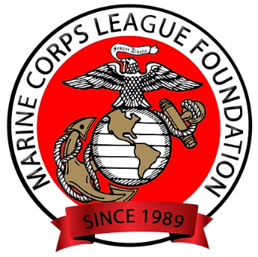
MARINE CORPS LEAGUE SCHOLARSHIP DONATION
To a young student, receiving a scholarship is more than just financial support—it's a validation of their hard work, potential, and promise. It affirms that someone believes in their ability to achieve, even when they may still be discovering it themselves. A scholarship can lift the burden of financial stress, but even more profoundly, it ignites confidence, hope, and a sense of purpose.
The Foundation was established in 1989 to raise and collect funds for the charitable and educational activities of the Marine Corps League and to distribute those funds diligently within the mandates of a non-profit 501 (c)(3) agency as designated by the Internal Revenue Service.
The foundation has a blocked scholarship fund that assists in the funding of the Marine Corps League's Scholarship Program. Scholarships are applied for and awarded by the Marine Corps League Scholarship Committee using applications and standards developed by that committee.

MARINE CORPS LEAGUE FOUNDATION SCHOLARSHIP DONATIONS
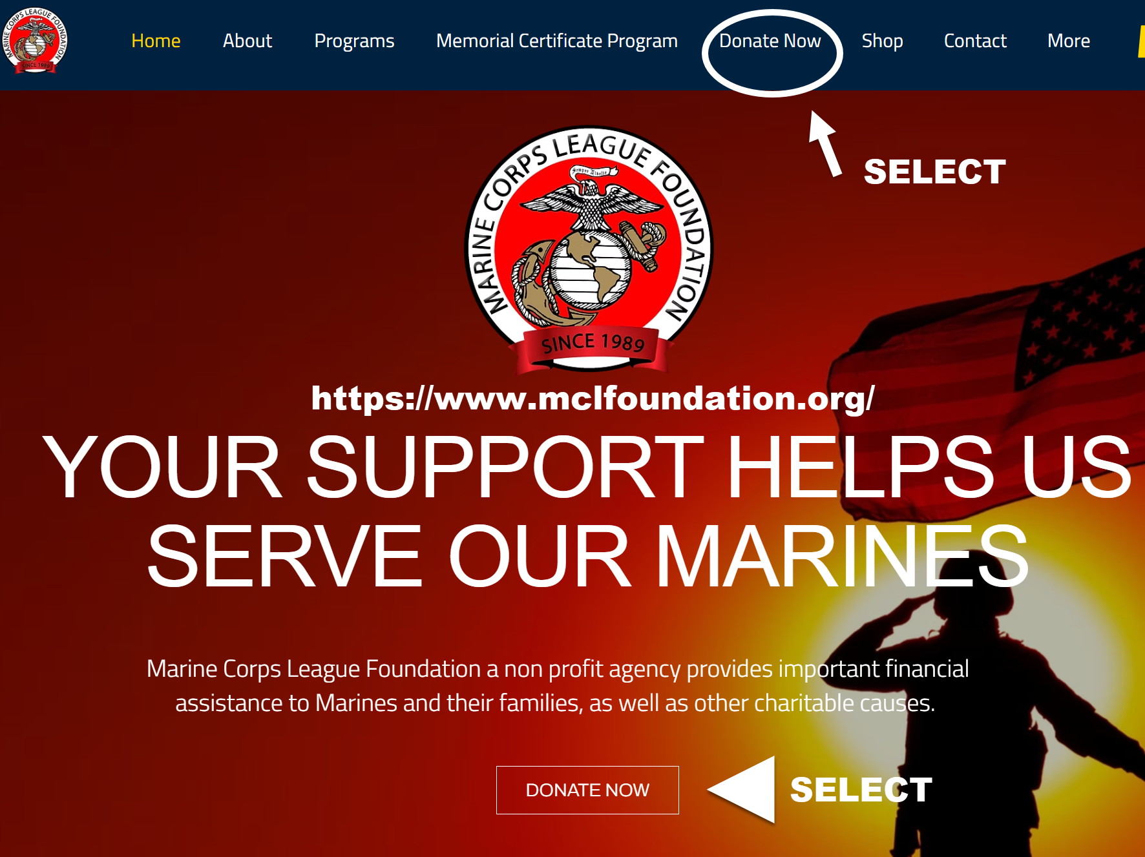 https://www.mclfoundation.org/
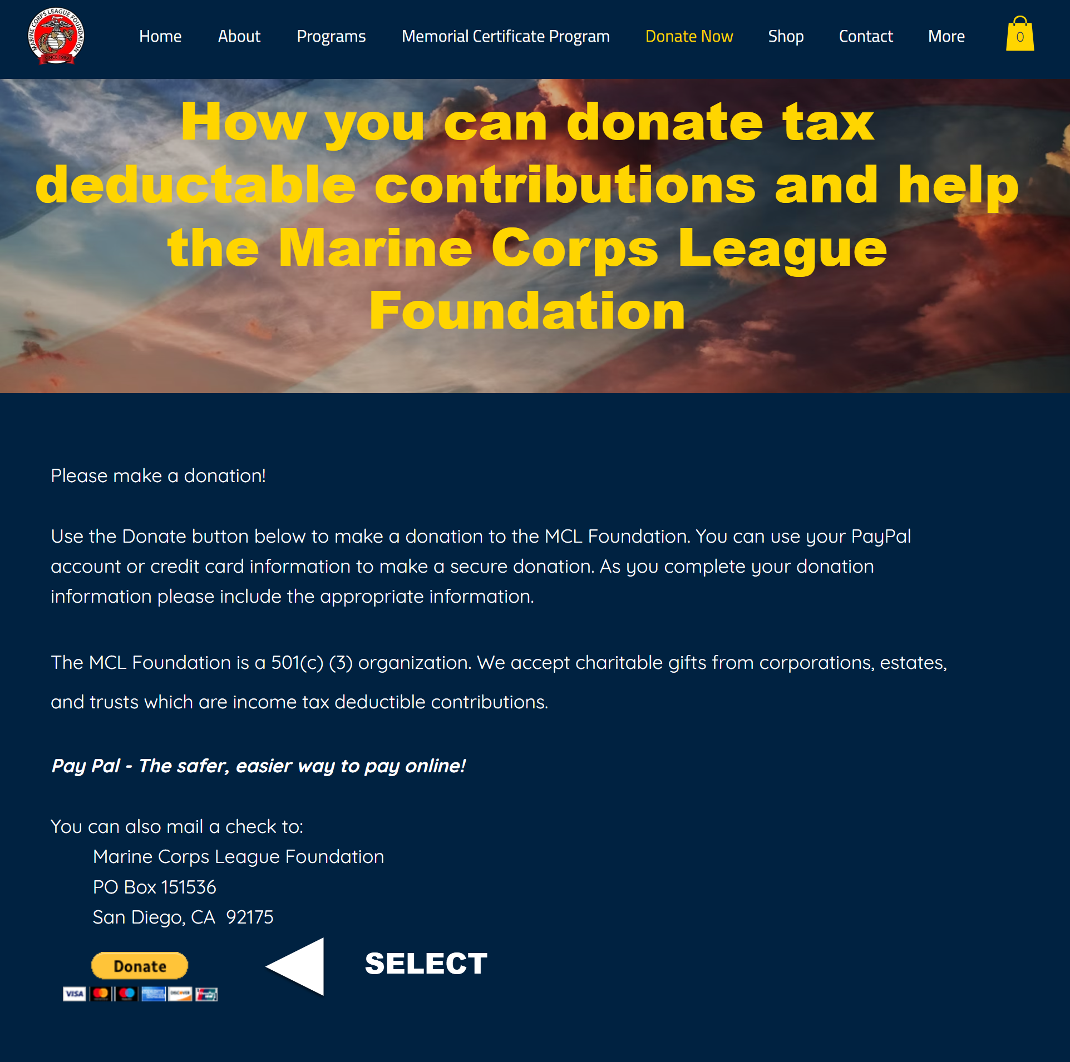
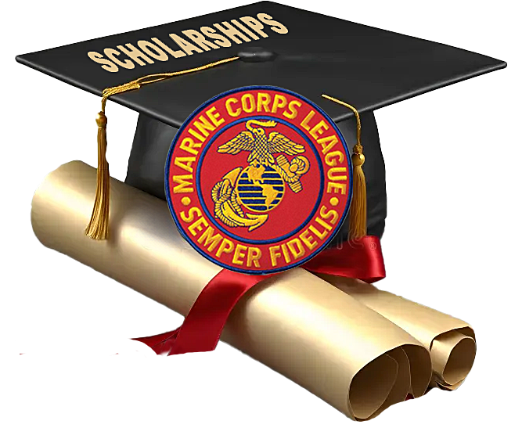

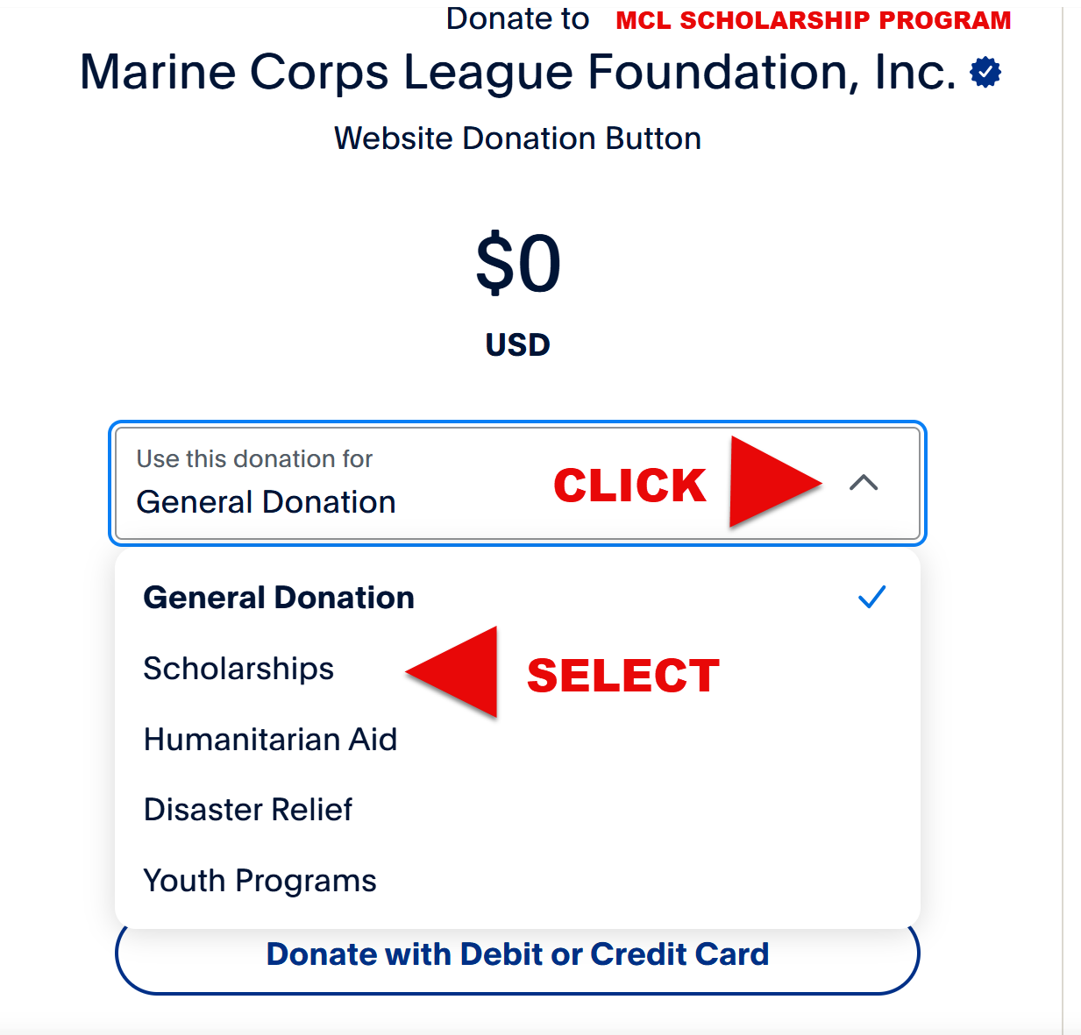
You can also mail a check to:
ADD NOTE IN CHECK MEMO SECTION “FOR MCL SCHOLARSHIP FUND”
Marine Corps League Foundation
P.O. Box 4693
Lake Charles, LA 70606
