
Patient demographic data sticker

Burns Management in the Emergency Department
(Referral Pro-forma)

WEIGHT in KG
Adult

Paediatric

Actual Time of Injury
Date of admission
Time of Admission
Year of admission
Age of patient

AIRWAY

Is the patient presenting with any of the following. Please circle Y / N.
Stridor / change in voice | Y | N
Injury in enclosed space. | Y | N  Is there any suggestion the patient has sustained an Airway / Inhalation injury?  Yes / No  If yes please seek senior anaesthetic review immediately.  Intubation may be required. If indicated use an uncut ETT to allow for facial oedema
Singed nasal hair | Y | N
Facial burn / burns to mouth | Y | N
High carboxyhaemoglobin. | Y | N
Brassy cough/ change in voice | Y | N
Carbonaceous sputum. | Y | N
Circumferential /semi circumferential neck burns | Y | N
Administer high flow oxygen if required | Y | N

BREATHING

Has this patient any of the following which may suggest a breathing impairment?
(Please circle Y/N)

Circumferential chest burns: Needs immediate discussion with local burns service. | Y | N
O₂ saturation lower than expected | Y | N
Respiratory rate outside expected limits | Y | N
Any other evidence of Broncho-pulmonary or chest wall injury | Y | N
Consider Carbon Monoxide / Cyanide poisoning, especially burns occurring in enclosed spaces (Bloods available with ABGs)  Treat as departmental policy. | Y | N
Elevated lactate, arrhythmias, reduced GCS and reduced arterial-venous oxygen saturation difference: Consider Cyanide poisoning. Use of antidote recommended. | Y | N

CIRCULATION

Has the patient any of the following which may suggest circulation impairment?
(Please circle Y/ N)

Tachycardia | Y | N
Tachypnoea | Y | N
Reduce level of consciousness | Y | N
Central and peripheral capillary refill time >2 seconds | Y | N
Cool peripheries / Circumferential limb burn. | Y | N
Patient demographics data sticker

POINTS TO NOTE  All patients requiring fluid resuscitation should have:  - Two large-bore intravenous cannulas and through the burn if necessary.  - An indwelling urinary catheter attached to an hourly urine collection bag. (Discuss with receiving burns service)  - IV fluid resuscitation should be commenced as per ATLS protocol  .  - If this does not improve parameters repeat primary survey looking for causes of shock. | Y  Y  Y  Y | N  N  N  N
Please take bloods for the following;  FBC (Inc. Haematocrit ) U&E, | Y | N
ABG, | Y | N
G&S | Y | N
CK | Y | N
Clotting screen | Y | N
BHCG | Y | N
Absence of peripheral pulses requires immediate contact with local burns service as ESCHAROTOMIES may be required .Please follow directions below | Y | N

Patient demographic data sticker

IF PATIENT REQUIRES ESCHAROTOMY PLEASE FOLLOW DIRECTIONS BELOW

Contact to be made with the Burns and Plastic Surgery team.
Consultant or SpR grade if the need for escharotomy is suspected.

Escharotomies are performed by plastic surgeons in the operating theatre.

Diathermy MUST always be immediately available when any escharotomy procedure is carried out

In immediate escharotomy situations, only carry out chest incisions, until satisfactory ventilation is achieved, then STOP.

Local anaesthetic and adrenaline infiltration along incision lines will reduce blood loss and improve comfort.

Escharotomy wounds should be dressed with appropriate haemostatic dressings, e.g. calcium alginate e.g. kaltostat dressings with overlying absorbent dressings.
Avoid tight dressings as will further restrict.

An escharotomy may cause bleeding and damage to underlying structures.

Do NOT perform a fasciotomy.

Patient demographic data sticker

DISABILITY

Does the patient have a GCS <9? Please indicate. | GCS …. / 15
Pupils equal and reacting to light? Please indicate. | Reactive | Unreactive
CONSIDER

Toxic exposure?  Carbon monoxide and hydrogen cyanide | Y / N  Blood results
Any associated trauma?  Limbs  Chest  Abdominal  Head  Other  None | IDENTIFY OTHER TRAUMA
Ensure ABG’s normalised | ABG Results
Notable comments

Patient demographic data sticker

EXPOSURE, ENVIRONMENT AND EVALUATION

Measure core temperature and maintain >36C | Current Temp  ___________C
Assess Total Burn Surface Area. ( TBSA) %.  - Use Lund and Browder chart below to document findings.  - The patients whole hand including fingers = 1%.  - Ignore simple erythema  - Total Burn Size =……….%.TBSA  - Partial thickness: = ………% TBSA  - Full thickness: = ……… % TBSA  - Total: =………..% TBSA  - Revised Baux Score = …..  **(Revised Baux Score: Age + % TBSA and add on 17 if severe smoke inhalation (SSI) present ** | ____________%
Question to ask = does burned skin and unburnt skin = 100%

Be as clear and accurate as is possible

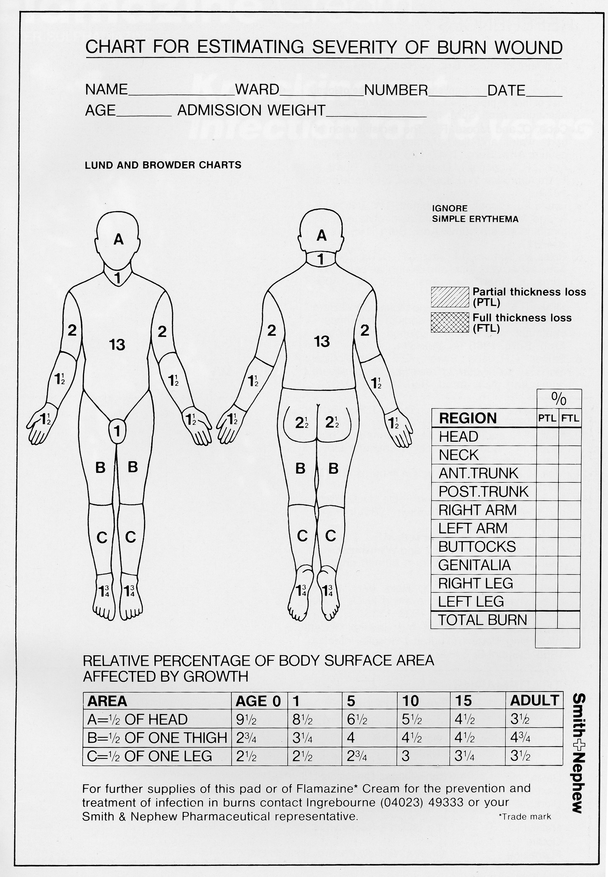

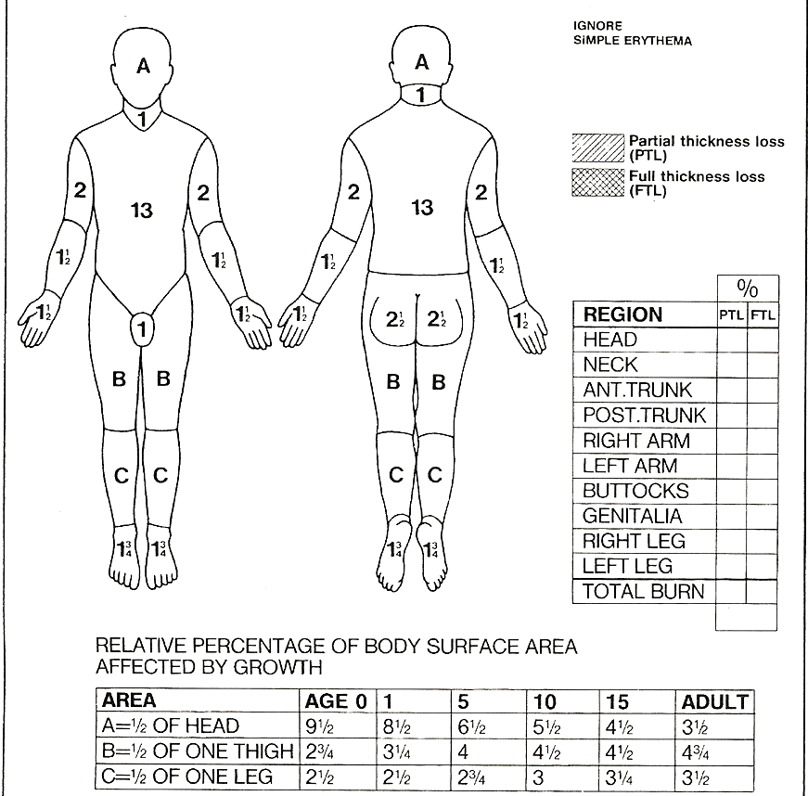

Patient demographics data sticker

FLUID RESUSCITATION WITH HARTMAN’S SOLUTION

ADULT >15% OF TBSA burned require IV fluid resuscitation = (Major Burn)

CHILDREN >10% OF TBSA burned require IV fluid resuscitation = (Major Burn)

re - confirm the ACTUAL TIME OF INJURY this ensures correct fluid management.

Use the Parkland Formula (see below) to calculate the amount of fluid required in the first 24 hours post burn injury. This should be given in the form of a balanced electrolyte solution (Hartman’s / Plasmalyte). Fluid requirement for the first 24 hrs is always calculated from time of injury.

2 -4 mls fluid x %TBSA burn x weight (kg) = Total Fluid Volume (TFV) over 1st 24hrs from time of injury.

Resus fluid is given in two parts: 50% of TFV for 8 hours + 50% given in next 16 hours.

Fluid for 1st 8hrs = 50% of TFV
Fluid for 9 – 24hrs = 50% of TFV

Give half of fluid in first 8hrs from time of injury and half in next 16 hrs

Percentage TBSA Burned = times

Weight in kg = times

Urine output target

Adults 0.5 ml/ kg/hr

Children
And
Infants 1- 2 ml/ kg/hr

Does the patient require catheterisation?

PLEASE DISCUSS WITH RECEIVING BURNS SERVICE

Catheterise and attach an hourly urine device
Maintenance fluids

Adults
No maintenance fluids

Children.

Calculate as normal with
0.9% saline +5% Dextrose

FLUID RESUSITATION IS ONLY A GUIDE AND INFUSION RATES SHOULD BE ADJUSTED AND TITRATED TO DELIVER APPROPRIATE URINE OUTPUT

Patient demographics data sticker

WOUND COVER AND AMBULANCE TRANSFER

Is the burn patient fit for transfer? Please indicate.  . | Y |  | N
- Is the patient critical and do they require ITU / PICU?  - If transferring, does the patient require critical care on route?  - If transferring does the patient require standard care on route?  - Do they require burns centre treatment and require care on route? | Y  Y  Y  Y |  | N  N  N  N
- Cover the burn wounds in loose cling film prior to transfer.
- If transfer is to be delayed, clean the burn wounds then cover with a non-adherent dressing e.g. Silflex / Atrauman

All ambulance transfers for resuscitation burns must be performed by crews who can and will continue to provide:

- on-going fluid resuscitation
- thermal regulation
- monitoring throughout transfer

Please attach any X-rays and blood results to the patient’s notes. | Y | N
COMPLETE AMPLE:  - Allergies  - Medicines  - Past medical history  - Last meal  - Events | Y  Y  Y  Y  Y | N  N  N  N  N

NO antibiotics required in E/D.

Patient demographics data sticker

- In the first instance ED’s should contact their local burn service for advice.
- If a burn bed is required and one is not available in the Network region the Burn clinician/service will advise ED departments to contact the National Burn Bed Bureau to find one.
- Contact with the burns service should be maintained for further advice/support until a bed is found.

NATIONAL BURN BED BUREAU TELEPHONE NUMBER = 01384 679036

The local burns service will provide support and guidance with burn injured patients admitted to Emergency Departments. This will help ensure burn injured patients are directed to the correct level of burns care service.

