Saturday & Sunday,
December 13 & 14 2025
Third Sunday of Advent, Year A

Christ Lutheran Church
“A Place Where You are Always Welcome”
Services: Saturday 5:30 pm and Sunday 10:00 am
Sunday School: 9:00 am (September- May)
600 North Main Street, Stockton, IL 61085 Office: 815-947-2033
Email: christlutheranchurch70@gmail.com http://www.christlutheranstockton.com
Ministers: ALL members of the congregation
Pastor: Rev. Chrissy Salser chrissytherev@att.net 815-988-9450
From Sundays and Seasons.com. Copyright 2017 Augsburg Fortress. All rights reserved. Reprinted by permission under Augsburg Fortress Liturgies Annual License #40643.New Revised Standard Version Bible, copyright 1989, Division of Christian Education of the National Council of the Churches of Christ in the United States of America. Used by permission. All rights reserved.
WELCOME: Thank you for joining us for worship today. We are glad you are with us. Communion will be served in the aisle or in your pew. All are welcome to share this meal. Jesus is our host and invites everyone. Those who would like to come forward, bread and wine will also be available in the front. When directed by the usher, come forward down the center aisle, Pr Chrissy will give you bread (she will be masked and wearing cloves) and then you will take a cup of wine (grape juice) from the tray. After taking communion, you will return to your seat by the side aisle. For those who are unable to come forward, communion elements can be found as you entered worship. At that part of the service, you are invited to take the bread and wine (or grape juice) when Pr. Chrissy leads. On Saturday’s offering is collected as you enter or leave worship. On Sunday we will pass the plate as a response to God’s grace. Online giving is available. Please see QR code on back of bulletin or visit our website.
INTRODUCTION: A note of joyful expectation marks today’s worship. Isaiah announces that the desert shall rejoice and blossom, and Jesus points to the unexpected and transforming signs of God’s reign. We wait with patience for the coming of the Lord, even as we rejoice at his presence among us this day: in word and holy supper, in church and in our homes, in silent reflection and in works of justice and love. We pray that God would open our eyes and ears to the wonders of Christ’s advent among us.

Gathering: The Holy Spirit calls us together as the people of God.
PRELUDE
WELCOME AND ANNOUNCEMENTS
CONFESSIONS AND FORGIVENESS
P: John the Baptist asked, “Are you the one who is to come, or are we to wait for another?” We too bring our questions, our doubts, and our broken pieces before God. Let us confess our sins and trust in God’s promise of mercy. (Silence for reflection)

P: Merciful God,
C: We confess that our lives feel unfinished.
P: We hold puzzle pieces of sorrow and regret.
C: We cannot see how they fit together.
P: We cling to pieces of anger and pride.
C: They leave gaps in our relationships.
P: We hide pieces of fear and doubt.
C: They weigh us down and leave us restless.
P: We have tried to complete the picture on our own.
C: But the picture is incomplete and broken without your grace.
P: Forgive us, Lord.
C: Place the missing piece of your mercy into our lives.
P: Transform us into people of hope.
C: Complete in us the good work you have begun.
P: Hear the good news! Jesus answered John’s question not with arguments, but with signs of healing, life, and grace: “The blind receive their sight, the lame walk, the lepers are cleansed, the deaf hear, the dead are raised, and the poor have good news brought to them.” In Jesus Christ, the missing piece has been found.
C: In Jesus Christ, the picture is made whole.
P: Your sins are forgiven. Your questions are held in God’s hands. Your broken pieces are gathered up in love. Walk now in the light of Christ. Live as people being made whole. For the puzzle of God’s kingdom is coming together in you.
C: Amen. Come, Lord Jesus.

GATHERING HYMN Come Thou Long-Expected Jesus ELW 264

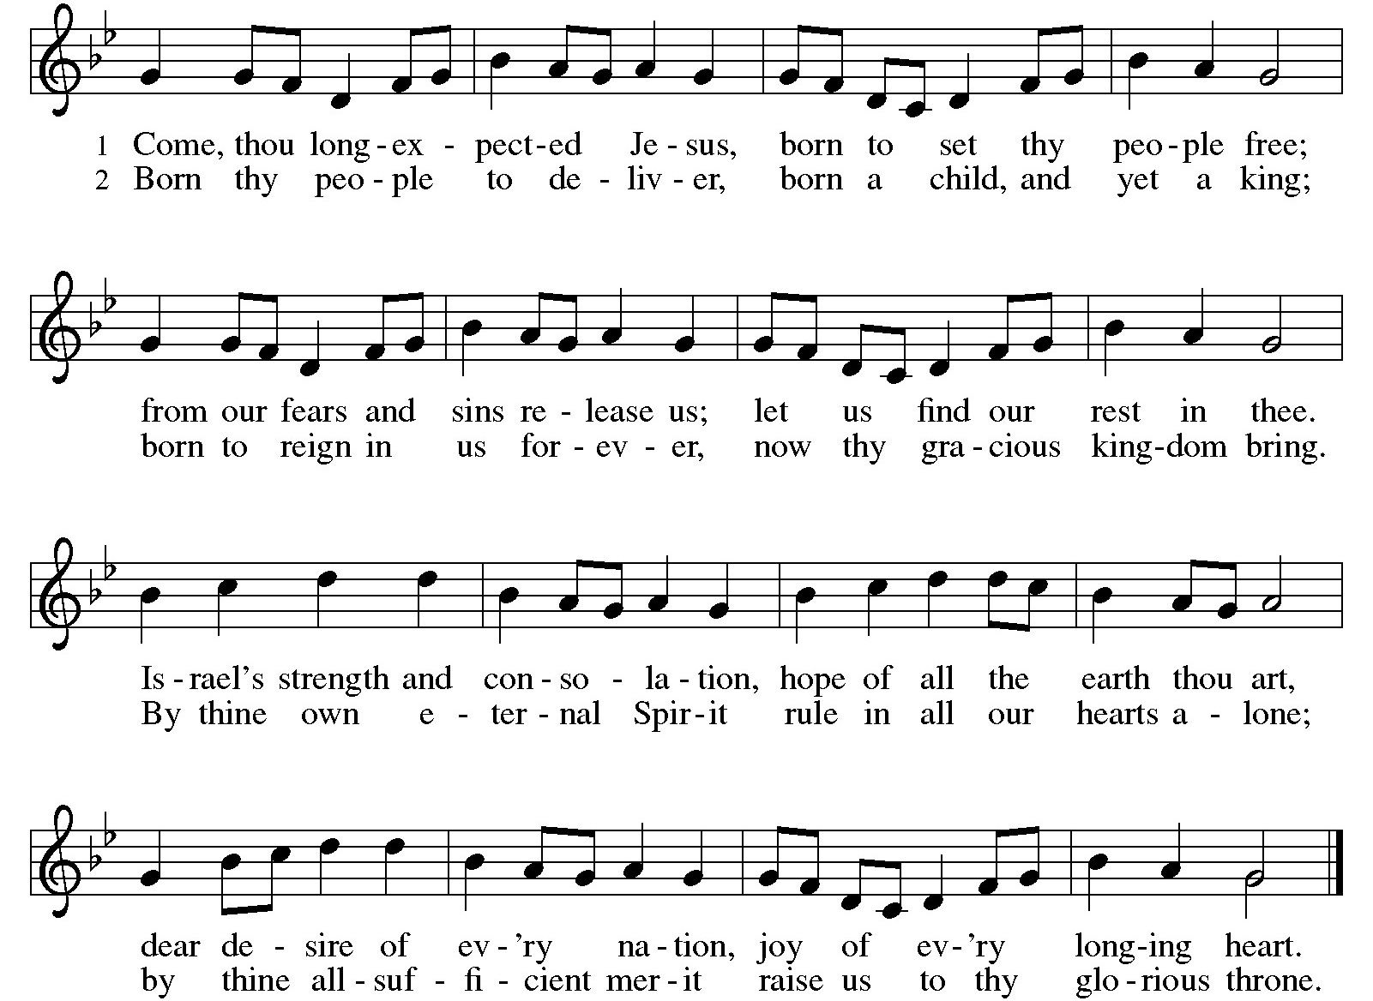
Greeting:
P: The grace of our Lord Jesus Christ, the love of God, and the communion of the Holy Spirit be with you all. C. And, with you.
PRAYER OF THE DAY:
P: Stir up the wills of your faithful people,
C: Lord God, and open our eyes and ears to your guidance. Help us to see the ways in which your grace draws us into a community of love and inclusion. Empower us to respond with your love to the needs of our neighbors; through Jesus Christ, our Savior and Lord, who lives and reigns with you and the Holy Spirit, one God, now and forever. Amen.

THE ADVENT WREATH
One of the best-known customs for the season is the Advent wreath. The wreath and winter candle-lighting amid growing darkness strengthen some of the Advent images found in the Bible. The unbroken circle of greens is clearly an image of ever- lasting life, a victory wreath, the crown of Christ, or the wheel of time itself. Christians use the wreath as a sign that Christ reaches into our time to lead us to the light of everlasting life. The four candles mark the progress of the four weeks of Advent and the growth of light.

ADVENT WREATH HYMN: Light One Candle To Watch for Messiah ELW #240 v 1-3
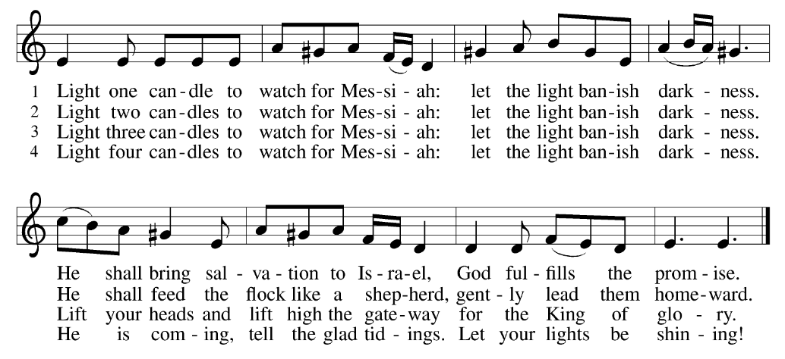

ADVENT WREATH PRAYER:
P: We praise you, O God, C: for this victory wreath that marks our days of preparation for Christ’s advent. As we light the candles on this wreath,
strengthen our hearts as we await the Lord’s coming in glory.
Enlighten us with your grace, that we may serve our neighbors in need.
Grant this through Christ our Lord, whose coming is certain and whose day draws near. Amen. Light three candles
Word: God speaks to us in scripture reading, preaching, and song.

First Reading: Isiah 35: 1-10
The prophet describes the return from the Babylonian captivity as a joyous procession to Zion. God’s coming reign will bring a renewal of creation in which health and wholeness will be restored. There is no need for fear, for God is coming to save.
¹ The wilderness and the dry land shall be glad; the desert shall rejoice and blossom; like the crocus ² it shall blossom abundantly and rejoice with joy and shouting. The glory of Lebanon shall be given to it, the majesty of Carmel and Sharon. They shall see the glory of the Lord,
the majesty of our God.]] ³ Strengthen the weak hands
and make firm the feeble knees ⁴ Say to those who are of a fearful heart,
“Be strong, do not fear! Here is your God. He will come with vengeance,
with terrible recompense. He will come and save you.”
⁵ Then the eyes of the blind shall be opened, and the ears of the deaf shall be opened; ⁶ then the lame shall leap like a deer, and the tongue of the speechless sing for joy. For waters shall break forth in the wilderness
and streams in the desert; ⁷ the burning sand shall become a pool and the thirsty ground springs of water; the haunt of jackals shall become a swamp;
the grass shall become reeds and rushes.
⁸ A highway shall be there, and it shall be called the Holy Way; the unclean shall not travel on it, but it shall be for God’s people; no traveler, not even fools, shall go astray. ⁹ No lion shall be there, nor shall any ravenous beast come up on it; they shall not be found there, but the redeemed shall walk there¹⁰ And the ransomed of the Lord shall return and come to Zion with singing; everlasting joy shall be upon their heads; they shall obtain joy gladness, and sorrow and sighing shall flee away.

R: The Word of the Lord. C: Thanks be to God.

Psalm: Psalm 146:5-10
⁵ Happy are they who have the God of Jacob for their help, whose hope is in the Lord their God;
⁶ who made heaven and earth, the seas, and all that is in them; who keeps promises forever;
⁷ who gives justice to those who are oppressed, and food to those who hunger. The Lord sets the captive free.
⁸ The Lord opens the eyes of the blind; the Lord lifts up those who are bowed down; the Lord loves the righteous.
⁹ The Lord cares for the stranger; the Lord sustains the orphan and widow, but frustrates the way of the wicked.
¹⁰ The Lord shall reign forever, your God, O Zion, throughout all generations. Hallelujah!

Second Reading: James 5:7-10
In anticipation of the Lord’s coming, Christians are called upon to cultivate patience rather than discontent.
⁷ Be patient, therefore, brothers and sisters, until the coming of the Lord. The farmer waits for the precious crop from the earth, being patient with it until it receives the early and the late rains. ⁸ You also must be patient. Strengthen your hearts, for the coming of the Lord is near. ⁹ Brothers and sisters, do not grumble against one another, so that you may not be judged. See, the Judge is standing at the doors! ¹⁰ As an example of suffering and patience, brothers and sisters, take the prophets who spoke in the name of the Lord.
R: The Word of the Lord. C: Thanks be to God.
GOSPEL ACCLAMATION Come Now O God ACS 902
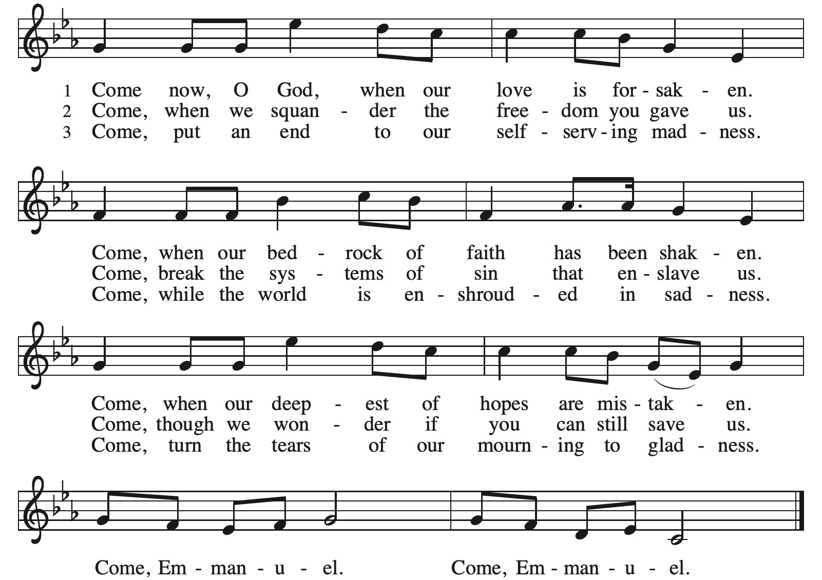

Gospel: Matthew 11:2-11

P: The Gospel according to Matthew C: Glory to you, O Lord
John the Baptist expects the Messiah to bring God’s judgment upon the earth (Matt. 3:11-12). From a prison cell, he wonders whether Jesus is the one who will do this. Jesus’ response indicates that God’s reign is indeed being fulfilled already through healing and restoration.
² When John heard in prison what the Messiah was doing, he sent word by his disciples ³ and said to him, “Are you the one who is to come, or are we to wait for another?” ⁴ Jesus answered them, “Go and tell John what you hear and see: ⁵ the blind receive their sight, the lame walk, those with a skin disease are cleansed, the deaf hear, the dead are raised, and the poor have good news brought to them. ⁶ And blessed is anyone who takes no offense at me.”
⁷ As they went away, Jesus began to speak to the crowds about John: “What did you go out into the wilderness to look at? A reed shaken by the wind? ⁸ What, then, did you go out to see? Someone dressed in soft robes? Look, those who wear soft robes are in royal palaces. ⁹ What, then, did you go out to see? A prophet? Yes, I tell you, and more than a prophet. ¹⁰ This is the one about whom it is written,
‘See, I am sending my messenger ahead of you, who will prepare your way before you.¹¹ “Truly I tell you, among those born of women no one has arisen greater than John the Baptist, yet the least in the kingdom of heaven is greater than he.”
P: The Gospel of Our Lord. C. Praise to you, O Christ.
CHILDREN’S MESSAGE
MESSAGE
HYMN OF THE DAY Christ, Be Our Light ELW 715 (Next Page)
APOSTLES’ CREED:
I believe in God, the Father almighty, creator of heaven and earth.
I believe in Jesus Christ, God’s only Son, our Lord, who was conceived by the Holy Spirit, born of the virgin Mary, suffered under Pontius Pilate, was crucified, died, and was buried; he descended to the dead. On the third day he rose again; he ascended into heaven, he is seated at the right hand of the Father, and he will come to judge the living and the dead.
I believe in the Holy Spirit, the holy catholic church, the communion of saints, the forgiveness of sins, the resurrection of the body, and the life everlasting. Amen.

PRAYERS OF INTERCESSION:
P: God of grace C: hear our prayer
PEACE
P: The peace of Christ be with you always. C. And also with you.

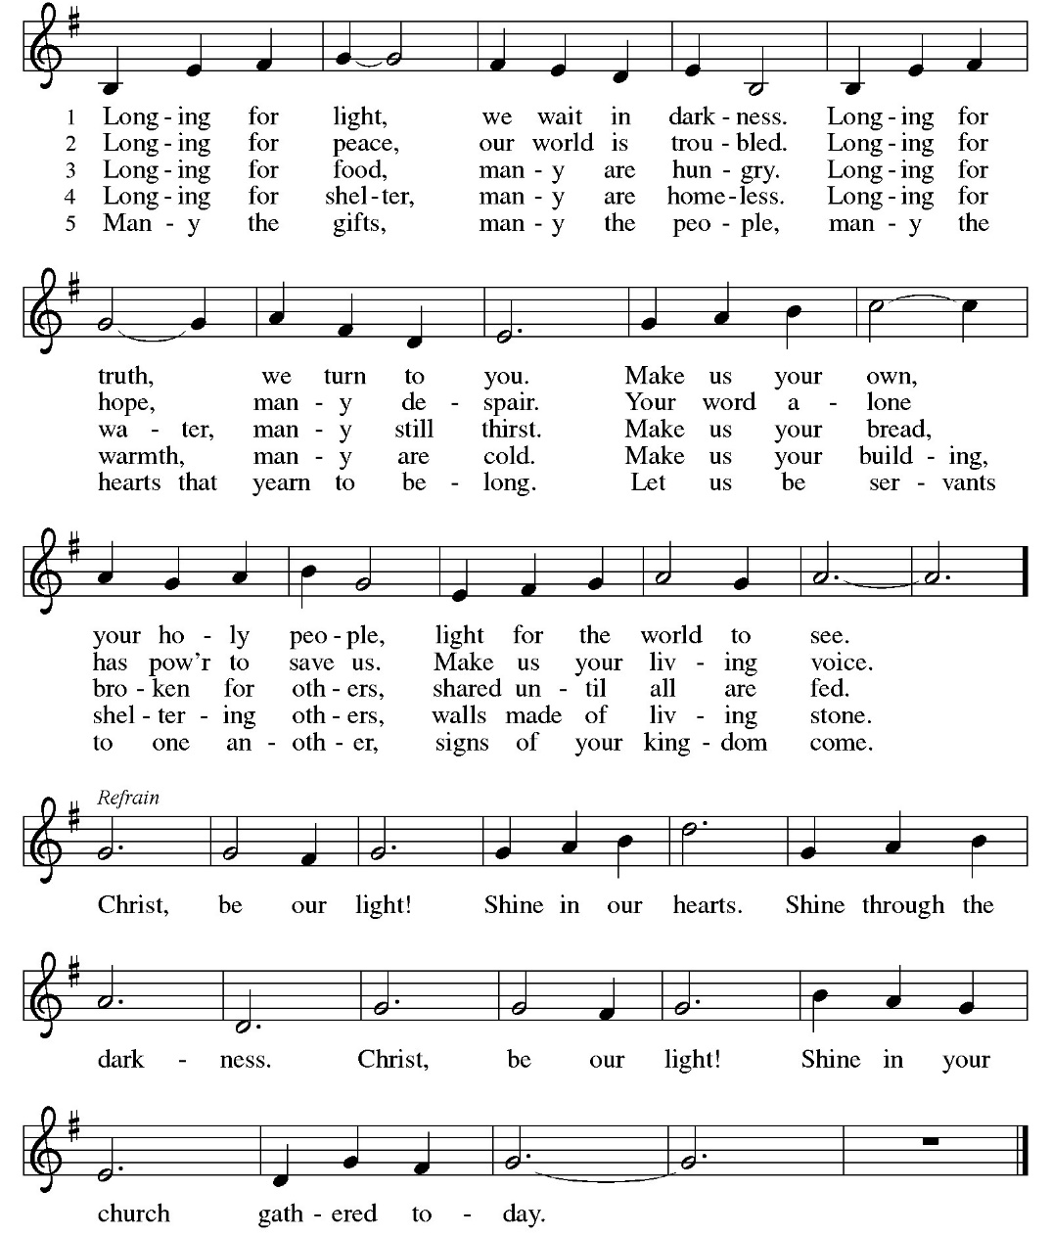

OFFERING: Our offering is a significant act of worship; we worship God through our giving. The ministry of this congregation is completely dependent upon your partnership and generosity. Offering is collected as you enter worship on Saturday. We will pass the offering plate on Sundays. Online giving is available.
OFFERING HYMN Come Now O Prince of Peace ELW 247
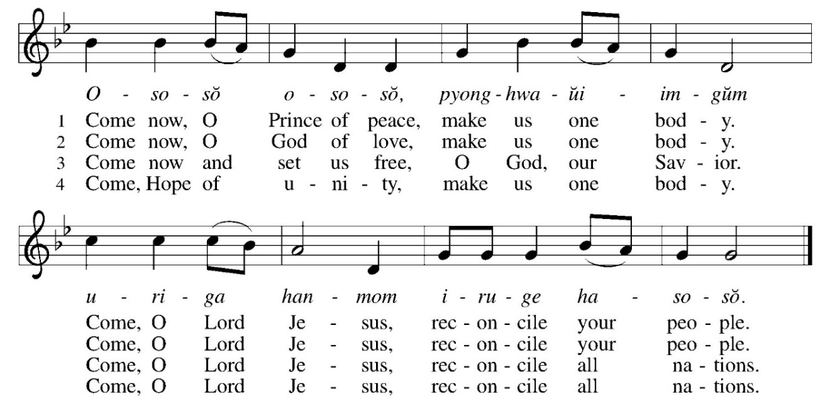
OFFERING PRAYER:
P: Nourishing God, C: you are water in the wilderness and streams in the desert. Through this meal, satisfy our parched places, that we may rejoice and be for the world signs of your kingdom come. Amen.
COMMUNION LITURGY:
In the night in which he was betrayed, our Lord Jesus took bread, and gave thanks, broke it and gave it to his disciples, saying: take and eat; this is my body, given for you. Do this for the remembrance of me. Again, after supper, he took the cup, gave thanks and gave it for all the drink, saying: this cup is the new covenant in my blood, shed for you and for all people for the forgiveness of sin. Do this for the remembrance of me.
THE LORD’S PRAYER:
Our Father, who art in heaven, hallowed be thy name, thy kingdom come, thy will be done on earth as it is in heaven. Give us this day our daily bread; and forgive us our trespasses, as we forgive those who trespass against us; and lead us not into temptation but deliver us from evil. For thine is the kingdom, and power, and the glory, forever and ever. Amen
INVITATION TO COMMUNION:
P: Here is life. God is with us. Come, receive what God has promised.
Please come down the center aisle, take the bread, then receive a cup (wine is dark, juice is light, return to your seats via side aisle.) Those who prefer to take communion in your pews, we will take all together after all are served.
DISTRIBUTION OF COMMUNION:
P: This is the body of Christ given for you. (All take bread).
P: This is the blood of Christ shed for you. (All take the wine).
COMMUNION HYMN: He Came Down ELW 253
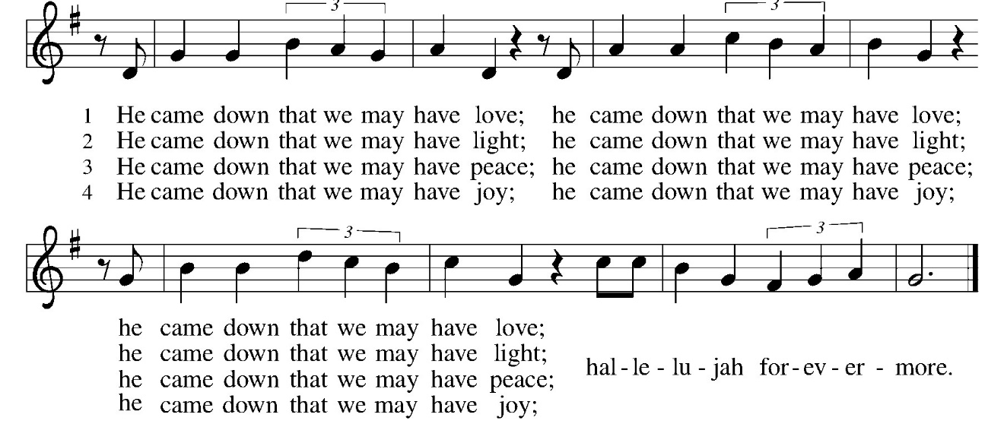
TABLE BLESSING: P: May the blood of our Lord Jesus Christ strengthen and keep you in His grace. C: Amen
PRAYER AFTER COMMUNION:
P: God our host, C: at this table you have fed us with joy and gladness. Send us forth, eager to share the feast, welcome the stranger, and bear good fruit in the name of Jesus. Amen.

SENDING: God blesses us and sends us in mission to the world.
BLESSING: P: May God who comes among us, Father, ☩ Son, and Holy Spirit, grant you patience in waiting, peace in the darkness, and good news to share today and always.
C: Amen.
SENDING HYMN Joy to the World ELW 267
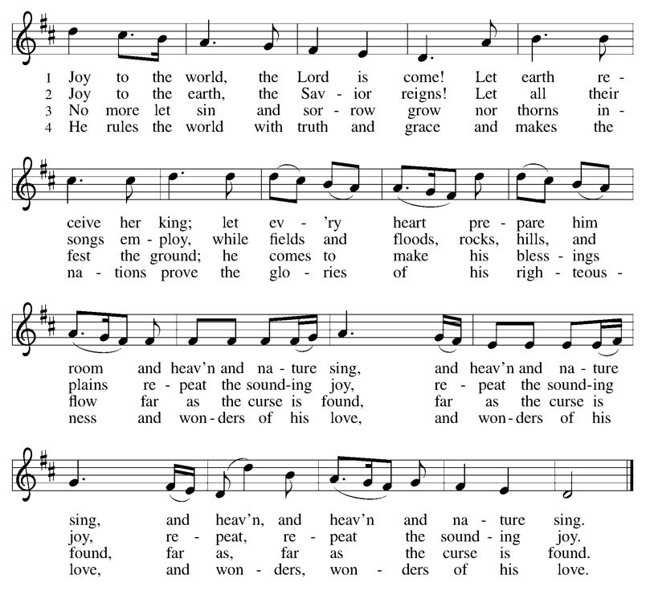
DISMISSAL:
P: Go in peace. Keep awake. C: Thanks be to God.
POSTLUDE
IN OUR PRAYERS TODAY: Teresa Hesselbacher, Elaine Schlicting, Darlene and Walt Steffes, Bob Schreck, Delores Wampfler, Marge and Gerald Arnold, Don & Judy Brudi, Diego Gonzalez, Grayson Raab, Dan Bonnet, James Dieter, Christine Happ, Kay Hesselbacher, Mary Lou Bunker, Lillian Sefford, Jeff Encheff, Judy Wilson, Russ Synder, Don Kunz, Johnny Blair, Jim Sullivan, Sally Duran Salser, Chris Marek, Joe Karr, John Becker and the family and friends of Darrell Lindstrom To add someone to the prayer list please contact Pastor Chrissy
CELEBRATING BIRTHDAYS / ANNIVERSARIES: Marcie Korth, Nick Eiders, Greg and Tammy Millerschone
Thanks be to God for your gifts for the ministry of  Christ Lutheran Church *these numbers do not reflect online giving- only offering in worship |  |  |  | Offering/ Attendance  Sat Dec 6 & 7
Current Expense | $930.00 | Building Fund | $15.00 | Dec 6 | 19
Benevolence | $20.00 | Sunday School | $20.00 | Dec 7  Sunday School | 32  9
 |  | Total
  $ 985.00

November Totals: As a way to improve communication around finances, we are sharing the following information: *these numbers reflect online giving contribution
2025
 | November | Year to date
Offerings: | $9,660 | $106,612
Expenses: | $9,286 | $111,730
Overall Gain / Loss | $374 | ($5,118)

ANNOUNCEMENTS
ONLINE GIVING: Your gift has a big impact on our ministries and those we serve. Scan this code or visit our website to give online today.
POINSETTIA ORDERS: Order forms are available at the back of the church. All orders are due to Janet Haas by December 18, 2025. Cost is $15.00.
CHRISTMAS EVE CHOIR: Let us make a joyful noise to the Lord! The choir will practice on Sundays December 14th, 21st following worship, to prepare for Christmas eve service at 7 pm, Wednesday, December 24. No experience necessary. All are welcome. Questions- reach out to Peggy Harmston.
CHILDRENS CHRISTMAS PROGRAM: The children’s Christmas program will be Sunday, December 21st at 10 am during worship. Please let us know if your children will be participating. We will be practicing every Sunday during Sunday School.
BLESSING BOX: the need is great. Consider making a special donation of money or bringing items for the blessing box. During this time of food insecurity, we would like to always keep the blessing box full. If blessing box is full, please put items in the narthex.
THE COMMUNITY TABLE: The Community Table is an opportunity for outreach to the local community. This is a twice a month meal on the first and third Tuesday of the month at 11:30, here at Christ to gather for food, fellowship and fun, if you are interested in volunteering please talk with Janet Haas or Debbie Goebel. Join us Tuesday, December 16th. All are welcome.

AMAZON WISH LIST: did you know that everyday items used at the church are items you could contribute? Find our list here or on our Facebook page.
BIBLE STUDY: note that bible study will take a break for until January 7, 2026.
38TH ANNUAL STOCKTON COMMUNITY CHRISTMAS DINNER- Thursday, December 25, 2025, noon at Christ Lutheran Church. Sponsored by the churches and businesses in the Stockton Community. All people are invited, especially those who will not be with family on Christmas day. Deliveries will be made to shut ins in the immediate Stockton area. Pickups will also be available. Please let your church know if you need a delivery, giving your address and phone number, or call Shirley Toepfer at 815-947-3639.
ANNUAL MEETING REPORTS: Please have your committee reports into the Church Secretary by Sunday, January 4th, 2026. You may email them to christlutheranchurch70@gmail.com or put them in the Secretary door mailbox.
Upcoming Events
- December 13- 5:30pm Worship
- December 14- 8:30 am Confirmation Class
- December 14- 9 am Sunday School
- December 14- 10 am worship
- December 14- after worship- Christmas eve choir practice
- December 14- 7 pm Advent/ Christmas Hymn Sing
- December 16- 11:30 Community Table
- December 17- 7 pm Church Council
- December 20- 5:30 Blue Christmas Worship
- December 21- 10 am Children’s Christmas Program
- December 24- 7 pm Christmas Eve Worship
- December 25- noon- Christmas Day Dinner at Christ Lutheran
- December 27/28- Christmas Lessons and Carols no communion
- January 3/4- Christmas Lessons and Carols with communion
- January 10/11 Christmas Lessons and Carols no communion
- January 18- 11 am Annual Congregational Meeting

