Organization Name Group ID:

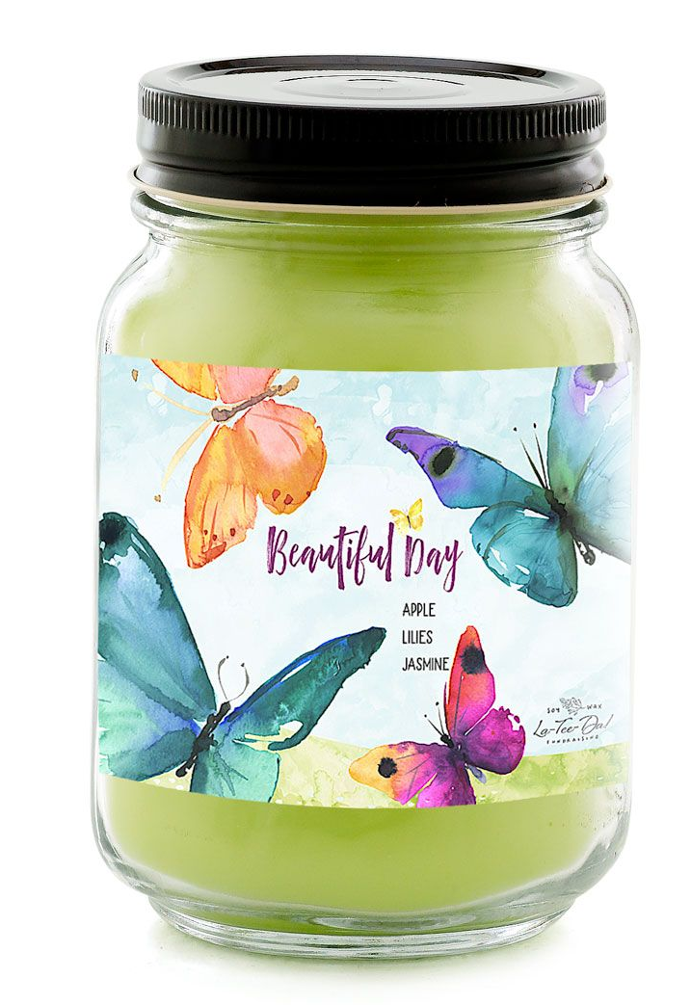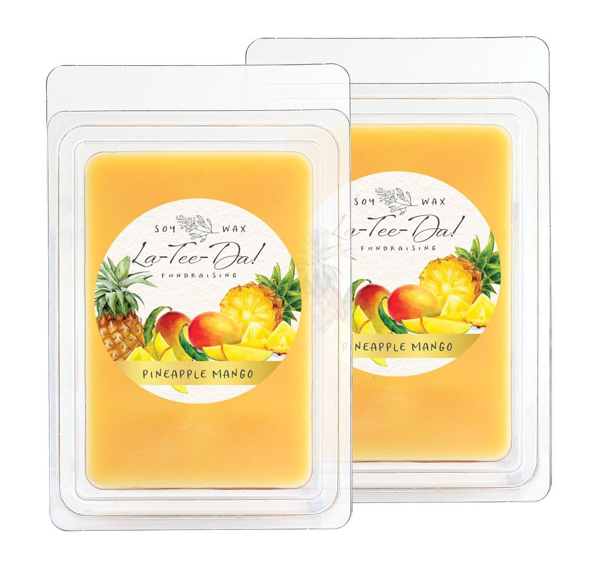

WHAT & WHY: We are raising money to …. Thank you for your support! Shop our online store for La-Tee-Da! Soy-Blend Candles, Room Sprays, Wax Melts, and Fragrance Gels.
OUR GOAL: We would like everyone to participate and sell 20 or more items. The more we sell, the more we will be able to do!
CHECKS: Make checks payable to (name of organization).
END DATE: Return order forms and money by (month and day). Online orders will ship directly to home once an order is placed.
QUESTIONS: Contact (name) at (email and/or phone number)

Promote our fundraiser to increase your sales!

1) Show your brochures and collect orders/payment in-person. In-person sales will raise the most money.

2) Invite supporters to shop online for a larger selection of items and faster shipping. All orders ship direct to your supporter’s home for just a flat $7.95 shipping fee. Please click on this link to register as a seller: https://ltdfundraising.com/pages/join-a-fundraiser?fundraiserId= Create an account by entering the required seller information, and then select the “Register as Seller” button. On the next page, enter your Group ID:#3381 and click on “Find Fundraiser”. Your organization will be listed and click on “Yes, Join it”. Register as a seller by entering your name and phone number. A confirmation email will be sent to you with your Seller ID number and a shopping link. You can copy and paste your personal online shopping link in emails, text, and social media. Note: Family and friends may also share your Seller ID link to help you reach your fundraising goal.

Once the customer confirms who they are shopping for, they will be taken to the online shopping landing page. Products can be purchased using credit cards and orders will ship directly to the customers.

Use all your resources including email, text, and social media! Send 30-40 emails! Text all your local contacts. Post on your Facebook page, create a Facebook Event, share the link by Messenger, Instagram, and Twitter!

Important: Send messages 3 times to your supporters to achieve higher sales:
1) Share the link s and website on day 1 to announce the start of our fundraiser. Send your messages ASAP!
2) Half-way through your sale, send reminders. Customers often intend to order but forget to do so!
3) A day or two before our fundraiser ends as a last chance to order.

Our organization will earn a 50% profit!
Thank you for your participation and supporting our fundraiser!

