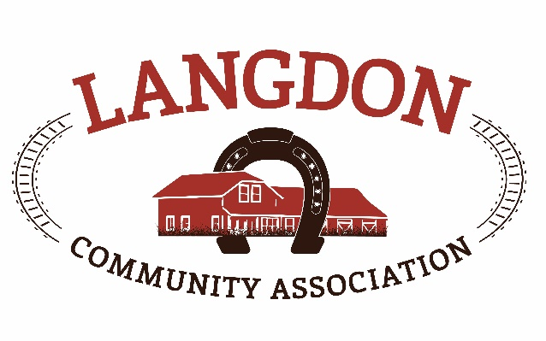
Langdon Community Association
Box 134
Langdon, AB T0J 1X0
www.goodlucktown.ca

LCA Meeting – February 21, 2021
Location: Teams Call

In Attendance:
Chrissy Craig – Chair
Jessica Smythe – Vice Chair
Tom Craig – Capital Projects
Nicole Porquet-Seitz – Director
Crystal Upstone – Events
Brian Ferguson - Treasurer
Corrie Carrobourg – Director
Nicki Black – Secretary
Heather Miller – Fiedlhouse
Brand-Lee Mouck – Community Programs
Dave Miller
Tony Baker
Georga Fisk
Bian Hogg

Meeting called to order at 1934

- Approval of Agenda:
  - Motion to approve the agenda with additions: Jessica & Nicole
- Approval of Minutes:
  - Motion to approve the minutes from January 17, 2021: Jessica & Crystal

- Reports No updated reports
Next LCC meeting – February 28, 2021, 6:30 – 7:30pm, Healthy Communities discussion

- Standing Business
  - Tasks review – reviewed and updated
  - Risk Management – Discussion regarding risk that affect our organization:
    - What risks in the community affect us reaching our goals – County (RVC), government funding, residents (cant please all), social media, volunteers, having members
    - What are LCA’s strengths – diverse group of volunteers, working with other groups in the community, support network, core group of members for a number of years brings stability and knowledge
    - What are LCA’s weaknesses – County (RVC), no staff and reliant on volunteers only, funding, 1 person writing grants
    - What opportunities do we have – applying for grants, community involvement, collaboration with other groups, supporting other groups, quad diamonds = revenue opportunity to help with other facilities, lots of family / drop in options
    - Things that threaten us – County (RVC), grants / funding, social media, volunteer fatigue, covid, community involvement.
  - Succession Planning –review after AGM
  - Education – Online Federation of Calgary Communities resources and education class for new board members or new board positions. Courses have been sent out and free to register. Chrissy will forward current courses available.
  - Strategic Planning – details sent to board for review
  - Langdon Community Campus – Waiting for final update when we will be able to start on the quads, LCA was granted Licence of occupation to operate the quads for 2 years. Ball committee is working on the budget and fees schedule. Covid will put a limit to the number of tournaments that will take place & working on a plan to maximize what we are allowed to do. At this point July 1st will be the opening of the diamonds.
- Discussion
- AGM planning – AGM will take place Match 14th at 7pm. Chrissy will set up zoom call. Positions up for renewal are Treasurer (Brian), Programs (Brandi-Lee), Grants, Members at large. Increase board positions from 11 to 15. All members are required to have up to date memberships in order to vote.
- Tennis Courts – have awarded the design and build of the hard court surface. New bid will go out for the landscaping around the area after. The goal is to have multicourt surfaces to open are to more groups and users. Awaiting the geotechnical survey to finalize costs. The presentation to RVC will be in May.
- Quad update – see above.
- Healthy Communities grant – Federal grant with a quick turnaround. Amounts from $5k - $250K and deadline is March 9th and will know outcome by end of April. Grant is for creating outdoor spaces where people can gather safely during Covid. Chrissy presented a plan to be presented with the grant application and all in favour of concept.
- Motions
  - Approved by email –
          - Motion to install temperature sensors in the Fieldhouse (approx. $200) – Motion by Heather, second Corrie, all in favor.
          - Motion to award the contract to design and build the tennis courts to Year Round Landscaping – Motion by Tom, second Corrie, 1 against, 1 abstain, all others in favour, motion passed
          - Motion to approve $6000 to be spent on the design of the tennis courts. Money to be drawn from sponsorship funds – Motion by Tom, second Corrie, 1 against, 1 abstain, all others in favour, motion passed
  - Approved at meeting – none
Adjourned 2039h

Reports
Events report –
Funds development report –
Communication report –
Parks report –
Program report –
Fieldhouse report –
Capital Projects Report –
Bingo Report –

Future Meeting (calendar invites sent to your goodlucktown.ca emails)
All meetings at 730pm at The Fieldhouse unless noted

Next meeting AGM - March 14, 2021

