**Neighborhood Oktoberfest**

The Farm at Creekside neighborhood Oktoberfest held Saturday, September 30, 2017, at the Eagleview Circle island was a lot of fun, in spite of a little rain. There were about 40 participants, including kids; 17 entries from 9 individuals in the homebrew contest (picture 1), 4 chili entries from 3 folks, plus some good homemade wines made by Adam Kuyt and Francesco Sangiorgi. Clothing was collected for HOPE ([www.hopeforlongmont.org](http://www.hopeforlongmont.org)). The homebrew judges had a difficult time with the variety of beers: a lager, seasonal pumpkin brews, wheats, ambers, lots of IPAs, a stout, a porter, a saison, an ESB, a Belgian strong dark, and even a cider. The first place prize, “beer for a year” from Left Hand Brewing Co., went to David Duckworth (center in picture 2) for his Duckridge Imperial Stout. Second place, a box of exotic bombers from Twin Peaks Liquor, went to Tim Wawrzynczak (right in pix 2) for his Imperial IPA. Third place, a growler from the Powder Keg Brewing Co. in Niwot, went to Francesco Sangiorgi (left in pix 2) for his saison. Fourth place, a $25 gift card to Bootstrap Brewing, went to Gabe Tovar for his Minnesota Nice IPA. In the chili contest, Sandy Strauss’s (pix 3) pork green chili won first place, a $35 gift card and box of sauces from The Rib House and $25 gift card from Lucky’s Market. Second place, a $50 gift card to Rosalee’s Pizzeria, went to Kim Dolan (left in pix 4) for her Manly Chili. Third place, a $25 gift card to Samples World Bistro, was won by Roz Weller (right) for her mild turkey and sweet potato chili. In addition to the establishments mentioned above, we want to thank Steven Noel of ReMax for being a major sponsor for the event.

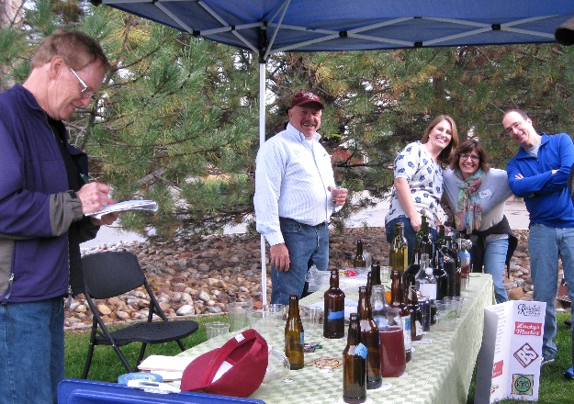 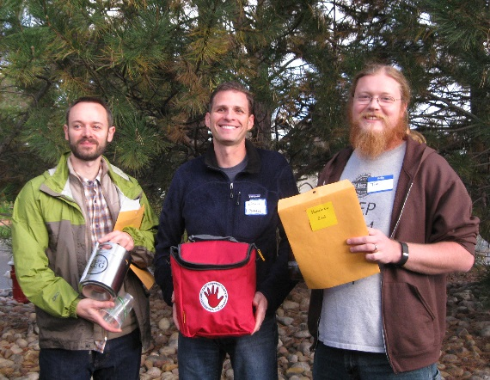 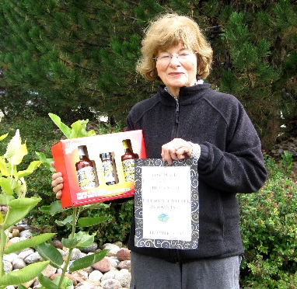 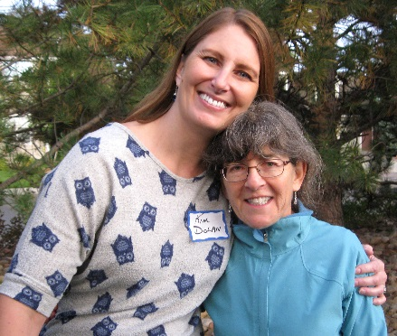

ard Yard of the

**Yard of the Month Contest Continues**

The contest for October will recognize Halloween decorations and for December will recognize holiday decorations.

**Social Committee and Yard of the Month Volunteers Needed for Next Year**

Note that Roz Weller will no longer be serving as chair of the social committee or yard of the month committee after December, so volunteers are needed next year for these programs to continue. Email the board at hoa@fachoa.org or [soc@fachoa.org](mailto:soc@fachoa.org) to volunteer or get more information about the positions.