ANNUAL TOWN MEETING
March 10, 2020
Aurora, MN

IN ATTENDANCE: (20) Jon Skelton, Craig Anttila, Edward Kippley, Jodi Knaus, Amanda Gross, Michael Kearney, Clark Niemi, Paul McDonald, Ed Alto, Bill Maki, Arlette Mikulich, Lorna Kallio, Mary Matteson, Ila Fodness, Mike Palm, Gerry Kangas, Donna Meacham, Jeannie Salo, Leroy Sprink, Alta Sprink

- The 2020 Annual Town Meeting of the Town of White was called to order by Chairman Skelton on Tuesday, March 10, 2020, at 6:00 P.M., at the Loon Lake Community Center.
- Pledge of Allegiance
- Skelton called for Nominations for Moderator
IT WAS MOVED BY MIKULICH, SUPPORTED BY MATTESON TO NOMINATE SKELTON AS MODERATOR. NO OTHER NOMINATIONS. MOTION CARRIED
IT WAS MOVED BY MIKULICH, SUPPORTED BY MATTESON THAT NOMINATIONS BE CLOSED. MOTION CARRIED
Jon Skelton took the chair as moderator.

4.) IT WAS MOVED BY PALM, SUPPORTED BY MAKI TO ADJOURN THE 2019 ANNUAL TOWN MEETING. MOTION CARRIED

5.) IT WAS MOVED BY KANGAS, SUPPORTED BY SAARI TO OPEN & CONDUCT THE 2020 ANNUAL TOWN MEETING. MOTION CARRIED IT WAS MOVED BY ALTO, SUPPORTED BY PALM TO ADOPT AND APPROVE THE AGENDA. MOTION CARRIED

6.) IT WAS MOVED BY SAARI, SUPPORTED BY KALLIO TO WAIVE THE READING & APPROVE THE 2019 CONTINUATION OF THE ANNUAL TOWN MEETING MINUTES AS PRESENTED. MOTION CARRIED

7.) IT WAS MOVED BY MATTESON, SUPPORTED BY ALTO TO SET THE DATE, TIME, AND PLACE FOR THE 2021 ANNUAL TOWN MEETING FOR TUESDAY, MARCH 9, 2021 AT THE LOON LAKE COMMUNITY CENTER AT 6:00 P.M. MOTION CARRIED

8.) Guest Speaker Commissioner Paul McDonald spoke to the community about the $60 million scheduled for projects this year throughout the County. Roads will be chip sealed this summer. Initiative over the next two years is to improve the condition of gravel roads. There is a citizen’s committee being established for roads. Also, a Rural Mental Health Committee is being established to bring people together for our schools and communities. The County set a record this year on tax forfeited land sales. County Board meetings are held throughout the area and well attended. He would like to host one in the Township in 2021. The County is also being aggressive with Invasive Species in our waters too! A discussion was held on the drug problem on the Range which will take a culture change, time, and jobs to change.

9.) Moderator Skelton read the PowerPoint Presentation outlining the Clerk & Treasurer’s Report including Strategic Plan Outcomes and the 2019-2020 Budget Discussion (slides included at end of minutes). Copies of the 2019 Final Budget, Investment, Indebtedness, and Board of Audit Financial reports were distributed.
9a.) IT WAS MOVED BY MATTESON, SUPPORTED BY ALTO APPROVING THE EMPLOYEE RECOGNITION POLICY ANNUAL AMOUNT OF $1,000.00 FOR 2020. MOTION CARRIED
9b.) IT WAS MOVED BY MATTESON, SUPPORTED BY ALTO TO DELAY SETTING LEVY UNTIL THE CONTINUATION OF ANNUAL MEETING ON SEPTEMBER 8, 2020. MOTION CARRIED
9c.) IT WAS MOVED BY PALM, SUPPORTED BY MATTESON TO ACCEPT THE CLERK & TREASURER’S REPORT. MOTION CARRIED
9.) Other Business – Mike Palm spoke of his Whitetail Unlimited event he is planning for 9/12/2020. Skelton spoke about recreation, softball, baseball, and youth events he’d like to see at Twin Lakes and the Loon Lake Community Center. Mesabi East Schools has hired Mark Goerdt as a Recreation Coordinator. Mary Matteson thanked the Board and Staff for everything they do. Mary Matteson asked each Board member to speak about the direction they see the Township going. Skelton responded the Board is very proactive and wants to promote the Loon Lake Community Center and all of our facilities and assets. He believes the staff is top notch and our roads have never looked better. He believes the overall state of the Township is great! Kangas responded with yes, things have gotten better! Kippley responded we are aggressive in working on bringing Broadband to the Township residents and businesses. The Board tries to be very fiscally responsible. He has been involved with the Township in one way or another for over 40 years. He also thinks the Township is doing great and thriving! Anttila agreed with everything Skelton and Kippley stated and added a thank you to all the employees. Mary Matteson requested signs of “Town of White” or “Palo” be added around the Township at our boundaries.
10.) IT WAS MOVED BY MATTESON, SUPPORTED BY SAARI TO KEEP THE 2020 ANNUAL MEETING OPEN UNTIL THE CONTINUATION OF ANNUAL TOWN MEETING ON SEPTEMBER 8, 2020. MOTION CARRIED AT 7:23 P.M.

POWERPOINT PRESENTATION SLIDES ARE ATTACHED.

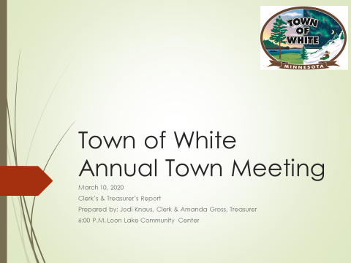

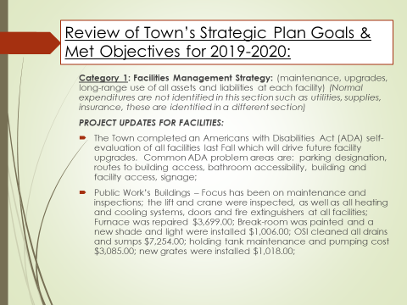

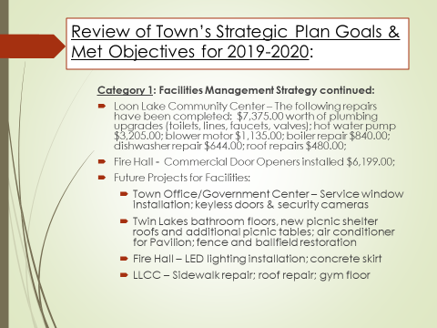

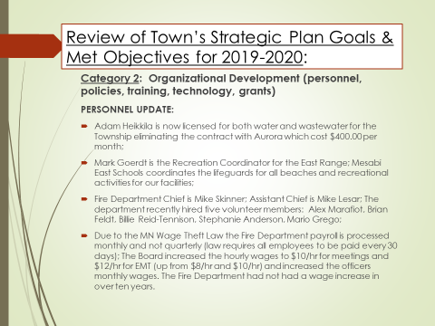

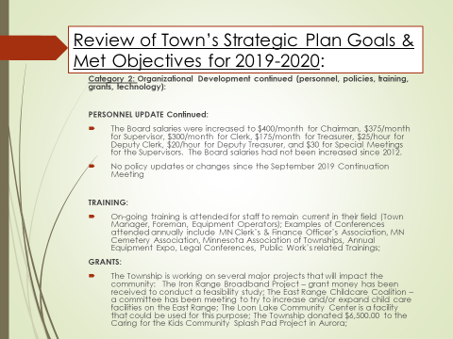

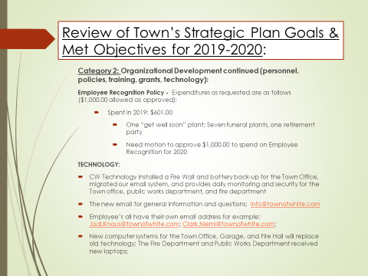

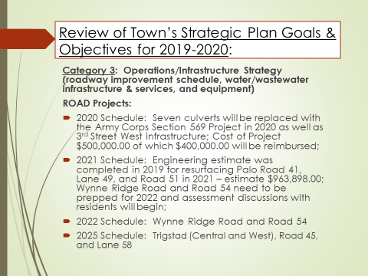

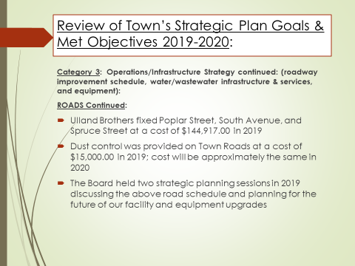

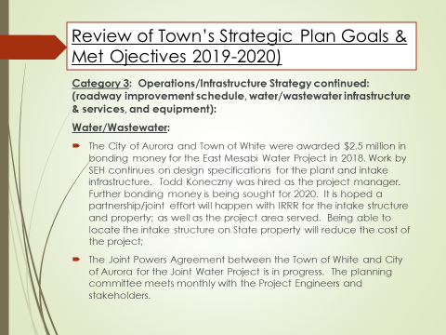

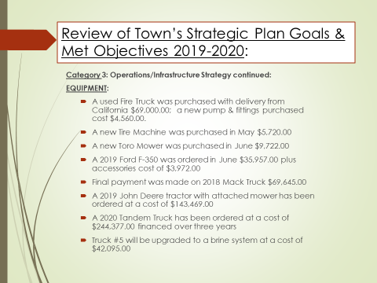

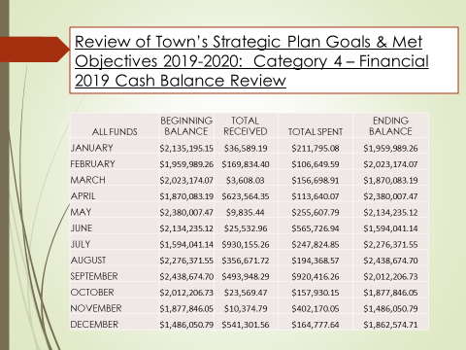

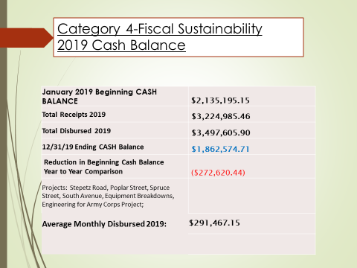

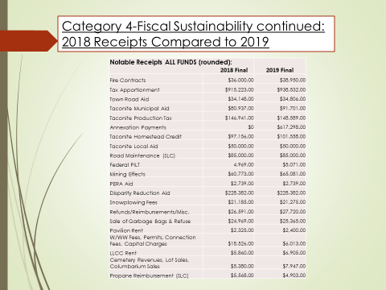

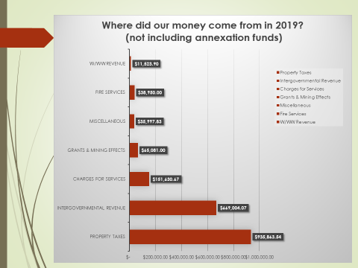

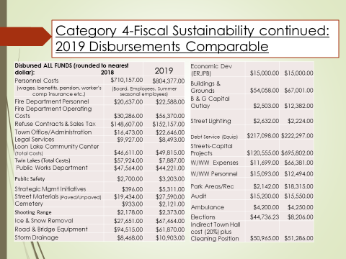

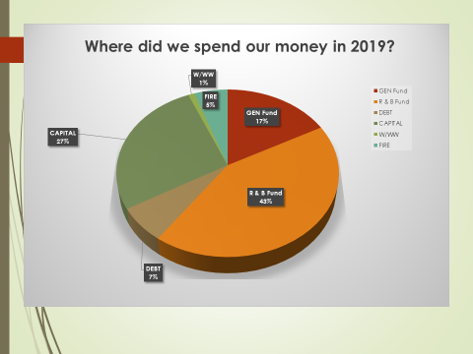

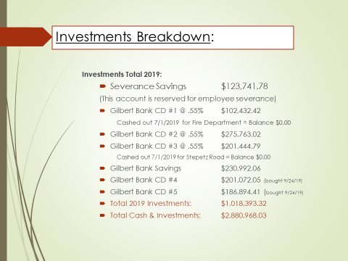

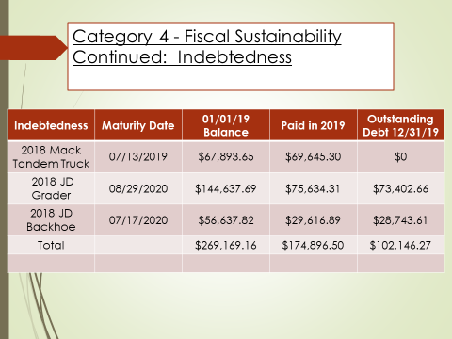

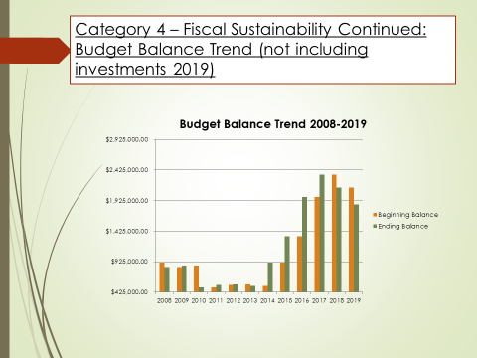

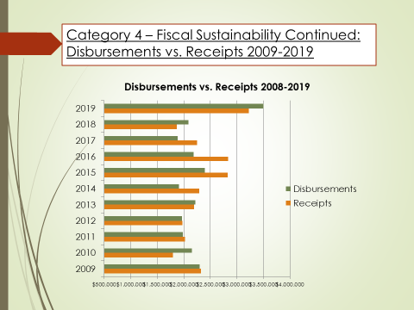

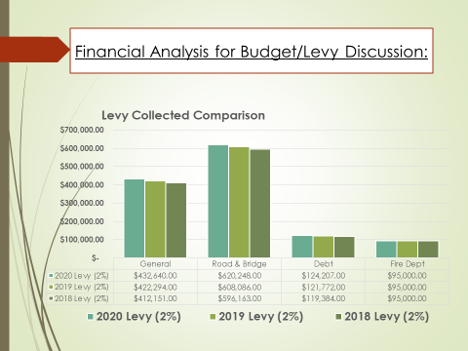

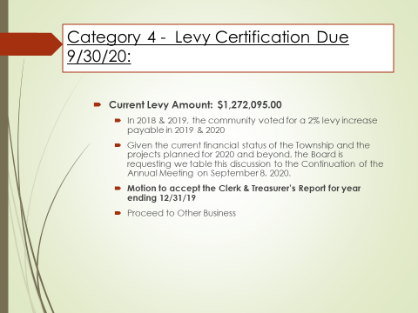

_____________________________________ _________________________________________
Jodi Knaus, Clerk Jon Skelton, Moderator

