GEN-630 (120V-3000W-60Hz-7.2kW-16yr) | Geneforce Emergency Power System  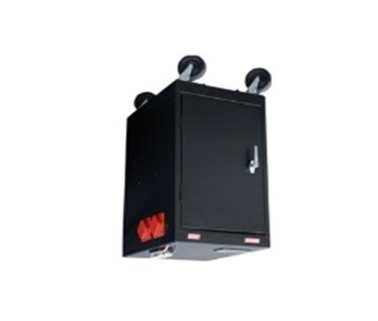
Product Features
Silent operation. Safe for indoors. No gas or emissions.
No Installation; No Maintenance; No Permits required
Automatic & one-touch start. May Connect to Breaker Box.
Advanced System Control Panel with Graphical 128 x 64-pixel, backlit LCD display that allows for setup and monitor of entire system including multiple solar charge controllers and auxiliary battery banks. Panel displays power reserves, amp hours consumed, fault conditions, solar panel output, charging, power consumption.
Pure Sine Wave and Built-in voltage regulation system provides clean output for sensitive electronics.
Built-in (30A) Automatic A/C transfer switch.
Temperature compensated charging for varying climate conditions
Power factor corrected multi-stage charger for fast, efficient charging
Electrical Specifications | GEN-630 (120V)
Output power (continuous at 40°C) | 3,000 W
Surge rating (5 seconds) | 6,000 W
Peak Output Current | 80A
Output frequency regulation | 60 Hz +/- 0.2 Hz
Output Voltage | 120 Vac
Output wave form | True Sine Wave
AC connections | Split phase in / dual out, Dual in / dual out
Charger
Output current (continuous at 25°C) | 150 A
Output voltage | 12 Vdc
Charge control | 3-stage (Bulk, Acceptance, Float)
Charge temperature compensation | Remote battery sensor (included)
Input current (for maximum charging) | 24 A rms nominal
Input AC voltage | 120 Vac
Input AC voltage range | 85 - 140 Vac
Dead battery charge | > 5 Vdc
General specifications
Transfer relay rating | 2 legs at 30 A each
AC Automatic transfer switch | (30A/125V)
Transfer time (AC to inverter and inverter to AC) | < 20 ms
Optimal operating temperature range | - 4°F to 140°F (- 20°C to 60°C)
Storage ambient temperature range | - 40°F to 185°F (- 40°C to 85°C)
Service Life (on float charge) | 12-16 Years
Stored Electrical Energy (battery reserve) | 7.5 kW (7,560 Watts)
AC input 1 | (30A/125V), 3-wire, Male Twist-lock plug
AC input 2 (optional input for auxiliary generator) | (30A/125V) *installed, not connected
AC output 1 | Four (20A/125V) Isolated Ground Receptacles
AC output 2 | (30A/125), 3-wire, Female Twist-lock receptacle
Solar Charge Controller (included) | (30A/12V) (~400W per hour of sunlight) *(60A/24V) optional
General Specifications
Monitor | LED Display (Reads V, Amps, DC amps, State of Charge, etc.)
Dimensions (H x W x L) | 36" x 24" x 18"
Construction | Four Heavy Duty Casters, Heavy Steel Enclosure, Color - Black
Weight | 480 lbs.
Warranty | 2 Year on Components; Up to 4 years on Batteries
Part numbers | GEN-630-120-3000-16YR
Regulatory Approvals & Protection
Safety - UL Listing | Components ETL certified to CSA 107.1, UL458, FCC Part 15, Class B
Voltage Regulation | Over voltage and under voltage protection
Temperature | Over-temperature protection
Output | Overload Protection
Electrical | Short circuit protection
Price | $6,979
Geneforce Incorporated www.geneforcepower.com Tel: (305) 215-5443 email: sales@geneforcepower.com

