**Come One, Come All, VENDORS WANTED**

**SATURDAY 9/6**

**Wilmington Sons & Daughters of Italy & Wildcat Band Parents**

***FLEA MARKET***

**8am to 2pm**

**Wilmington Town Common**

**Parking Lot**

**$25 per SPACE**

**Sell all your Treasures**

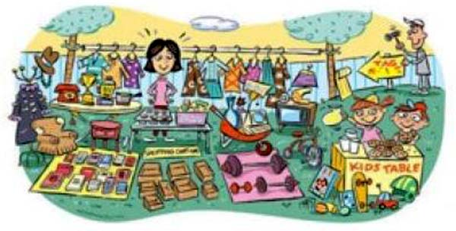

**FOR MORE INFO OR TO RENT A SPOT CONTACT: jromano45@gmail.com or (617) 750-9749**