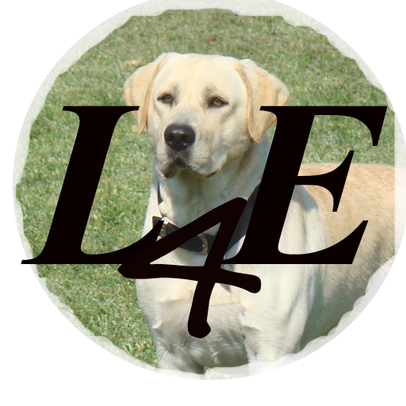

LABS4Ever.com

Contract and Bill of Sale for one Labrador Retriever Puppy
This contract is entered into on ______________, 2023, in Katy, Texas, by and between
Jodie Bunn (Seller) and ____________________ (Buyer), for the sale on one (1) Labrador Retriever puppy that was born on _______, 2023, from Dam __________________.
Jodie Bunn is the (litter) owner. Please feel free to reach out if you have any questions, 951-741-3412. This deposit reserves pick #__ out of the litter.

Congratulations!
After a puppy has been transferred from Seller to Buyer, all veterinary care is the responsibility of Buyer. To validate your puppy's health, Buyer has 72 hours from the pick-up time to have the puppy's health checked by a licensed veterinarian. If a disorder is detected, a signed statement by a licensed veterinarian is required as proof. Seller has the right to seek a second opinion from a veterinarian of her choice. If a disorder is present, at Seller's choice, the puppy will either be replaced with a puppy from the same litter conditioned on if a puppy is available from that same litter, or the purchase price will be refunded. To obtain a replacement puppy, or purchase refund, the original purchased puppy must be returned to the Seller.

Puppy selection will be made with the discretion and guidance of the Seller. Seller always retains the right to first pick of every litter.

Subject to Buyer's compliance with items 1-4 below, this puppy will carry a 25-month (from whelp date) guarantee to be free of genetic hip and elbow dysplasia. All guarantees apply only to the original Buyer. Guarantees are not transferable under any circumstance.
1. This puppy/dog must not have been used for breeding prior to two years of age.
2. Buyer must administer the vitamin NuVet Plus and NuJoint Plus up to 25 months of age and have proof of such vitamin administration.
Proof of NuVet use will be vitamin purchases as documented by NuVet labs code #59593.
3. If after 24 months of continuous NuVet use (item #2 above), but not to exceed 25 calendar months of dog’s age, the dog is positively diagnosed with hip or elbow dysplasia, Seller will replace the dog with another of comparable quality to the original, conditioned at the time. If no dog is readily available, Buyer expressly agrees to either wait until Seller has an available litter or if none will come into existence, accept a full refund of the purchase price, at Seller's discretion. The puppy selected for replacement will be mutually agreed upon by Seller and Buyer, however, in no case must Seller show more than 10 replacement puppies, nor must Seller obtain puppies from a source other than her own stock. Replacements will be made only
upon verification that the dog with hip and/or elbow dysplasia has been spayed/neutered at the Buyer's expense.
4. Buyer is recommended to have the dog's hips and elbows certified through The Orthopedic Foundation for Animals (OFA) at 24 months of age.

The following additional conditions apply to a puppy sale:
1. Deposit and/or purchase price is not refundable.
2. Breeder is not responsible for any other accidents, conditions, ailments, death, or disease
to the puppy after Seller has transferred the puppy to Buyer.
3. All costs and fees for OFA are the responsibility of the Buyer.
4. The Seller cannot guarantee that the puppy will be show quality, will be able to be bred,
or its size fully grown. The only guarantee provided are those listed above.

The puppy has received all vaccines and deworming due to date, as prescribed by a licensed veterinarian. The puppy has not been vaccinated against rabies. Shot records will be provided at the time the puppy is picked-up. To ensure the puppy's good health, it is strongly recommended that all vaccines be kept up to date with the guidance from a licensed veterinarian.

Buyer agrees that any and all disputes that arise under this contract between Buyer and Seller that cannot be settled by the parties is subject to binding arbitration.

Buyer's Signature: ___________________________________________________ ____
Co-Buyer's Signature:_________________________________________ ___________
Seller's Signature: _______________Jodie Bunn ______________ ________
Puppy's AKC Registration # : ___________________________________________________

Dog Pedigree Registration Disclosure:

The Labrador Retriever you are purchasing can be registered with AKC (American Kennel Club). What the American Kennel Club Registration means is only that AKC maintains information regarding the parentage and identity of this puppy. It does not guarantee the quality of health of this puppy, and it does not guarantee quality lineage. Since dog pedigree registries depend in large part on the honesty and accuracy of persons registering dogs, registration does not guarantee the accuracy of the lineage.
This puppy is being sold with a ___Limited_____ AKC Registration.

The Buyer agrees to care for, feed, exercise, provide necessary veterinary care for, and look out for the puppy's/dog's best interest at all times.
As follows, the Buyer and Seller agree to all the terms in this contract:
*Buyer is required to carry Labs4Ever Kennel name in registered name of puppy.

Dam's Name: ___________________________ Dam's AKC Number: ______________ _____
Sire's Name: __Bear ______________________ Sire's AKC Number: ____________________

Puppy Description:
Date Whelped: _____________ _____ AKC Number:_________________________________
Gender: ________________ _________ Microchip Number:____________________________
Color: _________yellow _ _________ Identifier (if any): ____________________________

Purchase Understanding: Sale Price: $2800
Deposit Amount (*) : ___$800 ______
Balance Due on Pick-up Date (Cash Only, please): __$2300 __________________________
ALL SALES ARE FINAL Actual Pick-up Date : ________________ _________
*Deposits and payments are not refundable. If puppy is not picked-up by 9 p.m. of the required pick-up date specified above, the Buyer forfeits all deposits and payments, and the Seller is relieved of the obligation to provide any puppy to the Buyer after the required pick-up date and time, unless previous arrangements have been made with the Seller.
Acknowledged:
Buyer: Co-Buyer:
Name:__________________________ _____ Name:_________________________________
Address: _____________________________ Address:_______________________________
______________________________ ______ ______________________________________
Phone Number:____________________ ___ Phone Number:_________________________
Email:________________________________ Email:_________________________________
Signature: ____________________________ Signature: _____________________________
Date:____________________________________ Date:_____________________________________

Seller's Signature: _____Jodie Bunn ______ Date: ___________________________________
Thank you for your purchase! We hope that you enjoy many happy years with your new companion!
Dear Puppy Buyer,

Please note that NuVet Plus supplements are required as part of your pet's Health Guarantee.

More than a million dogs and cats are using NuVet to protect against most ailments (from back yard pesticides, pet food allergies and hormones, toxic formaldehyde in furniture and carpeting, ailments transmitted from dog parks and the vet's office, etc.), while maintaining a beautiful skin and coat.

NuVet Plus is not just a vitamin. It is an immune system builder with a precise balance of vitamins, minerals, omega fatty acids, amino acids and high-potency antioxidants. That's why it works so well through all three stages of a dog's life.
- For younger dogs (under 2 years old), it strengthens their immune system, while building and strengthening the cardiovascular, skeletal and nerve systems.
- For dogs in their prime (ages 2-8), it improves the luster of their skin and coat while protecting against allergies, skin and coat problems, staining from tears, digestive problems, etc.
- For older dogs (over 8 years of age), it helps reduce and eliminate arthritis, tumors, premature aging, cataracts, heart conditions, diabetes, and many types of cancer, while extending the life and improving the vitality of most dogs.

NuVet Plus will keep your pet on the path to perfect health! It's not available in stores, and is only available to the general public with an order code from an authorized pet professional.

You may order directly from the manufacturer by calling 1-800-474-7044 and using Order Code: 59593, or ordering online at www.nuvet.com/59593. By using autoship, you can save an additional 15%.

To the long life and health of your puppy!

(Define whelp date here)
NuVet Labs maintains and will provide Seller a permanent record of sales by purchasers.

