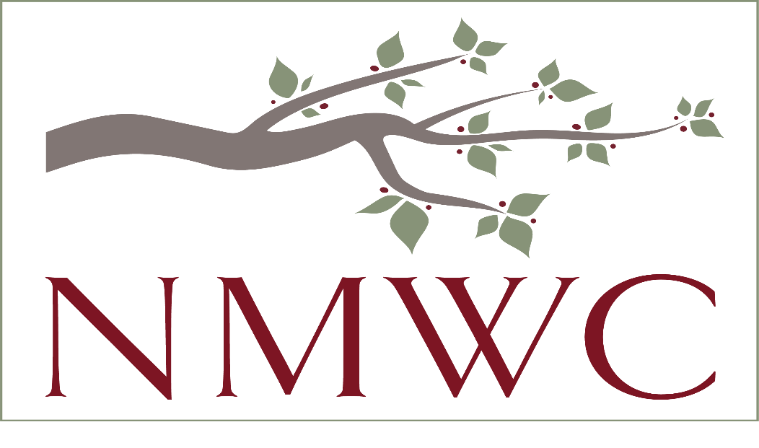

2022-23 NMWC Grant Application
With a strong sense of stewardship, our grant-making process is conducted with integrity, respect, and fairness to all applicants.
To be considered for a grant this year, please return, 1) this summary sheet, 2) your response to the narrative questions, and 3) the required attachments by July 15, 2022, to charityrequest.nmwc@gmail.com. Electronic submission is required.

NMWC GRANT SUMMARY
APPLICANT:
Organization’s Legal Name:________________________________________________
Organization’s Mailing Address: ___________________________________________
Name of Organization’s Executive Director or President: ________________________
Tax ID Number: _________________________ 501(c) (3) Tax Status? ___Yes ___No
Website: ___________________________________________________________
Year Founded: _________________________
Mission Statement:
______________________________________________________________________________ ______________________________________________________________________________
Geographic Area Served: (Where Clients live with estimated percentages)
______________________________________________________________________________

CONTACT:
Contact Name/Title: ____________________________________________________________
Phone Number: ___________________________
Email Address: _______________________________________________________________

GRANT REQUEST:
Program Name: ___________________________________________________________
Purpose of Grant (one sentence):
______________________________________________________________________________
______________________________________________________________________________ Prior Grants from NMWC (when/how much): ______________________________________________________________________________
Amount Requested: $___________________ Total Program Cost: $_________________
Current Operating Budget: $_________________
Program Start Date: ______________ Planned Completion Date: ________________
Expected Number of People Assisted: ____per week/month/year for ____weeks/months/years.

Check all that apply:
PRIMARY CLIENTS: SERVICES:
Women_________________ Community Development _____________
Children____________ Education________________
Families________________ Emergency Aid___________
Health Care ______________
Housing _________________
Social Services____________

GRANT APPLICATION NARRATIVE (Your total response to the following topics should not exceed three pages using twelve-point font.)

- ORGANIZATION OVERVIEW
Describe the purpose of your organization and the need(s) and populations that you serve. Help us understand WHY your organization is important to our community. Please include the number of people served, the number of full and part-time paid staff, volunteers and volunteer hours donated, collaborations and partnerships and other quantifiable information which will help us evaluate the effectiveness of your organization.

- CORE SERVICES
Describe your core services and/or models of service delivery. Help us understand HOW you achieve your mission.

- PURPOSE OF GRANT
Please describe needs/problems to be addressed; target population and how they will benefit; project goals; measurable objectives; action plans; and whether this is a new or ongoing part of your organization. Acknowledge similar existing projects or agencies, if any, and explain how your agency collaborates or differs.

- MEASURES OF SUCCESS
How do you know if your organization is achieving its mission? How do you gauge when you should adjust your services? Please provide quantitative data/metrics and qualitative outcomes/stories. What are the benefits to the North Mecklenburg community?

- SUSTAINABILITY
If this will be an ongoing program, please include long-term strategies for funding this project at the end of the grant period.

- PROJECT/PROGRAM FINANCIAL INFORMATION AND METRICS
Outline all direct project/ program costs, other funding secured and its source(s), other organizations from which you are seeking funding and the amount(s). How many people will the project/program benefit?

- ADVANCING YOUR MISSION
Are there volunteer/service opportunities within your organization for NMWC members? If so, please describe the service opportunities.

- CERTIFICATION
On behalf of our organization, I certify that the information contained in this application, including all attachments is true and correct.

____________________________________________
Signature, Executive Director, President or Authorizing Official

_____________________________________
Printed Name/Position

_______________________________________
Address City Zip Code

