

Supporting your child’s fine motor development

@ home

*June 2020*

**Fine motor skill** (or dexterity) is the coordination of **small** muscles, in movements—usually involving the synchronization of hands and fingers with the eyes. Children who do not have appropriate fine motor strength, are unable to hold a pencil correctly and therefore not ready to write. These children should not be hurried to pick up a pencil, instead they should be provided with the opportunities to develop their fine motor skills. Children mature and develop at different rates but at the end of the day, they all get to the same point and it is the journey that is important!

In order to have good fine motor skills, you must also have a strong sense of body awareness and core strength, so development of gross motor skills is also very important and goes hand in hand with fine motor development.

On this sheet you will find some simple, open-ended ideas for practising motor skills though art, sensory play and manipulative games; as well as gross motor activities Have fun!

Fine motor activities

* Thread beads onto a pipe cleaner or string (use cellotape to stiffen the end and to act as the needle).
* Make a pasta necklace.
* Thread cheerios onto a piece of spaghetti.
* Hammer golf tees into playdough.
* Pick up and sort dried beans using child friendly tweezers or just fingers (pincer grip between thumb and fore finger).
* Practise closing and opening buttons on a coat or shirt.
* Use a variety of scoops to transfer materials such as lentils, sand or small pasta shapes into containers.
* Use chunky chalks to decorate paths or drives at home!
* Warm wool or string around different shapes cut out of cardboard.
* Weave ribbon or string in and out of fencing or bannisters.
* Create pictures with tile shapes or blocks.
* Thread pipe cleaners into the holes in a colander.
* Thread small beads onto the spaghetti.

Gross motor activities

* Walk along a log
* Step across stepping-stones or paving slabs.
* Stand on one leg (look at a spot in front of you to help!)
* Jump from two feet to two-feet/ jump from a balance to two feet.
* Jump two feet to two feet around and around!
* Walk along a chalk line on the ground.
* Hold your arms out wide and be an aeroplane!
* Hopscotch
* Hoops provide a super jumping activity- in and out, in and out!
* Jumping down from a height- steps or small banks.
* Silly walks- tiptoeing, stamping, jumping, running (slow and fast), side stepping,
* Throwing stones and sticks into a river or stream.
* Jumping into a puddle or squelching through thick mud.
* Take a ball for a walk with your feet- keep it close!
* Roll down a bank.

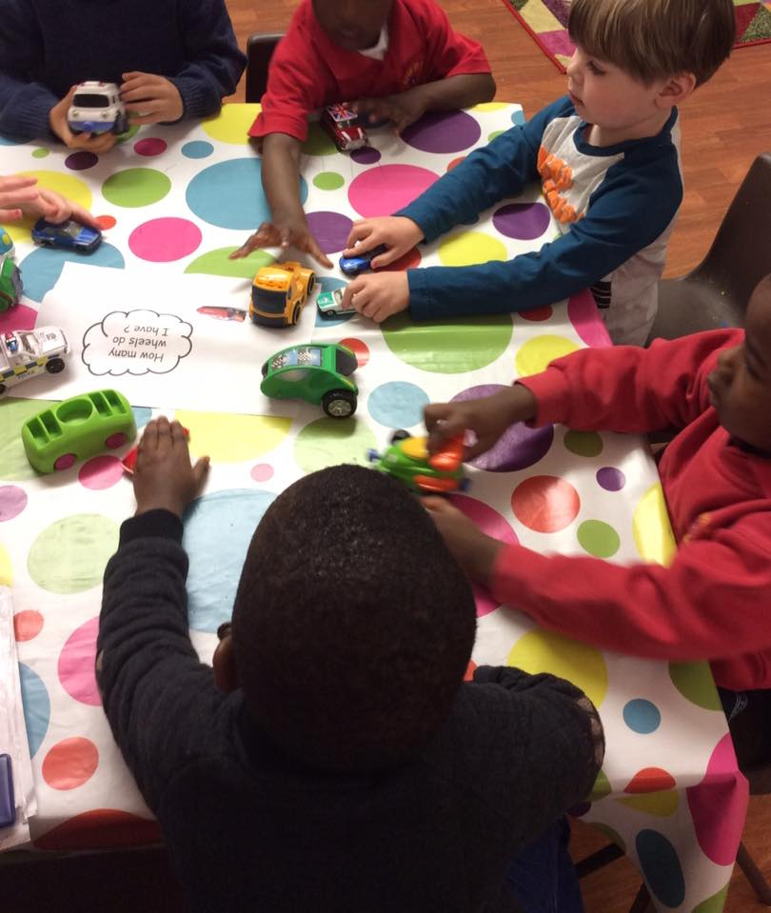

Playdough

Playdough provides a fantastic opportunity for children to manipulate, squeeze, twist and build with it.

You can add colour, glitter and spices. Natural materials can be added to create patterns and prints.

Make your own playdough

* 2 cups plain flour (all purpose)
* 2 tablespoons vegetable oil
* 1/2 cup salt
* 2 tablespoons cream of tartar
* Up to 1.5 cups boiling water (adding in increments until it feels just right)
* food colouring (optional)
* few drops glycerine (optional- adds more shine!)

*The children make this themselves in the classroom. If they are involved just use warm water. You will just need to knead it for a little longer to build up the gluten and the dough’s stretchiness!*

Mix the flour, salt, cream of tartar and oil in a large mixing bowl. Now add (optional) food colouring to the boiling water then into the dry ingredients. Stir continuously until it becomes a sticky, combined dough. Add the glycerine (optional) and allow it to cool down then take it out of the bowl and knead it vigorously for a couple of minutes until all of the stickiness has gone. This is the most important part of the process, so keep at it until it’s the perfect consistency! If it remains a little sticky then add a touch more flour until just right.

*Voila!*

Fine motor activities continued…

* Finger painting
* Draw pictures or patterns in the steam on a shower screen at bath time.
* Blow bubbles and try to pop them with your fingers in the bath or outside.
* Sort small objects like stones or shells- can you use them to make patterns?
* Build something fantastic with Duplo or Lego!
* Whisk up the washing up bubbles or bubble bath, using hand whisks.
* Create letters of your name using salt dough.
* Stack some disposable cups- can you make a high castle?
* Use cotton bubs to paint a picture.
* Play and sort coloured match-sticks (available from many pound shops).
* Spooning marbles into different containers.
* Sing number songs like five little ducks went swimming one day, using the fingers to count out the numbers of ducks.
* Hanging out some socks on a small indoor washing line using pegs.
* Squeeze a peg to the beat of a favourite song.
* Use tweezers to pick up small things, like pom poms.
* Use a hole punch (many child-friendly fancy pattern hole punches are available from retailers such as Hobbycraft or The Range).
* Creating pictures using mosaic paper squares or on pegs boards.
* Plastic pipettes (available from Amazon) or turkey blasters are fantastic to transfer liquids from one container to another and to explore colour mixing.
* Lacing activities- a simple piece of paper with holes punched would work a treat!
* Weave strips of paper into a pattern.
* Sort and counting 1p and 2p coins.
* Get constructing with small marshmallows and spaghetti!
* Stack building blocks, stones or buttons- how high can you go?!