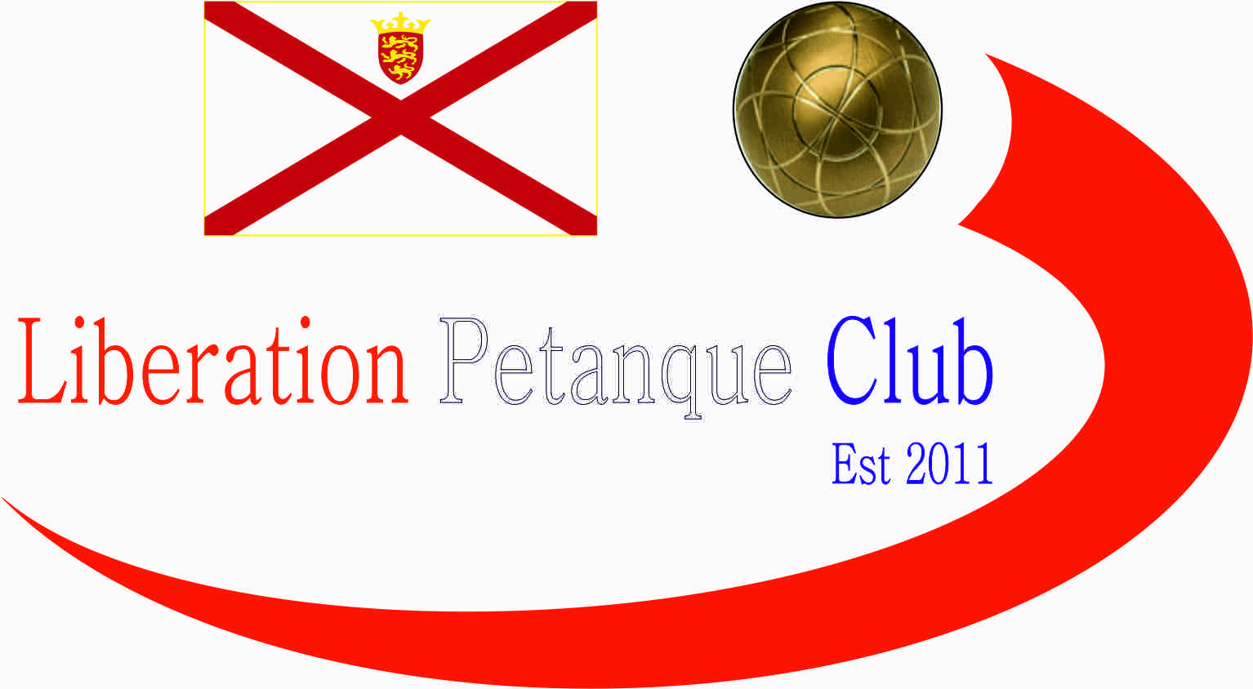  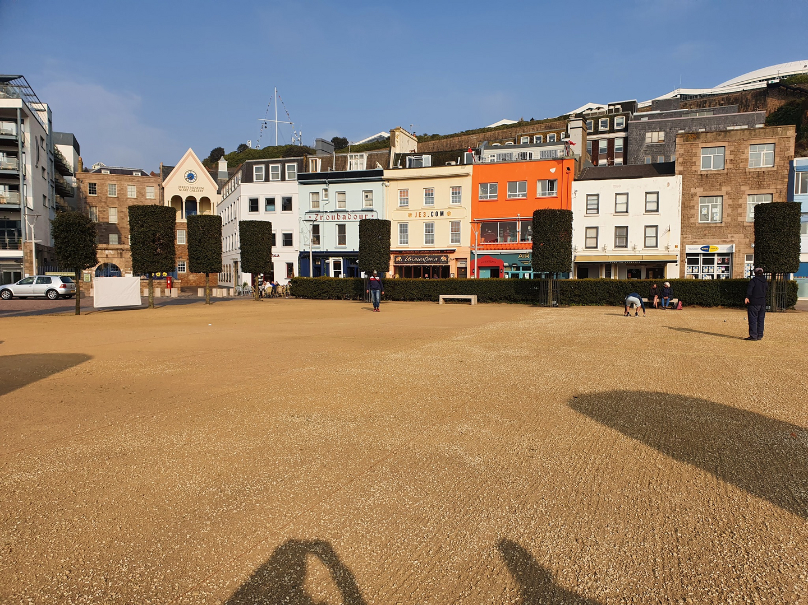  - 2025  open competitions  We are pleased to announce we will again be holding our International Open over Friday 25th to Sunday 27th July. See separate Entry form for International Open.  Entry Fee’s are £10.00pp for None Members for our Island Open Competitions.  Singles Open _______________________________  Doubles Open Player 1 _______________________  Doubles Open Player 2 _______________________  Charity Triples Open Player 1 _______________________  Charity Triples Open Player 2 _______________________  Charity Triples Open Player 2 _______________________  Contact No. _____________ Email ____________________ | Competition Dates  ____  International Open July Singles – Fri 25th Doubles-Sat 26th Triples-Sun 27th  ____  Singles – 28th June  ____  Doubles – 12th April  ____  Charity Triples Open 18th October  Liberation peranque club  www.liberationpetanque.co.uk  Club Email - liberationpc@gmail.com  Bacs Payments to: Sort Code – 30-94-61 Account No. 15475463
Liberation Petanque Club

