4/25/2017 The Timing of Major Events

This article will investigate unusual and rare events that have been of interest to a global audience. We will examine rare events such as the Apollo 11 moon landing, the very first test of an atomic device, and comet Shoemaker-Levy striking Jupiter 21 times. We'll look for evidence of our Creator, YaHuWaH Elohim, in the timing of these events.

The Olympics

The original Olympics started in 776 BC in Olympia, Greece, and stopped about 1,168 years later in 393 AD. The Olympic Games were a celebration of human strength and endurance, being symbolic of Greek Mighty Ones, Greek gods.

According to the book of Maccabees, there was an attempt by Grecian officials to replace the Hebrew culture with Greek culture. When Greece controlled Jerusalem in the 2nd century BC, a Gymnasium was built next to the Temple. Anyone caught reading the Torah was killed. If an infant was found to have been circumcised, the infant was killed and hung around the mother’s neck.

The ancient Olympic Games were revived in Athens, Greece, on April 6, 1896 which was Easter Monday in both the Eastern and Western Christian Churches. Easter is the veiled name of the ancient fertility goddess Ishtar which most modern Christians accept as unquestionable tradition. The Olympic Games today have a global audience and are filled with ancient pagan symbols in the opening and closing ceremonies. Through the modern televised Olympics, a global audience is being introduced to ancient pagan religious practices without their knowledge, just as millions of Christians have been each Sunday in churches around the world for centuries.

Mighty Ones, false gods, fallen angels and their progeny, have been the enemies of YaHuWaH Elohim for thousands of years. Those enemies desire man's worship, as revealed in Matthew 4:8-9 below.

Matthew 4:8 Again, the devil taketh Him up into an exceeding high mountain, and sheweth Him all the kingdoms of the world, and the glory of them;
9 And saith unto Him, All these things will I give thee, if thou wilt fall down and worship me.

Let's look at the timing of the 1st revived Olympic games in 1896 as compared with other rare events that reveal the working of a hidden hand.

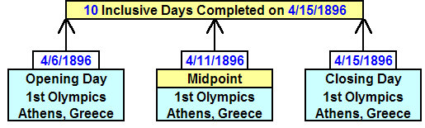
The midpoint of the first revived Olympic Games was 4/11/1896.

The Tav "X" on Medusa's Head and the 1896 Olympics

In 1996 and 1997 there was a very rare event that had astronomers buzzing. Two large comets that could be seen with the naked eye crossed the sky exactly 1 year apart and placed an "X", a Paleo Hebrew Tav (end mark), on the forehead of "the Ghoul" in the constellation Perseus. The constellation Perseus signifies an aspect of Israel's Messiah known as "the Breaker". The Breaker is the One who guards the door of the sheepfold. Perseus is shown in the sky with a sword in one hand and holding the severed head of Medusa. Medusa's hair is comprised of a bunch of snakes. One of the stars in Medusa's head is Al Ghoul, the Ghoul, the evil spirit. The picture message in the sky of the constellation Perseus is that Messiah, the keeper of the sheepfold, has severed the head of Satan.

Let's look at a timeline comparing the midpoint of the 1st modern Olympics compared with the rare comets of 1996 and 1997.

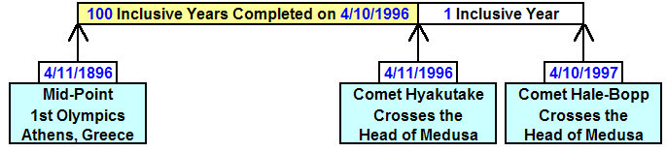
There are precisely 100 years from the midpoint of the 1896 1st modern Olympics to the day that comet Hyakutake crossed Medusa's forehead on 4/11/1996.

According to my astronomy program, comet Hale-Bopp precisely intersected the path of comet Hyakutake on Medusa's forehead on 4/10/1997. Most reports are that the second comet crossed the path of the first comet on 4/11/1997. The difference might be explained by a slight difference in orbital parameters used by different astronomy programs. In any event, the comets were both on the forehead for several days either side of 4/11/1996 and 4/11/1997. The 4/11/1996 and 4/11/1997 dates will be used in most timelines as that is the general online consensus for the crossing of the comets.

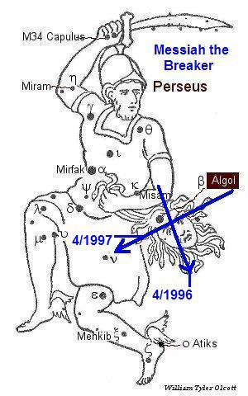
Above, showing the paths of comet Hyakutake in 1996 and comet Hale-Bopp in 1997 placing a "Tav" on the Ghoul's forehead in the constellation of Perseus, Messiah the Breaker, keeper of the sheepfold with the severed head of Satan. Note that if YAHUSHUA Messiah was born around 3 or 4 BC, it would have been exactly 2,000 years between His birth and the Tav being placed on the forehead of Medusa by the comets. We detect the fingerprints of our Creator Elohim in the unusual timing of all of the rare events mentioned above.

More Rare Events of Global Importance

Below is a graphic timeline showing the testing of the very first atomic device, the first man to walk on the moon, and comet Shoemaker-Levy 9 striking Jupiter 21 times.

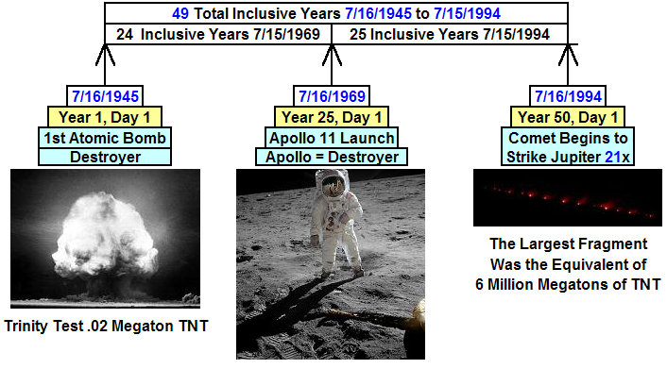
The graphic above has the Destroyer as it's general theme. The largest atomic devices that man has produced, probably around 60 megatons, are puny in comparison with the fragments of comet Shoemaker-Levy 9 that struck Jupiter beginning on 7/16/1994. The comet strikes continued for 7 inclusive days, ending on 7/22/1994. Note that Jupiter signifies Israel's Messiah, and that Jupiter was struck 21 times by fragments of the comet.

Apollo was a Greco-Roman god with attributes of distance, death, and terror, among others.

Revelation 9:11 And they had a king over them, which is the angel of the bottomless pit, whose name in the Hebrew tongue is Abaddon, but in the Greek tongue hath his name Apollyon.

Note that the globally newsworthy events in the graphic above occurred on the 1st day of the 25th year and the 1st day of the 50th year from the initial date, 7/16/1945, when man entered the atomic age and acquired the means to exterminate himself from the face of the earth. A total of 49 (7 x 7) complete inclusive years is involved in the timeline. Entering the 50th year on 7/16/1994 indicates a Jubilee of sorts, and a change, as indicated below.

The Striking of Jupiter and the "X" on Satan's Head

Now we examine some of the rare events mentioned above and discover another significant relationship.

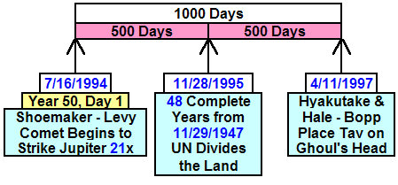
The graphic above shows a 1,000 day relationship between the comet beginning to strike Jupiter on 7/16/1994 and comet Hale-Bopp placing the "X" on Medusa's forehead on 4/11/1997. Note that the number 1,000 denotes a perfection of perfection.

The midpoint of the timeline above is 11/28/1995, exactly 48 inclusive complete years from 11/29/1947 when the United Nations partitioned the land promised entirely to the descendants of Jacob and gave part of the land to Arabs and Palestinians. The next day after the midpoint in the graphic above, 11/29/1995, was the 1st day of the 49th year from 11/29/1947.

We see the exquisite handiwork of our Creator, YaHuWaH Elohim, in the timing of these astronomical and earthly events.

Counting 21 Years for 21 Comet Strikes
The graphic below shows the timing relationship that begins to appear when we count 21 years from 7/16/1994, one year for each comet strike to Jupiter that began to occur on that date.

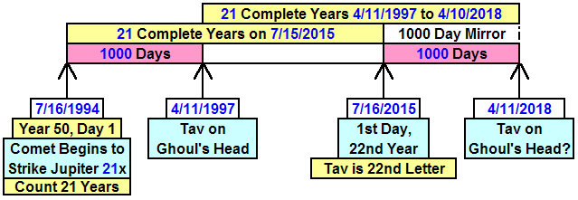
In the graphic above, we count 21 years and then mirror the 1,000 day event spacing of 7/16/1994 - 4/11/1997.

Note that we end up at 4/11/2018.

Expanding the End 1,000 Days

In the graphic below we expand the 1,000 day timeline that begins on 7/16/2015.

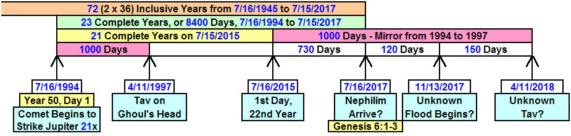

Note the timing relationships in the graphic above. The 72 inclusive years from the 1st atomic test have to do with doubling the Babylonian Magic Square, Babylon's 36 gods, and the number 666.

The Date of the "Flood"

In previous articles we have established that a "flood" of some sorts may begin on 11/13/2017. The way that was established is shown in the graphic below.

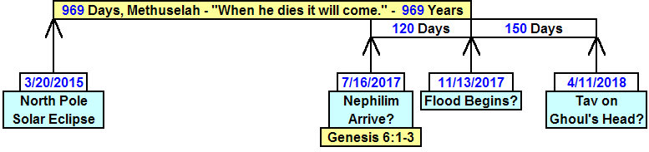
The beginning of a "flood" of sorts was established by a very rare, according to astronomers it was a once in 100,000 years total solar eclipse, that ended precisely at the North Pole on 3/20/2015. That total solar eclipse has a relationship with John chapter 21 and the catch of 153 large fish. This was treated on this page: http://www.joybysurprise.com/the-153-fish.html

The account of Genesis tells us that the flood waters covered the earth for 5 months, exactly 150 days in Noah's time. Note that 150 days from the beginning of the "flood" on 11/13/2017 is precisely 4/11/2018, a date we established previously in graphics further above by counting 21 years from 7/16/1994 (the striking of Jupiter 21 times by the comet fragments) and then adding in the 1000 days to the placing of the Paleo Hebrew Tav, "X", on Satan's head on 4/11/1997.

Note in the graphic above that 120 days before the "flood" may signal the arrival of fallen angelic beings. This can be found by careful consideration of the 120 years before the flood allotted to men "who were also human" in Genesis 6:1-3. In other words, there were two types of humans before the flood for 120 years. The second type of human is the nephilim, a giant, a descendant of an evil angel and enemy of YaHuWaH Elohim.

Note also that the 69th birthday anniversary of Hassan Rouhini, President of Iran, is 11/12/2017, one day before the "flood" and that the 69th birthday anniversary of Prince Charles is 11/14/2017, one day after the "flood" begins. Both of these men will enter the 70th year of their lives at that time. At his investiture ceremony as Prince of Wales, Prince Charles was proclaimed to have received his power from the "Red Dragon". A great Red Dragon, a sign in heaven, is mentioned in Revelation chapter 12.

Summary

There is plenty of new information above to try to figure out how it all interrelates.

Thanks to our heavenly Father, YaHuWaH Elohim, for revealing the above information. Be encouraged to cultivate a closer relationship with Him.

