Monument Valley, Slick Rock Country & Surrounding Vistas
Dates: May 15-17, 2020

Itinerary:
Friday, May 15
10:00am Depart - Exit 13 Maverik
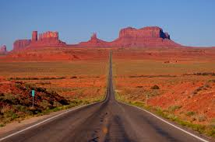
11:00am Bio Break - Kanab, UT
Noon Lunch - Page, AZ
1:30pm Depart - Page
3:30pm Arrive - Kayenta Monument Valley Inn, Kayenta, AZ
6:00pm Group Dinner - TBA
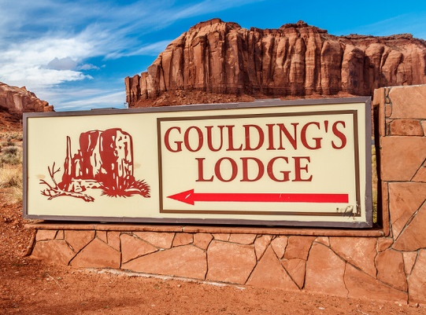
Saturday, May 16
10:00am Depart - Hotel
Noon Group Lunch - Goulding Lodge @ Monument Valley
2:00pm Depart - Goulding Lodge
3:30pm Bio Break - Blanding, UT
5:30pm Arrive - Super 8 Hotel, Green River, UT
6:30pm Group Dinner - TBA
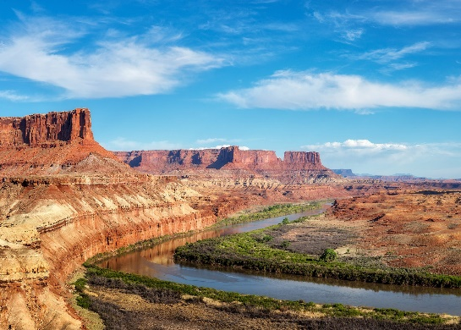
Sunday, May 17
9:30am Depart - Hotel
11:00am Bio Break - Salina, UT
12:00pm Group Lunch - Richfield, UT
1:30pm Depart - Richfield
4:00pm Arrive - St. George
Note: All times are Mountain Daylight Time
We have negotiated a group rates as follows:
1. Kayenta Monument Valley Inn, AZ - $128. When making reservation at the Kayenta Monument Valley Resort, call (928) 697-3221 and refer to Color Country Corvettes group reservation. We must have at least 6 rooms confirmed and reserved by March 16 to keep the rate, so book early!
2. Super 8 Motel, Green River, UT - $76.50. This hotel has an unusual way of handling groups. Before calling the motel to make a reservation, call or email me and I will give you a confirmation number to be used when you call the motel.

