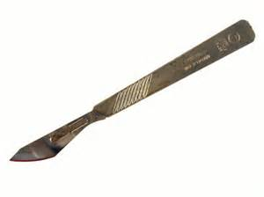
Date patient arrived
/ /
Name
ID Number
Date of Birth

SURGICAL SPECIALTY
SURGICAL SPECIALTY
INCIDENT: mechanism and circumstances
INCIDENTAL information: past history and personal circumstances
INJURIES: precise anatomical descriptions
INJURIES that relate to your specialty (you may include important negative findings) | Consultant:
OTHER INJURIES in brief (these will be described in detail by the appropriate specialties)
Name ID Number

/ /

Date patient arrived

INTERVENTIONS
COMPLETED OPERATIONS (with surgeon’s name and grade) & other physical interventions (e.g. debridement or suture)
PLANNED OPERATIONS & other physical interventions (with time scale and surgeon responsible)
ADJUNCT TREATMENT (e.g. instructions for anticoagulants, antibiotics, drain management, feeding and mobilising)
Comments and issues

Grade

Surgeon completing sheet
/ / :
Signature
Date & time

