Head-to-Toe Checklist
(For use with Body Condition Diagram)

Name: ______________________________________ Date: _______________________ Time:_____________
This form must be completed when any injury is noted and/or following any fall.
Direction (X ) appropriate column. If "yes" describe assessment findings and follow up in the COMMENT section below.

 |  | Problem |  |  |  | Problem
 |  | Yes | No |  |  | Yes | No
Head: | Face |  |  | Back: | Upper
 | Eyes |  |  |  | Lower
 | Ears |  |  |  | Buttocks
 | Mouth |  |  | Lower Body: | Waist
 | Scalp
If yes, include neurological check form. |  |  |  |  | Abdomen
Neck: | Front |  |  |  | Upper Legs
 | Back |  |  |  | Knees
Upper Body: | Shoulders |  |  |  | Ankles
 |  |  |  |  | Feet
 | Upper Arms |  |  |  | Toes
 | Elbows
 | Lower Arms
 | Wrists
 | Hands
 | Fingers
 | Chest

Signature/Title: ______________________________________________Date/Time: ___________________
RN Review: ________________________________________________ Date/Time: ___________________
Admin Review: ______________________________________________Date/Time:________________

BODY CONDITION DIAGRAM
Name: ___________________
Date: ___
Time:__________________
Staff:_________________

Identify each area, size, and time of observation. (Remember to also complete Head-to-Toe Checklist form.)
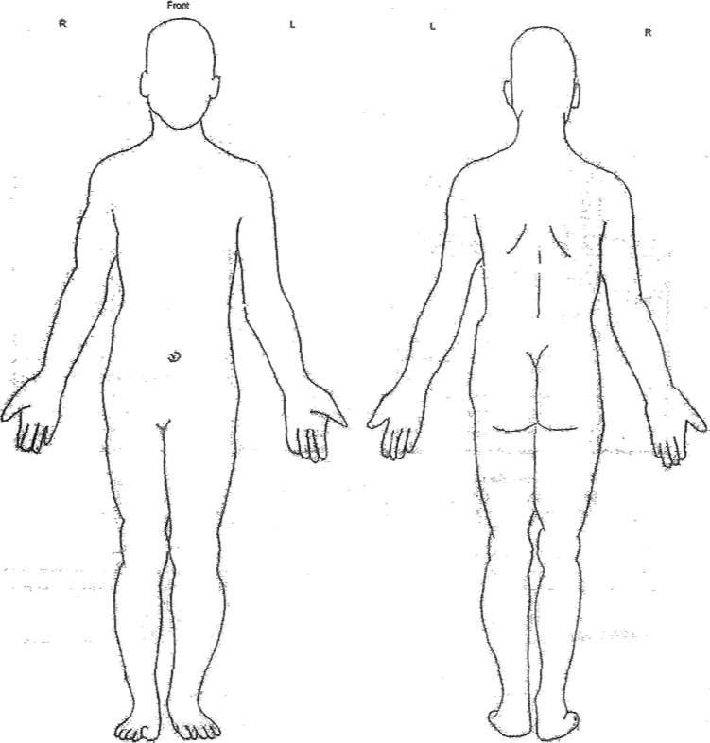

Is there a breakdown of skin integrity, (i.e.: scrape, cut, bruise, redness, warmth, swelling, rash, etc) Describe size of wound and specific location. Is there pain, tenderness, weakness, loss of use or deformity? Is there bleeding or drainage? Describe type and amount.
Comments: ____________________________________________________________________________________
______________________________________________________________________________________________
______________________________________________________________________________________________
______________________________________________________________________________________________

RN Review: ____________________________ Date:__________________________

