Emergency Dispensing Site
Action Plan



Gotham City
Batman’s Health Department

Public Health Emergency Preparedness
Version 1.5
City of Gotham
Emergency Dispensing Site Action Plan

Record of Amendments & Modifications
Date | Name | Description

Table of Contents

Record of Amendments & Modifications 2
Introduction 4
SECTION #1 7
Concept 8
Collaborate with Partner Health Authorities 9
Customize EDS to Incident Response Objectives 10
Plan for Special Populations 11
Estimate Resource Requirements and Identify Sources 12
Establish Communication Policies 13
Delegate Implementation to EDS Staff 14
Monitor and Support the EDS Operation 15
Post-Event Recovery 16
SECTION #2 17
Concept 18
Phase I: Staff Mobilization 19
Phase II: Open EDS 20
Phase III: Operate EDS 21
Phase IV: Close EDS 22
SECTION #3 23
APPENDIX
Appendix 1: EDS Design & Client Flow Diagrams/Clinic Layout 25
Appendix 2: EDS Management Structure & Job Action Sheets 28
Appendix 3: Estimating Staffing Requirements 52
Appendix 4: EDS Incident Response Objectives 54
Appendix 5: Human Resources 57
Appendix 6: EDS Supply List 59
Appendix 7: EDS Activity/Shift Report 62
Appendix 8: Strategic National Stockpile 64

Introduction

The purpose of this plan is to lay out the steps for opening, operating, and closing an emergency dispensing site (EDS) in response to a public health emergency. Since many of the details for any emergency dispensing operation can be determined only after the details of the emergency are known, the action steps and resources described in this plan are designed to be modified as needed.

How to Use

After reviewing the entire plan (an important first step), you should determine your place in the system (i.e., Incident Management Team, EDS Management Team, or both).

Pay close attention to the sections that are relevant to your position.

Incident Management Team:
- Review Section 1, the EDS Action Plan for Incident Management Team.
- Refer to the steps in Section 1 as needed for guidance.

Emergency Dispensing Site Management Team:
- Review phases in Section 2, the EDS Action Plan for EDS Management Team.
- Refer to relevant phase as needed for guidance.

All personnel:
- Review the Concept of Operations: Emergency Dispensing Site Action Plan (Page 5).
- Review Sections 1 and 2.
- Refer back to steps or phases as necessary for guidance.

Figure 1: Sequence of events following a public health emergency: Focus on the actions for an emergency dispensing site operation.
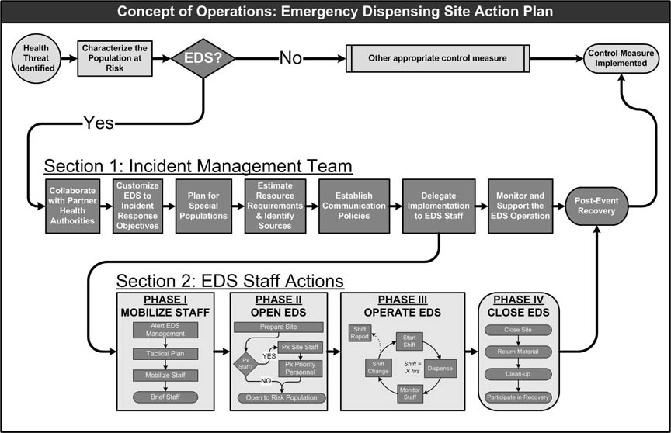

Figure 2: The incident command structure for an emergency dispensing site operation
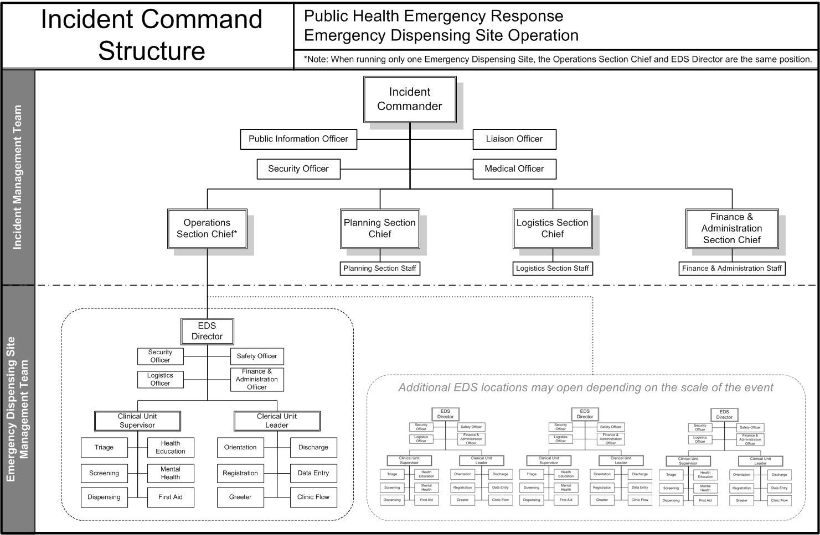

SECTION #1
EDS ACTION PLAN
Incident Management Team

Incident Commander

Command Staff
- Public Information Officer
- Liaison Officer
- Medical Officer
- Security Officer

General Staff
- Operations Section Chief
- Planning Section Chief
- Logistics Section Chief
- Finance & Administration Section Chief

Concept

The following steps must be taken by senior decision makers before Emergency Dispensing Site staff can begin operations. Information about critical decisions to be made and relevant resources are included for each step. Steps may be completed simultaneously or in a different order.

Figure 3: EDS Action Plan for Incident Management Team

When it is time to delegate implementation of the Action Plan to an EDS Management Team(s) the following information should be communicated to the EDS Director (or Operations Section Chief if only one EDS is being opened):

- Response objectives for the EDS
- Information specific to the health threat and vaccine or medication to be dispensed
- The EDS design customized to meet the response objectives
- Site location(s)
- An EDS organization chart
- EDS Management Staff names, contact information, and report location
- Job action sheets for EDS staff
- Directions on how the EDS will be supplied
- Directions on frequency of updates to planning section
- The media policy

Collaborate with Partner Health Authorities

If the incident response requires the collaboration of two or more jurisdictions, then the following issues must be resolved before any further steps are implemented:

- Clarify roles and responsibilities among senior officials
  - Who is the incident commander?
  - Who are the other members of the Command and General Staff?
  - What is the media policy?

- Identify and resolve insurance and liability issues
  - Site-specific insurance requirements
  - Malpractice insurance
  - Workplace injury

- Set administrative fees and billing policies
  - Administrative fees & reimbursement
    - Reimbursement based on residency of clients
    - Reimbursement based on resource expenditure
  - Client Billing
    - Medication/vaccine fees
    - Private insurance
    - Medicaid or Medicare
  - Record Keeping

Customize EDS to Incident Response Objectives

Table 1: Incident Management Team personnel needed to meet incident response objectives
Role | City/Town Department | Job title
Operations Section Chief
Incident Commander
Planning Section Chief
Logistics Section Chief
Security Officer
Medical Officer

Objectives

- Set target population service rate (i.e., the number of people who will move through the EDS per hour)
- Determine how many emergency dispensing sites will be necessary to achieve objectives and decide which sites to open
- Configure EDS flow to maximize efficiency of dispensing
- Determine plan for allocation of vaccine or medication if target population exceeds available supply
- Identify priority group of essential personnel (e.g., first responders and their families) to receive prophylaxis before EDS public operations begin
- Determine standard of care
- Establish documentation requirements for client information
- Determine transportation plan to sites
- Determine security plan

Resources
- Appendix 1: EDS Design & Client Flow Diagrams/Clinic Layout
- Section 3: Locations
- Transportation Plan (developed locally)

Plan for Special Populations

Table 2: Incident Management Team personnel needed to plan for special populations
Role | City/Town Department | Job title
Planning Section Chief
Operations Section Chief
Incident Commander
Logistics Section Chief

Objectives
- Identify the groups of the at-risk population with special needs
- Determine resources available/needed to serve these groups
- Initiate the special populations plan

Resources
- Appendix 1: EDS Design & Client Flow Diagrams/Clinic Layout

Estimate Resource Requirements and Identify Sources

Table 3: Incident Management Team personnel needed to estimate resource requirements and identify sources
Role | City/Town Department | Job title
Planning Section Chief
Logistics Section Chief
Operations Section Chief
Finance & Administration Section Chief

Objectives
- Customize EDS management structure
- Estimate the personnel-hours required to achieve the target population service rate
- Estimate the supplies and material resources required to run the EDS
- Identify human resources
- Identify material resources
- Initiate procedures for tracking resource expenditures

Resources
- Appendix 2: EDS Management Structure & Job Action Sheets
- Appendix 5: Human Resources
- Appendix 6: Basic EDS supply list

Establish Communication Policies
Table 4: Incident Management Team personnel needed to establish communication policies & messages
Role | City/Town Department | Job title
Public Information Officer
Incident Commander
Planning Section Chief
Operations Section Chief
Logistics Section Chief
Security Officer

Objectives
- Set the media policy
- Determine messages for:
  - Incident response staff
  - General public and population at risk
  - Special populations
  - Community stakeholders (e.g., hospitals and primary care physicians)

Resources

Delegate Implementation to EDS Staff

Table 5: Incident Management Team personnel that delegate EDS implementation to the EDS Staff
Role | City/Town Department | Job title
Operations Section Chief
Logistics Section Chief
Public Information Officer
Finance & Administration Section Chief

Objectives
- Brief EDS director
- Brief staff who will be immediately activated
- Coordinate release of information

Resources
- Appendix 4: Incident Response Objectives

Monitor and Support the EDS Operation

Table 6: Roles and responsibilities of Incident Management Team personnel during the EDS operation
Role | Responsibilities
Incident Commander | - Oversee the entire operation  - Determine incident objectives and strategy  - Develop Incident Action Plan  - Determine the end of operations
Planning Section Chief | - Assess situation and determine resource needs (personnel and material)  - Produce and disseminate Incident Action Reports  - Gather and analyze data on activities  - Anticipate needs and prepare alternative strategies
Operations Section Chief | - Implement Incident Action Plan  - Coordinate activity between the EDS and Incident Command
Logistics Section Chief | - Obtain and transport material resources to the EDS  - Mobilize EDS staff and volunteers
Finance & Administration Section Chief | - Provide financial management and accountability  - Track resource expenditures during the operation  - Track personnel time involved in start-up, operations, and breakdown of EDS  - Apply for reimbursement when possible
Public Information Officer | - Control information flow and media access  - Organize press conferences and releases to media, public  - Brief and prep the media spokesperson
Security Officer | - Assess site(s) for security issues  - Assign security staff to locations  - Coordinate with local law enforcement

Post-Event Recovery

The following activities should be completed by the Command and General Staff after EDS operations are completed. The Incident Commander should delegate responsibility for these tasks to appropriate personnel.

Objectives
- Facilitate return to normal department operations
- Replenish supplies for future emergency dispensing operations
- Review and evaluate operations and prepare After Action Report
- Revise emergency response plan as necessary

Tasks
- Debrief with EDS Director(s) and other managers
- Identify process strengths and challenges
- Identify outcome strengths and challenges
- Focus on stage objectives and operation goals

- Determine event costs and follow reimbursement procedures for costs, including:
- Personnel
- Supplies
- Facilities
- Transportation

- After Action Report, including:
- Information from debriefing and financial assessment
- Tactical planning documentation
- Lessons learned
- Recommendations for improvement

SECTION #2
EDS ACTION PLAN
Emergency Dispensing Site Management Team

EDS Management Team
- Director
- Security Officer
- Safety Officer
- Finance & Administration Officer
- Logistics Officer
- Clinical Unit Supervisor
- Clerical Unit Leader

Clinical Unit Team
- Clinical Unit Supervisor
- Dispensing, Screening, Health Education
- Triage, Orientation

Clerical Unit Team
- Clerical Unit Leader
- Clinic Flow
- Registration

Concept

Section 2 describes the phases of EDS operation, and includes information specific to the phase objectives.

Figure 4: EDS Action Plan for EDS Staff
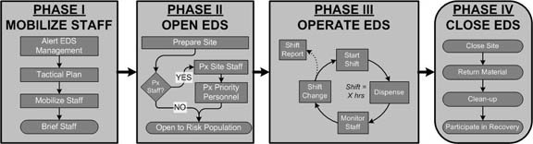
Before initiating this action plan, the EDS Director must have the following information from the Operations Section Chief:

- Site location(s)
- Response objectives for the EDS
- The EDS design customized to meet the response objectives
- The EDS organization chart
- Job action sheets for EDS staff
- Information specific to the health threat and vaccine or medication to be dispensed
- Directions on how the EDS will be supplied
- Directions on frequency of updates to the Operations Section Chief
- The media policy

ASSUMPTIONS

1. EDS Staff will be recruited and mobilized by the logistics section
2. Supplies will be provided and replenished as necessary by the logistics section
3. A protocol exists to track and report resource expenditures

Phase I: Staff Mobilization

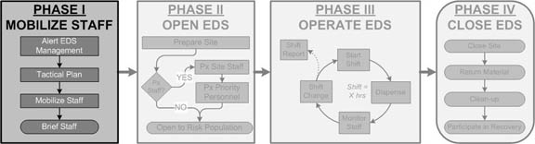

Objectives
A. Create a tactical plan to open the EDS
B. Mobilize and brief EDS staff

Action Steps
- Alert EDS Management Team
  - Alert the designated EDS Director
  - Alert the EDS management staff
  - EDS management staff report to designated location

- Make a tactical plan
  - Review design, management structure, and job action sheets
  - Clarify roles and responsibilities
  - Create a schedule to open and operate the EDS (Phase II)

- Mobilize EDS staff
  - Logistics Officer coordinates arrival of staff
  - Staff report to site
  - Provide staff with ID badges

- Brief the EDS staff
  - Brief staff about the incident
  - Review disease and prophylaxis/treatment facts and frequently asked questions
  - Discuss personal protection measures
  - Review standards of care
  - Describe EDS schedule, staffing, and operations
  - Review staff support services (e.g., meals, breaks, etc.)
  - Establish units to open the EDS

Resources

Phase II: Open EDS

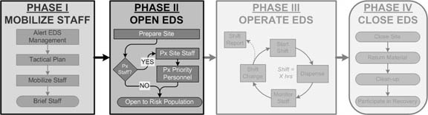

Objectives
- Set up EDS
  - Review operations protocols
  - Establish patient flow patterns
  - Determine additional staff needs
- Provide necessary prophylaxis and personal protective equipment to priority group of first responders and others identified by Incident Management Team under Section 1
- Begin to treat population at risk

Action Steps
- Prepare Site
  - Ensure site is open, operational (power, heat, or A/C) and accessible (streets open and plowed, parking lots empty).

- Ensure that supplies are received and provided to appropriate EDS Units for set-up
  - Ensure adequate number of patient information sheets
  - Ensure adequate staff is onsite and prepared
  - Ensure security and traffic plans are in effect

- If necessary, provide prophylaxis to priority group as identified by Incident Management Team in Section 1 (e.g., EDS staff and volunteers, other first responders and essential personnel, their household members, if included)
  - Obtain staff roster
  - Obtain roster of priority personnel and their families from Incident Command
  - Provide prophylaxis to priority group

- Open EDS to public at risk

Resources

Phase III: Operate EDS
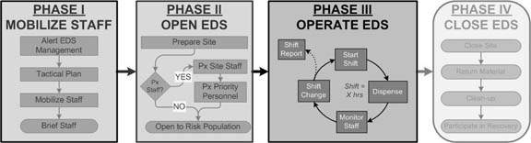
Objectives
- Provide safe and efficient services
- Execute smooth shift transitions
- Submit shift reports to Incident Management Team
- Monitor and maintain staff morale and wellness

Actions Steps
- Start Shift
  - Have shift schedule ready
  - Dispense vaccine or medication

- Maintain professional standards

- Maintain incident command management principles

- Assess adequacy and efficiency of EDS flow and readjust if needed

- Monitor Staff
  - Ensure that staff take regular breaks
  - Monitor staff for signs of fatigue or stress
  - Acknowledge work and provide feedback

- Monitor Supplies

- Maintain contact with Incident Management Team

- Shift Change
  - Ensure that staff complete dispensing in their queue before ending shift
  - Debrief with outgoing staff
  - Brief incoming staff
  - Complete Shift Report

Resources
- Shift Report

Phase IV: Close EDS

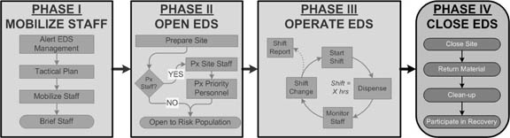

Objectives
- Coordinate site closure with Incident Command
- Repack EDS supplies
- Return supplies to appropriate authorities

Action Steps
- Close Site
  - Clear all clients from site prior to closing
  - Post clear signage indicating that the site is closed
  - Assign tasks for breakdown of site
    - Catalogue and repack supplies
    - Collect and dispose of trash
    - Bag and properly dispose of medical waste

- Return Material
  - Return EDS supplies to pre-designated storage area
  - Return pharmaceutical supplies

- Clean-up
- Follow site requirements for post-event clean-up

- Participate in post-event recovery activities as determined by Incident Command

Resources
- Appendix 8 - SNS

SECTION #3
EDS ACTION PLAN
Emergency Dispensing Site Locations

Insert the following information for each dispensing site location:

- MDPH EDS surveys
- Floor plan/layout
- Transportation plan or MOU with partner agency to manage and provide transportation
- Security plan or MOU with partner agency to manage and provide security

Appendix 1
EDS Design & Client Flow Diagrams/Clinic Layout

EDS Design & Client Flow Diagrams/Clinic Layout
This appendix reviews the most basic EDS design (also called a client flow diagram).
While this plan may be adopted “as is,” it is intended as a starting point rather than a final design. As you develop an EDS design that meets your specific incident response objectives, it is critical to consider the impact of the following factors:

- Whether the population will be screened for exposure status
- The target client service rate
- Client information requirements
- Staff availability

Whether the population will be screened for exposure status
Determining whether a client is at risk for illness can be a time intensive process for a screener. Eliciting details that would determine an individual’s exposure status can also require special training. Strategies for eliminating or reducing the need to determine client exposure status include: Opening the EDS to contacts of known cases only, advance screening and registration, and setting an open eligibility policy for medication or prophylaxis.

The target client service rate
As a general rule, the higher the target service rate, the greater the need for space and staff. This may not be the case, however, for an aerosolized anthrax attack, the scenario envisioned under the Cities Readiness Initiative (CRI). Strategies for attaining high service rates include: duplicating stations or increasing staff numbers at client flow “bottle-necks,” assigning clinic flow personnel to move clients along, and eliminating or decreasing paperwork requirements.

Client information requirements
Except in limited circumstances such as the CRI scenario described above, it is essential to collect client names, contact information, and the lot number of the medication or vaccine they received. This enables health departments to quickly contact people if medication or vaccine has been recalled. Only in the most critical circumstances should collection of this information be compromised.

Staff availability
Lack of available staff and volunteers may necessitate consolidation or elimination of positions or services due to human resource limitations.
Basic EDS Design
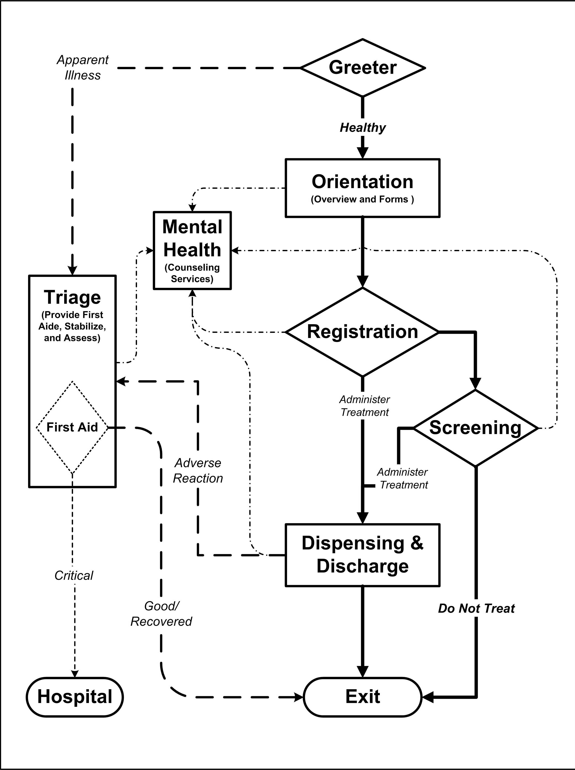

Appendix 2
EDS Management Structure & Job Action Sheets

EDS Management Structure & Job Action Sheets

The EDS Management Structure presented in Figure 5 is the broadest staffing structure for operating an EDS. Units can be consolidated or staff may be expanded as needed within this management structure. Management of any EDS should be based on the principles of incident command.

Figure 5: EDS Management Structure
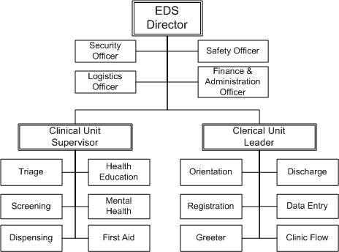

EDS Job Action Sheets
Table of Contents

Emergency Dispensing Site Director 31
Clerical Unit Leader 32
Clinical Unit Supervisor 33
Finance & Administration Officer 34
Logistics Officer 35
Safety Officer 36
Security Officer 37
Dispensing Assistant 38
Dispensing Provider 39
Health Education 40
First Aid 41
Mental Health Counselor 42
Screener 43
Senior Screener 44
Triage 45
Discharge 46
Clinic Flow 47
Greeter 48
Data Entry 49
Orientation 50
Registration 51

Emergency Dispensing Site Director
Supervisor: Operations Section Chief
Mission: | The EDS Director is responsible for overall management of EDS operations with support from the Operations, Logistics, and Planning Sections of the Command and General Staff. The EDS Director has executive responsibility for directing all aspects of deployment, operation and maintenance, and deactivation of the EDS.
Activation (Phase I & II)
- Meet with Operations Section Chief. Receive the following information:
- Site location
- Response objectives for the EDS
- EDS design
- EDS organization chart
- Job action sheets
- Guidelines regarding the frequency of updates to Operations Section Chief
- The media policy
- Report to EDS location and identify immediate resource needs
- Appoint and orient EDS staff
- Set time that stations will be ready for pre-opening review
- Review all EDS stations prior to opening and make necessary changes for smooth operation

Operation (Phase III)
- Oversee training and orientation of staff members with delegated roles
- Identify leaders in each area to provide focus and coaching
- Assess staff and supplies at the start and end of each shift
- Communicate additional staff and supply needs to the Operations Section Chief
- Monitor performance and make necessary changes to ensure smooth operation of the EDS
- Submit shift reports to Operations Section Chief
- Refer all media inquiries to the Public Information Officer
Deactivation (Phase IV)
- Oversee the closing and clean-up of the site
- Oversee the appropriate return of supplies
- Ensure the completion and collection of all required documentation
- Participate in recovery activities as directed by the Operations Section Chief
(Rev. 7/31/2026)

Clerical Unit Leader
Supervisor: EDS Director
Mission: | To ensure that clerical support staff are familiar with necessary forms, ensure the steady flow of client information throughout the EDS, and oversee the security of all client information.
Activation (Phase I & II)
- Report to the EDS Director
- Identify immediate resource needs
- Assign staff to workstations
- Orient staff to assigned roles
- Oversee set-up of clerical unit workstations
- Identify additional staffing and supply needs and communicate to Logistics Officer
- Appoint leaders in each area
- Ensure coordination with Clinical Unit areas
Operation (Phase III)
- Oversee training and orientation of replacement clerical unit staff
- Assess staff and supplies at the end of each shift and identify additional needs
- Communicate additional staff and supply needs to Logistics Officer
- Monitor the flow of client information
- Assess Clerical Unit performance and make necessary changes
- Provide service reports to EDS Director as requested
Deactivation (Phase IV)
- Close out logs when authorized by the EDS Director
- Oversee closing of Clerical Unit stations
- Oversee clean-up of Clerical Unit stations
- Return supplies to Logistics Officer
- Complete all required documentation
- Submit all required documentation to the EDS Director
- Participate in recovery activities as directed by the EDS Director
(Rev. 7/31/2026)

Clinical Unit Supervisor
Supervisor: EDS Director
Mission: | To ensure that clinical staff are familiar with their responsibilities and the clients are treated professionally throughout the EDS.
Activation (Phase I & II)
- Report to EDS Director
- Identify immediate resource needs
- Appoint and orient staff to clinical roles
- Oversee the set up clinical unit workstations
- Identify additional staffing and supply needs and communicate to Logistics Officer
- Appoint leaders in each area
- Ensure coordination with clerical unit workstations
Operation (Phase III)
- Oversee training and orientation of staff
- Ensure that required supplies are available to clinical unit staff
- Assess staff and supplies at the end of each shift
- Communicate additional staff and supply needs to the Logistics Officer
- Monitor client flow through the EDS
- Assess Clinical Unit performance and make changes as necessary

Deactivation (Phase IV)
- Close out logs when authorized by the EDS Director
- Oversee closing and clean-up of Clinical Unit stations
- Return supplies to Logistics Officer
- Ensure safe disposal of medical and biohazard waste in coordination with Logistics Officer
- Complete all required documentation
- Submit all required documentation to the EDS Director
- Participate in recovery activities as directed by the EDS Director
(Rev. 7/31/2026)

Finance & Administration Officer
Supervisor: EDS Director
Mission: | To monitor and document EDS resource expenditures including staffing, supplies, equipment, and pharmaceuticals.
Activation (Phase I & II)
- Report to EDS Director
- Identify immediate resource needs
- Establish and maintain a position log to record actions during your shift
- Determine your resource needs, such as computer, phone, EDS plan, and other reference documents
- Assign and orient Finance and Administration staff to duties
- Identify additional staffing and supply needs and communicate to Logistics Officer

Operation (Phase III)
- Oversee orientation of financial and administrative staff
- Assess staff and supplies at the start and end of each shift
- Communicate additional supply needs to Logistics Officer
- Track and document EDS staff/volunteer time
- Track and document EDS supplies, equipment, and pharmaceuticals
- Assess performance and make necessary changes
Deactivation (Phase IV)
- Complete all required documentation
- Submit all required documentation to EDS Director
- Close and clean-up workstation
- Return unused supplies to Logistics Officer
- Participate in recovery activities as directed by the EDS Director
(Rev. 7/31/2026)

Logistics Officer
Supervisor: EDS Director
Mission: | To ensure that the facility and support needs are met, including: staffing, supply and re-supply of EDS areas with equipment and other relevant materials, physical plant support, communications, IT support, and food and water for staff/volunteers.
Activation (Phase I & II)
- Report to EDS Director
- Identify immediate resource needs such as computer, phone, EDS plan, and other reference documents
- Set up Logistics work area
- Assign and orient Logistics staff
- Establish simple protocols for requesting and acquiring supplies and staffing
- Establish and maintain system for tracking supply requests and expenditures
- Establish and maintain system for receiving and distributing EDS supplies
- Ensure that appropriate personnel, equipment, and supplies are available, including maps, status boards, vendor references, and other resource directories
- Establish and maintain effective communication system within the EDS and to Incident Command
- Determine resource needs for the EDS including computers, phones, EDS plans, and other reference documents
- Work with EDS Director to determine hours of operation and staff needs
- Develop plan for on-going staffing as needed
- Oversee initial receipt and distribution of supplies within the EDS
Operation (Phase III)
- Participate in regular situation briefing meetings with the EDS Director
- Assess staff and supplies at the start and end of each shift
- Monitor staff and supply needs
- Assess performance and make changes as necessary
- Ensure coordination with Finance and Administration Officer
- Ensure that transportation requirements are met
- Ensure that requests for facilities and facility support are addressed
Deactivation (Phase IV)
- Repackage unused supplies
- Oversee the return of supplies to appropriate authority or organization
- Ensure safe disposal of medical and biohazard waste
- Close and clean-up workstation
- Complete all required documentation
- Submit all required documentation to EDS Director
- Participate in recovery activities as directed by the EDS Director
(Rev. 7/31/2026)

Safety Officer
Supervisor: EDS Director
Mission: | To monitor the EDS for hazardous and unsafe situations and develop measures for assuring personnel and client safety.
Activation (Phase I & II)
- Report to EDS Director
- Identify immediate resource needs
- Attend staff briefing
- Review clinic layout and process

Operation (Phase III)
- Ensure that EDS staff receive appropriate care in the event of an occupational exposure to potentially hazardous material
- Advise EDS staff in matters affecting personnel and client safety
- Monitor universal precautions and implement appropriate activities or measures to ensure staff and client safety
- Exercise emergency authority to prevent or stop unsafe acts
- Coordinate investigation of accidents that occur within the EDS
Deactivation (Phase IV)
- Complete all required documentation
- Submit all required documentation to EDS Director
- Participate in recovery activities as directed by the EDS Director
(Rev. 7/31/2026)

Security Officer
Supervisor: EDS Director
Mission: | To ensure the security the EDS and coordinate security with police and other law enforcement personnel
Activation (Phase I & II)
- Report to EDS Director
- Identify immediate resource needs
- Ensure that all EDS staff are properly identified and wearing legitimate identification
- Attend staff briefing
- Review clinic layout and process
- Review parking and transportation plans
- Meet supply vehicle and provide security to site location
- Secure all entrances and exits to the EDS
Operation (Phase III)
- Provide security for the EDS
- Maintain order within and outside the facility
- Maintain communication with law enforcement
Deactivation (Phase IV)
- Ensure that facility is empty of clients
- Provide security for remaining medications and supplies until returned
- Complete all required documentation
- Submit all required documentation to EDS Director
- Participate in recovery activities as directed by the EDS Director
(Rev. 7/31/2026)

Dispensing Assistant
Supervisor: Clinical Unit Supervisor
Mission: | To assist the dispensing provider in dispensing or administering medication according to existing protocols in medical standing order(s).
Qualifications: |  | Licensed health care provider (e.g., RN, NP, PA, DVM, DDS, or MD).
Activation (Phase I & II)
- Report to Clinical Unit Supervisor and obtain identification
- Attend staff briefing
- Receive assignments from Clinical Unit Supervisor
- Review educational materials on medications to be dispensed or administered
- Review the medical standing order
- Set up dispensing station
- Identify additional supply needs and communicate to Clinical Unit Supervisor
- Review clinic layout and flow
Operation (Phase III)
- Obtain additional medication or vaccine as needed
- Fill syringes with appropriate vaccine dose (if necessary)
- Maintain organization of medication or vaccine lots
- Practice universal precautions
Deactivation (Phase IV)
- Clean-up service area
- Dispose of waste properly and in coordination with Logistics Officer
- Pack unused supplies and return to Logistics Officer
- Complete all required documentation
- Submit all required documentation to Clinical Unit Supervisor
- Participate in recovery activities as directed by the Clinical Unit Supervisor
(Rev. 7/31/2026)

Dispensing Provider
Supervisor: Clinical Unit Supervisor
Mission: | To dispense or administer appropriate medication/vaccine according to existing protocols in the medical standing order(s).
Qualifications: |  | Must be a licensed health care provider (e.g., RN, NP, PA, DVM, DDS, or MD).
Activation (Phase I & II)
- Report to Clinical Unit Supervisor and obtain identification
- Attend staff briefing
- Receive assignments from Clinical Unit Supervisor
- Review educational materials on medications to be dispensed or administered
- Review the medical standing order
- Set up dispensing station
- Identify additional supply needs and communicate to Clinical Unit Supervisor
- Review clinic layout and flow
Operation (Phase III)
- Ensure that the client understands why they are receiving the medication/vaccine
- Confirm that the client is not contraindicated for the medication/vaccine
- Ensure that the client understands how to use the medication
- Confirm client’s informed consent
- Properly dispense or administer medication or vaccine
- Log the lot and dose administered to each client on the appropriate form
- Sign and date client’s form
- Practice universal precautions
- Maintain medication logs
Deactivation (Phase IV)
- Clean-up service area
- Dispose of waste properly and in coordination with Logistics Officer
- Pack unused supplies and return to Logistics Officer
- Complete all required documentation
- Submit all required documentation to Clinical Unit Supervisor
- Participate in recovery activities as directed by the Clinical Unit Supervisor
(Rev. 7/31/2026)

Health Educator
Supervisor: Clinical Unit Supervisor
Mission: | To communicate health education information clearly and understandably, and to reinforce key messages to clients.
Activation (Phase I & II)
- Report to Clinical Unit Supervisor and obtain identification
- Attend staff briefing
- Receive assignment from Clinical Unit Supervisor
- Familiarize self with EDS layout and personnel
- Set up education area
- Review educational materials on health threat and medications to be dispensed or administered
- Prepare brief lesson to educate clients about the health threat and the medication
- Obtain copies of health education materials
Operation (Phase III)
- Convey key messages about the nature of the health threat
- Emphasize the importance of the medication or vaccine in the prevention or treatment of disease
- Deliver information about possible adverse affects of the medication or vaccine
- Explain what clients should do if they have an adverse reaction to the medication or vaccine
- Explain what clients should do if they become ill
Deactivation (Phase IV)
- Clean-up health education area
- Pack and return unused supplies and materials to Logistics Officer
- Complete all required documentation
- Submit all required documentation to Clinical Unit Supervisor
- Assist with the clean-up of the EDS
- Participate in recovery activities as directed by the Clinical Unit Supervisor
(Rev. 7/31/2026)

First Aid
Supervisor: Clinical Unit Supervisor
Mission: | To provide appropriate first aid to clients or staff that require immediate medical attention.
Qualifications: |  | Must be a licensed health care professional (e.g., RN, NP, PA, MD, or EMT).
Activation (Phase I & II)
- Report to Clinical Unit Supervisor and obtain identification
- Attend staff briefing
- Receive assignment from Clinical Unit Supervisor
- Set up first aid station
- Identify additional supply needs and communicate to Clinical Unit Supervisor
- Review educational materials on health threat and medications to be dispensed or administered
- Familiarize self with EDS layout and personnel
Operation (Phase III)
- Assess medical condition of patient or staff as necessary
- Administer first aid and emergency medical care to patients or staff
- Stabilize acute patients for transport
- Assist in transport of acute patients to hospital or other medical facility
Deactivation (Phase IV)
- Clean-up workstation
- Pack and return unused supplies to Logistics Officer
- Dispose of waste properly and in coordination with Logistics Officer
- Assist in the clean-up of the EDS
- Complete all required documentation
- Submit all required documentation to Clinical Unit Supervisor
- Participate in recovery activities as directed by the Clinical Unit Supervisor
(Rev. 7/31/2026)

Mental Health Counselor
Supervisor: Clinical Unit Supervisor
Mission: | To serve as a brief counseling resource, provide assessment and crisis intervention, and refer clients to existing community resources as appropriate.
Qualifications: |  | Must be a mental health care professional (e.g., M.S.W., Ph.D., PsyD, MD).
Activation (Phase I & II)
- Report to Clinical Unit Supervisor and obtain identification
- Attend staff briefing
- Receive assignment from Clinical Unit Supervisor
- Set up Mental Health station
- Identify additional supply needs and communicate to Clinical Unit Supervisor
- Familiarize self with EDS layout and personnel
- Review educational materials on health threat and medications to be dispensed or administered
Operation (Phase III)
- Collaborate with Clinical Unit Staff to create a safe and comfortable environment for clients
- Manage clients with acute mental health issues
- Report activities and recommendations to the Clinical Unit Supervisor
- Work with security staff if clients become disruptive or unruly
- Refer clients to mental health services outside of the EDS when necessary
- Complete appropriate paperwork for each client
Deactivation (Phase IV)
- Clean-up workstation
- Pack and return unused supplies to Logistics Officer
- Assist in the clean-up of the EDS
- Complete all required documentation
- Submit all required documentation to Clinical Unit Supervisor
- Participate in recovery activities as directed by the Clinical Unit Supervisor
(Rev. 7/31/2026)

Screener
Supervisor: Clinical Unit Supervisor
Mission: | To assess clients for contraindications to the medication or vaccine, determine risk of disease or infection, identify clients with complex medical conditions, and review risks and benefits of treatment with clients.
Activation (Phase I & II)
- Report to Clinical Unit Supervisor and obtain identification
- Attend staff briefing
- Receive assignment from Clinical Unit Supervisor
- Set up screening area
- Review screening forms
- Identify additional supply needs and communicate to Clinical Unit Supervisor
- Familiarize self with clinic layout and personnel
- Review educational materials on health threat and medications to be dispensed or administered

Operation (Phase III)
- Review client record
  - Verify the risk category
  - Verify that the form is legible, accurate, and complete
- Review key messages with client
- Provide fact sheets for contraindications and explain the risks and benefits
- Answer client’s questions
- Ensure that the client has signed necessary consent form
- Sign and date the medication order
- Refer clients with complex medical conditions or questions to Senior Screener
- Direct clients to appropriate area depending on whether they will be receiving medication or vaccine.
Deactivation (Phase IV)
- Clean-up workstation
- Pack and return unused supplies to Logistics Officer
- Assist in the Clean-up of the EDS
- Complete all required documentation
- Submit all required documentation to Clinical Unit Supervisor
- Participate in recovery activities as designated by the Clinical Unit Supervisor
(Rev. 7/31/2026)

Senior Screener
Supervisor: Clinical Unit Supervisor
Mission: | To assess clients with complex medical conditions for contraindications to the medication or vaccine and for risk of disease or infection, and to review treatment risks and benefits with clients.
Activation (Phase I & II)
- Report to Clinical Unit Supervisor and obtain identification
- Attend staff briefing
- Receive assignment from Clinical Unit Supervisor
- Set up private screening area for clients with complex medical conditions
- Review screening forms
- Review educational materials on health threat and medications to be dispensed or administered
- Identify additional supply needs and communicate to Clinical Unit Supervisor
- Familiarize self with clinic layout and personnel
Operation (Phase III)
- Interview clients with complex questions or contraindications
  - Review medical record
  - Make a recommendation concerning prophylaxis or treatment
  - Clarify and confirm client’s decision regarding prophylaxis or treatment
- Provide fact sheets for contraindications and ensure client understands the risks and benefits
- Ensure that the client has signed necessary consent form
- Sign and date the medication order
- Direct clients to area depending on whether they will be receiving medication or vaccine.
Deactivation (Phase IV)
- Clean-up workstation
- Pack and return unused supplies to Logistics Officer
- Assist in the clean-up of the EDS
- Complete all required documentation
- Submit all required documentation to Clinical Unit Supervisor
- Participate in recovery activities as designated by the Clinical Unit Supervisor
(Rev. 7/31/2026)

Triage
Supervisor: Clinical Unit Supervisor
Mission: | To triage new arrivals to the first aid station and determine if they require immediate isolation, or medical or mental health assistance.
Qualifications: |  | Must be a licensed health care professional (e.g., RN, NP, PA, MD, EMT).
Activation (Phase I & II)
- Report to Clinical Unit Supervisor and obtain identification
- Attend staff briefing
- Receive assignment from Clinical Unit Supervisor
- Set up Triage area
- Identify additional supply needs and communicate to Clinical Unit Supervisor
- Review educational materials on health threat and medications to be dispensed or administered
- Familiarize self with EDS layout and personnel
Operation (Phase III)
- Identify sick persons and immediately direct them to the First Aid station accompanied by EDS staff
- Identify acutely distressed persons and direct them to Mental Health station accompanied by EDS staff
- Provide or direct assistance to persons with special needs (e.g., disability or language).
- Identify disruptive persons and notify security
- Direct appropriate clients to the appropriate first station in clinic flow
Deactivation (Phase IV)
- Clean-up Triage area
- Pack and return unused supplies to Logistics Officer
- Assist in the clean-up of the EDS
- Complete all required documentation
- Submit all required documentation to Clinical Unit Supervisor
- Participate in recovery activities as directed by the Clinical Unit Supervisor
(Rev. 7/31/2026)

Discharge
Supervisor: Clerical Unit Leader
Mission: | To assure that forms are accurate, complete, and legible.
Activation (Phase I & II)
- Report to Clerical Unit Leader and obtain identification
- Attend staff briefing
- Receive assignment from Clerical Unit Leader
- Set up Discharge area
- Identify additional supply needs and communicate to Clerical Unit Leader
- Review educational materials on health threat and medications to be dispensed or administered
- Familiarize self with EDS layout and personnel
Operation (Phase III)
- Ensure that all forms are accurate, complete, and legible
- Instruct clients to keep the informational materials and forms they have received
- Address any remaining questions from clients
Deactivation (Phase IV)
- Clean-up Discharge area
- Pack and return unused supplies to Logistics Officer
- Complete all required documentation
- Submit all required documentation to Clerical Unit Leader
- Assist in clean-up of the EDS
- Participate in recovery activities as directed by the Clerical Unit Leader
(Rev. 7/31/2026)

Clinic Flow
Supervisor: Clerical Unit Leader
Mission: | To assure smooth and continuous patient movement through EDS stations, and provide support in areas that need additional or replacement personnel.
Activation (Phase I & II)
- Report to Clerical Unit Leader and obtain identification
- Attend staff briefing
- Receive assignments from Clerical Unit Leader
- Familiarize self with EDS layout and personnel
- Support EDS staff in setting up workstations and areas
- Review educational materials on health threat and medications to be dispensed or administered
Operation (Phase III)
- Monitor and facilitate the flow of clients throughout the clinic, addressing any interruptions
- Maintain client lines throughout the EDS
- Report activities and recommendations to Clerical Unit Leader
- Identify and refer clients to Security or Mental Health Area when necessary to respond to client flow disruption
- Facilitate assistance for clients with special needs (e.g., elderly, disabled or non-English speaking) to reduce flow disruption
- Ensure that family members remain together
- Accompany clients as directed by Triage
Deactivation (Phase IV)
- Assist in clean-up
- Assist in packing and returning unused supplies to Logistics Officer
- Complete all required documentation
- Submit all required documentation to Clerical Unit Leader
- Participate in recovery activities as directed by the Clerical Unit Leader
(Rev. 7/31/2026)

Greeter
Supervisor: Clerical Unit Leader
Mission: | To greet clients as they arrive/assemble, answer general questions, explain EDS process, and direct clients in need of immediate medical attention to Triage/First Aid Station.
Activation (Phase I & II)
- Report to Clerical Unit Supervisor and obtain identification
- Attend staff briefing
- Receive assignments from Clerical Unit Supervisor
- Set up Greeting area
- Identify additional supply needs and communicate to Clerical Unit Leader
- Review educational materials on health threat and medications to be dispensed or administered
- Familiarize self with EDS layout and personnel
Operation (Phase III)
- Greet clients as they arrive/assemble, and answer their initial questions
- Let clients know that all of their technical questions will be answered in the briefings and/or clinical screening process.
- Provide or direct assistance to persons with special needs (i.e., disability or language).
- Identify disruptive persons and notify security
- Direct clients to the appropriate first station in clinic flow
Deactivation (Phase IV)
- Clean-up Greeting area
- Pack and return unused supplies to Logistics Officer
- Assist in the clean-up of the EDS
- Complete all required documentation
- Submit all required documentation to Clerical Unit Leader
- Participate in recovery activities as directed by the Clerical Unit Leader
(Rev. 7/31/2026)

Data Entry
Direct Supervisor: Clerical Unit Leader
Mission: | To perform data entry, organize paper records for easy retrieval, and manage all records as protected health information.
Activation (Phase I & II)
- Report to Clerical Unit Leader and obtain identification
- Attend staff briefing
- Receive assignment from Clerical Unit Leader
- Set up Data Entry area
- Establish simple process for receiving forms, entering data, and filing
- Identify additional supply needs and communicate to Clerical Unit Leader
- Review educational materials on health threat and medications to be dispensed or administered
- Familiarize self with EDS layout and personnel
Operation (Phase III)
- Review forms for completeness
- Enter data promptly and accurately
- Conduct periodic analyses of database to confirm information integrity
- Generate reports at the request of Clerical Unit Leader

Deactivation (Phase IV)
- Clean-up Data Entry area
- Deliver hard copies and database of client records to Clerical Unit Leader
- Pack and return unused supplies to Logistics Officer
- Complete all required documentation
- Submit all required documentation to Clerical Unit Leader
- Participate in recovery activities as directed by the Clerical Unit Leader
(Rev. 7/31/2026)

Orientation
Supervisor: Clerical Unit Leader
Mission: | To inform incoming clients about what to expect at the EDS.
Activation (Phase I & II)
- Report to Clerical Unit Leader and obtain identification
- Attend staff briefing
- Receive assignment from Clerical Unit Leader
- Set up orientation area
- Review educational materials on medications to be dispensed or administered
- Review key messages about the nature of the health threat
- Identify additional supply needs and communicate to Clerical Unit Leader
- Familiarize self with EDS layout and personnel
Operation (Phase III)
- Distribute EDS forms (i.e., record, consent, etc.)
- Instruct clients on how to complete forms
- Briefly review forms for legibility, accuracy, and completeness
- Notify Triage staff if clients appear unhealthy or distressed
- Notify Clinic Flow staff if clients appear to have special needs that have not been addressed
- Coordinate with Registration, Screening, and Dispensing areas to reduce congestion
- Direct clients to next station or area
Deactivation (Phase IV)
- Clean-up Orientation area
- Repackage and return unused supplies to Logistics Officer
- Complete all required documentation
- Submit all documentation to Clerical Unit Leader
- Participate in recovery activities as directed by the Clerical Unit Leader
(Rev. 7/31/2026)

Registration
Supervisor: Clerical Unit Leader
Mission: | To assure collection of complete and accurate client information.
Activation (Phase I & II)
- Report to Clerical Unit Leader and obtain identification
- Attend staff briefing
- Receive assignment from Clerical Unit Leader
- Set up Registration area
- Establish and maintain registration log and registration procedures
- Identify additional supply needs and communicate to Clerical Unit Leader
- Familiarize self with EDS layout and personnel
Operation (Phase III)
- Review client paper work for legibility and completeness
- Assist clients to correct errors or omissions in paperwork
- Notify Clinic Flow staff if clients appear to have special needs that have not been addressed
- Direct clients to the appropriate next station or area
Deactivation (Phase IV)
- Clean-up Registration area
- Repackage and return unused supplies to Logistics Officer
- Complete all required documentation
- Submit all documentation to Clerical Unit Leader
- Participate in recovery activities as directed by the Clerical Unit Leader
(Rev. 7/31/2026

Appendix 3
Estimating Staffing Requirements

Estimating Staff Requirements

Since current mathematical models used to determine Emergency Dispensing Site staffing needs are too complex for use in local health departments with limited staff, this appendix presents a list of key questions to consider when determining the staffing needs of an Emergency Dispensing Site:

Baseline Information

- What is the size of the population at risk?
- How many dispensing sites will be opened?
- How many hours will each dispensing site operate?
- What is the target EDS flow rate (i.e., number of clients per hour) for each site?

Station-Specific Information

- Will client orientation or registration be required, and how will this affect staffing requirements?

- Will medication be prepared by staff other than those directly administering it?

- How many clients will a clinical staff person be able to treat per hour (based on the physical space and the training and expertise of the staff)?

- How many staff members do you need to orient incoming staff?

- How much security will be needed, given the target flow rate and public perception of the health threat?

- How much post-service education needs to occur?

- How much post-service data collection needs to occur?

- How large should the sick area be, based on the nature of the health threat and the dispensing site intervention?

- What level of mental health services will be needed?

- Which functions must be filled, and which should be filled as allowed by staffing resources?

- Which functions can be combined and performed by one person?

Appendix 4
EDS Incident Response Objectives

[Name of City/Town]
EDS Incident Response Objectives

Date: |  |  |  | Time:
EDS Location
Disease-causing agent:
Population at risk (n) =
Notes on risk exposure
Target population service rate (n/24 hrs.) =
Target EDS flow rate (n/hr.) =
Description of service
Medications or Vaccines
Standards of Care
Client Flow Diagram/Clinic Layout
Operations Section Chief
Name (printed):
Signature:
Incident Commander

Name Printed:
Signature:

Appendix 5
Human Resources

[Name of City/Town]
Human Resources
Emergency Dispensing Site Operation

Use this form to identify different sources for personnel or volunteers who can be mobilized to assist with Emergency Dispensing Site operations. Describe steps for contacting and mobilizing each group.

1 | Description: Internal Department Staff
1 | Instructions to Mobilize
1 | - [insert step by step instructions to mobilize your department staff here]
2 | Description: Municipal Personnel
2 | Instructions to Mobilize
2 | - [insert step by step instructions to mobilize municipal staff here]
3 | Description: Regional Assistance
3 | Instructions to Mobilize
3 | - [insert step by step instructions to mobilize regional resources here]
4 | Description: Community Volunteers/Medical Reserve Corps
4 | Instructions to Mobilize
4 | - [insert step by step instructions to mobilize community volunteers here]

Appendix 6
EDS Supply List

Basic Emergency Dispensing Site Supply List

 | Item Description | Source/Location | Item # | Qty | Unit Cost | Total  Cost
Public Information | Fact Sheets
Public Safety & Security | Crowd Count Clickers
Public Safety & Security | Police Tape
Public Safety & Security | Line Dividers
Public Safety & Security | Flashlights & Batteries
Public Safety & Security | 2-Way Radios
Public Safety & Security | Fluorescent Vests
Public Safety & Security | Signage (assorted)
Public Safety & Security | Megaphone
Public Safety & Security | Traffic Cones
Materials Management | Flatbed Cart/Hand truck
Materials Management | Box Cutters
Materials Management | Strap Cutters
Materials Management | Duct Tape
Materials Management | Packing Tape
Materials Management | Adhesive Labels
Office Supplies | Pencils
Office Supplies | Pens
Office Supplies | Highlighters
Office Supplies | Dry Erase Markers
Office Supplies | Thumbtacks
Office Supplies | Rubber Bands
Office Supplies | Post-It Notes
Office Supplies | Staplers & Staples
Office Supplies | File Folders
Office Supplies | Paper (reams)
Office Supplies | Pads of Paper
Office Supplies | Adhesive Tape
Office Supplies | Binder Clips
Office Supplies | Index Cards
Office Supplies | Clipboards
Office Supplies | Portable Whiteboard Easel
Office Supplies | Easel Refill Pads
Office Supplies | Easel Pad Markers
Office Supplies | Garbage Cans (50 gal)
Office Supplies | Garbage Bags (50 gal)
Office Supplies | Adhesive Nametags (blank)
Office Supplies | Indelible Markers
Office Supplies | Scissors

Basic Emergency Dispensing Site Supply List
(continued)

 | Item Description | Source/Location | Item # | Qty | Unit Cost | Ext Cost
Clinical Supplies | Gloves
Clinical Supplies | Syringes & Needles
Clinical Supplies | Alcohol Swabs
Clinical Supplies | Sharps Containers
Clinical Supplies | N95 Masks
Clinical Supplies | Underpads (chucks)
Clinical Supplies | First Aid Supplies
Clinical Supplies | Medical Waste Bags
Clinical Supplies | Blood Pressure Cuffs
Clinical Supplies | Stethoscopes
Clinical Supplies | Thermometers
Furniture | Privacy Screens
Furniture | Folding Chairs
Furniture | Tables
Furniture | Wheelchairs
Furniture | Cots
Miscellaneous | Extension Cords
Miscellaneous | Surge Protectors
Miscellaneous | Laptop Computers
Miscellaneous | Bottled Water for Staff
Miscellaneous | Food for Staff
Miscellaneous | Paper Towels
Miscellaneous | Purell
Miscellaneous | Trash Cans & Bags
Miscellaneous | Cell Phones
Miscellaneous | Scales
Miscellaneous | Blankets
Miscellaneous | Fans

Appendix 7
EDS Activity/Shift Report
[Name of City/Town]
EDS Activity/Shift Report

Date: | Time (hh:mm) |  |  | EDS Location
Shift #:
Shift #: | (Start) |  | (End)
Number of clients presenting: |  |  |  | Form completed by: |  |  | Name:
Number of clients treated: |  |  |  |  |  |  | Title:
Number of staff on duty during shift:
Medical Incidents
Describe what occurred and how it was resolved
Anticipated Resource Needs
Additional Notes
Signature of EDS Director |  |  |  |  |  | Date
At the end of each shift, complete form and submit to the Operations Section Chief/Incident Commander as directed

Appendix 8
Strategic National Stockpile
Massachusetts Protocols and Procedures

THIS PAGE INTENTIONALLY LEFT BLANK

MASSACHUSETTS DEPARTMENT OF PUBLIC HEALTH
CENTER FOR EMERGENCY PREPAREDNESS

STRATEGIC NATIONAL STOCKPILE

PROTOCOL - MATERIEL TRANSFER OF CUSTODY

This document assumes basic knowledge of the Emergency Dispensing Site Management and Operations component of the Template for Infectious Disease Emergency Plan. Send questions/comments to edsinfo.dph@dph.state.ma.us.

This document also assumes familiarity with the federal Strategic National Stockpile Program. For additional information on the SNS, please visit http://www.bt.cdc.gov/stockpile.

For questions not directly related to SNS asset delivery, please refer to the ”SNS Frequently Asked Questions” working document as posted at on the Massachusetts Department of Public Health Center for Emergency Preparedness website at http://www.mass.gov/dph/bioterrorism/advisorygrps/index.htm.

The state CEMP referenced in this document may be accessed at the following link:
http://www.mass.gov/?pageID=eopsmodulechunk&&L=3&L0=Home&L1=Public+Safety+Agencies&L2=Massachusetts+Emergency+Management+Agency&sid=Eeops&b=terminalcontent&f=mema_cemp_rev3&csid=Eeops.

The Massachusetts Department of Public Health (MDPH) maintains the locations of the receipt, staging and storage (RSS) warehouse facilities on behalf of the U.S. Centers for Disease Control and Prevention (CDC). The CDC, when administering the Strategic National Stockpile (SNS) Program, will utilize one such facility in Massachusetts in order to dispense medical materiel in response to a public health emergency or natural disaster.

Upon request from Massachusetts’ Governor (or his/her designee), the CDC will ship a 12- hour “push package” or managed inventory (MI) materiel from the SNS repositories to Massachusetts. The CDC will determine the method of transport for these SNS assets (air or land) and the selection of the RSS to which it will deliver the medical materiel. Please review the information posted on CDC’s website at http://www.bt.cdc.gov/stockpile should your community not be familiar with the components of the SNS.

The CDC will request a transfer of custody for the materiel according to federal and state laws and regulations, as well as any applicable emergency provisions put into effect at the time of SNS materiel delivery to the state warehouse facility. The initial federal-to-state transfer of custody will be mirrored later on in the state-to-municipality transfer of custody, as outlined in this document.

I. PRE-EVENT PLANNING

1. IDENTIFICATION OF EMERGENCY DISPENSING SITES

Communities should have previously identified an emergency dispensing site(s) (EDS) and provided MDPH with the necessary information in order to receive SNS assets. Communities who have yet to identify EDS may do so by submitting to MDPH the Emergency Dispensing Site Identification Form, as posted on the MDPH-CEP website, as soon as possible to ensure delivery in response to an incident. Cities and towns may also select “secondary” EDS – the same form would be used, and the location would be flagged as “secondary” in the MDPH database. Prior to delivery of SNS assets, the respective municipality would notify its regional MEMA office of the use of the secondary EDS should the primary EDS be out of commission for any reason. The change in delivery locations would not pose a problem as MDPH would have already geo-coded and mapped the secondary location.

2. EDS SURVEY

Prior to arrival of SNS assets, communities must also submit the Emergency Dispensing Site (EDS)/Treatment Center (TC) Survey for each EDS within their respective jurisdictions (Appendix A). The site survey contains information critical to delivery by providing a brief description of the delivery conditions for an EDS, such as whether the facility operates a working loading dock or can access a pallet jack. A statewide incident would require delivery to over 500 municipal EDS as well as additional deliveries to treatment centers and hospitals. The warehouse staff charged with the deliveries must have minimum information on hand (such as ability to turn a 53-foot truck or whether the EDS has a loading dock) in order to plan to use an appropriate truck (with or without an electronic lifting gate, smaller-sized truck, etc.) for delivery to each EDS.

Any community that has not submitted the form runs the risk of having to off-load assets at a facility other than the designated EDS. In this case, the municipality may have to transport the assets to the EDS and may disrupt local emergency response efforts. Please send an email to EDS Info at edsinfo.dph@dph.state.ma.us for a copy of the site survey form.

II. REQUEST FOR ASSETS DURING AN EMERGENCY

1. CONTACT LOCAL EMERGENCY MANAGEMENT DIRECTOR

Cities and towns will request medical assets as they would request any asset necessary to respond to a disaster situation according to their respective municipal Comprehensive Emergency Management Plans (CEMP). The local health official would contact the local Emergency Operations Center (EOC) or the local emergency management director for the municipality and make the need known, as identified in the local CEMP and/or EDS plan. The local EOC would initially look locally to determine if the assets required can be met by the municipality itself. Depending on the nature of the incident, there may be sufficient supplies already within the immediate local region to meet the request.
2. COMMUNICATE REQUEST TO MEMA

If the needs cannot be met locally, the request for medical assets will be forwarded from the local EOC to the municipality’s respective regional Massachusetts Emergency Management Agency (MEMA) office (www.mass.gov/mema). The protocol for activation of the local EOC as well as communication between the local EOC and the regional MEMA office should be outlined in the municipality’s CEMP.

Should the regional MEMA office not be able to meet the request, the request for medical assets will be forwarded through the regional MEMA office to the State Emergency Operation Center (SEOC). The SEOC would follow proper protocol for the notification of MDPH regarding the need for emergency medical materiel as outlined in the state CEMP. The SEOC would relay pertinent information and assets to the affected regional accordingly should medical materiel be found in other regions of the state.

Local Board of Health reports the need for medical materiel to the local emergency management director (EMD) or the local emergency operations center (EOC).
Local EOC searches within the municipality’s borders to assess available materiel, and expands the search to other communities with which it has mutual aid agreements.
If need for materiel remains unmet, local EOC contacts its regional MEMA office to request additional materiel.
Regional MEMA office relays request to other communities in the region OR to the MEMA state emergency operations center (SEOC), depending on the nature of the incident. MDPH works with MEMA to provide additional assets.

3. STATE REQUESTS FEDERAL SNS ASSETS

The state makes the determination to request federal SNS assets should the state not have the necessary medical materiel within its borders to adequately address the incident. Following notification by the SEOC, MDPH would recommend the request for deployment of the federal SNS to the Governor of the Commonwealth. The Governor would then make a formal request for assistance from the CDC, who would then deliver/deploy SNS assets to Massachusetts.

MDPH, via the SEOC and the regional MEMA, would contact the affected communities as to the approval of SNS status. At this time, local EOCs would be asked to identify, in a timely manner, which EDS(s) would be receiving the SNS assets.

In emergency situations, MDPH places staff at the SEOC and the regional MEMA offices per the state CEMP to ensure proper communication for public health emergency response efforts. Throughout the remainder of the document, this will be referred to as MDPH/SEOC.

All communication between the state and municipalities regarding SNS assets must be relayed through the regional MEMA office following state/local CEMP protocol.

III. COMMUNICATION OF EDS STATUS

1. IDENTIFY INTENDED EDS

Following the notification of the local EOC as to the impending arrival of SNS assets at the state warehouse, municipalities must convey to the regional MEMA office their selection of EDS(s) to activate as well as indicate the “ready” status of their EDSs relative to the receipt of SNS assets at their respective facilities.

2. INDICATION OF EDS “READY” STATUS

The “ready” status should be the hour at which the site manager or incident commander believes the EDS will be fully prepared to receive SNS materiel. The criteria to determine this “ready” status will vary from town to town as each municipality will follow its own EDS plan regarding the preparation of the EDS facility. The individual charged with making this decision may determine the status in advance of actual preparation – for example, the notification to the regional MEMA office may be placed at 6 AM to indicate a “ready” time of 9 AM. The individual who confirms this “ready” status should be identified in advance according to the local municipal EDS plan and/or CEMP – MDPH will not identify this individual on behalf of any city/town. Individuals should be identified by position in the municipal CEMP; names and contact information for these positions should be in an appendix to the CEMP to allow for updates.

Upon receipt of EDS “ready” status confirmation, MDPH/SEOC will flag the location on the EDS database maintained by MDPH and add the location to the delivery route for distribution of SNS inventory. MDPH/SEOC will not confirm a delivery time at this point; that will come later when the trucks making the delivery from MDPH’s warehouse are actually on the road.

3. LOCAL NOTIFICATION

Once the state receives confirmation from CDC that SNS assets will be delivered, MDPH/SEOC will notify local EOCs and emergency management directors in the affected areas (via regional MEMA offices) about the delivery of SNS assets. The protocol for this notification will follow procedures outlined in the state CEMP.

IV. ASSET DEPARTURE FROM THE MDPH WAREHOUSE

1. TRANSPORTATION OF ASSETS

The method of transport from the RSS to municipal emergency dispensing sites (EDS) will be via state and federal highways and local roads using contracted trucking companies and drivers. Each truck loaded at the facility will depart for its pre-designated EDS(s) with a driver accompanied by a state police escort. A truck may deliver assets to several communities depending on the amount to be delivered to each respective EDS.

2. COMMUNICATION IN TRANSIT

Each vehicle will be equipped with proper communication equipment as well as any information provided by communities to MDPH on the Emergency Dispensing Site Identification Form. Please refer to the section entitled “Identification of Emergency Dispensing Sites” on page 2 of this document.

3. PRIOR TO ASSET ARRIVAL AT EDS

It is critical for MDPH to have the site survey information on hand IN ADVANCE of delivery due to the sheer number of potential delivery sites. Collecting this information at the time of an incident for every EDS would not well serve either MDPH or municipalities in medicating the citizens of the Commonwealth. Please refer to the section entitled “EDS Survey” on page 2 of this document.

The EDS must supply the personnel to off-load the assets. Due to the logistics of deliveries to potentially 500+ locations state-wide, MDPH cannot supply staff to the EDS for this purpose. The number of personnel required to offload the assets will depend on the amount of materiel expected at the EDS; this can be tentatively determined from the through-put information submitted on the Emergency Dispensing Site Information Form. The through-put information remains the key factor in MDPH’s determination of the amount of assets delivered to each EDS for the first 24 hours of operation.

4. MATERIEL PACKAGE DIMENSIONS

One pallet of antibiotic materiel such as doxycycline or ciprofloxacin permits the treatment of approximately 10,000 people with a 10-day regimen. A standard grocery pallet measures 40 x 48; MDPH warehouses will use pallets close to this size as opposed to the 72 x 48 heavy-duty stevedore pallets utilized at seaport shipping docks. The boxes containing unit-of-use bottles of doxycycline and ciprofloxacin weigh five and seven pounds each, respectively. The exact configuration of the pallet will depend on the amount of actual materiel shipped from the warehouse to the EDS. MDPH anticipates that local personnel will not experience any difficulty in off-loading the materiel at the EDS.

5. NOTIFICATION OF ARRIVAL AT EDS

MDPH will contact the site manager at the EDS (using information provided in the aforementioned EDS Identification Form) prior to delivery to provide an update. MDPH cannot specify a time frame at which it will provide an update on delivery; the contact depends on the efficiency of asset apportionment at the warehouse and the time required to drive that EDS’ delivery route. (More than one EDS may be serviced by any given vehicle.) Please know that MDPH intends to give the earliest notification possible as to arrival time at an EDS.

V. PROCEDURES FOR RECEIPT OF SNS ASSETS AT EDS

1. ARRIVAL OF ASSETS AT EDS

The driver and the state police escort must be greeted by the site manager (or designee) and a member of the security team. The site manager (or designee) does not need to be a municipal employee. The security representative must be in uniform (school security, sheriff’s employee, municipal police, contracted security, etc.) at the time of materiel receipt. This security representative embodies the counterpart of the Massachusetts State Police member that will accompany each delivery vehicle. Both the security representative and the site manager (or designee) will be signing the Transfer of Custody document for receipt of materiel.

MDPH will not require prior knowledge of who is to sign at each site; the only criteria MDPH requires is that a uniformed security representative and a site manager (or designee) be on hand to sign off on security for the materiel. Please retain the 24/7 contact information for these individuals in the form attached at the end of this protocol document (Appendix B). This form may be duplicated to address anticipated shift changes at an EDS and may be included as an appendix to local CEMPs.

2. DEPOSITING MATERIEL AT EDS FACILITY

MDPH will not specify to municipalities as to how the materiel is to be “broken down” and stored at the EDS – this will be done at the discretion of the site manager and the personnel at the EDS. The materiel will arrive in labeled case lots to make consideration of the disbursement more “user friendly.”

MDPH highly recommends having a pallet jack or hand carts (dollies) on hand for off-loading SNS assets. Memoranda of Agreement (MOA) may be used to secure the necessary equipment from a private company or other public entity/agency.

3. CONFIRMATION OF MANIFEST

An inventory of the assets off-loaded will be confirmed by the manifest accompanying said assets. The manifest is not the same as the Medical Materiel Transfer of Custody Form; rather, this is the inventory document accounting for items actually shipped to the EDS. The site manager will sign the manifest to attest to the delivery. MDPH does not require the signature of the security representative on the manifest document. Sealed case lots will make up the bulk of the delivery. This should expedite the confirmation of the materiel delivered matching the materiel outlined in the manifest.

The driver and the state police escort may confer with DPH personnel at the RSS facility to resolve any discrepancies between the manifest and assets present at the EDS.

4. TRANSFER OF CUSTODY

The Medical Materiel Transfer of Custody Form requires the signatures of both the EDS manager (sometimes also referred to as the EDS Coordinator or EDS Director) or designee and the security representative. SNS assets will not be released to the site manager without the accompanying signature of the EDS’ uniformed security representative. The form instructs the driver of the truck and the state police escort to sign the document to confirm delivery of assets to the EDS. All fields of the form must be legibly completed.

Upon completion of the transfer of custody form, the driver and state police escort will depart the EDS. All responsibilities and liabilities regarding the protection and proper distribution of the materiel now reside with the municipality. The site manager now possesses the authority to determine the protocol for dispensation of the materiel to persons within his/her jurisdiction.

VI. FACTORS TO CONSIDER

- Annually update Emergency Dispensing Site Identification Form(s) with MDPH. This may be done at any time; however, MDPH will also solicit updates annually to ensure up-to-date information in the case of SNS activation.

- Annually update MDPH with any corrections to the Emergency Dispensing Site (EDS)/Treatment Center (TC) Survey for each EDS location so that MDPH has the necessary information about the facility in its database.

- Cities and towns may want to contact local pharmacists to gauge their interest in participating in a local emergency response effort. Current Massachusetts General Law stipulates that only pharmacists may dispense medication; however, in a state of emergency, the Commissioner of the Massachusetts Department of Public Health would waive this requirement in order to efficiently dispense medication to residents of the Commonwealth. Regional MEMA offices as well as MDPH would be advised as to the declaration of a state of emergency, and would take proper action to ensure that necessary regulation waivers are put in place to expedite the mass dispensing process. Municipalities would greatly benefit from the placement of someone familiar with medication and pharmaceutical terminology at an EDS.

- Update contact information contained in municipal EDS plan semi-annually, especially after local elections.

- Register those identified on the Emergency Dispensing Site Identification Form on the Health and Homeland Alert Network (HHAN) for notification of public health emergencies and information pertaining to natural disasters. Towns and cities will be responsible for determining what EDS staff requires HHAN registration, and will be responsible for registering the necessary parties with the HHAN. It is in the best interest of cities and towns to make sure the appropriate people are registered to receive emergency notifications from the HHAN. Please contact your MDPH Regional Coordinator should you wish for additional information on HHAN registration.

APPENDIX A Massachusetts Department of Public Health (MDPH)
Emergency Dispensing Site (EDS)/Treatment Center (TC) Survey
(Complete one survey for each EDS/TC)

Name/Address of EDS/TC: ________________________________________________________________________
________________________________________________________________________

- Receiving emergency medical materiel from MDPH: To facilitate delivery of materiel to your EDS/TC, we will need to dispatch a truck appropriate to the site. The following will assist us in this effort. Please describe if necessary.

- Is there a working loading dock (raised platform with the ability to adjust to truck height) at the EDS/TC? □Yes □No

  - If Yes, will it accommodate a 53 foot trailer? □Yes □No

If No (to i. above), what size truck will it accommodate? _____ft

  - If No (to a. above), please identify physical location at site for delivery (i.e. gymnasium entrance).

- Offloading materiel from truck at location: The following questions relate to offloading pallets of materiel from the delivery truck at the EDS/TC. (Note: Equipment may be available from other departments in the town and moved to the EDS/TC during activation.)

- Will there be a pallet jack available to unload and move pallets? □Yes □No

- If Yes, number of pallet jacks available_______

- Will hand trucks/carts be available? □Yes □No

- If Yes, number of hand trucks/carts available_______

- Americans with Disabilities Act (ADA): Is at least one EDS/TC in the municipality or region compliant, to which disabled individuals can be directed? □Yes □No

________________________________________________________________________
Name/title/agency/phone number of person who filled out this form.

Please send completed form to Jennifer.McCullough@dph.state.ma.us or fax (617) 624-5587.
APPENDIX B SNS MATERIEL TRANSFER OF CUSTODY

Contact information listed below is to be used for the following emergency dispensing site:

SITE FACILITY NAME

SITE FACILITY ADDRESS

DPH EP REGION TOWN INFO LAST UPDATED

SITE PHONE 1: ( )

SITE PHONE 2: ( )

SITE FAX: ( )

SITE EMAIL:

SITE MANAGER:

DAY: ( )

EVENING: ( )

CELL/MOBILE: ( )

PAGER: ( )

MISC:

SITE MANAGER DESIGNEE/BACKUP:

DAY: ( )

EVENING: ( )

CELL/MOBILE: ( )

PAGER: ( )

MISC:

SECURITY REPRESENTATIVE:

DAY: ( )

EVENING: ( )

CELL/MOBILE: ( )

PAGER: ( )

MISC:

