South Middleton
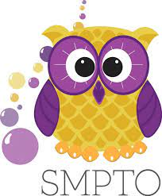
Parent Teacher Organization

BUBBLETHON 2024 PRIZES

AGAIN THIS YEAR: BUBBLETHON T-SHIRT DESIGN CONTEST! WILL YOU BE THE ONE TO DESIGN THE OFFICAL BUBBLETHON T-SHIRT LOGO? SEE ATTACHED PAGE

PRIZE STRUCTURE
Individual-$40- Bubblethon T-shirt
**Please complete this form to indicate your student’s shirt size - https://forms.gle/VndHudDB4xbZY6L86**
GRAND PRIZES- Top 3 fundraising students in each grade level will receive a PRIZE PACK
Classroom levels:
$500- Popsicles at Bubblethon
$750- Movie and Popcorn Party
$1,000- Silly string the teacher!
SCHOOL LEVEL
$20,000
WHEN EITHER SCHOOL REACHES THE SCHOOL LEVEL FUNDRAISING GOAL, THE STUDENTS AT THAT SCHOOL WILL EARN AN EXTRA SPECIAL REWARD DAY.
All classroom prizes are cumulative. Classrooms will receive prizes up to and including their current fundraising level. Parties will be held on a date and time determined in conjunction with the classroom teacher.

