Pleasant Township Board of Trustees Meeting Highlights
Date _June 24, 2025______________ Next Resolution No._ 33—06-24-2025_ _

- Call to Order -- The meeting tonight will also be on WebEx.
- Please stand for a moment of silence. --Pledge of Allegiance--Roll Call
- Visitors –
- Minutes to approve- No minutes
- Financial Reports – Paula –
  - Resolution__33___ transfer $15,000 from 01-A-26-OTHER to 01-B-07-REPAIRS for the sidewalk and new door.
  - Expenditures this meeting totaled $20,611.90, this includes $15,000 for the sidewalk repair. We received $225,000 for the second advance for real estate.
  - MOTION to pay expenditures.
- Department Reports
- Franklin County Sheriff’s Dept-Community Liaison, Deputy Adkins, 1120- Cell: 614-809-5843
  - None
- Road Department- Greg in for Robert Bausch, Superintendent (Robert is cutting wheat)
- Timberlake paving.-We will be able to do Timberlake Circle all the way back to the end. Does not include the cul-de-sacs and Pheasant Dr. But it is more than originally planned. Due to be paved July 2nd.
- Gay Rd. surface treatment.- on budget
- Ditch mowing.
- Rolling Hills Lane.
- Cemetery mowing
- 2 burials
  - 6296 Oakhurst Drive where he was forced to remove rocks to keep people out of his yard said a roofing company has driven along the edge putting ruts so large he can’t mow. He has contacted the roofing company, they said they would put down grass seed. He said it needs more than grass seed. Will you take a look at it please?
- Fire Dept. – Chief Whiting
- Firefighter Safety Stand Down June 15- 21st.
- Theme: “Break the Stigma, Behavioral Health Reset”
- Apparatus
- General maintenance & repairs
- Grass fighter pm.
- Personnel
- o
- Equipment
- Numerous repairs
- Township Hall - Replaced the computer due to failure.
- Hose Testing Competed
- Hurst tool cutters OOS, working with a replacement.
- Training
- Companies attended training at Mt Carmel
- Fire Behavior Lab Flashover simulator.
- Driving Simulator
- Departments participating: Prairie, Pleasant, Scioto, Jefferson, and Jackson.
- Station
- The concrete walkway was completed.
Working with Robert to grade around the new sidewalk and clean up flower beds.
- Water softener issue- the plumber has been contacted.
- HVAC to get serviced.
- Issues with the side door going into the township hall will probably need to be replaced due to poor construction. – if estimates are obtained before next meeting could we possibly have a Special Meeting to get this started.
- Community Risk Reduction
- Building inspections
- Installation of Smoke alarms
- Billing
- Medicount to change to submitting a check once a month, eliminating the need for the township to pay for a drop box.
- Dispatching
- Locution-met with Grove City on dispatch protocols. Have additional meetings scheduled.
- Nancy would like to have a printed copy of longevity for everyone for my records in keeping track of funds and go back to a printed copy each meeting of hours worked with a breakdown of overtime and part time hours. We used to get this, and I found it very helpful in decision making.
- In the future, could we do better with communications, for example, the flashover simulator. If trustees had known about it, we could better answer questions to our residents when they call with concerns or complaints. This is after the fact, but I think in the future if anything out of the ordinary goes on at the station or any place in the township, we should notify the neighbors as a courtesy.
- Old Business-
- New Business –
- 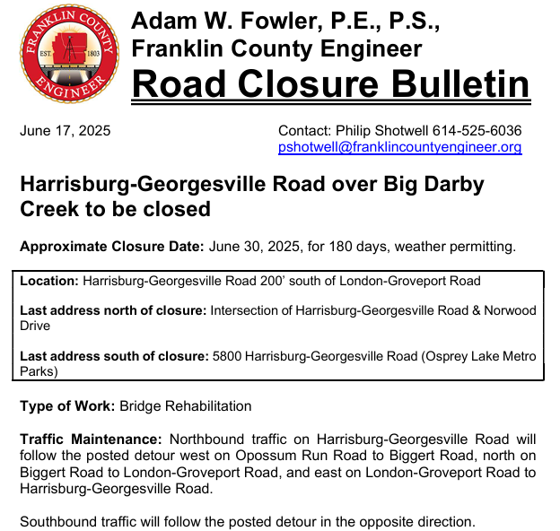

  - Received an email from Kailey of Local Waste for 2944 NORTON RD- The road was closed due to construction. We were unable to access when we were there for collection. She asked if it’s closed completely and can they get through or suggestions.

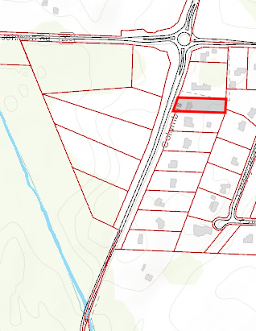
- Announcements -.
  - Big Darby Accord Master Plan Amendment Meeting tonight at Prairie Twp Recreation Center - Topic Workshop 3: Parks & Open Space. We thank Paul Denton for attending this meeting to represent Pleasant Township.
- Clerk Updates- Paula
- Miscellaneous correspondence
- Resolution 34 appoint Trustee Sheets as representative and Fiscal Officer Paula Wilkins as alternate for OTARMA.
- Resolution 35 authorize Paula to request unclaimed funds of $126.83.
- Speaker Sheets- (come to the podium to be heard on WebEx)
- Adjourn

