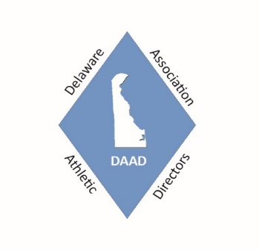
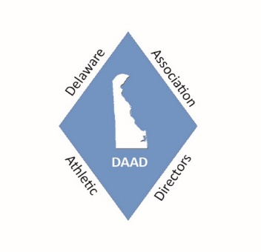
Delaware Association of Athletic Directors
(DAAD)
Send application and check to:
Rick Shea
DAAD Treasurer
Brandywine High School
1400 Foulk Road
Wilmington, DE 19903

Membership Application / Renewal and Invitational Payment Form
- Please print or type; make sure you include your school name and your e-mail address.
- Complete all information for each individual AD / school AND the Invitational Events your school plans on attending.
- Send in all completed forms attached to one check.

Name: __________________________________________ School: _________________________________________

E-mail Address: ____________________________________ Cell Phone: ________________________________
_______ Number of Years as an AD: (Include 2019 – 2020)

*************************************************************************************
DAAD Dues and Professional Day Fee – Please Check all that apply

________$200.00 High School (If you are both the high school and middle school AD the fee is still $200.00)

________ $50.00 Middle School AD only or Assistant AD (For all active athletic directors, assistant athletic directors, and other athletic administrators in public and private schools, and state agencies.)

________$80.00 NIAAA (National Interscholastic Athletic Administrators Association)

________$45.00 Registration for Field Maintenance Staff to attend the 14th Annual Sports Field Management Day
October 7, 2020 – Name(s) of staff Attending- $45 per person ______________________________

DAAD Invitational Events for 2020 – 2021 - Please check the ones that your school plans on attending.

_____ $ 275.00 Varsity and JV OR $175.00 – HS only event Upstate Downstate Boys Soccer Challenge (September 12, 2020)

_____ $ 210.00 10th Annual DAAD Middle School XC Invitational (October 28, 2020) 20 Middle Schools attended in 2019

_____ $ 275.00 9th Annual DAAD Middle School Volleyball Invitational (November 6, 2020) 22 Middle Schools attended in 2019 (Most teams in this event play 3 full matches)

********************************************************************************************************

$ _______________ Total Amount Enclosed for the 2020 -2021 School Year
Please send a copy of this form and your check to the address at the top of this page.
Make checks payable to DAAD (Sorry – No Credit Cards)
(DE Vendor ID # - 0000034342)

