March Members Meeting & Program

April 8, 2024

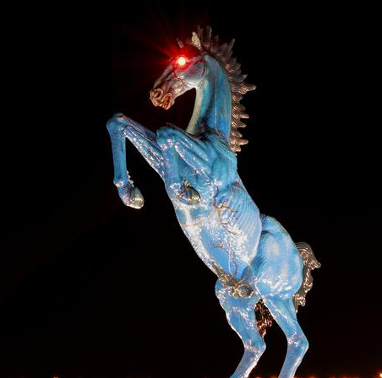
WHAT: April 2024 RMGA MEMBERS ANNUAL MEETING & PROGRAM
WHEN: April 8, 2024
6:00 pm – Networking
6:30 pm – Business Meeting – Election of Officers 2024-2025
6:45 pm – Program: The Public Art at Denver International Airport
Samantha Weston, Public Art Program Director at Denver International Airport, and her colleague Alyssum Skjeie, will deliver a presentation of public art at Denver International Airport.
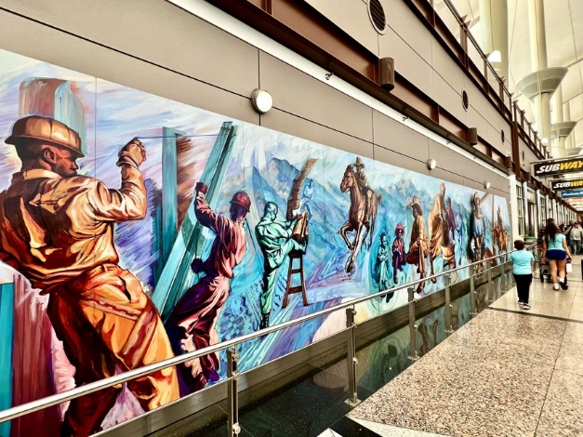
This presentation will cover the Public Art and Rotating Exhibition programs at DEN. Join the DEN Arts team to explore the current exhibitions on display, learn the history of the collection and dive deeper into our most asked about works. Learn how artwork is selected, maintained, and get a sneak peak of future artworks to come!

If you have any topics or questions, you want covered, be prepared to ask them.
Michael Dulude organizes this program.
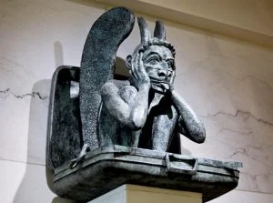

WHERE: VISIT Aurora Meeting Room, Ste 290, Stanley Marketplace, 2501 Dallas St, Aurora or Via Zoom --
https://us06web.zoom.us/j/85774465551
Meeting ID: 857 7446 5551
FOOD: Empanadas will be provided by Visit Aurora.
PARKING:

The Stanley Marketplace has installed a brand-new parking system that will allow three hours of complimentary parking in their parking lots.

A nominal $3 fee per hour, after the first 3 hours, is charged for an extended trip. The average guest visits Stanley for less than 1.5 hours, so they are giving you double that time to spend shopping, dining, and exploring Stanley.

No gates or arms. The system is monitored via LPRs - license plate reader camera technology - which also adds an extra layer of security.

Once you pull into our lot, find the payment signs sprinkled throughout. They will also be posted at each entrance to the building. Scan the QR code and follow the prompts to get your car registered. Make sure to pay for your time (if over 3 hours) PRIOR to departing the property. ***If you do not have a smart phone, please locate the iPad at the welcome desk (nearest the Southeast entrance).

GUESTS: Members are encouraged to invite potential members as guests to the meeting.

GUEST FEES: 1st and 2nd Time Guest: Free, Third thru Fifth Time, Same Guest Visit is $10 each time. Succeeding Times, Same Guest Must Join RMGA.

MEETING NIGHT CONTACT: Mike Pearl (303) 868-0023 voice & text or Tom Jensen (303) 968-0515l

