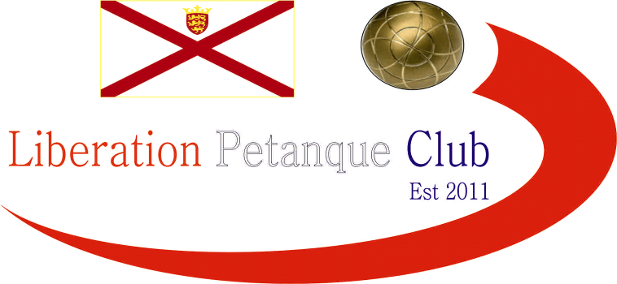

**SUMMER 2025 SEASON**

**WEEK 11 – 11th June 2025**

**LIBERATION CUP DOUBLES 2025**

# The new season and new terrains playing indoors, well at least for a little while.

# Round one saw big wins for champions Neil & Ross over Daniel & James, whilst Andrew & Callum made light work of Brian & Colin.

# A low scoring 8 – 4 win for Geoffroy & James over Keith & Mo and a carreaux for game for Toby with Laurent against Gary & Wendy.

# Round 2 - Neil & Ross went one better with a 13 – 1 win over Andrew & Callum whilst Geoffroy & James beat Laurent & Toby 13 – 3.

# Brian & Colin just beat Daniel & James 9 – 7 and Gary & Wendy beat Keith & Mo 10 – 6.

# Round 3 - Two close 10 – 8 wins saw Neil & Ross beat Geoffroy & James and Andrew & Callum beat Laurent & Toby.

# Keith & Mo got to 13 against Daniel & James winning to 8 and Gary & Wendy also did winning 13 – 3 over Brian & Colin.

# In the final round Gary & Wendy 12 – 5 win over Neil & Ross their first defeat saw Gary & Wendy finish second with Neil & Ross third.

# Geoffroy & James second defeat in a row saw them drop to third and just qualify by one BHN over Laurent & Toby with Andrew & Callum finishing top.

# FINAL SWISS RANKINGS

# SEMI-FINALS

# Ranked 1st Andrew & Callum v Geoffroy & James Ranked 4th

# Ranked 2nd Gary & Wendy v Neil & Ross Ranked 3rd

# In a strange twist the semi finals were the same matches as the final swiss rounds but with the opposite results as Neil & Ross helped by Gary moving the jack in their favour twice won 9 – 2 whilst Geoffroy & James made light work of Andrew & Callum winning 13 – 2.

# Andrew & Callum took third, the fifth top three finish for the pair.

# Well the score doesn’t represent the match as some excellent pointing by Neil & Ross was met with superb shooting from Geoffroy in fading light and with James pointing well ran out 13 – 1 winners.

# Thanks to everyone who helped out.

# NEXT WEEK - SINGLES LEAGUE

# Club email address - [liberationpc@gmail.com](mailto:liberationpc@gmail.com)

# Club Website - [www.liberationpetanque.co.uk](http://www.liberationpetanque.co.uk)

# Kind Regards

# Toby Northern

# Chairman - Liberation Petanque Club