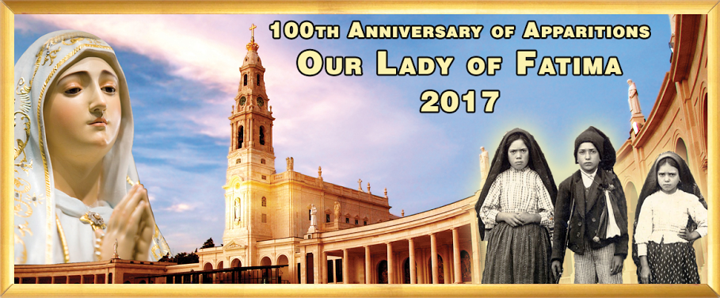
Pre-Book for
2018 NOW.

Limited Seats for Sept 5-16 &
Oct 24- Nov 4, 2017

Fatima, Lourdes & Shrines of Spain 2017:
12 Days from $1831 per person twin share
Religious Tours
INCLUDES:
Breakfast: 11
Dinner: 6
THE ANGLO-INDIAN AUSTRALASIAN ASSOC. OF VIC &
RUBY TRAVELS WORDLWIDE PRESENT
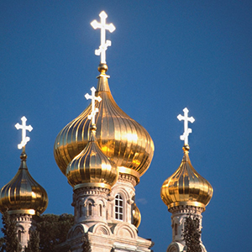
The Holy Land Discovery:
8 Days from $1871 per person twin share
Tour includes Portugal, Spain and France
Overnights in Lisbon, Fátima, Santiago de Compostela, Burgos, Lourdes and Barcelona.
Attend Mass in Fátima, join pilgrims for the Rosary and candlelight procession at Our Lady of Fátima Basilica.
2 nights in Lourdes, nightly Rosary and guided tour.
In Lisbon visit the Cathedral La Se’, where St. Anthony was baptized
Inclusions: Sightseeing, Guides, Transportation, Hotels.
Flights: Not Included.
Join a Group from Melbourne
and Celebrate the
100th Anniversary of Apparitions
INCLUDES:
Breakfast: 7
Dinner: 4
Call June to book your TOUR & FLIGHTS
0401 895 998
Tel Aviv, Jerusalem, Nazareth, Bethlehem, Jericho,
Visit Jerusalem’s Old Town, the Garden of Gethsemane, the Jewish Quarter
and Western Wall, the Basilica of the Holy Sepulchre & Via Dolorosa
In Nazareth, visit the Church of the Annunciation, visit Cana of
Galilee, Mount of Beatitudes,
In Bethlehem, visit Church of the Nativity, situated on the site where Jesus was born.
Scenic Highlights: Sea of Galilee, Jordan River, Dead Sea, Jordan Valley, Mount Carmel.
Inclusions: Sightseeing, Guides, Transportation, Hotels.
Flights: Not Included

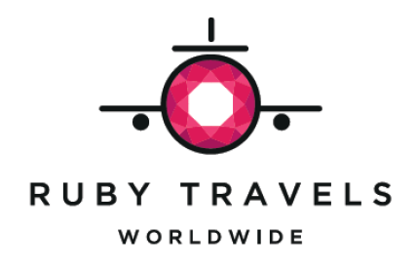
Ruby Travels Worldwide is an Authorised Agent for Globus Family of Brands
For detailed itinerary email: june.rubytravels@gmail.com

