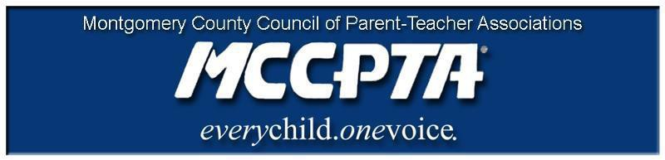

DELEGATES’ ASSEMBLY MEETING AGENDA
Tuesday, January 25, 2022
Meeting Held on Zoom

7:00 pm WELCOME

- Approve Agenda; Approve November 2021 Minutes

7:05 pm SPEAKER

- Dana Edwards, Chief of Districtwide Services and Supports, Out of School Time (OST) Initiative

7:25 pm INFORMATIONAL UPDATES

- National/MDPTA Update/Delaware PTA

7:30 pm NEW BUSINESS

- MCCPTA Standing Rules Adoption

7:50 pm OFFICER REPORTS

- Cynthia Simonson, President
- Rodney Peele, Vice President- Educational Issues
- Rochelle Fink, Vice President- Administration
- Charisse Scott, Vice President- Programs
- Laura Mitchell, Vice President- Advocacy
- Francesco Paganini, Treasurer
- All Reports - https://mccpta-my.sharepoint.com/:f:/g/personal/office_mccpta_org/ElbPYvFOjg1IigTzJxAvZNwB_VTjG00g5xkdWxhBIorbXQ?e=D4mOqw

8:25 pm COMMITTEE REPORTS

- All Reports – https://mccpta-my.sharepoint.com/:f:/g/personal/office_mccpta_org/ElbPYvFOjg1IigTzJxAvZNwB_VTjG00g5xkdWxhBIorbXQ?e=D4mOqw

8:50 pm ANNOUNCEMENTS & ADJOURNMENT

DATES:

- February 9, 2022 – BOD Meeting, 7 pm on Zoom
- February 22, 2022 – DA Meeting, 7 pm on Zoom
- March 9, 2022 – BOD Meeting, 7 pm on Zoom
- March 22, 2022 – DA Meeting, 7 pm on Zoom

