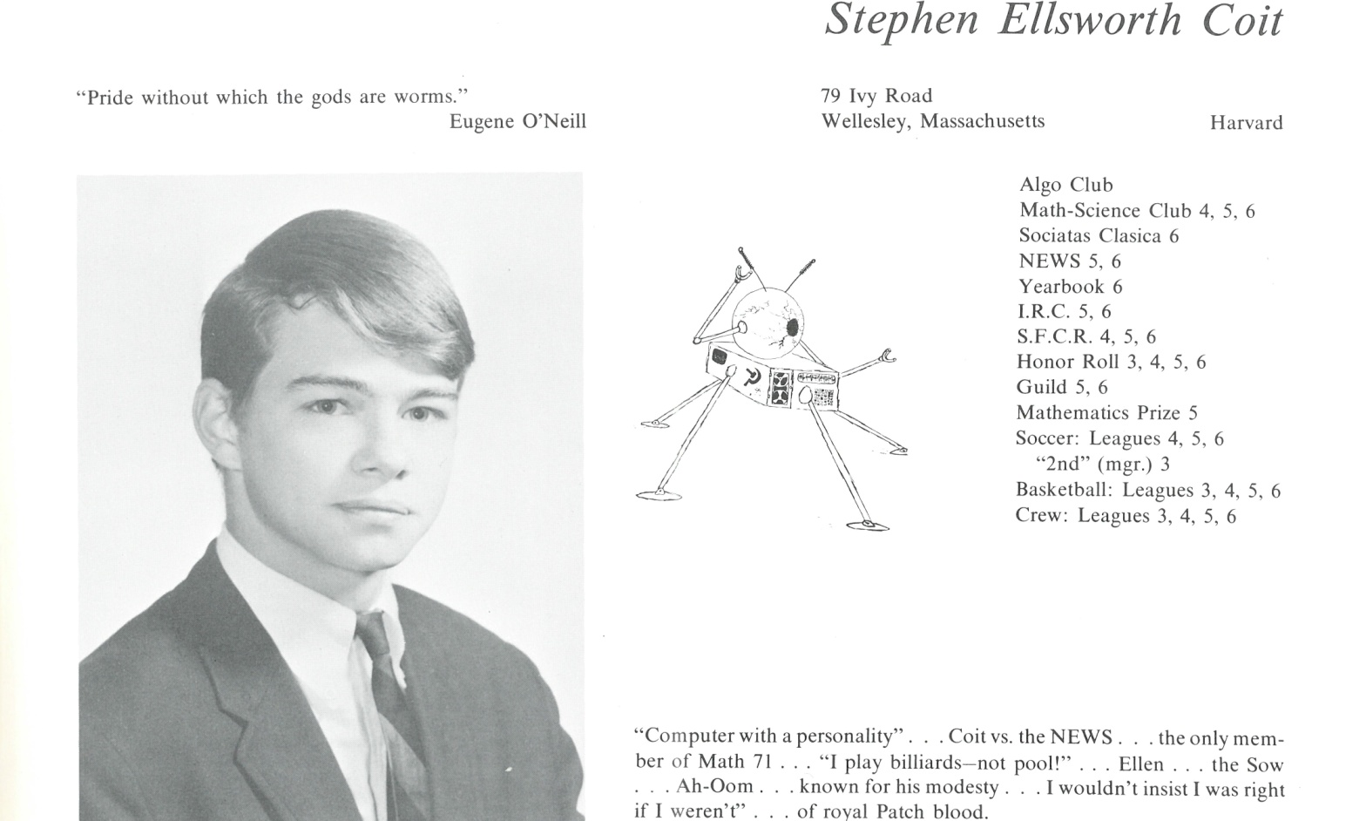

Stephen E. Coit

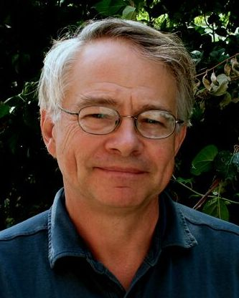Dear Steve,

Congratulations, graduate. You did well. But Steve, let me say that looking over your 1967 Kent yearbook photo above, I do see the uncertainty and apprehension in your eyes, maybe even some sadness. Therefore, I thought it might be useful to write to you and tell you a bit of what destiny has in store for you from my vantage point here in Cambridge, Massachusetts, where you will live in 2017, fifty years from now.

Let me start with some reassuring news: You’ll graduate in computer science and also get an MBA from Harvard. You will enjoy a lucrative and successful career in high tech capped off by being a venture capitalist in both Silicon Valley and Boston, the right places to be for a high tech career. So much for “Computer Coit.”

But that’s not where your story will end. Thirty years from now, in 1997, you will drop all that and take on a second career; this time, as a fulltime painter. And you will do pretty well at that too.

To explain: Approaching middle age, your love of art will simply take over your life. You will have a diminishing interest in business and doing deals, and trying to keep up a front as a VC will become hard. What you have to say inside just won’t stay inside. So really, you will have to make the move. Only those that know you well will understand.

Drawing people – portraiture -- will become your passion. You’ll discover that you see things in people’s faces that others miss, allowing you to paint them in a vivid, lifelike way. Being able to do this will begin to get you commissions without too much difficulty, and you will create dozens of portraits that hang in some pretty fancy places. For Harvard alone, you’ll create over twenty paintings that will hang on that university’s walls for a long time to come. Cool, eh?

There’s one piece of news I have to alert you to, something I wish you could do something about, though I know you can’t: Steve, you will marry too young, and will eventually get divorced 27 years later. However, you will have three lovely daughters who will stay close to you throughout your life and will bring you much joy.

The better news is that roughly ten years after your divorce, you will be lucky enough to marry Susan Napier, your love and new lifelong partner. And just before your fiftieth Kent reunion, to celebrate your fifth anniversary, the two of you will take a wonderful walk through Cotswolds in England, choosing to ignore a siege of inclement weather that just will not quit. But this is what you have to do in life sometimes. The trick is to find someone to do it with.

So relax, Steve. It will all work out.

Steve



______________________________________________________________

______________________________________________________________ ______________________________________________________________ ______________________________________________________________ ______________________________________________________________ ______________________________________________________________ ______________________________________________________________ ______________________________________________________________ ______________________________________________________________

Attach Picture in .jpg Format

______________________________________________________________

______________________________________________________________

___________________________________________________________________________________ _________________________________________________________________________________________________________________________________________________________________________________________________________________________________________________________________________________________________________________________________________________________________________________________________________________________________________________________________________________________________________________________________________________________________________________________________________________________________________________________________________________________________________________________________________________________________________________________________________________________________________________________________________________________________________________________________________________________________________________________________________________________________________________________________________________________________________________________________________________________________________________________________________________________________________________________________________________________________________________________________________________________________________________________________________________________________________________________________________________________________________________________________________________________________________________________________________________________________________

___________________________________________________________________________________