The SEE THE FUTURE ‘Education for Life’ Program
P.O. Box 63022
Colorado Springs, CO 80962-3022
Email applications to: twtheune@comcast.net; Phone: 719-640-0997
- Application Deadline: March 1, 2025
_______________________________________________________________
The SEE THE FUTURE Fund 2025 Application
The SEE THE FUTURE Fund is pleased to award scholarships to qualified visually impaired and blind students who are Colorado residents. This scholarship fund is made possible through generous donations by ophthalmologists, optometrists, opticians, staff, corporations, educators, foundations and many others with an interest in the lives of the visually impaired and blind. All scholarships are awarded based on academic achievement, school and community service, and individual need.
Amount
Scholarships totaling up to $42,000 may be awarded. Probable distribution will be one (1) $12,000 four year scholarship, one (1) $10,000 four year scholarship, one (1) $8,000 four year scholarship and three (3) $4,000 two year scholarships. The Selection Committee will determine the final number of scholarships awarded and the amount of each scholarship.
In memory of Ashley Fritz, a 2004 recipient of a SEE THE FUTURE scholarship, the SEE THE FUTURE Fund selection committee will award an additional $1,000 to a recipient who demonstrates exceptional humanitarian and leadership abilities in the spirit of Ashley. (Obtain more information about Ashley’s scholarship on the last page of this application)
Who Is Eligible
Any Colorado resident * who submits a completed application prior to the March 1st deadline, and meets the following criteria:
* For STF purposes, a Colorado resident is one who has lived in Colorado as a dependent at least one year prior to the March 1st deadline; or has held a valid Colorado ID for at least one full year prior to the March 1st deadline.
Educational Criteria
Applicant must be enrolled as a full-time student in one of the following:
1. an entering freshman in an academic post-secondary program
2. an undergraduate (sophomore, junior or senior) in an academic, post-secondary program
3. a graduate student in an academic program
4. a vocational/technical school student or student who is pursuing an associate's degree from a community college. 5. A certified certificate program (such as massage therapy).
Applicants must also meet the following Vision Loss Criteria
20/70 or less, central vision, best corrected, in better eye,
and/or
20 degree peripheral field or less in better eye
or
20/40 or less, best corrected, in better eye, and associated field loss with a prognosis of further vision loss secondary to underlying disease process.
Application deadline
All applications must be received (by email) by Dr. Theune on or before March 1, 2025.
Selections
The SEE THE FUTURE Fund nominating committee will review all applications. Individual phone interviews may be arranged and will be determined based on an individual basis.
Final selections will be made by April 15, 2025.
Scholarship Distribution
The scholarship award will be divided over the duration of the student's post-secondary career (two or four years) and all scholarship moneys will be sent directly to the post-secondary institution on a semester basis. The student must be enrolled full-time and in good standing to receive future money. The award may be used toward tuition, fees, and books.
If a recipient does not use a portion of their award within one year from selection, their award will be forfeited unless a special extension is requested (in writing) by the recipient and granted by the STF Nominating Committee.
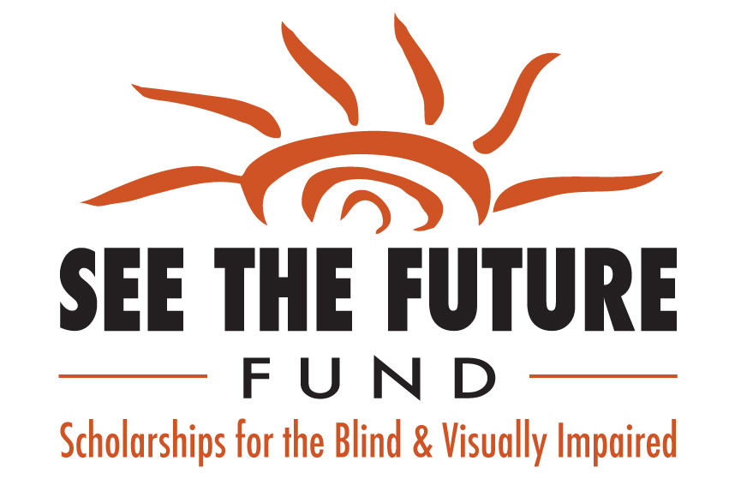

To apply, please complete this application form (typewritten or printed legibly) and emailed along with required attachments to:
Thomas W. Theune, OD (STF Chairperson) twtheune@comcast.net
* MUST BE RECEIVED BY March 1, 2025
Name: Date:
Home address:
City: State: Zip:
Home Phone: Cell Phone:
Email Address:
Name of high school: Graduation date:
City:
Cumulative high school grade point average: Class Rank:
Cumulative grade point average of school currently attending:
(if different than high school)
Have you been accepted to a college or university: NO If No, please explain:

If Yes: Name of School: Stated Major:
School address:
City: State: Zip:
Desired Degree:
Vocational goal:
This application can be made available in Braille upon request.

Please enclose the following information:
* All materials submitted must be typewritten or printed legibly
1. Completed application form
2. Autobiographical summary. No longer than two double-spaced pages. Please include the following in this order(A-G):
A. Field of study, and why?
B. Personal goals
C. Achievements, honors, hobbies, leadership qualities
D. School activities beyond academics (music, art, sports, drama, etc.)
E. Orientation / mobility and independent living skill abilities and strategies to achieve independence in a college environment
F. Adaptive equipment and media used (large print, Braille, recordings, CCTV, computers, magnifiers, etc.)
G. Strategies to succeed in college with vision loss
3. A paragraph stating your financial need including information on any scholarships or grants you are, or will be, receiving
4. Transcripts and ACT and/or SAT scores from the school you are currently attending or have most recently attended
5. A letter of recommendation from EACH of the following:
- Current or recent schoolteacher or administrator
- An individual in the community (outside of school
setting)

6. Current letter of medical visual condition from your eye care practitioner. Please include diagnosis, prognosis, visual acuity and extent of peripheral field loss, if applicable.



Ashley K. Fritz Memorial “Humanitarian” Scholarship

An additional $1,000 scholarship will be awarded to one of the 2012 SEE THE FUTURE recipients who the STF Selection Committee feels demonstrates exceptional humanitarian and leadership abilities, in the spirit of Ms. Ashley Fritz.

Ashley was a 2004 winner of a SEE THE FUTURE scholarship. She was valedictorian of her class at the Colorado School for the Deaf and the Blind. She received her Bachelor’s Degree in Hotel Management from Johnson & Wales University and her Masters degree in Business from The University of Phoenix. Ashley achieved the status of being an honor student while obtaining her BS and MS degrees.

Ashley passed away in 2011, however, her determination in making a difference to people in need was evident throughout her life and will always be remembered.
Ashley writes: “As a leader of the El Pomar Youth in Community Service Program at the Colorado School for the Deaf and the Blind, I was responsible for getting everyone equally involved in helping non-profit organizations. I was responsible for constructing a variety of food drives, fundraisers and toy drives for those who are less fortunate. Now I fully understand the philosophy behind philanthropy.”

After receiving her SEE THE FUTURE Scholarship, Ashley was asked by Dr. Theune if she was “less fortunate” because of her visual impairment. She replied:
“Absolutely not - I have plenty of food to eat, a roof over my head, warm clothes to wear and a loving family. The people in this world who are less fortunate do not have these basic necessities of life.”

It is with this spirit that the SEE THE FUTURE Fund presents the Ashley K. Fritz Memorial “Humanitarian” Award.

