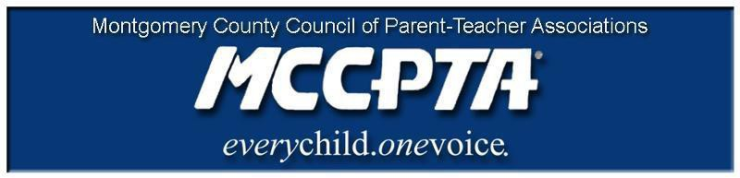

DELEGATES’ ASSEMBLY MEETING AGENDA
Tuesday, October 22, 2019
Carver Center Auditorium

7:00 pm Call to Order

- Welcome; Approval of Agenda & September 2019 Minutes

7:05 pm Dr. Smith & Dr. McKnight

- Dr. McKnight’s vision for her work
- Questions

7:25 pm Unfinished Business

Standing Rules

Advocacy Priorities Document Amendments/Approval

- Explanation of amendments and voting process
- Only those comments that affect all/most students/schools will be considered during the DA meeting; this document must adhere to MCCPTA’s mission

Resolution in Support of Amending MCPS Absence Policy

8:50 pm Officer Reports

- All reports in the October 2019 Folder

8:50 pm Committee Updates & Announcements

- Membership Report & Awards

9:00 pm Adjourn

Dates:

10/23/19 MCCPTA/MCPS/BOE Annual Meeting (7 pm, Carver Auditorium)
10/30/19 MCPS/MCCPTA CIP Workshop (MCPS provides MCCPTA with information about the Superintendent’s recommended Capital Improvement Program (CIP) Budget. The workshop helps cluster coordinators gather information for their CIP testimony. There is a separate CIP testimony prep session for MCCPTA.)
11/5/19, 11/7/19 & 11/13/19 CIP Testimony Dates (6 pm, Carver Auditorium)
11/14/19 MCCPTA Board of Directors Meeting (7 pm, Carver Room 134)
12/4/19 Delegates Assembly Meeting, Wednesday night (7 pm, Richard Montgomery HS)
12/12/19 MCCPTA Board of Directors Meeting (7 pm, Carver Auditorium)

